Greek musicians from Trikala
Vasilis Tsitsanis
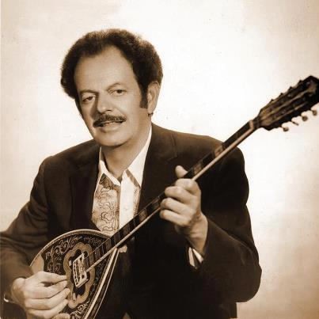
He was born in Trikala on January 18, 1915 to Epirus parents and passed away on January 18, 1984. From an early age he was interested in music and learned mandolin and violin and of course bouzouki. In the autumn of 1936 Tsitsanis visited Athens. His main purpose was to study law, but he soon gained a degree in music.

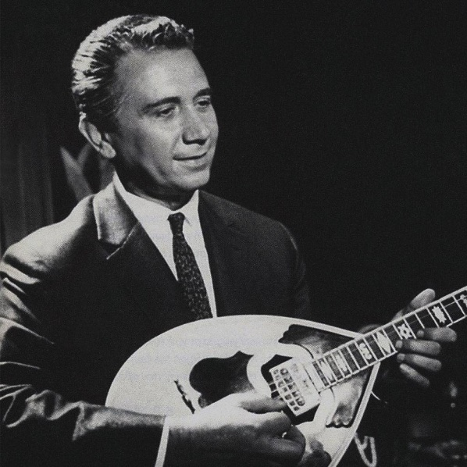
Apostolos Kaldaras
He was born in Trikala, Thessaly, on April 7, 1922. He finished high school and initially engaged in the art of bouzouki. During the Occupation, however, he dealt professionally with this musical instrument and of course with the music it represented. Immediately after his occupation, he began recording in 1946.

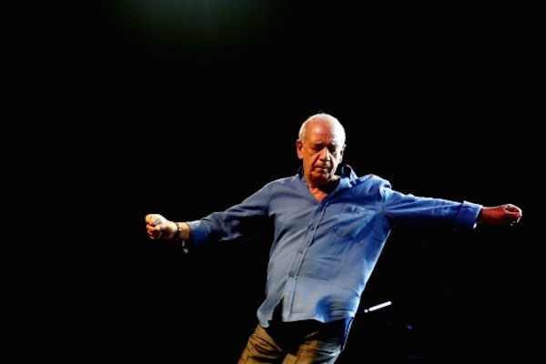
Dimitris Mitropanos
Dimitris Mitropanos (Trikala, April 2, 1948 ) was a Greek singer. He performed characteristic songs by major artists and composers. He is considered one of the best and most important Greek singers of all time.
At the same age, at the urging of Gregory Bithikotsis, whom he met at a gathering of his uncle's company, in which he sang, he visited Columbia. There Takis Lambropoulos met George Zambetas, next to whom he would work in "Early Days". Zabeta mentions him as his great teacher and second father.

