Local writers
Efi Papayannidou-Gougoulakis was born in 1926 in Trikala. She studied music (piano and harmony diploma) and for 25 consecutive years served as director of the Trikala Municipal Conservatory. Her aim was to spread classical and artistic music in general. She has participated in many artistic events in various regions of Thessaly. From 1967 to 1983 she was a representative of Trikala of the "Musical Neat" club, which aimed to disseminate classical and generally artistic music.
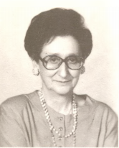

Marula Kliafa was born in 1937 in Trikala, where she lives permanently with her family. She has studied journalism and since 1972 she has been involved in literature, the study of local history, the collection of folk tales, traditional games and old photographs. Her teenage novels have been widely republished, two of her books have been translated into Russian and German, and excerpts of her works have been included in elementary school textbooks and in the "Modern Greek Literature Texts" of high schools. She has been honored by the Academy of Athens, the Society of Greek Writers, the Children's Book Circle and Women's Companionship. In 2010 the Department of Primary Education of the Faculty of Human Sciences of the University of Thessaly awarded her the title of Honorary Doctor.
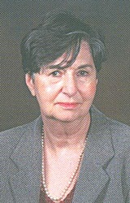

Elias Kefalas was born in 1951 in the village of Meligos Trikala. He studied political science in Athens, where he lived from 1969 until 1992. Today he lives again on his hometown, photographing nature, writing poetry, essay and prose and practicing literary and art criticism in literary and art magazines. Some of his poems have been translated into English, French, German, Spanish, Italian and Polish.
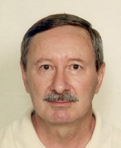

Nikos Pappas (Trikala Thessaly 1906-Athens 1997) was a Greek poet and historian of Modern Greek Literature. He studied law at the University of Athens and worked as a lawyer in Trikala and Athens. He first appeared in the literary scene in 1928 with the publication of his messages in the journal "New Estia". During the occupation from 1941 until 1944 he took an active part in the National Resistance. He has been a member of the Society of Greek Writers. He has translated works by Brecht, Rilke, Apollinaire and others.
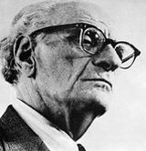

Tula Tiga was born in Trikala at the end of the war. She studied English Literature. She has written books for children and young people and novels. Her works include the Prize-winning Greek Children's Book Circle "Gravia Street", "The Age of Hyacinths" and the Prize-winning "Diavazo" literary magazine.
