Rediscovering our historical heritage in Santa Comba

Introduction about the Romanization of Galicia
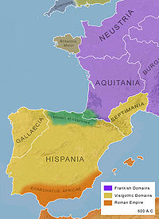
In the year 19 B.C, the Roman Empire finished their military conquest in the last territory of north-western Hispania. This territory was called Gallaecia, which bordered to the south with the river Douro and to the west with the river Navia. The process of Romanization in this territory was marked by the assimilation between the Castro culture¹ and the Roman culture.
The Romans arrived to Gallaecia when they were looking for tin and gold. According to the researcher Manuel Quintáns Suárez, the Xallas region was an important strategic centre due to their important mining operations, particularly of gold. In Zas, a city council near Santa Comba, it is located Pozo Limideiro, a mine of gold and tin of Roman origin. In Santa Comba, the Romans focused on the gold, but the mining became inactive soon and it was abandoned in the 3rd century. One of the first concerns of the Romans was the displacement of their troops and products. So, they adapted the Castrexos’ roads. Per loca maritima is the name of one of the most important roads that the Romans used to connect the cities of Braga (Braccara Augusta) and Lugo (Lucus Augusti) along the coast, crossing the Xallas region through Santa Comba, passing near the port of Cee-Corcubión and entering in the port of A Coruña-Betanzos (Brigantium).

¹ Castro Culture: (in Galician language: cultura castrexa) this is the term used for the material culture of the north-western regions of the Iberian Peninsula from the end of the Bronze Age (c. 9th century BC) until it was assimilated by Roman culture (c. 1st century BC). “Castro” is an archaeological term that refers to the hill-forts of their settlements.

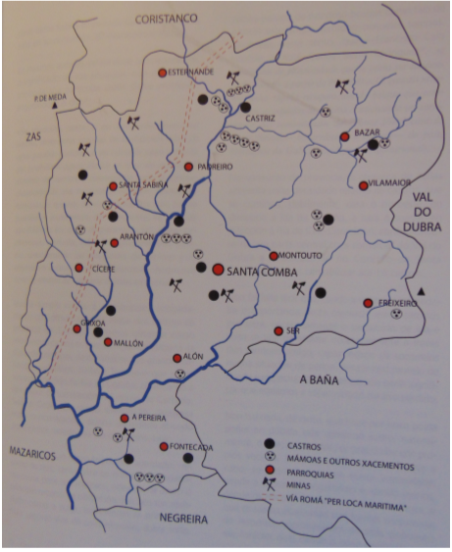
Evidence of the importance of Xallas area in the process of Romanization of Galicia

As one of the aims of our SOS Project is to rediscover our cultural and historical heritage, a group of students who study Latin, thanks to the teacher Inma Rodríguez, have worked on the historical value of the area of Santa Comba and found out some important information, mostly unknown for us.

First of all, we came to know that the area around the River Xallas may have been an important zone for the Romanization process of Gallaecia. There is even a theory that points out the existence of a Roman military camp, more specifically the headquarters of Cohors I Celtiberorum, an army auxiliary unit recruited under the Flavian dynasty.
We know that because there is some evidence that the Roman Via XX, or “per loca maritima” crossed may villages of Santa Comba, which means that our area was important for the land planning of the Roman Empire.

Roman people built excellent roads, they paved the ground when it was necessary, they built bridges to cross rivers and they indicated distances with milestones. The roads were so well built, that nowadays there are still remains which allow us to rebuild their country’s organization. For example, in Santa Comba and surroundings four milestones and two funerary steles were found.

A milestone is a cylindrical or oval column that was placed on the edge of the Roman roads to indicate distances. They used to be made of granite and the majority of them had inscriptions which referred to the emperor to whom they were dedicated or to the governor or military unit responsible for road works. In fact, milestones started to lose their indicative function and became elements of political advertising.

Milestones found in Santa Comba:

1- Galerio
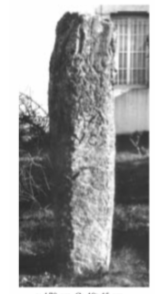
It is known as “Galerio” because it is dedicated to the emperor Caesar Galerio Valerio Maximo, dated about 305-311 A.D., years in which this emperor ruled the Eastern Roman Empire. It is a milestone of propaganda, so it doesn’t indicate miles. It was found in 1984, it was part of the wall of the disappeared church of Santa Comba. Nowadays, it is found in the front garden of the “Casa da Cultura”. In addition to the inscription dedicated to the emperor, there is a six-pointed star and the letters LQ.
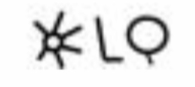

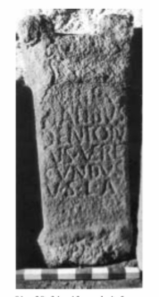
2- Lares Viales -Brandomil milestone
It was discovered at around 1885 in the rectory house of Brandomil and today it is preserved in the Santiago Cathedral Museum. An inscription can be reconstructed referring to Dentonio Vercundo about taking his vow to the lares viais, gods of the ways.

3- Milestone Brandomil
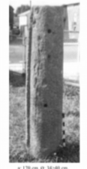
It was found while remodellings were being made in a house in Brandomil (Zas). It is “anepígrafe”, which means that it hasn’t got any inscription, or this was erased. Nowadays, it is preserved in the garden of its owner’s house.

4- Milestone Brandomil, “anepígrafe” (without preserved inscriptions).
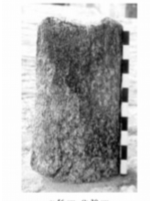
Possible milestone found during the reconstruction of the Brandomil’s bridge, on the river Xallas.

These last two milestones, although they are without epigraphs, they are rests which prove the existence of a Roman road. The same happens with two funerary steles.

A funerary stele is a rectangular stone, which is placed vertically on the top of the tomb. The name of the deceased and his dedication were inscribed on the steles.

Steles found in Santa Comba:

1- Mallon’s funerary stele. It was found in 2005 by a farmer while he was ploughing. In this stele it is indicated that soldier Quinto Iulius Aqunus and his partner Tiberia Claudia Urbana were buried there. It is located in “Museo do Pobo Galego” (Museum of Galician People) in Santiago de Compostela.

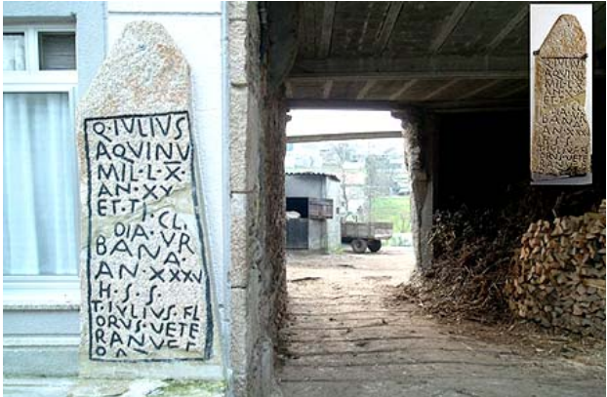

2- O Busto’s funerary stele. It was found in 1985 in the garden of a house. Nowadays it is in “Casa do Pazo” (Santa Comba), a house-museum where there are a lot of interesting and important ancient remains found in Santa Comba and where you can go if you want to know more about the history of Santa Comba and its people.
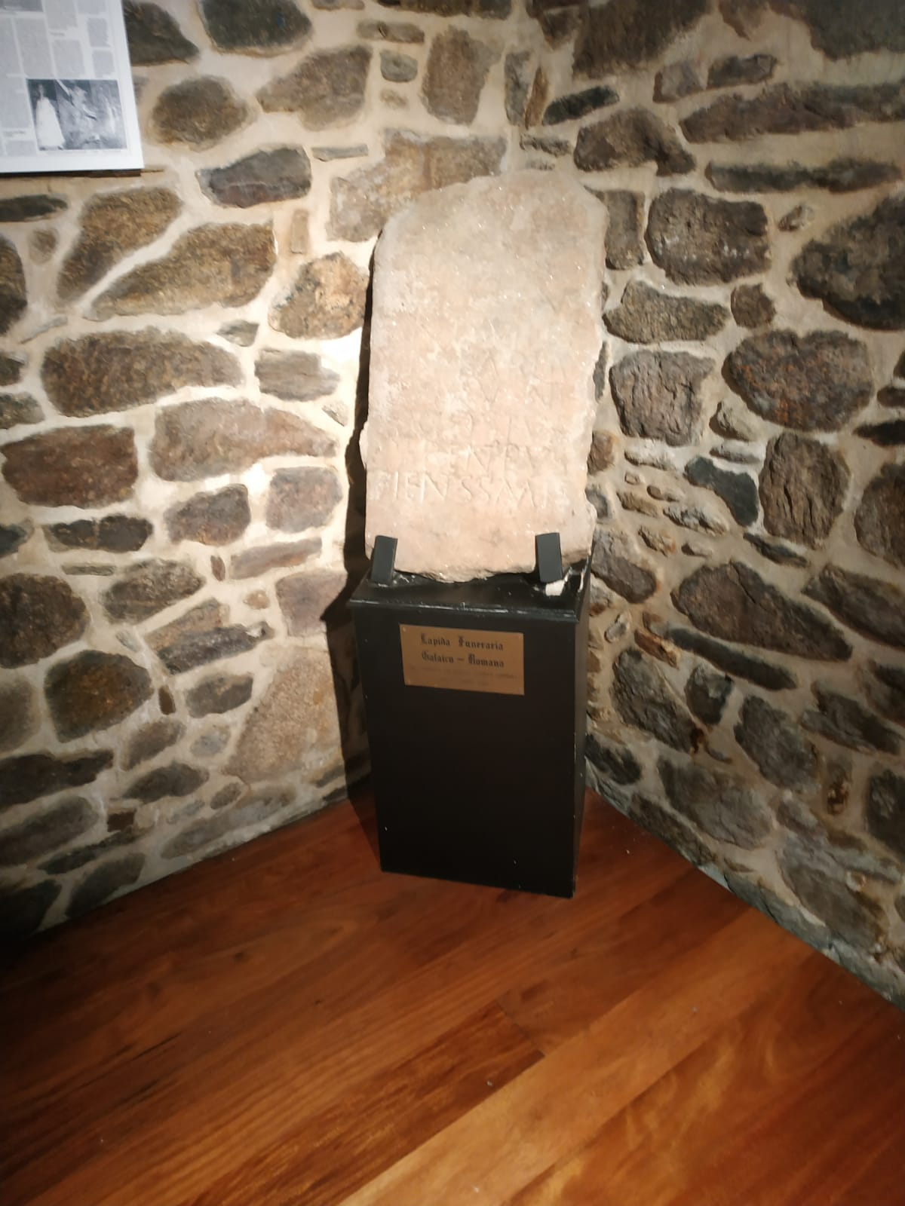

Done by Patricia Pose and eight other students of 1st course of Bacharelato in the class of Latin (June 2019)

