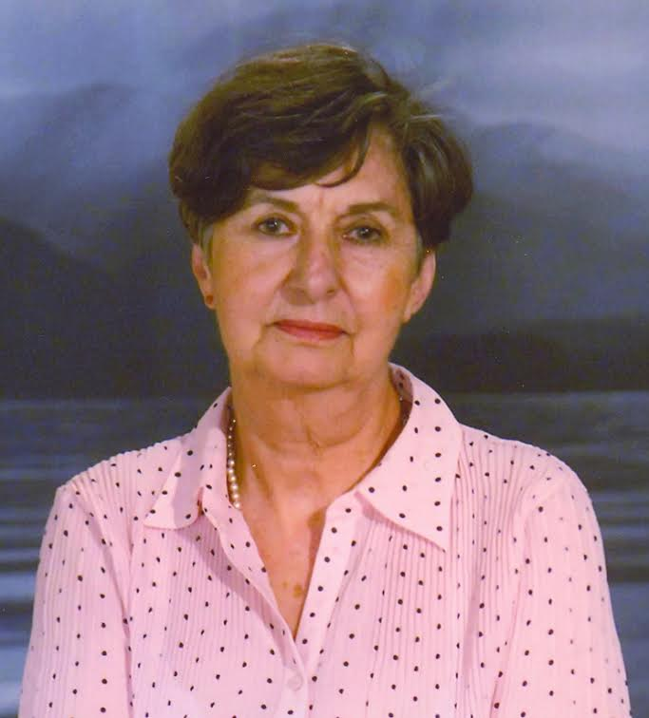

Maroula Kliafa (1937) has a rich work (literature, photography, local history and folklore of Thessaly, albums, anthologies of popular speech) while, as the valid criticism notes, she renewed the children's literature in style and themes.
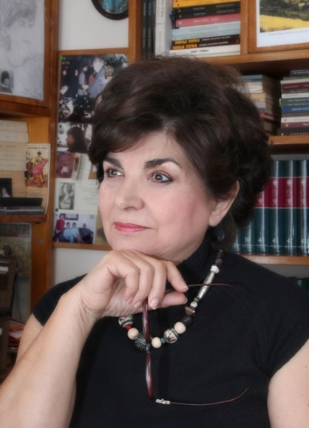
Toula Tigka (1944) has written so far twelve books for teenagers and adult readers many of which are award-winning or are in school anthologies ("Gravia Street", "The era of Hyacinth", "The Sea of Water", "The Birds in the snow", "The years Running "etc.).
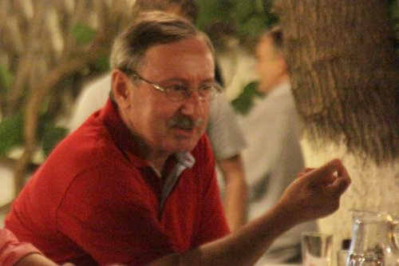
Elias Kefalas (1951). Poet of the generation of 1970. He has written texts of high sensitivity, poetic and artistic, after conversing and arranging responsibly the critical production with the deep understanding of Human.
The Agathocles Azelis (1963) has printed three poetic collections while he is systematically involved in the study of history and historical research.

The prose writer Alexandros Vanargiotis (1966) published the collections of short stories "Short stories for the end of the day" and "The Theory of Kites”.
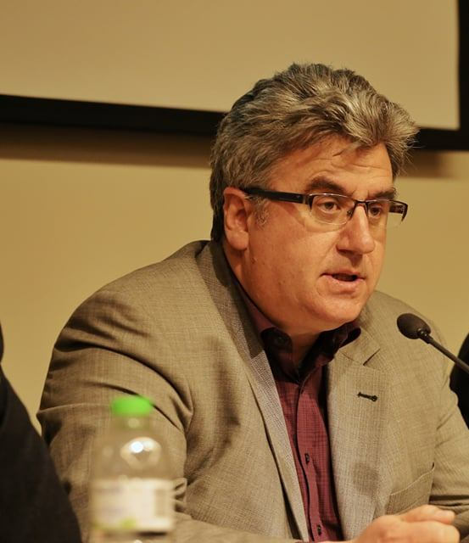
Georgia Koloveloni appeared in the letters with the highly lyric poetic collection "Stories with Sad Beginning". In the second poetic collection with the imaginative title "Ink on the Palate" her voice matures: The wounded self is no longer always in love, nor do we hear the voice of sexual despair.

Paraskevi Alexi (1972). In her first poetic collection "Class of Dreams" what dominates is the fear and its connotations.

Eleni Alexiou (1980) has published two books of poetry, "The Flash" and "Poems that we wrote together". The second-most mature collection- is distinguished by the dominance of the body and an emphasis on the contestant word.

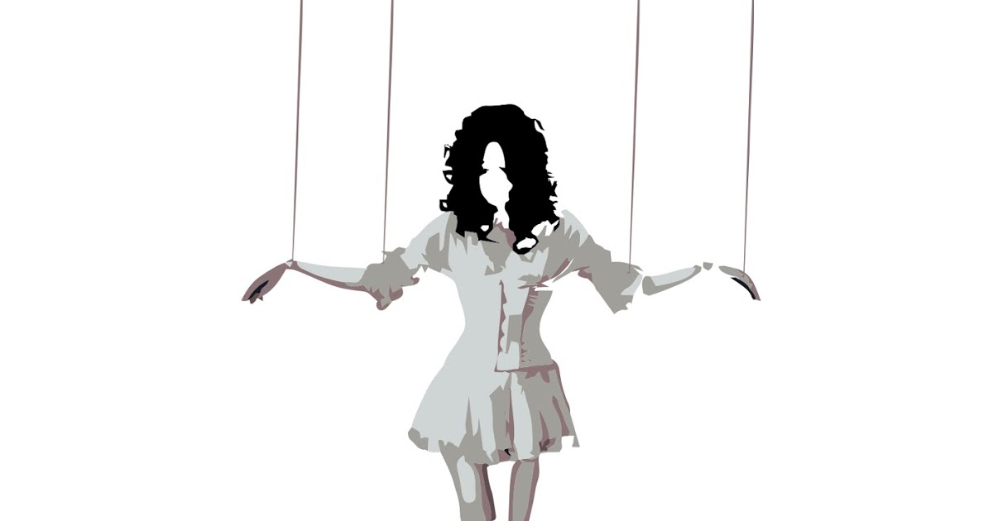
Vaso Christodoulou has published the poetry collection "60 shades of black in white background". These are poems that seek justice in the body of today, among losses and triangles.
Giannis Plexidas (1972) is included in this tribute as a representative not of the literary scene of his city but as an Essay writer (the essay is a separate kind of speech that many owes, however, to the narrative writing itself). His way of writing has, beyond the profound knowledge of the subject, and a personal style with elements of rhetoric and literary grace (echoes, verbal gambling, etc.)

