DIAMANTE POEMS

AUTHORS: students from partner countries who worked in international teams- Germany, Romania, Greece, Spain, Italy and Poland

VENUE: virtual meeting for Art and Design in Nature
Liceul de Arte ”Ionel Perlea”, Slobozia

Romania, 3-5 March 2021
E. A. Poe: “Poetry is the rhythmical creation of beauty in words”
1. Brainstorm a list of 6 NOUNS, 6 ADJECTIVES AND 6 VERBS related to NATURE
NOUNS | ADJECTIVES | VERBS

2. Brainstorm a list of 6 NOUNS, 6 ADJECTIVES AND 6 VERBS related to ……………….
FLOWER, TRRE, LEAF…
NOUNS | ADJECTIVES | VERBS

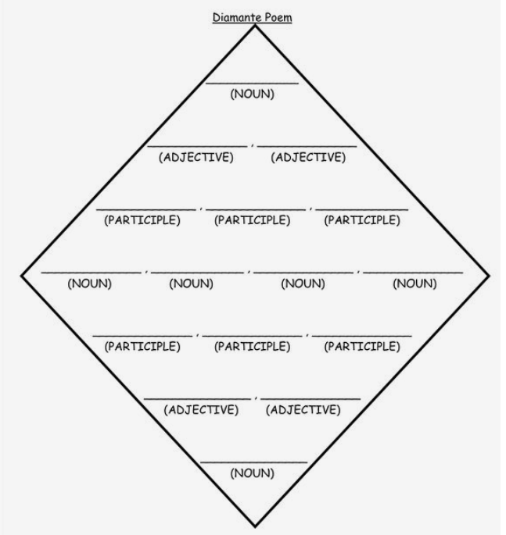

nature
colourful
beautiful
blooming
shining
Shimmering
flowers
river
grass
sun
flourshing
growing
withering
luminous
green
flowers

flower
red
tall
glooming
growing
picking
tulips
lily
rose
sunflower
flourshing
giving
withering
small
white
blossoms

FLOWER
BEAUTIFUL
COLORFUL
GROWING
PICKING
BLOSSOM
SHELL
SEEDS
ROSE
DANDELION
BLOOM
WHITER
BUD
LITTLE
SCENTED
FLOWER

NATURE
FRESH
BLOOMING
GROW
RAINING
EVOLVE
ANIMALS
THUNDER
FLOWERS
WATER
ACCLIMATIVE
BLOOM
NATURALIZE
BREATHTAKING
ETHEREAL
CREATION

SEA
BLUE
CALM
SWIMMING
DIVING
SAILING
WAVES
RIVER
SHORE
DOLPHINS
SURFING
FLOATING
SINKING
STORMY
ALIVE
OCEAN

FLOWER
BEAUTIFUL
COLORFUL
BLOOMING
GROWING
BEARING
GARDEN
BOUQUET
PETALS
LEAF
CLIMBING
COMING OUT
SPROUTING
GREEN
LIVELY
PLANT

flower
delicate
colourful
colourful
giving
offered
preserve
rose
daisy
sunflower
lily
growing
breathing
wither
small
poisonous
tulip

Nature
Gracefull
wild
grown
judge
repair
lakes
flowers
mountains
wind
Create
Blooms
change
Green
clean
water

Thank you for your participation!

