Greek poems about nature

These trees don’t take comfort in less sky
these rocks don’t take comfort under foreigners’
footsteps
these faces don’t take comfort but only
in the sun
This landscapes is merciless like silence
it hugs its fiery rocks tightly in its bosom
it hugs tightly in the sun its orphan olive trees
and grapevines
it clenches its teeth There is no water Only light

Yiannis Ritsos
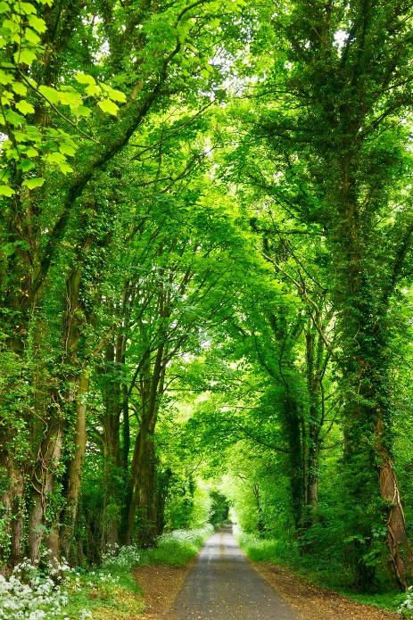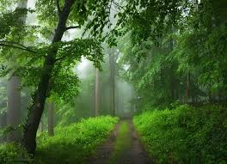

I’ve never seen a homeland more strange and beautiful
than this one that fell to my lot
Thrown a line to catch fish catches birds instead
Sets up a boat on land garden in the waters
Weeps kisses the ground emigrates
Becomes a pauper gets brave
Tries for a stone gives up
Tries to carve it works miracles
Goes into a boat reaches the ocean
Looks for revolutions wants tryants
Odysseas Elytis

I wiil mourn forever, can you hear me? For you,
All alone,in Paradise.

I
Fate will turn elsewhere thr engravings
Of the palm, like a key owner
One moment Time will give its assent

How else, since people love each other

The sky will portray our entrails
And innocence will hit the world
With the poignancy of black death
Odysseas Elytis

