Greece is also known for its many literary and non-fiction writers. One of the best known is Odysseus Elytis, who has also won the Nobel Prize.
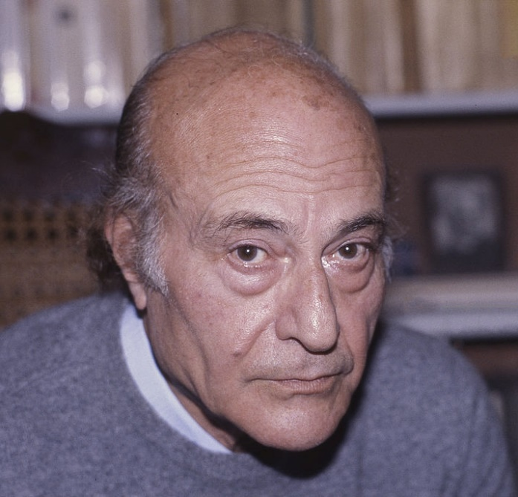
Odysseus Elytis (Heraklion Crete, November 2, 1911 - Athens, March 18, 1996), was one of the most important Greek poets, a member of the literary generation of the 30s. He was awarded the National Poetry Prize in 1960 and the Nobel Prize for Literature in 1979, the second and last to date Nobel laureate. His best-known poetic works are Axion Esti, The Sun the First and Orientations. He formed a personal poetic idiom and is considered one of the innovators of Greek poetry.

George Seferis (Smyrna March 1900 - Athens, September 1971) was a Greek diplomat and poet and the first Greek to be awarded a Nobel Prize. He is one of the most important Greek poets and one of the only two Nobel Prize-winning Greeks. Some of his works are:
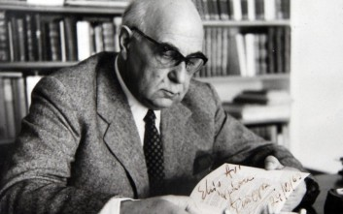
Turn, 1931
On a Vinegar , 1931
Sterna, 1932

