

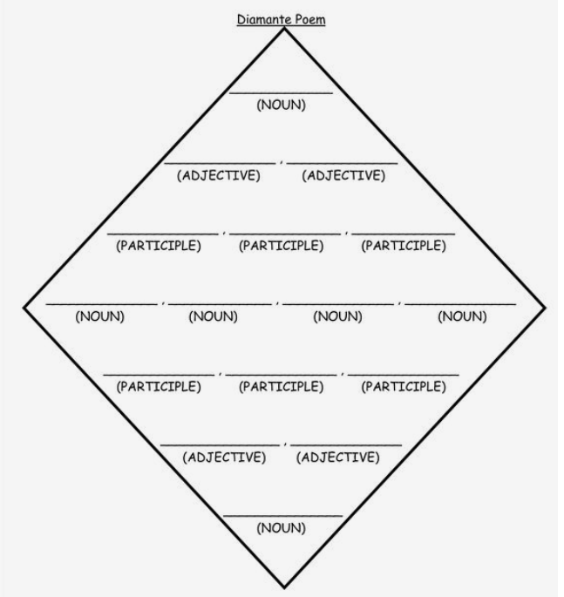

SEA

BLUE

CALM

SWIMMING

DIVING

SAILING

WAVES

RIVER

SHORE

DOLPHINS

SURFING

FLOATING

SINKING

STORMY

ALIVE

OCEAN

