Business plan for area development
TEAM OF STUDENTS
Avramita Mara
Banica Bogdan
Constantin Alexandru
Costache Mark
Grosu Adrian
Patru Stefan

- TARGET
Targeted area: Amara, Ialomita, Romania
- LOCATION
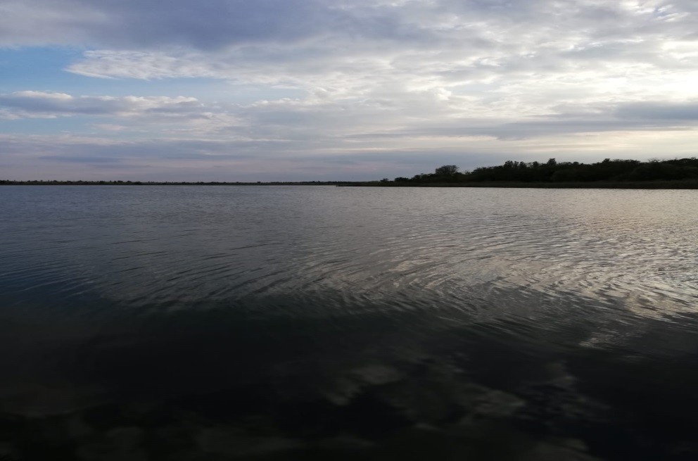
Area description: Amara is a small town located near Slobozia, the biggest city of the Ialomita county, situated between Bucharest - the capital city of the country - and Constanta - the seaside resort.

III. THE IMPORTANCE OF SLUDGE
The main attraction of Amara is the lake with the same name and it is widely used by people of all ages, more so by elders and adults with rheumatic health issues. The sapropelic sludge from Lake Amara is a true source of health. It can be used in countless antirheumatic therapies. Beyond its curative effects, the mud is a source of income. It is sold in cubic meters by representatives of the Water Management System Ialomita, the institution that manages the lake. The business of the sapropelic sludge extracted from the Amara lake was put into practice by representatives of the Ialomita Water Management System three years ago. "We were receiving more and more requests from the hotels, especially those from Amara, to provide them with sludge. So we said to extract and sell it," says engineer Adrian Diaconescu, executive director of the Ialomita Water Management System. So it is that for three years, the sapropelic mud of Amara has become the most precious natural resource in the whole region. To market it, authorities need to carry out complete sets of analyzes to see if the sludge is in optimal parameters. Thus, several samples extracted from the lake reach the laboratories of the National Mineral Resources Agency and the National Balneoclimatology Institute, where specialists analyze whether chemical substances that enter the chemical composition of the sludge are in normal parameters.
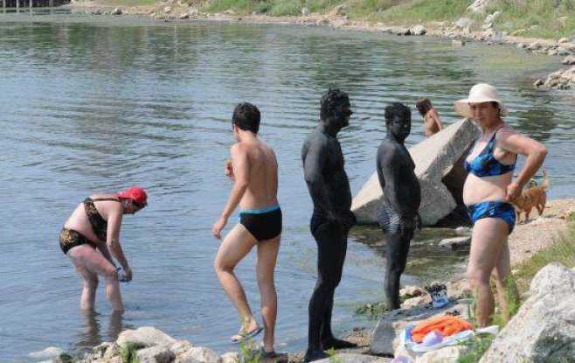
Primary physician Daniela Pitea, a specialist in medical recovery, explains why the sapropelic sludge is considered an effective treatment: "The role of sapropelic sludge is to store the heat. This effect is considered a good vasodilator and analgesic. Practically, it relaxes the body and soothes any pain." Specialists recommend treatment with mud bathing or in nature, on the shores of Lake Amara. Amara slurry is considered a "panacea for anything" as it is indicated in treating a wide range of conditions.
"The sludge is recommended for degenerative rheumatic diseases, such as spondylosis or atrophy, inflammatory rheumatism, fractures, sprains, dislocations, neurological disorders or if the patient has suffered a vascular accident," adds specialist doctor Daniela Pitea. Patients wishing to receive mud treatment should know that the most beneficial for the body is to carry a single mud bath per year for 10 consecutive days.
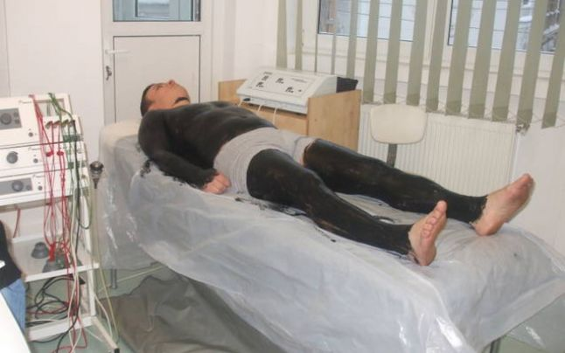
Obviously, as any medical treatment, sapropelic sludge also has side effects. That is why it is not indicated for use by patients suffering from cardiovascular system diseases or those suffering from infectious diseases or mental illness."As we have said, the sludge retains heat and is given to a patient with cardiac conditions and can cause serious rhythm disorders" warns doctor Daniela Pitea. At the same time, before applying the mud, the skin must be clean and free from damage. The statistical data show that the curative effects of the sapropelic sludge extracted from the Amara lake benefit annually 5000 patients coming to receive treatment at the Amara spa facilities. Most of the medical problems they face are caused by rheumatic diseases.
The authorities have strategies for the sludge to be used in the treatment halls that the hotels have.
The authorities don’t have a strategy for the sludge for people who come to the beach and need to find it by their own. That is an important thing to be developed, because this sludge could be bottled and sold.
SUGGESTIONS:
- employ people to help the clients on the beach extract the sludge from the lake
- arrange special areas on the beach where clients can find sludge
- arrange cleaning areas for the clients to was off the sludge when they finish the treatment
IV. BEACHES, POOLS, RESTAURANTS AND PARKS
Another reason why this town, Amara, is such a good idea for an investment it is because of its touristic places, for example beaches, pools, hotels and parks.
Because this town is known for its sludge and its power to heal, every complex and every hotel in this resort has places for treatment that assure the execution of Peloiodtheraphy procedure, hydrotherapy, physical therapy and kinetotherapy. Most of them have their own beaches.
- Hotel ‘Lebăda’ is a two stars hotel, has a capacity of 944 people and it is structured in two buildings.
- Hotel ‘Ialomita’ is a three stars hotel, has a capacity of 480 people and after 1998, this hotel had lots of benefits.
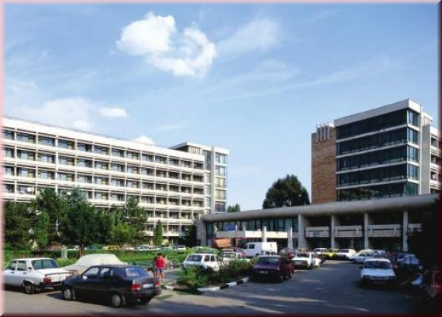
- The balneary complex ‘Parc’ is formed from two hotels, one of them has three stars named ‘Hotel Parc’, with a capacity of 432 people. The other one has four stars and it is named ‘Hotel Dana’, with a capacity of 78 people, because it is private. It is fully renovated.
- ‘Vila Irina’ has a capacity of 56 people.
- The children camp ‘Pavilioane’ it is a camp for summer and it is renovated since 1975, being situated in an acacia forest, a plantation of hardwood and a grove of nut trees. This camp has a capacity of 110 people and in the backyard has a sportive complex.

SUGGESTIONS:
- investment in the refurbishment of the hotels as some of the furniture is very old
- redecorating the rooms in a more modern way, more attractive for the new type of tourists
- rethinking the menu that is used so that it fits all tastes
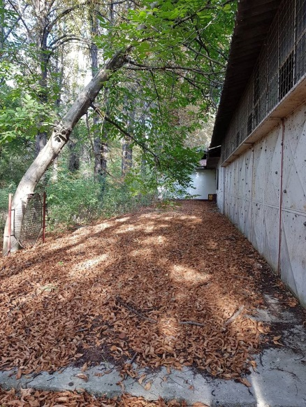
With some money, those hotels could be transformed in true resorts. Also, Amara has some abandoned buildings that could be finished and used at so many things.
- cinemas
- pubs
- restaurants
- playing areas

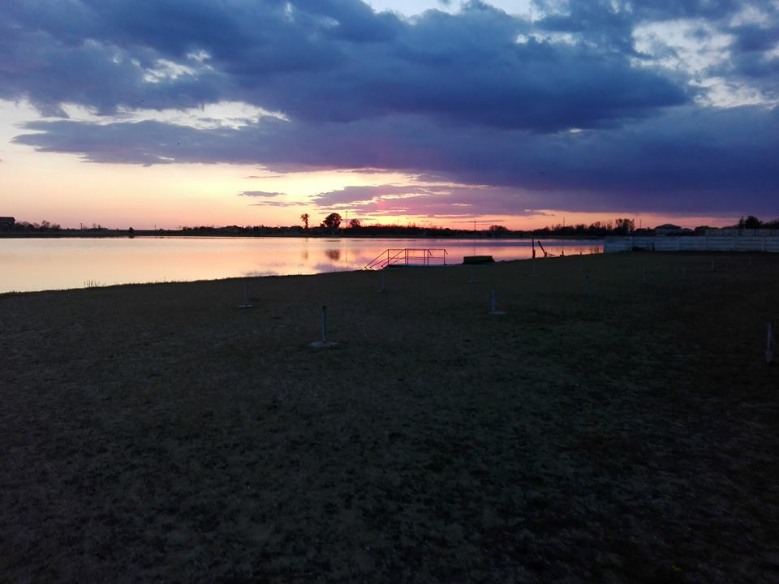
The beaches are divided in: hotel beaches, beaches for children and beaches for nudists.

- Hotel beaches: ‘Lebăda’, ‘Splendid’ belongs to Hotel ‘Ialomita’ and ‘Mircesti’ which belongs to Complex ‘Parc’.
- Beaches for children: it is arranged within the camp.
- Beaches for nudists: it is arranged with different sections for women and men and it belongs to hotel ‘Parc’.
Unfortunately, the beaches are not so modern. They need simple things like:
- wi-fi,
- toilets
- little shops.
- beach chairs for which people should not pay a fee
-small tables that could be placed between beach chairs

Also, the steps which lead in the water are very slippery and they should spend money on some solutions which can be used on them.

V. NATURAL AREAS
Besides all of that, this city has the biggest park of this type from the south-east of Romania. The ‘dendrologic’ park occupies a space of 64 hectares. This has a great touristic potential, appreciable and it completed the ‘balneary’ touristic offer of Amara resort.
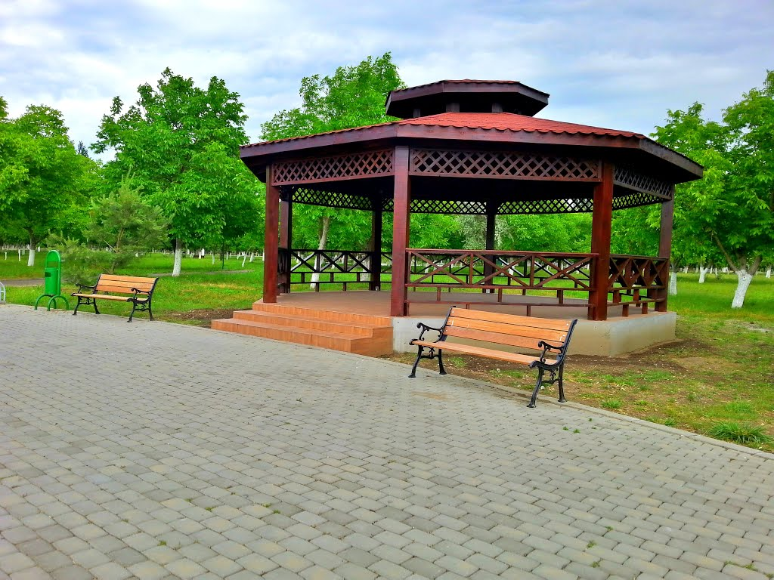
The Dendrologic Park can be considered a real heaven of nature. As we walk down on the paths, we can enjoy different types of tree species, while people of all ages walk and admire the nature, jogging, or sit on the benches.
This park can be used for cycling and also here is a lot of space for building tennis, football and basketball pitches.

VI. CONCLUSION
To sum up, Amara is a city with potential. If the current attractions would be developed and some new places for entertainment would be open, this little town will grow up.

