Recipe for pancakes

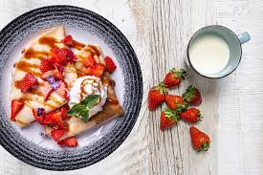
Ingredients

1 egg
1 cup of floor
½ glass of milk
1 teaspoon of baking powder
a pinch of salt
some still or sparkling water
oil
jam/cheese

Instructions

1.Take a bowl and beat an egg, then combine it with flour, milk and water.
2.Add salt and baking powder, after that combine it with all the ingredients.
3.Pour some oil over the frying pan.
4.When the frying pan is hot enough, you can start making pancakes. First, fry a pancake on its one side and then flip it over. Fry it on the other side.
5.Put the pancake on the plate and fill it with jam, cheese or whatever you prefer.
6.The roll it and serve whit some fruit, chocolate, or even ice cream.
Enjoy your meal!

