MISSION I celebrate The Earth Day.
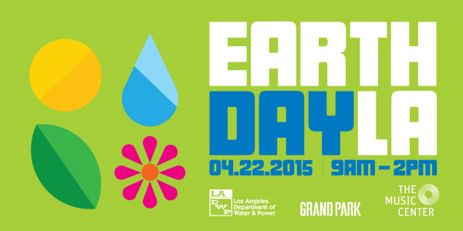
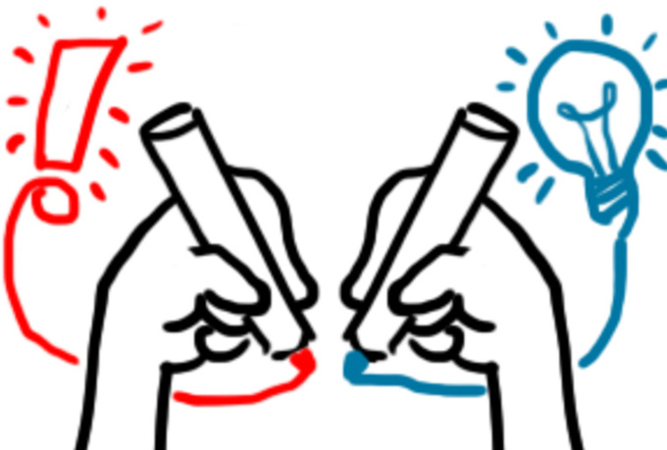
Task 1 I think about seasons.

Activity 1 I write the correct season.

_______________________________

_______________________________

_______________________________

_______________________________
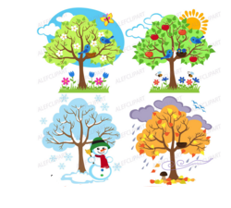
Activity 2 I write the words in relation with “spring”.
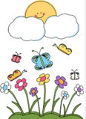
When _______________________ begins, nature wakes from its _______________ rest.

The _______________ melts the snow and warms the soil. _______________________pop
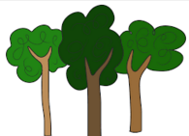
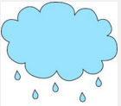

out of the soil and bloom from the ._____________________. __________________ sprout new
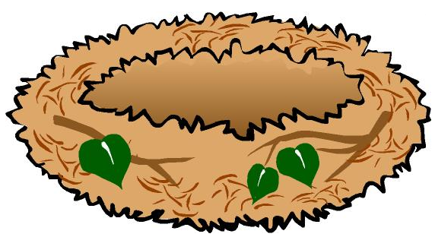
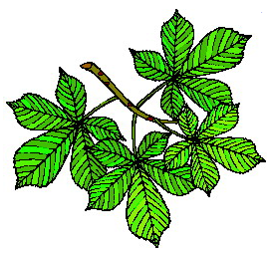
___________________ . The birds ___________________ in the trees and ________________.

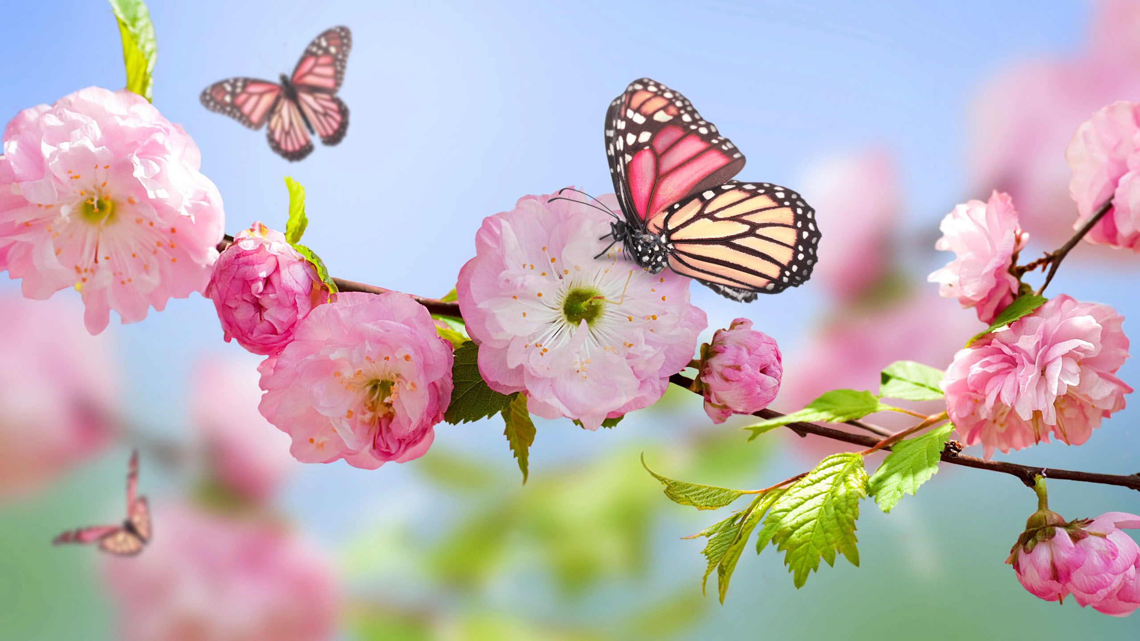
Welcome ______________________________.

Activity 3 I find out words in relation with spring.

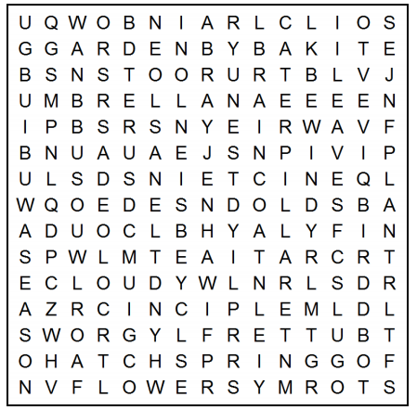
Baseball Picnic
Bird Plant
Bloom Puddle
Butterfly Rainbow
Caterpillar Raincoat
Cloudy Rainy
Flowers Roots
Fog Season
Garden Seed
Grow Soil
Hatch Spring
Insect Stormy
Kite Sunshine
Leaves Umbrella
Nest Windy

Activity 4 I write a Haiku thanks to the following elements.
http://www.ahapoetry.com/aadoh/sprpla.htm

WHAT IS A HAIKU? A haiku is an unrhymed three-line poem. It is based on a traditional Japanese poetic form.

Bee lines Air of rain A white parasol Nest-building sparrows

Moonlight Exciting the air Wild flower notes Between flowers

Of bird song A twitter Along blossoming trees Cherry blossoms

A fragrant lunch Rain colored A meadow Permitting picnickers

Into a flower A rainbow Filled with drops A passing shower

Made by a violin By the light falling Spring rain Cloud in the bushes

Activity 5 I write a Haiku.
http://www.insite.com.br/rodrigo/poet/haicreate.html

Linguistic A / An / The Pluriels irréguliers Adjectifs

Task 2 HIKING AND BLOOMING
Brainstorming Before hiking, I find out the different steps of a flower life cycle.

Pollination germination root and stem flowers seed leaves
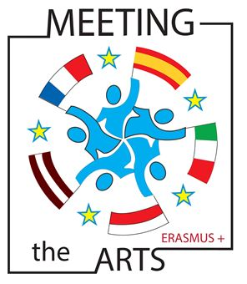

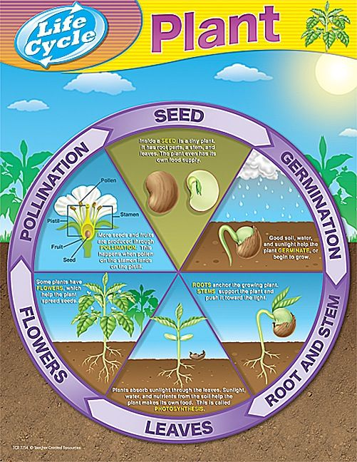
A robin sings
As if it was he
Who planted the garden

In the shade
A spot of sun
A stray dandelion

Activity 1 I take photos of flowers and trees.

Activity 2 I collect some flowers.

Activity 3 I draw the flowers collected.

Activity 4 I create a herbarium with dried flowers, the photos, the drawings and the Haikus.

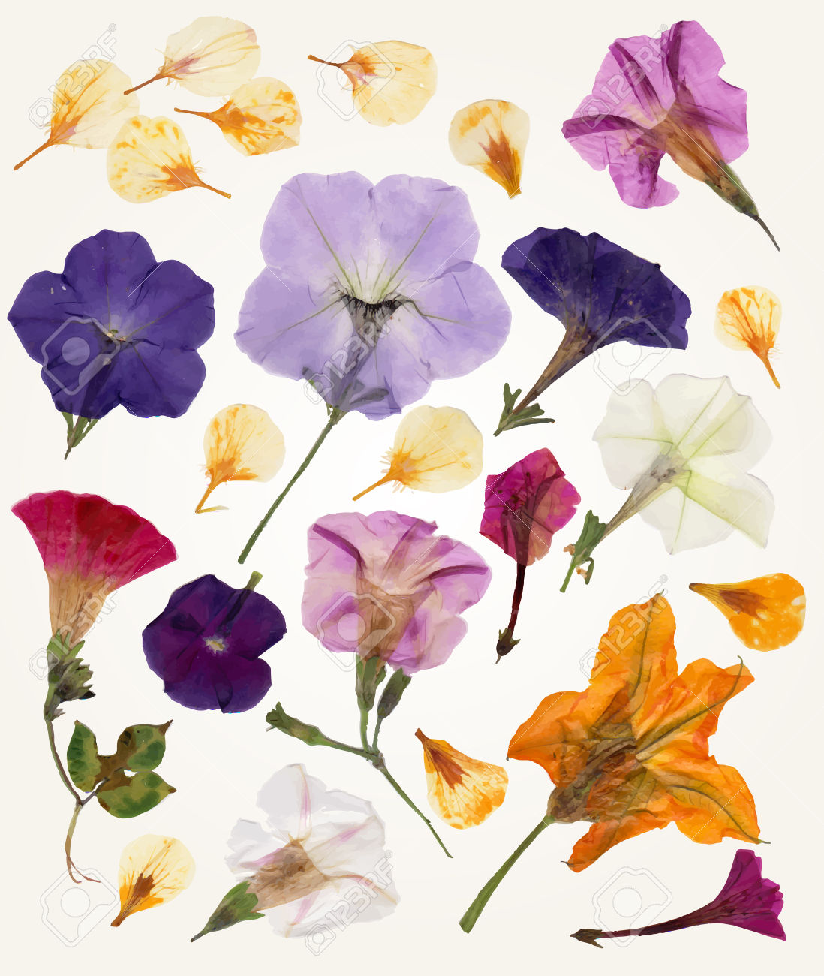

Task 3 I watch a video from Youtube.
https://www.youtube.com/watch?v=24_gqlIURMs

Activity 1 I tick off the correct solution(s).

1) This video is a film trailer a commercial a cartoon a warning bell

2) It is about industries pollution agriculture car traffic

3) It shows solutions reasons causes consequences

4) It depends on everybody nobody all of us only some people

Activity 2 I fill in the blank thanks to the following words.

protect planting warns up save consequences

This video ______________________ us about the ___________________________ of pollution.

We can __________________ and _______________________ our planet by small deeds like ___________________ trees.

It is ____________ to us.

Task 4 I read a wikipedia article.

Earth Day is an annual event, celebrated on April 22, on which day events worldwide are held to demonstrate support for environmental protection. It was first celebrated in 1970, and is now coordinated globally by the Earth Day Network, and celebrated in more than 192 countries each year.
In 1969 at a UNESCO Conference in San Francisco, peace activist John McConnell proposed a day to honor the Earth and the concept of peace, to first be celebrated on March 21, 1970, the first day of spring in the northern hemisphere.
Numerous communities celebrate Earth Week, an entire week of activities focused on environmental issues.
Activity 1 I underline capital letters, numbers and transparent words.
Activity 2 I answer the questions in French.
1) Quand et pourquoi fête-t-on la Journée de la Terre?
_______________________________________________________________________________________________________________________
2) Pourquoi a-t-on choisi cette date ?
_______________________________________________________________________________________________________________________
3) Dans combien de pays est-elle fêtée ?
_______________________________________________________________________________________________________________________
4) Qui a créé cette journée ? Quand?
______________________________________________________________________________________________________________________
Activity 3 I imagine some activities to celebrate the Earth Day.
1) We can _________________________________________________________________________________________________________
2) We can _________________________________________________________________________________________________________
3) We can _________________________________________________________________________________________________________
4) We can _________________________________________________________________________________________________________

