MISSION For the Erasmus+ project, I am asked to read and then translate into
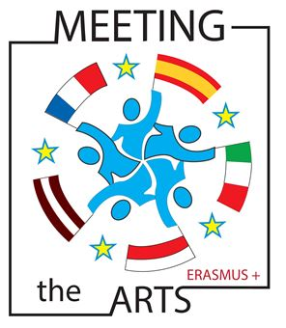
English a popular French tale.
In order to share it with the other European partner, I read and record it.
Task 1 I watch a video.
From http://www.dailymotion.com/video/xxacqu_swing-shift-cinderella_shortfilms

Activity 1 I Read the definition of “fairy tale” from Wikipedia.

A fairy tale is a type of short story that typically features European folkloric fantasy characters, such as dwarves,elves, fairies, giants, gnomes, goblins, mermaids, trolls, or witches, and usually magic or enchantments.

Activity 2 How do you say in English…?

1) un personnage | 1) | 4) un nain | 4)
2) une sorcière | 2) | 5) une fée | 5)
3) une sirène | 3) | 6) caractériser | 6)

Activity 3 Would you say this video is a fairy tale? Explain your answer.
Task 2 I read this French fairy tale you will have to translate.

Activity 1 I underline the words I must look for in a dictionary.
I make the list of their English equivalents.

Activity 2 I think about the verb tenses.
I use the toolbox “How to select the verb tenses”

Activity 3 If necessary, I change the order of words.

Activity 4 I begin the translation.

