DICTIONARY FESAC
 | WORDS | MEANING | IMAGE | TRANSLATION
 |  |  |  | CROATIAN | HUNGARIAN | ITALIAN | LITHUANIAN | MACEDONIAN |  | SPANISH
A | Amasser | A person who collects/ amasses a huge amount of money. |  | sakupljač | felhalmozó | accumulatore | Kaupikas | Собирач |  | Amasador
 | Amazed | To be amazed means to be greatly surprised about something |  | zadivljen | meghökkent |  | Nustebęs | Воодушевен |  | Asombrado
 | Amortization | The sum devoted to this purpose. |  | Amortizacija | amortizáció | Ammortamento | Amortizacija | Амортизација |  | Amortización
 | Applicant | A person who applies for a job. |  | Podnositelj zahtjeva | pályázó | candidato, aspirante | Kandidatas | Кандидат |  | Aspirante
 | Assist | Assist mean to help or to give aid to someone in need of help. |  | Pomoći | támogat |  | Padėti, pagelbėti | Помош |  | Ayudar
 | Asset | An asset is something you own, such as property, structures, money, or investments like stocks or bonds |  | Imovina | vagyontárgy |  | Turtas, vertingas dalykas | Средство |  | Activo
B | Back charge | A back charge is a billing made to collect an expense incurred in a previous billing period. It can be due to lack of payment by the recipient of services or goods, an adjustment due to an error or to collect an expense that was not billable until a later period due to timing issues. |  |  |  |  | Atgalinis mokestis | Банкарска наплата |  | Cargo en diferido
B | Bank account | An agreement with a bank where the customer puts and takes money and the bank keeps it. | 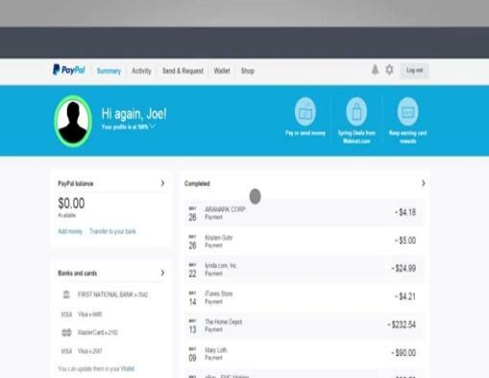 | Bankovni račun | bankszámla | conto bancario | Banko sąskaita | Банкарска Сметка |  | Cuenta bancaria
 | Banknote | It comes from the word bank. It identifies paper currency and the  enactment of its circulation by an issuing bank. | 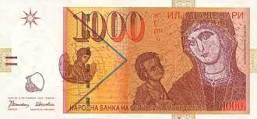 | Novčanica | bankjegy |  | Banknotas | Банкнота |  | Billete
 | Bankruptcy | When an individual or a company has insurmountable debt and cannot repay it, it's possible to declare bankruptcy to receive legal protection from the debts. Bankruptcy involves a legal process, possibly including the sale of assets to reduce the debt amount. |  | Bankrot | csőd |  | Bankrotas | Банкрот |  | Bancarrota
 | Balance | Total money that you have. | 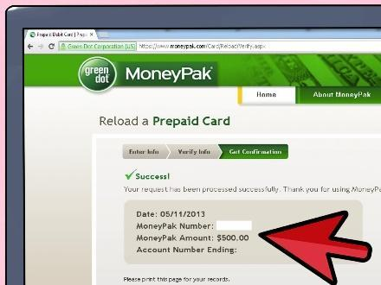 | Stanje | egyenleg | saldo | Balansas | Состојба |  | Balance
 | Barter | To trade by exchanging one commodity for another | 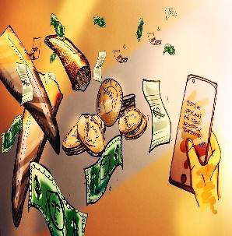 | Razmjena dobara | cserekereskedelem | baratto | Mainyti | Бартер |  | Trueque
 | Bill | A statement of money owed for goods or services supplied |  | Račun | számla | Conto | Sąskaita | Сметка |  | Cuenta
 | Bitcoin | A digital currency whose value is only  determined by the lever of supply and  demand |  | Bitcoin | bitcoin |  | Bitkoinas | Биткоин |  | Bitcoin
 | Budget | Of expected income and expense for a given period in the future. |  | Budžet | költségvetés | bilancio | Biudžetas | Буџет |  | Presupuesto
 | Buyer | Party which acquires in exchange for money |  | Kupac | vevő | Acquirente | Pirkėjas | Купувач |  | Comprador
C | Calculate | To determine, typically in a mathematical sense; analyze; compute. "He had to calculate which of the health care plans would save his family the most money." "She calculated the odds of winning the lottery were one in a million |  | Računati | kiszámít |  | Apskaičiuoti | Пресметка |  | Calcular
C | Cash | Money that you keep in your wallet. |  | Gotovina | készpénz | contanti | Grynieji pinigai | Готовина |  | Dinero suelto
 | Cash/Liquid assets | To pay by coins or banknotes | 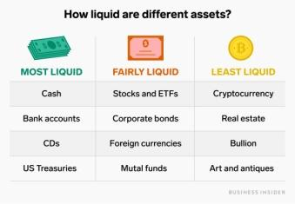 | Novčana/likvidna imovina | likvid tőke |  | Grynieji pinigai | Готовина/ликвидни средства |  | Metálico
 | Coinage | The act of coining |  | kovanica | pénzverés |  | Monetų kalykla | Старост на монетите |  | Acuñación
 | Coin-stamp | It is the hard metal welding stick on  which the image that is reproduced on  the coin is imprinted. | 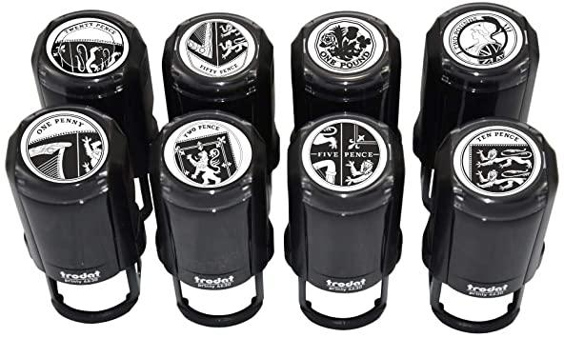 | Pečat za kovanice |  |  | Monetos anstpaudas | Машина за штампање на монети |  | Sello monetario
 | Commerce | Commerce relates to "the exchange of goods and services, especially on a large scale". It includes legal, economic, political, social, cultural and technological systems that operate in a country or in international trade. |  | Trgovina |  |  | Komercija,prekyba | Трговија |  | Comercio
 | Cost estimate | Approximation of the cost of a program,  project,or operation. | 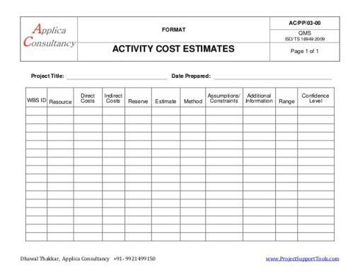 | Procjena troškova | becsült költség | costo stimato | Apytikslė kaina | Проценка на трошоците |  | Costo estimado
 | Counter note | Paper document testifying the right to  levy funds of the corresponding gold  and silver coins deposited by the  goldsmiths that guarded them in their  coffers. | 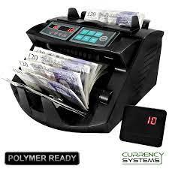 | Kontra bilješka |  | nota di banco | Kontratnotai | Белешка за пресметка
 | Credit | Give credit where it is due,  a source of pride or honor. |  | Kredit | Hitel | Credito | Kreditas | Кредит |  | Crédito
 | Credit limit | The maximum amount of credit that a customer of a store, bank, etc., is authorized to use. |  | Kreditno ograničenje | Hitelkeret | Limite di credito | Kredito limitas | Кредитен лимит |  | Límite de crédito
 | Cryptocurrency | Dematerialised equal and digital currency whose implementation is based on the principles of  cryptography. |  | Kriptovaluta |  | Criptovaluta | Kriptovaliuta | Криптовалута |  | Criptomoneda
 | Currency | Something that is used as a medium of exchange; money. | 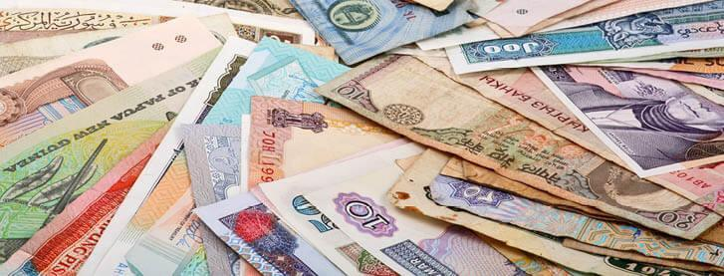 | Valuta | Valuta | Moneta | Valiuta | Валута |  | Moneda
D | Delayed gratification | Describes the process that the subject undergoes when the subject resists the temptation of an immediate reward in preference for a later reward. |  | Odgođeno zadovoljstvo |  | soddisfacimento ritardato | uždelstas apmokėjimas | Одложено задоволство |  | Satisfacción retardada
 | Debt | A liability or obligation to pay or render something. | 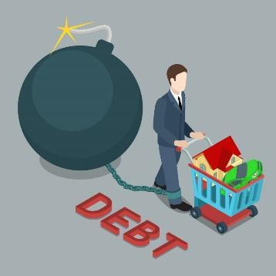 | Dug | Adósság | Debito | Skola | Долг |  | Deuda
 | Debit card | It is a thing by means of which you can store your money. | 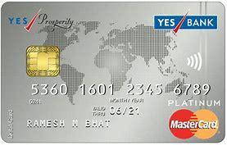 | Debitna kartica |  | carta di debito | debetinė kortelė | Дебитна картичка |  | Tarjeta de débito
 | Delivery charge | This is when you need to pay for the delivery of the shipment. | 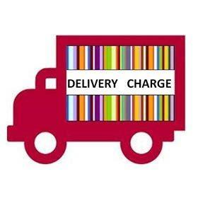 | Poštarina |  | spesa di spedizione | pristatymo mokestis | Наплата за достава |  | Gastos de envío
 | Democracy | A system of government by the whole population or all the eligible members of a state, typically through elected representatives. |  | Demokracija |  |  | Demokratija | Демократија |  | Democracia
 | Denaro (money) | In Roman times it identified the  monetary unit equivalent to 10 asses from Deni=10 | 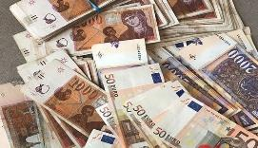 | Novac |  |  | Dinaras | Пари |  | Dinar
 | Dindi(Italian slang) | Baby talk meaning money, a word in Tuscan. |  |  |  |  |  | Итлијански сленг |  | Parné
 | Discount | Off-Price amount. | 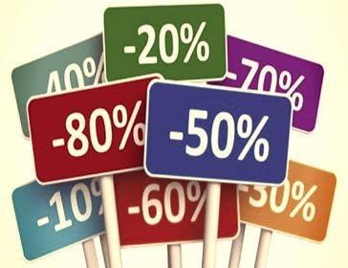 | Popust | Kedvezmény | Sconto | Nuolaida | Попуст |  | Descuento
 | Divide | Separate or be separated into parts. |  | Podijeliti |  |  | Paskirstyti | Да се подели |  | Dividir
 | Donate | Give (money or goods) for a good cause, for example to a charity. |  | Donirati |  |  | Aukoti | Донација |  | Donar
E | Economize | Keep and save money. |  | Štedjeti | Spórol | economizzare |  | Taupyti |  |  |  | Економизирај | Economizar
 | Entrepreneurship | It's a way to earn money by starting your own business. |  | Poduzetništvo | Vállalkozói szellem | Imprenditoria |  | Verslumas | Претприемништво |  | Emprendimiento
 | Employee | An individual who works part-time or full-time under a contract of employment, whether oral or written, express or implied, and has recognized rights and duties. Also called worker. |  | Zaposlenik |  |  |  | Darbuotojas | Вработен |  | Empleado
 | Employment | The action of giving someone a job. |  | Zaposlenje |  | impiego |  | Įdarbinimas | Вработување |  | Empleo
 | Euro | The official currency adopted by the 19 countries of the European Union. | 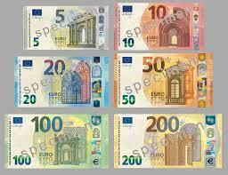 | Euro |  |  |  | Euras | Евро |  | Euro
 | Evaluating | Evaluation is a systematic determination of a subject's merit, worth and significance, using criteria governed by a set of standards |  | Ocjenjivanje |  |  |  | Vertinimas | Проценка |  | Evaluar
 | Expenses / Expenditure | 1. The action of spending your money for some purposes. 2.The amount of money spent | 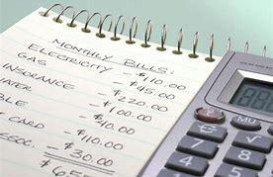 | Trošak | Kiadás | Spesa | Išlaidos | Трошоци |  | Gastos
 | exchange rate | The ratio at which a unit of the currency of one country can be exchanged for that of another country. |  | Tečaj | Árfolyam | Tasso di cambio | Valiutos kursas | Девизен курс |  | Tipo de cambio
F | Fixed expenses | An expense whose total amount does not change when there is an increase in an activity such as sales or production. | 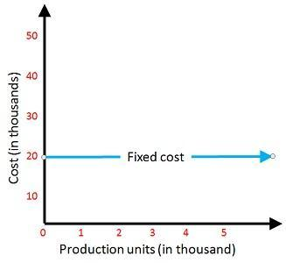 | Fiksni troškovi | Fix költségek | Spese fisse | Fiksuotos išlaidos | Фиксни трошоци |  | Gastos fijos
 | Financing | The act of obtaining or furnishing money or capital for a purchase or enterprise. |  | Financiranje | Ffinanszírozás | Finanziamento | Finansavimas | Финансирање |  | Financiación
 | Florin | A 24-karat golden coin coined for the  first time in Florence in 1252.  The word is derived from Lily Flower,  whose image is found on one side of the coin. |  | Florin |  | Fiorino | Florinas | Флорин |  | Florín
G | Gain | Profit or advantage. |  | Dobit | Nyereség | Guadagno | Pelnas | Добивка |  | Ganancia
 | Goods | Profit or advantage; worth; benefit. | 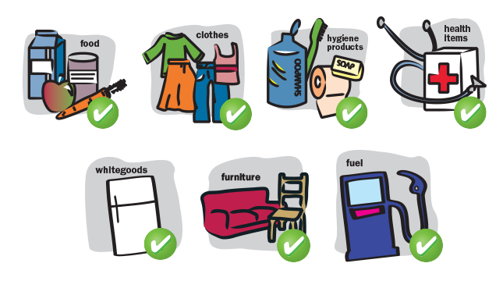 | Roba | Áruk | Merce | Prekės | Стоки |  | Bienes
 | Grana (Italian slang) - Dough | It comes from the Latin word “granum”  and is understood as weight. It stands for the first kind of commodity money. |  |  |  | Grana |  | Тежина
H | Hoarder | To accumulate money, food, or the like, in a hidden or carefully guarded place for preservation. |  |  |  | accaparratore | Kaupikas | Складирање |  | Acaparador
I | Income | Money received from doing work. |  | Prihod | Jövedelem | Reddito | Pajamos | Приход |  | Ingreso
 | Investment | The investing of money or capital in order to gain profitable returns, as interest, income, or appreciation in value. |  | Ulaganje | Beruházás | Investimento | Investicijos | Инвестиции |  | Inversión
 | Investment risk | Likelihood of occurrence of losses relative to the expected return on any particular investment. |  | Rizik ulaganja | Befektetési kockázat | Rischio di investimento | Investavimo rizika | Инвестициски ризик |  | Riesgo de inversión
 | Invoice | Receipt, but more official one. A detailed list of goods shipped or services rendered with an account of all costs. | 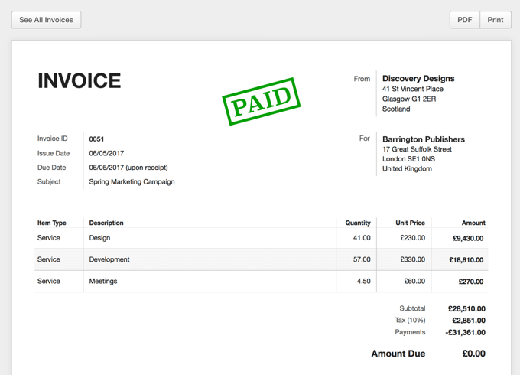 | Dostavnica | számla | Fattura | Sąskaita - faktūra | Фактура |  | Factura
J | Job application | An act when you want to get a job and you have to write a request for that job. |  | Prijava za posao |  | domanda di lavoro | Darbo prašymas | Апликација за вработување |  | Solicitud de empleo
 | Job interview | The part of the employee's search during which the employer evaluates potential employees during the interview. |  | Razgovor za posao |  | colloquio di lavoro | Darbo pokalbis | Интервју за вработување |  | Entrevista de trabajo
K
L | Labour market | The availability of employment and labour, in terms of supply and demand. |  | Tržište rada |  | mercato del lavoro | Darbo birža | Пазар за работа |  | Mercado de trabajo
 | Lira | Monetary unit of the Italian  government until February 2002. | 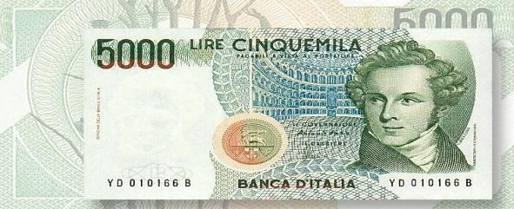 | Lira |  | Lira | Lyra | Лира |  | Lira
 | Long-term saving | Saving over an extended period. |  | Dugoročna štednja |  | Risparmio a lungo termine | Ilgalaikis taupymas | Долгорочно штедење |  | Ahorro a largo plazo
 | Loss | Something that is lost |  | Gubitak | Veszteség | Perdita | Nuostoliai | Загуба |  | Pérdida
M | Medium-term saving | Balance between risk and return, being more conservative than long-term investments, but more risk tolerant than short-term options. | 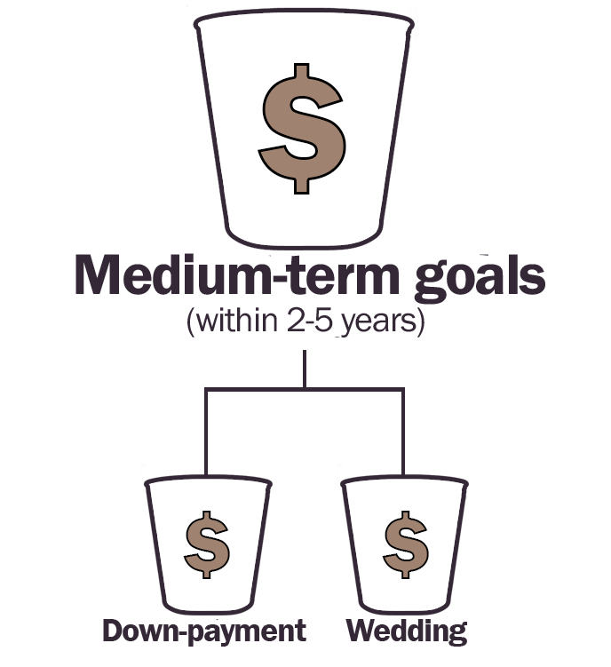 | Srednjoročna štednja |  | risparmio a medio termine | Vidutinio ilgio taupymas | Минимални заштеди |  | Ahorro a medio plazo
 | Moneta (Money) | It was a name originally given to the coin  workshop that the ancient Romans had  placed on the temple of the Goddess  Juno Moneta. | 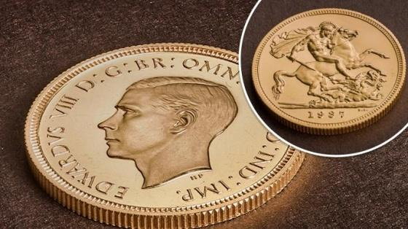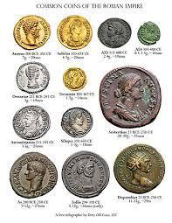 | Moneta |  |  | Moneta | Монета(Пари) |  | Moneda
 | Money management | The act of managing or organising your finances |  | Upravljanje novcem |  | gestione del denaro | Pinigų valdymas | Менаџирање со пари |  | Gestión del dinero
N
O | Overdraw | Having taken more money out of your bank  account than the account contained. |  | Prekoračiti |  | prelievo in scoperto | Limito išeikvojimas | Повторно извлекување |  | Entrar en descubierto
 | One-off payment | Something you make once  for some particular charge or fee, and then in the future you might pay a regular fee every month or whatever. |  | Jednokratno plaćanje |  | pagamento una tantum | Vienkartinis mokestis | Еднократно плаќање |  | Pago único
P | Pocket money | A small amount of money given to a child by their parents, typically on a regular basis. |  | Džeparac |  | paghetta | Kišenpinigiai | Џебни пари |  | Dinero de bolsillo
 | Pecunia | From the Latin word “pecus” that means livestock. |  | Pecunia |  |  |  | Пекуниа |  | Pecunia
 | Personal Budget | Finance plan that allocates future personal income towards expenses, savings and debt repayment. |  | Osobni proračun |  | bilancio personale | Asmeninės lėšos | Персонален буџет |  | Presupuesto personal
 | Penalty | Punishment (usually a specified sum) imposed for wrongdoing. |  | Kazna |  | penale | Bauda | Казна |  | Pena
 | Profit | A financial gain, especially the difference between the amount earned and the amount spent in buying, operating, or producing something. |  | Dobit |  | profitto | Pelnas | Профит |  | Beneficio
Q
R | Ramini(Copper - Italian slang) | A way of identifying copper money in the Tuscan dialect. |  | Bakar |  |  |  | Рамини |  | Plata
R | Rate | A measure, quantity, or frequency, typically one measured against another quantity or measure. |  | Stopa |  |  | Kursas | Стапка |  | Tipo
 | Recycling | Placing “money laundering” on the market. |  | Recikliranje |  | riciclaggio | Perdirbimas | Рециклирање |  | Blanquear
R | Return on investment | Performance measure used to evaluate the efficiency of an investment or compare the efficiency of a number of different investments. | 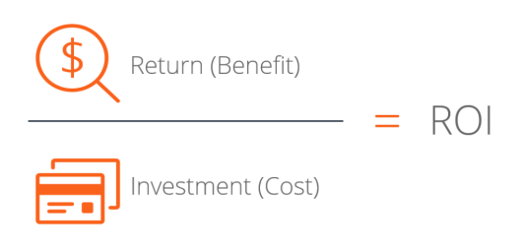 | Povrat na investiciju |  | rendimento dell’investimento | Įplaukos iš investuoto kapitalo | Поврат на инвестиција |  | Rendimiento de la inversión
 | Revenue | Income, especially when of an organization and of a substantial nature. |  | Prihod |  | reddito | Pajamos, įplaukos | Приходи |  | Rédito
 | Refund | An amount ofmoney that is given back to you, especially because you are not happy  with a product or service that you have bought |  | Povrat |  | rimborso | Grąžinimas | Враќање на средства |  | Reembolso
 | Rate of investing | Performance measure used to evaluate the efficiency of an investment or compare the efficiency of a number of different investments. | 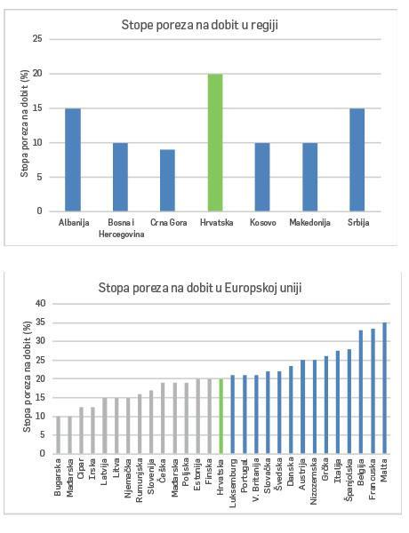 | Stopa ulaganja |  | tasso di investimento | Investavimo norma | Стапка на инвестиција |  | Tasa de inversión
 | Receiver |  |  |  |  |  | Gavėjas | Примач |  | Receptor
 | Receipt | Small paper with product‘s name, price, company’s name and various numbers. | 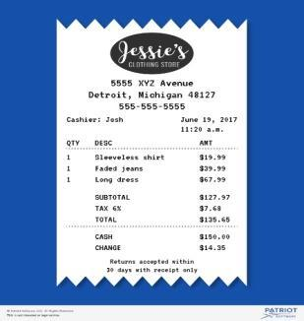 | Račun | Kvitas | ricevuta | Kvitas | Сметка |  | Recibo
S | Salary | A fixed regular payment, typically paid on a monthly basis but often expressed as an annual sum, made by an employer to an employee. | 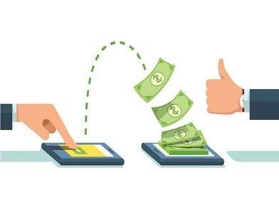 | Plaća |  | stipendio (mensile) | Mėnesinė alga | Продажба |  | Salario
 | Saving | An economy of or reduction in money, time, or another resource. | 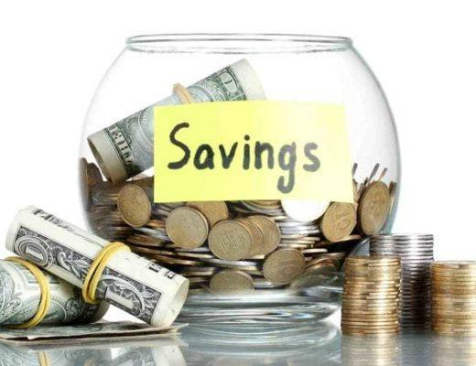 | Ušteda |  | risparmio | Taupymas | Заштеда |  | Ahorro
 | Savings | Income not spent |  | Štednja |  | risparmi | Santaupos | Заштеди |  | Ahorros
 | Sghei (Italian slang) | Money, cash, loot, a word coming from  the regions of Lombard and Veneto. |  |  |  |  |  | Пари |  | Dinero
 | Shift – work | It's a job when you change place and divide the working days with someone for a while |  | Rad u smjenama |  | lavoro a turni | Darbas pamainomis | Работа во смени |  | Trabajo a turnos
 | Short-term saving | Money you'll spend six months to three years out. |  | Kratkoročna štednja |  | risparmio a medio termine | Trumpalaikis taupymas | Краткорочни заштеди |  | Ahorro a corto plazo
 | Seller | A party that makes, offers or contracts to make a sale | 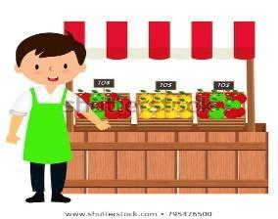 | Prodavač |  | venditore | Pardavėjas | Продавач |  | Vendedor
 | Skilled | Having a knowledge to perform a certain activity well. |  | Vješt |  | specializzato | Kvalifikuotas | Оспособен |  | Cualificado
 | Supervise | To watch a person or activity to make certain that everything is done correctly. |  | Nadgledati |  | supervisore | Stebėti, vadovauti | Надгледувач |  | Supervisar
T
U | Unit Sales | The unit sales number on a balance sheet represents the total sales of a product in a given period. This sales information is used to determine the price point that allows for the greatest profit per unit considering the actual cost of production. | 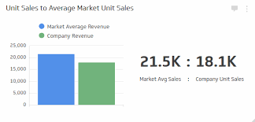 |  |  |  |  | Број на продажба |  | Unidades de ventas
U | Underpricing | Underpricing is the practice of listing an initial public offering (IPO) at a price below its real value in the stock market. When a new stock closes its first day of trading above the set IPO price, the stock is considered to have been underpriced. |  |  |  |  |  | Пренаплаќање |  | Infratasado
V | Variable expenses | Expenses that can change depending on your use of products or services; they are somewhat unpredictable |  | Varijabilni troškovi |  | spese variabili | Kintamos išlaidos | Варијабилни трошоци |  | Gastos variables
W | Wage | It’s a fixed regular payment, typically paid weekly. |  | Plaća |  | salario settimanale | Atlyginimas | Рата |  | Sueldo
 | Wagers | Betting money on a sport,betting for the sport you think is gonna win.Betting is extremely bad. |  | Oklade |  |  | Lažybos | Рати |  | Apuestas
 | Well-paid | Earning or providing good payment. |  | Dobro plaćen |  | ben pagato | Gerai apmokamas | Добро платен |  | Bien pagado
X | Xenocurrency | The term xenocurrency refers to any currency that is traded in markets outside of its domestic borders. Its name derives from the Greek prefix “xeno”, meaning “foreign”. |  |  |  |  | Ksenovaliuta | Хеновалута |  | Moneda extranjera
Е | Equivalence | The interest rate at which a tax-exempt bond and a taxable security of similar quality give the investor the same rate of return | 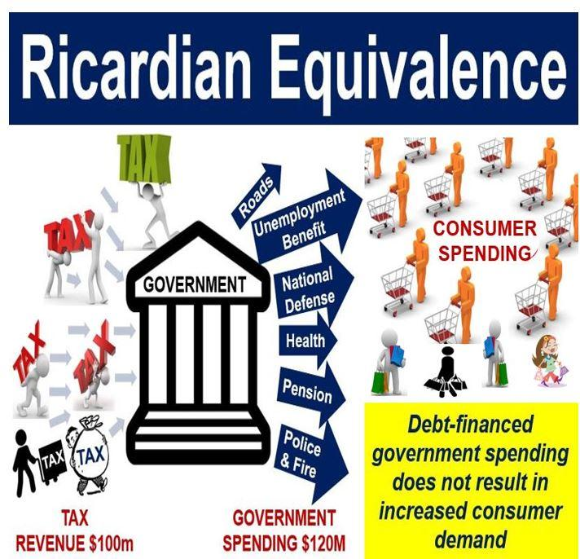 |  |  |  | Lygiavertiškumas | Еквивалентност |  | Equivalencia
Y | Yield | The percentage return paid on a stock in the form of dividends, or the effective rate of interest paid on a bond or note. |  |  |  |  | Pelnas | Принос |  | Rendimiento
M | Merchant cash advances | A merchant cash advance is the opposite of a small business loan in terms of affordability and structure. While this is a quick way to obtain capital, cash advances should be a last resort because of their high expense. |  |  |  |  | Avansas grynaisiais | Аванси на трговски пари |  | Adelanto en metálico
C | Convertible debt | Convertible debt is when a business borrows money from an investor or investor group and the collective agreement is to convert the debt to equity in the future |  |  |  |  | Konvertuojamos skolos | Конвертабилен долг |  | Deuda convertible
P | Partner financing | With strategic partner financing, another player in your industry funds the growth in exchange for special access to your product, staff, distribution rights, ultimate sale or some combination of those items. |  |  |  |  | Partnerių finansavimas | Партнерско финансирање |  | Socio financiero
P | Peer-to-peer lenders | Matches people who have money to invest with people looking for a loan. Loans may need to be repaid within a certain time period and interest rates may vary according to the level of risk. | 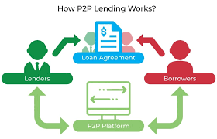 |  |  |  | Lygiaverčiai skolininkai | Врсник на врсник заемодаватели |  | Prestamista
i | Interchange | Every time you swipe a card at a store, the merchant pays a small percentage of the money to the bank that issued the card, called an interchange fee. |  |  |  |  | Mainai | Размена |  | Intercambio
N | Net interest margin | This is the difference, or “net”, between the interest paid to depositors and the interest received from borrowers. |  |  |  |  | Grynosios palūkanos | Нето каматна маргина |  | Margen financiero
C | Credit union | A credit union, a type of financial institution similar to a commercial bank, is a member-owned financial cooperative, controlled by its members and operated on a not-for-profit basis |  |  |  |  | Kredito unija | Кредитна унија |  | Unión de crédito
D | Debt Financing | Most people are familiar with debt as a form of financing because they have car loans or mortgages. Debt is also a common form of financing for new businesses. Debt financing must be repaid, and lenders want to be paid a rate of interest in exchange for the use of their money. |  |  |  |  | Skolų finansavimas | Финнсирање на долг |  | Financiación de deuda
L | Lender | A lender is an individual, a public or private group, or a financial institution that makes funds available to a person or business with the expectation that the funds will be repaid. Repayment will include the payment of any interest or fees. |  |  |  |  | Skolintojas | Заемодавател |  | Prestamista
D | Dividend | A special dividend declared at the end of a fiscal year that usually represents distribution of higher-than-expected company profits. |  |  |  |  | Dividendas | Дивиденда |  | Dividendo

