Christmas Tree Ornament
(Father Christmas / Elf)
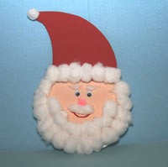
You need:
- 2 CDs
- Red, green, black and pink paper
- Cotton
- Googly eyes
- String/ribbon
- Glue

Method:
- Pass the string/ribbon through the CD middle hole and tie at the top. This will be the hanger.
- Make a circle with the CD on the pink paper and cut it. Stick on one side of the CD. This will be the face.
- Draw a triangle on the red paper. Make sure it is as wide as the CD. That is the hat. Stick it on top.
- Cut a reasonable amount of cotton to make the beard. Stick it at the bottom of the CD.
- Decorate the hat with some cotton wool.
- Stick the googly eyes and draw the nose.
For the elf:
- Repeat steps 1 and 2.
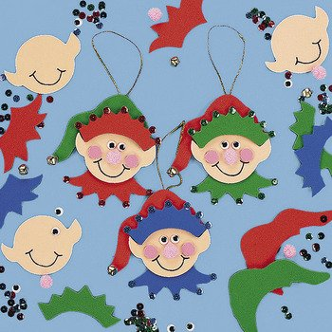
- Make the hat from the green paper. It’s a kind of floppy hat to the side. Stick it on top of the CD.
- Cut a sort of crown as wide as the CD to stick at the bottom of the hat.
- Add the eyes, nose, rosy cheeks and other decorations as you please.

- Enjoy your two little decorations on your Christmas Tree

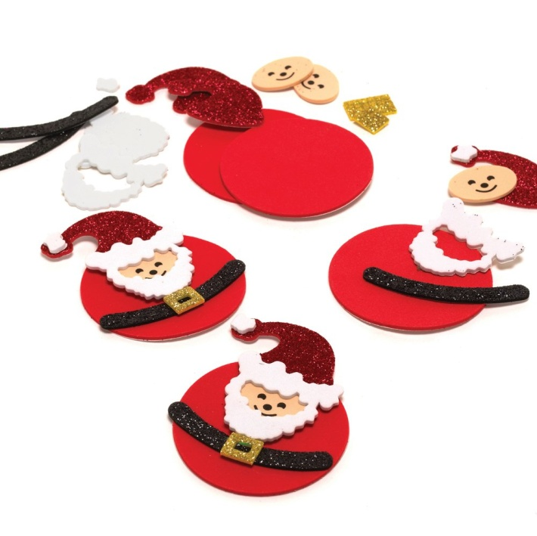
Other version of Father Christmas:

You can also make a snow man by sticking the two CDs together and cover in cotton.

