**INITIAL QUESTIONNAIRE In Baza, 04TH FEBRUARY, 2019**

**FULL NAME: \_\_\_\_\_\_\_\_\_\_\_\_\_\_\_\_\_\_\_\_\_\_\_\_\_\_\_\_\_\_\_\_\_\_\_\_\_\_\_\_\_\_\_\_\_\_\_**

**THE PROJECT AND ITS PARTICIPANTS**

1. **What is the name of the project?**
2. **What are its main priorities or topics? (Specify at least 2)**
3. **What are the official languages in each of the participating countries? And how many of these languages have a Latin origin?**
4. **What is considered “ Intangible Heritage”? C:\Users\Usuario\AppData\Local\Microsoft\Windows\INetCache\IE\G22JMPL0\tick-27406_960_720[1].pngTick the right answer(s)**

|  |  |  |  |
| --- | --- | --- | --- |
|  | **Oral traditions (for example legends and languages)** |  | **Performing arts (for example, folklore)** |
|  | **Rituals and festive events** |  | **All of them** |
|  | **Crafts** |  | **None of them** |
|  | **Knowledge and practices concerning nature** |  | **Others, please specify** |

1. **Can you name a festival , legend or tradition of each of the participating countries? (Do not mention your own country)**

**Country 1:………………………… Festival, legend or tradition:………………………………………..**

**Country 2:………………………… Festival, legend or tradition:………………………………………….**

**Country 3:……………………….. Festival, legend or tradition:…………………………………………..**

**EUROPE AND EUROPEANS**

1. **To whom or to which can the origin of Europe and its shared values be traced back? Tick C:\Users\Usuario\AppData\Local\Microsoft\Windows\INetCache\IE\G22JMPL0\tick-27406_960_720[1].pngthe one(s) you consider to be the historical roots of European identity**

|  |  |  |  |
| --- | --- | --- | --- |
|  | **European Economic Community** |  | **Eurovision song contest** |
|  | **Enlightenment or Age of Reason** |  | **Roman Empire** |
|  | **Islamic civilization** |  | **Church and Christendom** |
|  | **Plato and Copernicus** |  | **Charles V** |
|  | **Charlemagne** |  | **Renaissance and Erasmus** |
|  | **The fall of Constantinople** |  | **Others, please specify** |

1. **What do the stars in the European flag stand for? Tick the right answer**
   1. **The number of founding countries**
   2. **The number of member countries**
   3. **The ideals of unity and harmony**
   4. **The Greek myth of Europa**
2. **In your opinion, what is the best part of being European? and the worst part?**

|  |  |
| --- | --- |
|  |  |
| **C:\Users\Usuario\AppData\Local\Microsoft\Windows\INetCache\IE\45TV177T\smiley-1635454_960_720[1].png** |  |

1. **What does the word “Brexit” refer to?**
2. **What type of Europe would you like to live in when you finish studying and start working?**
3. **What is this programme called “Erasmus+” ?**
   1. **It is an acronym for European Region Action Scheme for the Mobility of University Students.**
   2. **The programme is named after Erasmus of Rotterdam, a Dutch humanist and theologian (XV century), who travelled in different European countries to understand the various cultures**
   3. **Other,( please specify)**

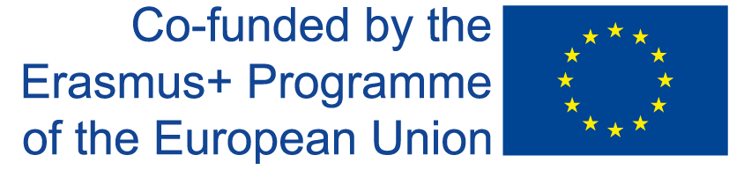The European Commission support for the production of this publication does not constitute an endorsement of the contents which reflects the views only of the authors, and the Commission cannot be held responsible for any use which may be made o the information contained therein