"Europan Heritage: opening minds for integration and progress"
Liceo Scientifico "M.Pagano" - Campobasso – Italy
14-18 October 2019

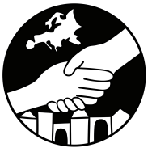
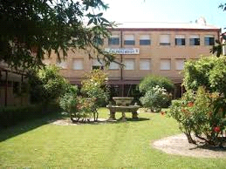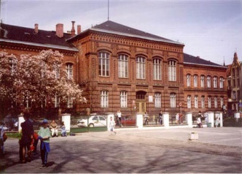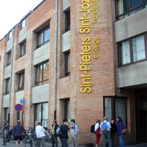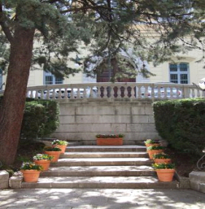
Ies Pedro Jimenez Montoya I Liceum Ogolnoksztalcace Sint Jozef Sint Pieter Mario Pagano

Speeddating : You are going on a speeddate during which you are trying to get as much information as you can. As soon as the bell rings the ones on the inside scoot move over to the desk on the right of you. As soon as the signal is given again you start moving.
Shake hands and introduce yourself to each other

Now in turns ask a question from the list. You can choose any question you like.

Do you know where this monument is? 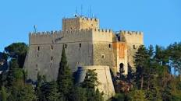

Where can you find this river? 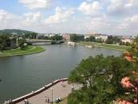

In which part of Europe can you find this magnificent site? 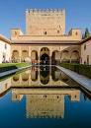

Who does this monument represent and why is he important? 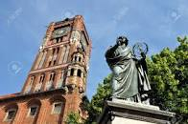
Why is this house unusual? 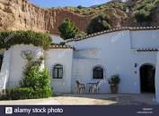
Have you ever tasted these delicious biscuits?
Have you ever been at this pier? Where is it? 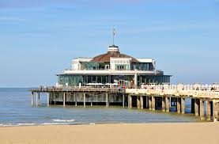

Where can you admire a “flower parade” at the end of 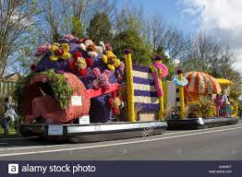
August?

Do you know this famous fountain ?what can you do there? 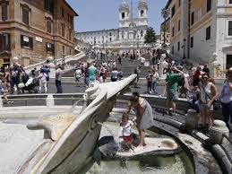

This is the typical Italian pizza. Do you know its name?
Do you know anything about this dance?
What is a traditional typical dance in your country?
What’s the meaning of “zo lekker”?
When do you say “dzień dobry”?
When do you say “Buon appetito!” ? and what’s the corresponding expression in your country?
When was the EEC born?
Can you name the six founding countries?
What does the Schengen Treaty state?
What did the Maastricht Treaty grant?
When was the Euro introduced as the official currency of the EU?
How many member states have adopted it?
When was the Erasmus Programme launched and what for?
In your opinion, has the Erasmus Programme contributed in making young people feel more
European Citizens? Why? Why not?

Are you proud of being in an Erasmus programme project? Why?
What is Brexit?
What is inclusion?
What are the major forms of intolerance present in your country?
Have you ever seen any bullying actions? If you have, how did you react?
Are people in your country very sensitive about discrimination and intolerance?
What are your local authorities doing to favour inclusion?
What did you achieve with your awareness campaign?
What is the EU doing to foster inclusion? Is it enough?
In your country what possibilities are offered to differentially challenged people?
Do they have the same rights and duties as all other people?
In your opinion can a higher education level enable people to overcome prejudices more easily?

