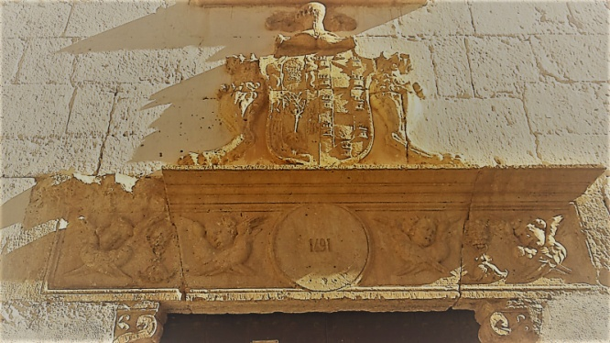 |  | 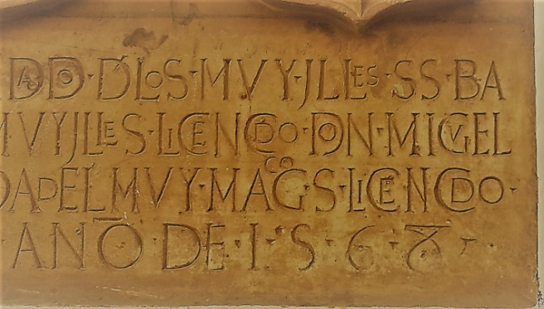 |  | 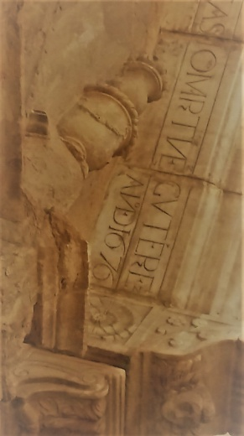
Dit grote witte huis is nabij een private school. Rechtover dit gebouw vind je een heel grote boom. Op de hoek vind je ook een nobel schild |  | To jeden z najpopularniejszych widoków Bazy. Jest to zabytkowy budynek dawniej używany jako rzeźnia. |  | Puoi trovare questa data in una cornice decorativa che protegge una Pietà. Questa scultura è seriamente danneggiata dal vento perché questo è uno dei posti più ventosi di Baza.
 |  |  |  | 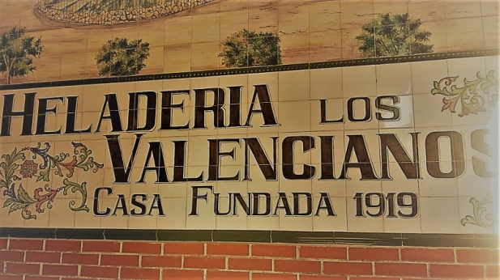
Vandaag de dag is dit gebouw een dienstencentrum waar je tickets kan kopen voor culturele activiteiten, universitaire cursussen kan volgen voor ouderen of volksdansen kan leren |  | This image belongs to one of the best-known pastry and cake shops in Baza, but there are many others! Have a look above the windows, what letters can you see there? Do you know the reason why? |  | - Questa è una delle gelaterie più famose di Baza .... ma a febbraio la troverai chiusa .... che peccato!
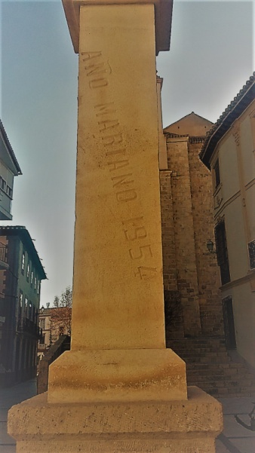 |  | 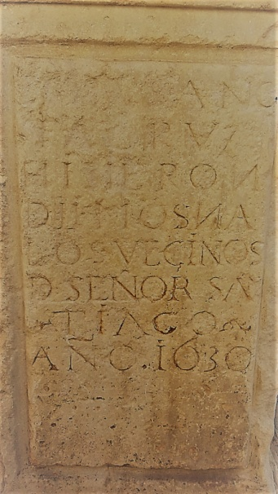 |  | 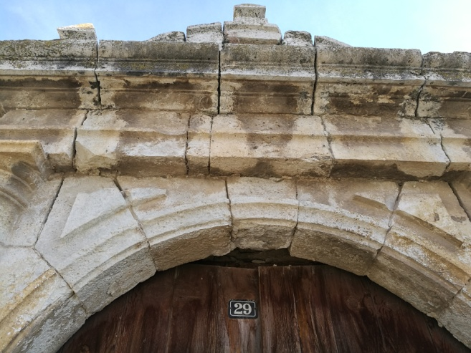
To jest naprawdę blisko rynku głównego, z tego miejsca dobrze widać wieżę kościoła Encamacion |  | This date is hard to find. It is not in the city centre, it is situated in the middle of a sidewalk, close to a long road called “La Corredera |  | Perhaps the most famous 29th number in Baza, attached to a famous monastery.
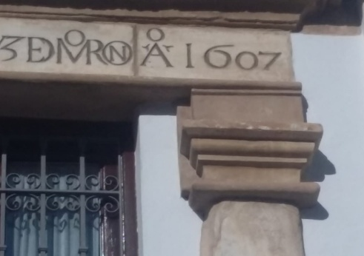 |  |  |  | Your Mission  - To find these places and prove you were there taking a picture of all of you  - Choose 3 of the dates and find an important event which took place at that time in the partners’ cities/ regions or countries  - Finally prepare a timeline
At present, this place is an ordinary house with a fantastic faÇade, don’t you think so? Long time ago it was a trough for animals carrying grain into the city |  | This building, a marvellous church, has a long history, but it got this award during a short and weird period of our history

