The ecosystem of Lake Marmara, Turkey.

The Protected Area of Lake Marmara, Turkey (Central coordinates 38º 37’ 0” North (38.62º) and 28º 1’ 0” East (28.02º), Area: 6,911 ha, Altitude: 79-79 m, IBA Criteria: A1, A4i, A4iii, B1i, B2 (2004)) is a Ramsar wetland of international importance (figure 1).
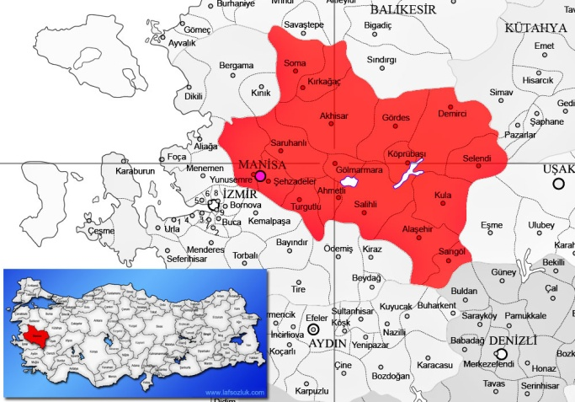

Figure 1.
Gölmarmara is one of the smallest districts of Manisa Province which is named after Lake Marmara, located 12 km away from the district. Lake Marmara, which is a natural alluvial lake, has gained the characteristics of a dam reservoir through artificial channels. Channels which are connected to the lake work for flood control and for the storage of significant amounts of water during rainy seasons and contribute significantly to the irrigation the area during summer months. Also, water of Gediz River has begun to be transferred to the Lake Marmara. Lake Marmara has been recognized as an internationally important wetland due to the diversity of wildlife. An irrigation reservoir averaging 3,400 ha in area (depth 3-4 m); reedbed (Phragmites) and marsh cover varies according to the water-level. It is rounded by hills to the north and north-east, with Gediz valley to the south and Akhisar valley to the north-west. Flood-plains are used for growing cotton, and cattle-grazing is widespread on the marshes. Birds, fish, mussels as well as crayfish are observed in the lake.

A) Representative species of fauna.
Birds, fish, mussels as well as crayfish are observed in the ecosystem of the lake.

Aa) Observed bird species.
The lake is an important area for breeding and wintering water birds. The following thirty five (35) bird species, among the others, have been observed in Lake Marmara:
Küçük batağan
Karaboyunlu batağan
Karabatak
Küçük karabatak
Tepeli pelikan
Küçük ak balıkçıl
Büyük ak balıkçıl
Gri balıkçıl
Saz delicesi
Atmaca
Şahin
Sakarmeke
Suçulluğu
Karabaş martı
Gümüş martı
Sumru
Kumru
Yalıçapkını
Tepeli toygar
Çayır incirkuşu
Dağ incirkuşu
Akkuyruksallayan
Kara kızılkuyruk
Taşkuşu
Ökseardıcı
Maskeliötleğen
Saksağan
Leş kargası
Sığırcık
Serçe
İspinoz
Saka
Dikkuyruk Ördek
Ketenkuşu, Flamingo

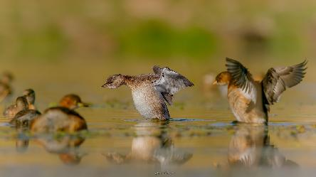
Küçük batağan - Little Grebe - Tachybaptus ruficollis
Incubationperiod |  | 20 days
Number of egg |  | 4-6
The size of egg |  | 33-43 x 24-28 mm

Height | wingspan | weight
25-29 cm | 40-45 cm | 117-236 g

Grebes are primarily fish-eaters and the little grebe is no exception, but as it takes smaller fish than others in its family, they can establish themselves on ponds that are too small to accommodate big fish. This gives them a greater choice of habitat and means the little grebe has a more widespread distribution in the UK. However, they are quite shy birds and will often lurk within easy reach of cover along the margins of the water and will dive or disappear amongst the reeds when disturbed. The usual clutch consists of between four and six eggs, laid in April in a floating nest of vegetation anchored to submerged water plants. Young grebes are frequently carried on the adult birds' backs and are fed with small fish, crustaceans and mollusks. Grebes often give feathers to their chicks, which the young birds swallow in order to form a protective lining to their stomachs. This avoids the possibility of the stomach being damaged by the bones of their fish meals. They are perfect swimmers and divers, not very sociable. They are extinct in Western Sahara. They are visitors in Australia; Faroe Islands; Gibraltar; Mongolia.
Population estimated: a) England 5,000-10,000 couple, b) Ireland: 3,000-6,000 couple, c) Russia: 500-5,000, d) Turkey: 5,000-50,000, e) World: 610,000- 3,500.000

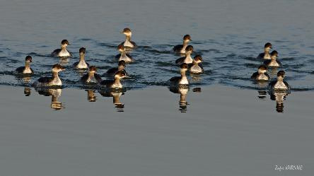
Karaboyunlu batağan – Black necked Grebe – Podiceps nigricollis
Incubation period |  | 20-22 days
Number of egg |  | (1-2)3-4(5-6)
The size of egg |  | 43.4x29.7 mm

Height | wingspan | weight
28-34 cm | 56-60 cm | 265-450 g

This small grebe has beautiful golden tufts of feathers on its face, contrasting with its black head and neck. Its step forehead makes its head looked peaked. A rare breeding bird, it is also uncommon in winter. It eats insects, crustaceans and small fish. They live in colonies in inner lands. In winter, they are found in big lakes and seasides.
Population
According to the data released by Bird Life International:
Europe: 53,000 – 96,000 couples Turkey: 800 – 1,600 couples.

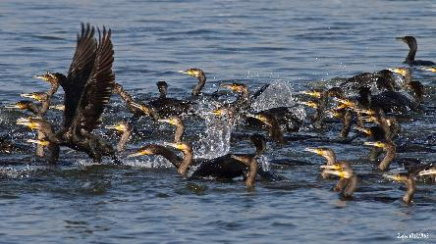
Karabatak - Great Cormorant - Phalacrocorax carbo

Average lifespan |  | 20 years
Incubation period |  | 29 - 31 days
Number of eggs |  | 3 - 4

Height | wingspan | weight
80 - 100 cm | 130 - 160 cm | 2000 - 2500 g

It is the biggest dark seabird in Turkey. Its wings are short, tails are long. Its cheeks and neck are white. It lives in the seasides and lakes. It nests in the water and on the rocks in large colonies. They eat fish. It is a good diver and can dive up to 3 meters staying under water about 1 minute. It is on the red list of IUCN (International Union for the Conservation of Nature).

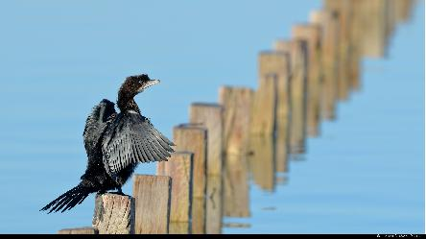
Küçük karabatak - Pygmy Cormorant - Microcarbo pygmeus
Incubationperiod |  | 27 - 30 days
Number of eggs |  | 3 - 6

Height | Wingspan | weight
45-55 cm | 80-90 cm | 570-870 g

Compared to the great cormorant, it is smaller, and has a ticker neck. Its beak is shorter and thicker, its head is dark and round shaped, its tail is long and its eyes are black. It flies fast. It is the smallest cormorant in Turkey. It only eats fish. It is a good diver being able to dive up to 3 meters and stay under water up to 1 minute. It usually flies in long quees or in scattered groups, breeds in colonies. It lives in the reeds in fresh and hard water. It may also be seen in small ponds. It nests on tress or reeds.
Population
It is on the red list of IUCN (The World Conservation Union)
Europe: 37,600-50,400 çift (45,000-139,999 single) estimated.
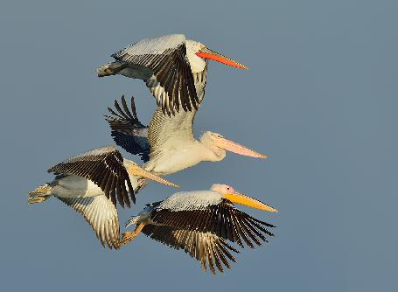
Tepeli pelikan - Dalmatian Pelican - Pelecanus crispus
Averagelifespan |  | 20-25 years
Incubation period |  | 30-32 days
Number of eggs |  | 2-3
Size of eggs |  | 90-93 mm

height | wingspan | weight
160-180 cm | 310-345 cm | 10000-12000 g

It is the biggest of the pelicans. The feathers on its head give the name to this species. The general body color is greyish white, the breast is orangish yellow. The light color of eyes of it is not clear on its face. The feathers in the front wing are black. In winter, it feeds on in fresh water lakes, dams, river mouths in which there can be found lots of fish and it can be observed in the islands or islets having rest. During the breeding period, it can be observed within colonies around the water lands. It mostly eats fish, all the kinds of fish in the water land. It incubates in colonies. It nests on the rocky islets in the water lands. In our country it incubates in mid February. The number of breeding Dalmatian pelican couples increases in Turkey, Greece and Romania according to the recent years. The conservative studies for Dalmation Pelican-being an endangered species on the international scale- have a positive results and today in Greece, 1500 couples reproduced all around the country and around 1400 of them reproduced only in Lake Mikri Prespa. Accordingly, in Turkey, thanks to the observation and conservative studies on Dalmation Pelican done by Ege University Ornithology Department and also thanks to the Conservation of Nature and National Parks Directorates, the number of the breeding couples increased and has reached to 341 couples.

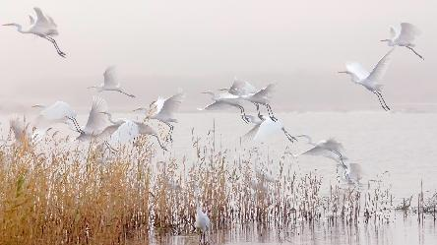
Büyük ak balıkçıl - Great Egret - Ardea alba
Incubationperiod |  | 25-26 days
Number of eggs |  | 3-5
Size of eggs |  | 54-68 x 40-46 mm

height | wingspan | Weight
85-100 cm | 145-170 cm | 1000-1500 g

The great egret is a little over three feet tall with a wingspan of almost five feet. Its feathers are entirely white. It has a long, sharp yellow bill and long gray to black legs, with non-webbed feet with very long toes. The great egret lives along salt and freshwater marshes, marshy ponds and tidal flats. The male great egret chooses the nesting site and builds a nest platform of sticks and twigs in a tree or bush before he selects a mate. Both the male and female aggressively defend the nesting territory. Great egrets nest in colonies, often with herons and ibis. The great egret feeds alone in shallow water. It stalks prey like frogs, crayfish, snakes, snails and fish.

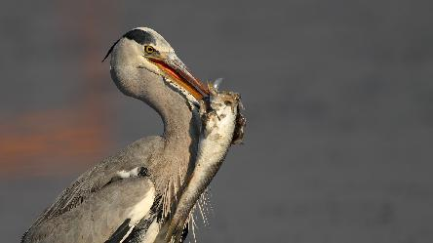
Gri balıkçıl - Grey Heron - Ardea cinerea

Averagelifespan |  | Max. 35 years
Incubation period |  | 25-26 days
Number of eggs |  | 3-7
Size of eggs |  | 42x50 32x39 mm

height | Wingspan | Weight
84-102 cm | 175-195 cm | 1000-2000 g
This species has an extremely large range, and hence does not approach the thresholds for Vulnerable under the range size criterion (Extent of Occurrence <20,000 km² combined with a declining or fluctuating range size, habitat extent/quality, or population size and a small number of locations or severe fragmentation). For these reasons the species is evaluated as Least Concern. This species is a generalist in its habitat use, although shallow water, relatively large prey, and four or five months of ice-free breeding season are among the essential characteristics of its habitat. Its diet consists predominantly of fish and eels 10-25 cm long, as well as amphibians, crabs, mollusks, crustaceans, aquatic insects, snakes, small rodents and small birds. The nest is a stick platform that is often re-used over successive years, usually positioned high in a tall tree up to 50 m, but also on the ground or on cliff edges, in reedbeds or in bushes. The species commonly nests in colonies.

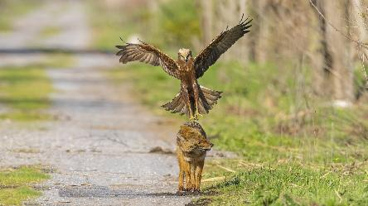
Saz delicesi - Western Marsh Harrier - Circus aeruginosus

Incubation period |  | 31 - 38 days
Number of eggs |  | 3 - 8
height | Wingspan | Weight
48 - 56 cm | 115 - 130 cm | 400 - 800 g

The species inhabits extensive areas of dense marsh vegetation, in fresh or brackish water, generally in lowlands but up to 2,000 m in Asia and 3,000 m on its wintering grounds in Cameroon. It is a generalist predator taking a variety of prey types, with small birds generally preferred but mammals such as voles, rabbits and rats being more important in parts of its range. The nest is a pile of reeds built in dense marsh vegetation. It is mainly migratory, with populations in Western Europe, North Africa and at the south of its range in Asia being generally resident. Migrant birds leave their breeding grounds in September and October.

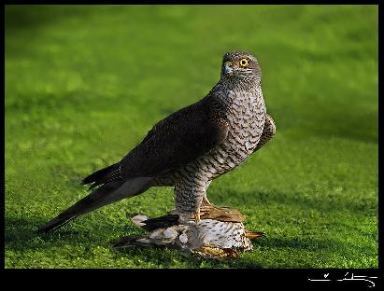
Atmaca - Eurasian Sparrowhawk - Accipiter nisus
Averagelifespan |  | 13 years
Incubation period |  | 31-37 days
Number of eggs |  | 1-7
Size of eggs |  | 36.0-47.2 x 29. mm

height | wingspan | weight
28-42 cm | 55-74 cm | 110-342 g
The species is migratory in the north of its range, with these birds wintering in southern Europe, southern Asia and less commonly in Africa. Further south, birds tend to be resident or dispersive. Migrants move south between July and November, returning between March and June. Birds are generally solitary, except when nesting, and tend to migrate singly although large concentrations do form at narrow sea crossings. It mainly inhabits forest, although preferring this to be interspersed with open areas. Small birds make up the vast majority of its diet. The nest is built in the lower crown of trees, on a fork or branch. Population trends are generally stable or increasing in areas where persecution has been controlled.

Şahin - Common Buzzard - Buteo buteo
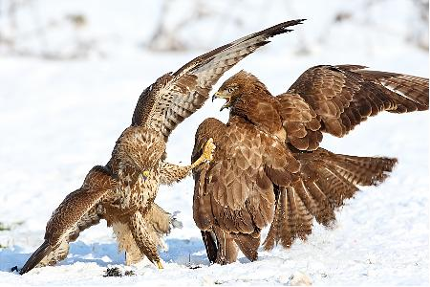
Average lifespan |  | 25 years
Incubation period |  | 33-36 days
Number of eggs |  | 3-6
Size of eggs |  | 56x45 mm

height | Wingspan | Weight
46-58 cm | 110-132 cm | 550-1200 g

Generally, older subjects are much darker, showing nearly white under parts with brown stripes turning to reddish-brown on the abdomen. Primary feathers are dark, close to black. Tail is short and wide. Eyes are brownish yellow. Beak is dark and cere is yellow. Feet and claws are yellow. It lives in all kind of forests, country as well as mountains, but always close to an open space. It is also found in places where trees are scattered, in agricultural zones and in rocky areas in the mountains. Buzzard eats small mammals caught on the ground, but also birds, reptiles, batrachians and insects. This species has a great adaptability. This is perhaps the reason why it has high breeding figures. Common Buzzards nest in high trees in forests, plains, mountains and also in rocky areas scrubs.

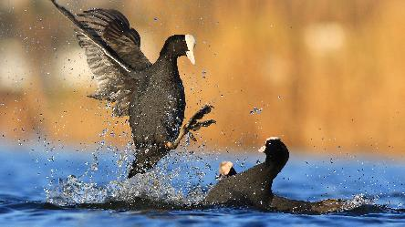
Sakarmeke - Eurasian Coot - Fulica atra
Averagelifespan |  | 18-19 years
Incubation period |  | 21-24 days
Number of eggs |  | 6-9, rarely 15
Size of eggs |  | 44-61 x 32-40 mm

height | wingspan | Weight
36-42 cm | undefined | Undefined
The Eurasian Coot is recognized by its snowy white bill and forehead shield. The remainder of the bird is dark sooty grey, except for its bright red eye. Immature birds are generally paler than adults with a white wash on the throat. Nestlings are downy, black with fine yellow tips. The head is orange-red and the bill is red with a cream-white tip. It is a resident species in Turkey. Food is mainly obtained during underwater dives, lasting up to 15 seconds and ranging down to 7 m in depth. In Australia, Eurasian Coots feed almost entirely on vegetable matter, supplemented with only a few insects, worms and fish. Birds of the northern hemisphere tend to take much more animal prey. Eurasian Coots may breed at any time that conditions are favorable, and may produce successive broods. During the breeding season pairs establish and maintain territories with vigor. The nest is often a floating raft of vegetation or is built on logs or tree stumps that are surrounded by water. Both sexes share incubation and care of the young. If food becomes scarce, the young birds may be killed by the parents.

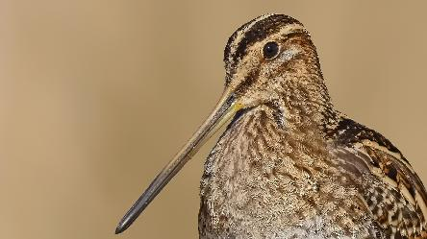
Suçulluğu - Common Snipe - Gallinago gallinago
Averagelifespan |  | Max. 15 years
Incubation period |  | 18-20 days
Number of eggs |  | (2-)4(5)
Size of eggs |  | 39.2x27.9 mm

height | wingspan | weight
25-27 cm | 39-45 cm | 100 g
The species breeds in open fresh or brackish marshland with rich or tussocky vegetation, grassy or marshy edges of lakes and rivers, wet hay fields, swampy meadows and marshy tundra, in forest tundra and extreme northern taiga zones. The species breeds in general in areas providing combination of grassy cover and moist soils, rich in organic matter. Outside breeding season, generally occupies similar habitats, with more use of man-made habitats, e.g. sewage farms and rice fields, upper reaches of estuaries and coastal meadows. Its diet includes larval insects (10–80%), adult insects, earthworms, small crustaceans, small gastropods and spiders. Plant fibers and seeds are consumed in smaller quantities. It typically forages in small groups. Lying takes place in April-June. Monogamous, but both sexes show high degree of promiscuity. This species is mostly migratory.

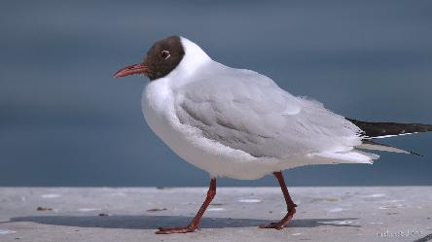
Karabaş martı – Black headed Gull - Chroicocephalus ridibundus

Averagelifespan |  | 32 years
Incubation period |  | 21-27 days
Number of eggs |  | 2-6
Size of eggs |  | 52x37 mm

height | wingspan | weight
34-37 cm | 100-110 cm | 200-400 g
It is small gull white triangle in outer part of wing, blackish under tip of wing, back pale gray, under parts white. Its head is dark brown during breeding. Dark spot can be seen behind eyes in winter. Immature juveniles show much brown on head, neck, and back, a dark bar across the wing, and a black tail tip. Immature is similar to non breeding adult, but with brownish black bar across the base of the wing, much black in the outer wing, and a black band across the tip of the tail. In first breeding plumage the black head is partly mottled with white. This species breeds along lakes, rivers, bogs, moors, grasslands, swamps, and coastal marshes. In winter, found primarily along seacoasts, estuaries, and bays. In Europe the Black-headed Gull is found scavenging in flocks in parks. Perhaps this difference is because it usually is found associating with large flocks of Bonaparte's Gulls, which do not eat refuse or scavenge food from people.
The Black-headed Gull is one of the few hooded gulls that do not actually have a black head during breeding. Its hood is dark chocolate brown. Black-headed gulls were rare inland over 100 years ago. However, they now use inland sites for breeding, roosting and foraging and are the gull species most commonly seen in urban and suburban gardens. Their diet consists of a variety of different foods, including insects, plant material, earthworms and human leftovers. Their catholic diet means that they regularly visit gardens in search of kitchen scraps. They are quite feisty birds and groups will often squabble over available food, especially when there are few feeding opportunities. While most of our breeding populations are resident birds, it is estimated that more than two-thirds of black-headed gulls wintering in the UK have come from mainland Europe. This migration happens from late summer with earlier arrivals thought to be young birds from Western Europe. Birds often seem to be site-faithful, returning to the same place year after year.

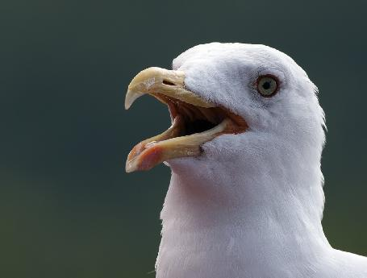
Gümüş martı – Yellow legged Gull - Larus michahellis

Average lifespan |  | 32 - 33 years
Incubation period |  | 26 - 32 days
Number of eggs |  | 2 - 3
Size of eggs |  | 75,8-90x54-49,8 mm

height | wingspan | Weight
55 - 67 cm | 137 - 142 cm | 750-1200 g
Populations may be dispersive or sedentary. Post-breeding movements to wintering areas occur from July to November, with the return migration occurring from mid-February to mid-June. The species breeds from mid-March to April It breeds colonially in groups of up to 8,000 pairs, and may nest in monospecific clusters within mixed-species colonies. Outside of the breeding season the species remains gregarious, congregating around ports, harbors. During the breeding season the species nests near lakes surrounded by reedbeds pastures reservoirs, river sand on grassy or shrubby river islands also forming colonies on sea cliffs, rocky and sandy offshore islands, rocky coasts sandy beaches, and brackish coastal marshes. During outside the breeding season it forages in cultivated fields and along rivers, and is especially common at refuse dumps. Its diet consists of fish, invertebrates (including insects, mollusks and crabs), reptiles, small mammals. The nest is constructed of nearby vegetation, feathers, debris and old carcasses, and is preferably positioned close to or under bushes or on rocky and sandy islands, beaches, spits, sea cliffs, grassy or shrubby river islands, species breeds colonially in monospecific or mixed-species groups, with pairs usually nesting a few meters apart.

Sumru - Common Tern - Sterna hirundo
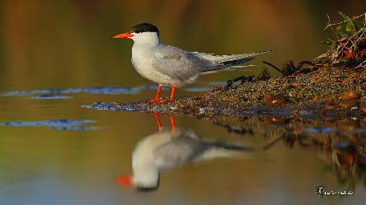
Incubationperiod |  | 20-26 days
Number of eggs |  | 2-5
Size of eggs |  | 41.3x30.1 mm

height | wingspan | Weight
31-35 cm | 82-95 cm | 98-129 g

The global population is estimated to 1,600,000-3,600,000 individuals (Wetlands International 2015). The European population is estimated at 316,000-605,000 breeding pairs (Bird Life International, 2015). This species is a strongly migratory coastal seabird. It breeds between April and June in solitary pairs or colonially in groups of up to several thousand pairs. Palearctic breeders migrate south after breeding between August and October, returning to the breeding grounds in March or April. The species is opportunistic, its diet consisting predominantly of small fish and occasionally planktonic crustaceans and insects. The species breeds in a wide variety of habitats in coastal and inland areas from sea-level to heights of greater than 4,000 m. Along the coast, it shows a preference for nesting on flat rock surfaces on inshore islands, open shingle and sandy beaches, dunes and spits, vegetated inter-dune areas, sandy, rocky, shell-strewn or well-vegetated islands in estuaries and coastal lagoons, salt marshes, mainland peninsulas and grassy plateaus atop coastal cliffs.
Kumru - Eurasian Collared Dove - Streptopelia decaocto
Number of eggs |  | 2

height | wingspan | weight
31-33 cm | 47-55 cm | 150-220 g

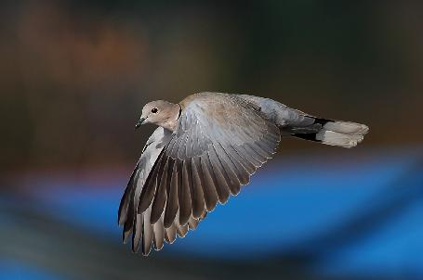
Eurasian Collared-Doves have plump bodies, small heads, and long tails. They’re larger than Mourning Doves but slimmer and longer-tailed than a Rock Pigeon. The wings are broad and slightly rounded. The broad tail is squared off at the tip, rather than pointed like a Mourning Dove’s. Eurasian Collared-Doves are chalky light brown to gray-buff birds with broad white patches in the tail. The bird’s collar is a narrow black crescent around the nape of the neck. In flight and when perched, the wingtips are darker than the rest of the wing. Eurasian Collared-Doves perch on telephone poles, wires, and in large trees. Males show females potential nest sites in trees and on buildings. The male dove brings the female twigs, grasses, roots and other nesting materials. They live in pairs and are loyal to each other. They eat mainly seed and cereal grain such as millet, sunflower, milo, wheat, and corn. They also eat some berries and green parts of plants, as well as invertebrates.
Yalıçapkını - Common Kingfisher - Alcedo atthis
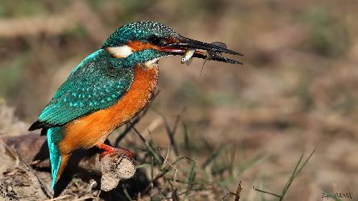
Incubationperiod |  | 19-21 days
Number of eggs |  | 6-7
Size of eggs |  | 18-24 x 15-19 mm

height | wingspan | weight
17-19,5 cm | 25 cm | 40 g
This species has the typical short-tailed, dumpy-bodied large-headed and long-billed kingfisher shape. The adult male of the western European subspecies, A. a. ispida has green-blue upperparts with pale azure-blue back and rump, a rufous patch by the bill base, and a rufous ear-patch. It has a green-blue neck stripe, white neck blaze and throat, rufous under parts, and a black bill with some red at the base. The legs and feet are bright red. This species is resident in areas where the climate is mild year-round, but must migrate after breeding from regions with prolonged freezing conditions in winter. The food is mainly fish. Minnows, sticklebacks, small roach and trout are typical prey. About 60% of food items are fish, but this kingfisher also catches aquatic insects such as dragonfly larvae and water beetles, and, in winter, crustaceans including freshwater shrimps. Both sexes incubate by day, but only the female at night. An incubating bird sits trance-like, facing the tunnel; it invariably casts a pellet, breaking it up with the bill.

Tepeli toygar - Crested Lark - Galerida cristata
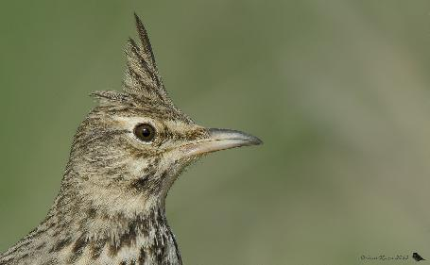
Incubationperiod |  | 12-13 days
Number of eggs |  | 3-5, sometimes 6
Size of eggs |  | 19-25*15-18 mm

height | wingspan | weight
17-19 cm | 34 cm | 46 g
It is a small, brown bird which has a short tail with light brown outer feathers. Its plumage is downy but sparse and appears whitish. The crested lark is a songbird. Largely vegetarian birds, the crested lark primarily feeds on grains and seeds, such as oats, wheat and barley, but will also eat insects, particularly beetles, with food either being scavenged from the ground or dug up. It nests in small depressions in the ground, often in wastelands and on the outskirts of towns. The nests are untidy structures composed primarily of dead grasses and roots. Three to five brown, finely speckled eggs, similar to those of the Eurasian skylark, are laid at a time and will hatch after 11–12 days. The crested lark has been categorised by the IUCN Red List of Threatened Species as being of least concern, meaning that it is not currently threatened with extinction.

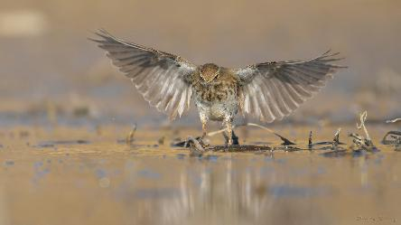
Çayır incirkuşu - Meadow Pipit - Anthus pratensis
Averagelifespan |  | 8 years
Incubation period |  | 11-15 days
Number of eggs |  | 3-5
Size of eggs |  | 19x15 mm

height | Wingspan | weight
14-15.5 cm | 22-25 cm | 16-25 g

A small, brown, streaky bird, the meadow pipit is the most common songbird in upland areas. Its high, piping call is a familiar sound. In flight it shows white outer tail feathers and in the breeding season it has a fluttering 'parachute' display flight. In winter, they are quite gregarious and gather in small flocks, often invisible among the vegetation, suddenly flying up with typical jerky flight.
Meadow pipit numbers in the UK have been declining since the mid-1970s, resulting in this species being included on the amber list of conservation concern. They eat insects - flies, beetles and moths - and spiders. They are found in open country - upland moors to salt marshes in summer, more agricultural land and marshes in winter. They will even come to suburban parks and playing fields.

Dağ incirkuşu - Water Pipit - Anthus spinoletta
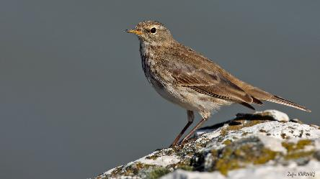
Incubationperiod |  | 14-15 days
Number of eggs |  | 4-6

height | wingspan | weight
15.5-17 cm | 23-28 cm | 20-30 g

The species breeds on alpine pastures and high-lying mountain meadows with short grassland and scattered rocks, bushes or trees, usually with some wet areas, often on mountain slopes and also on stony scree with thickets in the far east of the range. In the winter it is found on coastal saltings, lagoons, marshes, grassy edges of lakes and rivers, sewage farms, watercress farms, rice fields and other irrigated cultivation. In Europe, egg-laying occurs from the end of April to early July. The nest is a cup made of grass stems and leaves with some moss incorporated and lined with finer material and some hairs. It is sited on the ground in the side of a bank or hollow, usually well concealed by vegetation or sometimes at the end of a tunnel. Normally four to six eggs are laid. It feeds mainly on invertebrates but also takes some plant material. The species is chiefly a short-distance or altitudinal migrant with regular migration from the high mountains down to the lowlands in autumn.
,

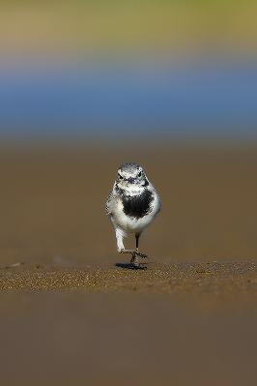
Akkuyruksallayan - White Wagtail - Motacilla alba
height | wingspan | weight
18 cm | 25-30 cm | 19-27 g

This species inhabits a very wide variety of non-forested wet and dry habitats, including seashores, rocky or sandy upland rivers and slow-moving lowland rivers, lakeshores, farmland, gardens, parks, short grassland such as that found in vicinity of factories in towns and cities. It is also often found in towns and villages. It mostly breeds from early April to August, starting later in the north. It is monogamous and both sexes build the nest which is a rough cup of twigs, grass stems, leaves, rootlets and mosses, lined with hair, wool or feathers and placed in a hole or crevice in a riverbank, wall or bridge. It also often nests in buildings or even machinery. Clutches are three to eight eggs. It feeds on a wide range of small terrestrial and aquatic invertebrates, as well as fish fry, crumbs and other household scraps. Most populations are regular long-distance migrants, others are partial migrants or largely resident. In western and southern Europe some populations of the nominate race and of yarrellii are resident but northern populations of the latter are partial migrants.

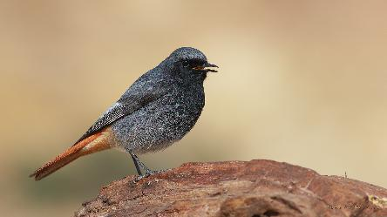
Kara kızılkuyruk - Black Redstart - Phoenicurus ochruros

Incubationperiod |  | 13-17 days
Number of eggs |  | 4-6
Size of eggs |  | 17-22 x 13-15 mm

height | wingspan | weight
13-14,5 cm | 23-26 cm | 14-20 g

This species is found in sparsely vegetated rocky areas, including stony slopes with xerophytic vegetation, crags and gullies in high river valleys and rocky mountain tops up to snow-line as well as villages, towns and cities. In Carpathians, it is mainly found on mountain slopes covered with juniper (Juniperus), scree and boulders. The breeding season runs from mid-April to mid-July in Western Europe but can be up to two weeks later in Eastern Europe. In Morocco it breeds late April-June, April-July in Israel, May-August in India, April-July in Nepal and June-July in China. The nest is a loose cup of grass, moss, hair, wool and feathers, which are set in a crevice of a wall or rock, or in an earth bank, pile of stones or on the ground. Clutches are four to six eggs. The diet consists of invertebrates and berries. The species is resident, partially migrant, a vertical migrant and fully migrant in different parts of the range. Breeding populations in Morocco, Iberia, southern/central France, Italy, the Balkans and central Turkey are generally sedentary, with mountain breeders moving to lower elevations in winter. Populations breeding in northern Europe migrate south-west towards the Balearic Islands, Spain, Morocco and Algeria. More eastern breeding populations move south-east and reach as far as Egypt.

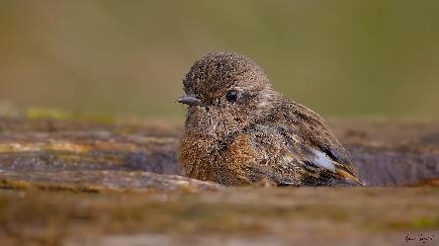
Taşkuşu - European Stonechat - Saxicola rubicola
Averagelifespan |  | 4 - 6 years
Incubation period |  | 14 - 15 days
Number of eggs |  | 3 - 8 adet

Height | wingspan | weight
12,5 cm | 18 - 22 cm | 14 - 18 g
Both sexes have distinctively short wings, shorter than those of the more migratory whinchat and Siberian stonechat. The summer male has black upperparts, a black head, an orange throat and breast, and a white belly and vent. It also has a white half-collar on the sides of its neck, a small white scapular patch on the wings, and a very small white patch on the rump often streaked with black. The female has brown upperparts and head, and no white neck patches, rump or belly, these areas being streaked dark brown on paler brown, the only white being the scapular patch on the wings and even this often being buffy-white. European stonechats breed in heath land, coastal dunes and rough grassland with scattered small shrubs and bramble, open gorse, tussocks or heather. They are short-distance migrants or non-migratory, with part of the population (particularly from northeastern parts of the range, where winters are colder) moving south to winter further south in Europe and more widely in north Africa.

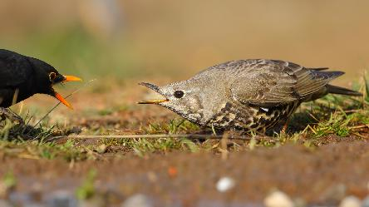
Ökseardıcı - Mistle Thrush - Turdus viscivorus
Average Lifespan |  | 11 years
Incubation period |  | 12-15 days
Number of eggs |  | 3-6
Size of eggs |  | 13x15 mm

height | wingspan | weight
27 cm | 42-48 cm | 110-140 g

The species requires a mosaic of wooded and open country, and thus inhabits open mature forest, woodland glades, orchards, riverside forest, open grassland with scrub and mountain steppe with shrubs; often penetrating grassy-bracken moorland areas on low craggy hills and mountains at some distance from trees. It is most typically found, in rolling, open landscapes with scattered trees or copses, including parkland and park-like farmland. In western and central Europe, it breeds from late March to late June and from late April in the north. It breeds from late March to July in Afghanistan east to the western Himalayas. In north-west Africa it breeds from March to June. The nest is a large cup of dry grass, plant stems, roots and moss, bound together with mud and lined with fine grasses and sometimes pine needles. Typically it is found two to ten meters up in the fork of a tree and normally lays three to five eggs. It feeds on invertebrates as well as seeds and fruit in the autumn and winter. In the west of its range the species is sedentary or a partial migrant and in the north and east of its range it is more fully migratory.

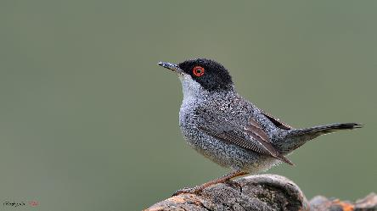
Maskeliötleğen - Sardinian Warbler - Sylvia melanocephala
Number of eggs |  | 3-6

height | wingspan | Weight
13,5 cm | 15-18 cm | 14-23 g

As probably one of the most generalist of the Mediterranean warblers, this species is present in all types of warm habitat at low altitudes, and up to c. 1,200–1,300 m in most of its range and up to 1,800 m in north-west Africa. It is found in maquis, garrigue, dry coastal habitats, urban and suburban environments, abandoned farmland and dry coast sites. It will also inhabit Mediterranean cultures such as olives, almonds, orchards, citrus groves, vineyards, but favors mosaic landscapes with hedgerows, bushes and stands of pine. It is also frequently found in holm oak (Quercus ilex) forests. Breeding occurs mainly from March to June. The nest is a grass cup placed usually 30–60 cm above ground in scrub or bush or, less frequently, among dense herbs or in a small tree. Most nests in Spain are in kermes oak (Quercus coccifera) at low height. Clutches are three to five eggs. It feeds mostly on arthropods but also takes a significant amount of fruit in the autumn and winter. Island and coastal populations appear to be mostly sedentary but the proportion of migrants increases inland and to the north, especially in the east.

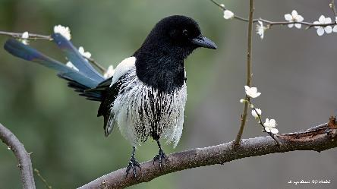
Saksağan – Eurasian Magpie - Picapica
Incubation period |  | 20-25 days
Number of eggs |  | 4-7
Size of eggs |  | 32.9 mm × 23 mm

height | wingspan | weight
40-51 cm | 52-60 cm | 200-250 g

The Eurasian magpie, European magpie, or common magpie (Pica pica) is a resident breeding bird throughout Europe, much of Asia and northwest Africa. The Eurasian magpie is one of the most intelligent birds, and it is believed to be one of the most intelligent of all animals. The expansion of its nidopallium is approximately the same in its relative size as the brain of chimpanzees, orangutans and humans. Its head, neck and breast are glossy black with a metallic green and violet sheen; the belly and scapulars (shoulder feathers) are pure white; the wings are black glossed with green or purple. The legs and bill are black. The magpie is omnivorous, eating young birds and eggs, insects, scraps and carrion, acorns, grain, and other vegetable substances. In winter, magpies often form groups, feeding and roosting at night. Magpies prefer tall trees for their bulky nest, firmly attaching them to a central fork in the upper branches. These huge nests are conspicuous when the leaves fall. Where trees are scarce, though even in well-wooded country, nests are at times built in bushes and hedgerows.

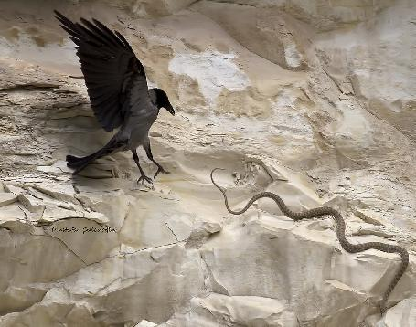
Leşkargası - Hooded Crow - Corvus cornix
Averagelisfespan |  | 8 years
Incubation period |  | 17-19 days
Number of eggs |  | 4-6
Size of eggs |  | 43 x 30 mm

height | wingspan | Weight
48-52 cm | 98 cm | 510 g

The hooded crow is closely related to the carrion crow, which until recently was regarded as the same species. In areas where the two species overlap there may be some interbreeding with hybrids showing a mixed grey and black body plumage. Like carrion crows, hooded crows also feed on dead animals. Unlike crows they can be more sociable in the feeding habits and groups of them may be seen together in fields. They eat omnivorous - includes carrion, invertebrates, grain, eggs, and young birds. They are resident.
Sığırcık - Common Starling - Sturnus vulgaris
Incubationperiod |  | 12-15 days
Number of eggs |  | 4-9
Size of eggs |  | 26-34 x 19-23 mm
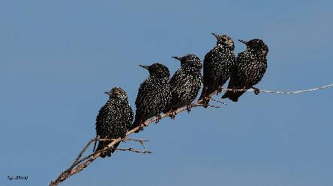

height | wingspan | weight
19-22 cm | 37-42 cm | 75-90 g

During the breeding season this species occupies open country, including modified habitats, with access to suitable nesting and roosting sites. It requires cavity nest-sites, typically in woodland or on man-made structures, close to open areas of short grassland for foraging. At other times it exploits a wide range of habitats, including moorland, salt marshes, seashore and tidal flats, stubble fields, orchards, refuse dumps and sewage-treatment works. It roosts in reedbeds, scrub and trees, as well as bridges and buildings and even in town centers. Breeding occurs mostly between March and July. The nest is a bulky structure of dry grass, conifer needles, twigs, string and other materials and the cup is lined with softer materials such as grass, feathers, moss, wool, hair and paper, fresh green leaves and flowers. It is typically built in a hole in a tree, cliff, building or other structure and nest boxes are also readily used. Clutches are normally four to six eggs. It is omnivorous, taking animal and plant material all year round but during the spring animal food predominates and is fed almost exclusively to nestlings. The northern and eastern populations are migratory whereas southern and western populations as well as those in urban areas tend to be resident.
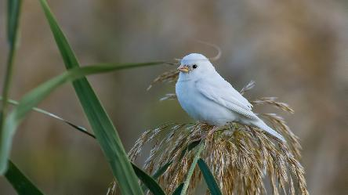
Serçe - House Sparrow - Passer domesticus
Incubationperiod |  | 14 days
Number of eggs |  | 3-5 rarely 8
Size of eggs |  | 16-26x13-17 mm

height | wingspan | Weight
14-16 cm | - m

House Sparrows are small stockily built birds with strong sturdy beaks. Sparrows’ plumage is similar to many bunting species, but can be distinguished by the absence of white edging to the tail. Sparrows’ tails are also shorter than those of buntings. Male House Sparrows have greyish cheeks, a grey cap, a black bib, and a reddish brown patch behind their eyes extending round the back of the neck. Females’ heads do not have these markings, and their only distinctive facial feature is a pale greyish eyebrow stripe. House Sparrows’ upper parts are brown with black markings, and their wings have a narrow white stripe. Their legs are pale brown and their irises are reddish brown. Breeding period is very long, even lasting all year in urban areas, with 2–3 broods raised annually. They nest in holes in buildings, nest boxes or sometimes in trees. Nest is made of dry grass, lined with feathers, hair, thread etc. They eat seeds, invertebrates. They are sedentary, though some birds may roam short distances, particularly in October and between March and May.
Population around 3.600.000 couple.

İspinoz - Common Chaffinch - Fringilla coelebs
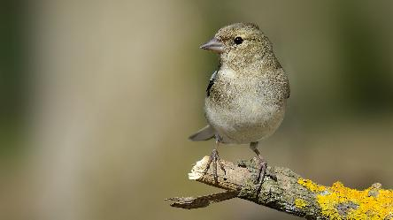
Incubation period |  | 11-13 days
Number of eggs |  | 4-5
Size of eggs |  | 16-24 x 13-16 mm

height | wingspan | Weight
14-16 cm | 24,5-28,5 cm | 18-29 g

It has a black forehead and a blue-grey crown, nape and upper mantle. The rump is a light olive-green; the lower mantle and scapulars form a brown saddle. The side of head, throat and breast are a dull rust-red merging to a pale creamy-pink on the belly. The central pair of tail feathers is dark grey with a black shaft streak. This bird is not migratory in the milder parts of its range, but vacates the colder regions in winter. This species forms loose flocks outside the breeding season. The main food of the chaffinch is seeds, but unlike most finches, the young are fed extensively on insects, and adults also eat insects in the breeding season. The date for breeding is dependent on the spring temperature and is earlier in southwest Europe and later in the northeast. In Britain most clutches are laid between late April and the middle of June. Nests are built entirely by the female and are usually located in the fork of a bush or a tree several meters above the ground. The nest has a deep cup and is lined with a layer of thin roots and feathers.

Saka - European Goldfinch - Carduelis carduelis
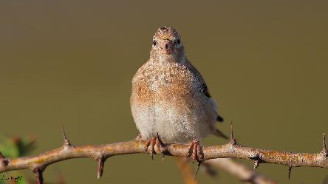
Average lifespan |  | 6-8 years
Incubation period |  | 10-14 days
Number of eggs |  | 3-7

height | Wingspan | Weight
12 cm | 21-25 cm | 14-17 g

This species inhabits open or sparse deciduous woodland and mixed deciduous and conifer woods, forest edges, thickets, heaths, hedgerows, streams, riverine and marshy areas with bushes and trees, roadside verges, steppe grasslands with scattered trees to edges of semi-desert areas, scrub, orchards, edges of cultivation and parks and gardens. Breeding occurs from April to early August. The nest is a compact small cup of grasses, moss, plant fibers and down, cobwebs, animal hair and feathers, a few aromatic flowers on outside, placed up to 10 m from the ground, concealed beneath foliage. Clutches are four to six eggs. It feeds mostly on seeds (ripe and unripe), buds, flowers and the fruits of plants but also takes arthropods. The species is resident, migratory, partially migratory and nomadic. Carduelis carduelis is widely distributed across Europe and central Asia, from the British Isles, Western Europe and the northern tip of Africa through eastern Europe, the Balkans, Turkey and into the Urals, Israel, Azerbaijan and Iran.

Ketenkuşu - Common Linnet - Linaria cannabina
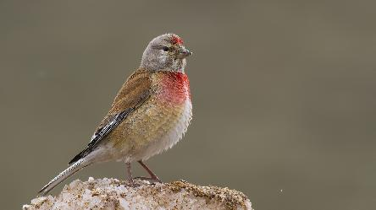
Incubation period |  | 11-13 days
Number of eggs |  | 4-7

height | wingspan | Weight
13,5 cm | 21-25 cm | 15-21 g

This species inhabits lowland open heaths and commons, moorlands and hills with scattered trees and light woodlands, open rocky hillsides, mountain slopes, alpine meadows and maquis or valleys with low shrubs. It is also found in woodland and forest clearings and edges, edges of cultivation, fallow fields, scrub and weed patches, plantations, orchards, vineyards, hedgerows, parks and large gardens. During the non-breeding season it also occupies coastal dunes, salt marshes and shingle banks. Breeding occurs from mid-April to early August and it lays four to six eggs. The nest is built mostly from small twigs, plant fibers and down, roots, moss, animal fur and feathers and is placed low down, in dense bush or shrub, usually in a thorn bush or a hedge or conifer sapling. It feeds mainly on small to medium-sized seeds as well as buds and some invertebrates. The species is resident, migratory and partially migratory. Southern European, Mediterranean and Atlantic island races which are entirely sedentary.

Flamingo -Lesser Flamingo- Phoeniconaias minor
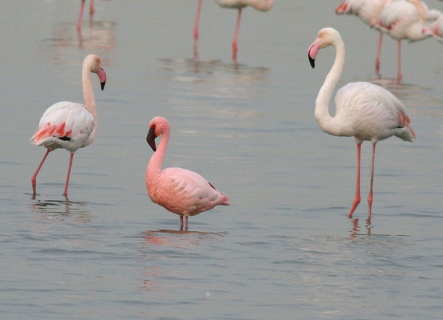
height | wingspan | Weight
80-90 cm | 90-100 cm | 1,2-2,7kg

This species is itinerant and makes extensive movements in response to environmental conditions The Asian and southern African populations are partially migratory, with many making regular movements from their breeding sites inland to coastal wetlands when not breeding. The species breeds in huge colonies of many thousands of pairs. The timing of breeding is irregular and varies geographically, depending on the timing of the rains. The species is an obligate filter feeder and feeds during the night and early morning when the surface of the water is calm. When necessary, the species forms large dense feeding flocks that create calm water for feeding near the centre of the flock. The species breeds on large undisturbed alkaline and saline lakes, salt pans or coastal lagoons, usually far out from the shore. It has a highly specialised diet consisting almost entirely of microscopic blue-green algae (Spirulina spp., Oscillatoria spp. and Lyngbya spp.) and benthic diatoms (Navicula spp., Bacillariophyceae) found only in alkaline lakes, salt pans and saline lagoons and estuaries. To a lesser extent, the species will also take small aquatic invertebrates such as rotifers (Brachiomus spp.). The nest is built from mud substrates. The species will breed successfully on artificial breeding islands in ideal conditions.

Dikkuyruk Ördek – White Duck – Oxyura leucocephala
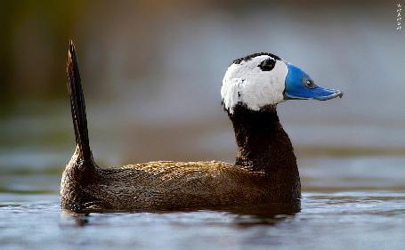
They prefer semi - permanently or continuously salty, bitter and sweet lakes having closed basin hydrology.
They generally prefer areas having large, deep and small flora or areas surrounded with larger watery areas as winter areas. They make their nests on small, swimming islands between water plants. They are polygamic. Reproduction area varies between April and the first half of July. They have very big eggs and the number of eggs varies in between 4 - 9. Incubation period is between 22 - 24 days. The larva feed with invertebrates and water plants. Turkey is one of the most important countries for Oxyura leucocephala. It spends the winter in Kuş Lake (max 34), Marmara Lake (max 20), Karataş Lake (max 128), Yarışlı Lake (Max 82), İrfanlı Dam (max 122).It has the biggest winter population among the countries where it shows distribution.

Ab) Observed fish species.
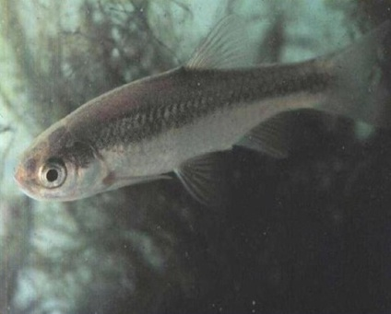
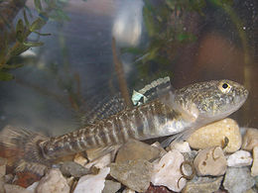
At least sixteen fish species (families Cyprinidae, Atherinidae, Cobitidae, Percidae, Poecilidae, Ariidae and Plotosidae) as well as eel (family Ophichthidae) have been observed in the lake.
The 2 endemic species of Turkey, found in Lake Marmara. Ladigeso cyprismermere, also known as the Izmir minnow, is a species of ray-finned fish in the family Cyprinidae. It is found only in Turkey. Its natural habitats are rivers, intermittent rivers, and freshwater springs. It is threatened by habitat loss. Ladigeso cyprisirideus is the other member of the genus according to Fish base.

Family: Atherinidae
Gümüş balığı - Atherina boyeri (Risso, 1810)
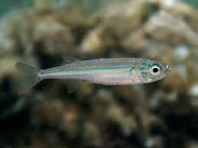
Atherinaboyeri (Risso, 1810), which a species of Atherinidae
Atherinaboyeri (Risso, 1810), which a species of Atherinidae
This family has great adaptation capability and large spreading area on the world. Length frequency of population ranges from 0.6 to 20cm in the different regions. Age frequency of population changes between 0-4+. Breeding season is between February and August. Weight frequency of population changes between 0.001-13.070 g. Basic food items of sand smelt are zooplankton.

Family: Cyprinidae
İncibalığı - Alburnus battalgilae (Özuluğve Freyhof, 2007)
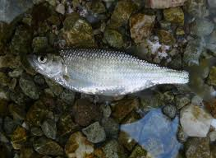
The current systematic status of endemic Anatolian species, Alburnus nasreddini, has been enlightened by making its morphological description and comparing it with the closest species, A. escherichii. This species has distinguished from the closest species, A. escherichii, by fever perforated scales along lateral line (44-48 vs. 46-53), dipper body depth (26.64 vs. 23.92% SL), shorter snout (25.54 vs. 27.55% HL) and larger eye diameter (31.22 vs. 27.88% HL).

Sazan - Cyprinus carpio (Linnaeus, 1758)
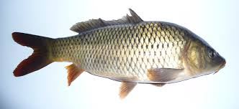
The length at first maturity was determined for carp as 28 cm for males and 28.8 cm for females. The carp reproduce from the beginning of May to mid July.
Kababurun balığı - Chondrostoma holmwoodii (Boulenger, 1896)
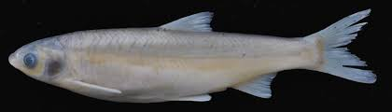
A diverse genus of the Cyprinidae family genus Chondrostoma Agassiz, 1832 has a wide distribution. More than half of the species distributes in Turkey, however there is little biological information about them.

Bergama Sirazbalığı - Capoeta bergamae (Karaman, 1969)
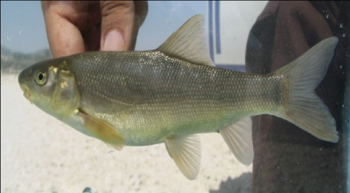
The species is assessed as being of "least concern" according to the IUCN Red List of Threatened Species (Freyhof and Kottelat, 2008). Aegean scraper Capoeta bergamae (Karaman, 1969) is an endemic cyprinid species of southwestern Anatolia (Turkey).

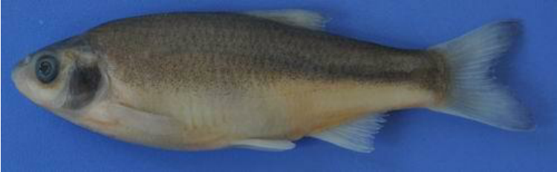
İlikbalığı - Ladigeso cyprismermere (Ladiges, 1960)
It is under the IUCN Red List of Threatened Species. Threads: limited habitat, presence of other species (Carassius gibelio, Pseudorasbora parva). Habitat: Akpınar spring (38o 41’40’’N 27o 58’40’’E) (Lake Marmara-Manisa) 20.

Çizgilisazancık Maviş - Pseudorasbora parva (Temminck & Schlegel, 1846)
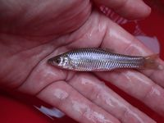
Head moderately small, pointed. Snout short, protractile. The eye is large and the interorbital space is broad. Mouth is small, superior, lower jaw longer than upper; barbels absent. Body elongated, slender, slightly compressed, belly rounded; dorsal profile slightly arched; caudal peduncle slender. Scales are moderately large, cycloid, lateral line complete. L.l.：35-38; dorsal fin rays：3+7; pectoral fin rays：1+12-14; pelvic fin rays：1+7-9; anal fin rays：3+6. Dorsal fin origin above pelvic fin origin; pectoral fin end distant from pelvic fin origin; pectoral and pelvic fins at lower side of body; caudal fin forked. Grayish dorsally and silvery white ventrally. Distal margin of scales is dark. Sexually dichromatic, a conspicuously dark stripe on side of female and the young from snout tip to caudal peduncle end, absent in male.

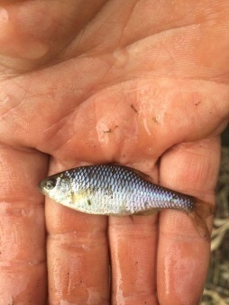
Acıbalık - Rhodeus amarus (Bloch, 1782)
Total lengths ranged from 1.60 to 8.30 cm and total weights from0.06 to 10.65 g for all individuals of the species in the freshwater of Turkey.

Eğrez - Vimba vimba (Linnaeus, 1758)
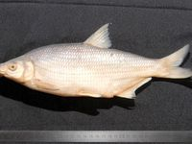
It is under the IUCN Red List of Threatened Species.
Threads: pollution, dams, the usage of the water sources.
Total length and weight of the specimens ranged from14.2 to 24.9 cm and from 36.30 to 236.90 g. the spawning period of the species take place between April and May.

Family: Cobitidae

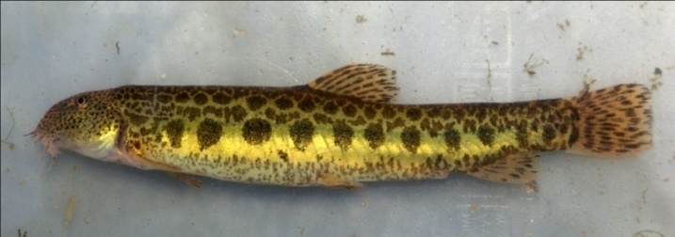
Taşyiyen - Cobitis fahirae (Erk'akan, Atalay-Ekmekçi & Nalbant, 1998)
This species appears minute and rounded lateral spots. Head moderately long, with relatively small eyes placed in its anterior half. Mouth rather arched with three pairs of very short barbels. Both lips furrowed. Mental lobes well developed.

Taşyiyen balığı – Stone Eel Fish – Cobitis taenia
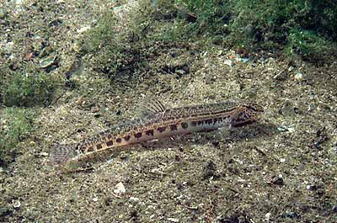
Dorsal soft rays (total): 6-8; Anal spines: 3; Anal soft rays: 5; Vertebrae: 40 - 42. Caudal fin with 15-16 rays (Ref. 2196). Single small spot on upper caudal base. Pigmentation (Gambetta's longitudinal zone of pigmentation): zones Z1-Z4 usually well differentiated, extending backward to caudal peduncle; height of blotches of zone Z4 usually less than 2 times in their length; if more than 2 times, then height equal to or greater than horizontal eye diameter. The distribution is Europe and Asia. IUCN Red List Status: LC (Least Concerned).

Family: Percidae
Sudak - Sander lucioperca (Linnaeus, 1758)
The stomach contents of 986 pikeperch. The diet of pikeperch consists of some fish species (Knipowitschia sp., Aphanius anatoliae anatoliae, Gambusia affinis, Nemacheilus lendli, Carassius gibelio, and Sander lucioperca), odonats (Calopteryx splendens), mysids (Mysis), amphipods (Gammarus) and dipterans (Chironomus).

Family: Poecilidae
Sivrisinek balığı - Gambusia affinis (Baird & Girard, 1853)
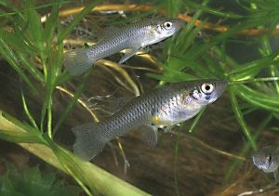
The mosquitofish Gambusia affinis (Baird and Girard, 1853) is a member of family Poeciliidae (Poeciliids), subfamily Poeciliinae and inhabits standing to slow-flowing water; most common in vegetated ponds and lakes, backwaters and quiet pools of streams. G. affinis feeds on zooplankton, small insects and detritus and is used as live food for carnivorous aquarium fishes. G. affinis is commonly present in the pond and streams near agricultural areas.

Sudak – Zander - Sander lucioperca
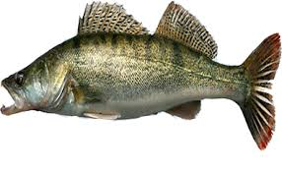
The Zander has a long, slender body with two separated dorsal fins, a mouth filled with many small teeth and a few larger ones for catching prey, and large, reflective eyes. Coloration ranges from blue-gray to green with a silver-white belly, several dark vertical bands on the body, and yellow-gray fins. The dorsal and caudal fins have rows of black spots on their membranes.

Yayın balığı - Catfish – Lacus

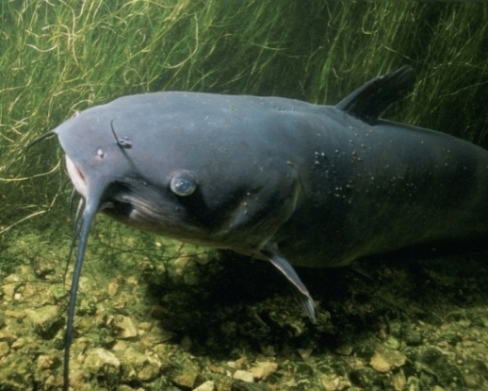
Living catfishes constitute nearly 2,900 species placed in about 35 families. The majority of species inhabit fresh water, but a few, belonging to the families Ariidae and Plotosidae, are marine. Freshwater catfishes are almost worldwide in distribution and live in a variety of habitats from slow or stagnant waters to fast mountain streams; marine catfishes are found in the shore waters of the tropics. Catfishes are generally bottom dwellers, more active by night than by day. Most are scavengers and feed on almost any kind of animal or vegetable matter. All species are egg layers and may exhibit various types of parental care.

Yılan balığı - Eel
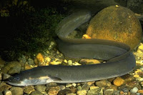
Snake eel, any of numerous marine fishes in the family Ophichthidae (order Anguilliformes). Representatives of the more than 200 species are found throughout the world, mostly in tropical or temperate waters. These snakelike creatures are more benign than their aggressive relatives, the morays. The tail of the snake eel is pointed and sharp compared with the flattened tail of the moray.

Ac) Other species: mussels and crayfish.
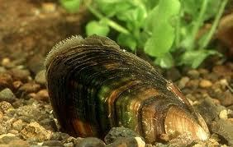
Mussels (Tatlı Su Midyesi, Aquae Dulcis Hippopotami) are mollusks with two hinged shells (Bivalves) which filter their food from the surrounding water. Mussels can be found attached to gravel, seawall, and rocks in intertidal and subtidal coastal areas. They can survive out of water for an extended period of time if kept in a cold, moist environment. The most commonly marketed species is the Blue Mussel. A healthy mussel whose shell is open should close when gently tapped. If the shell is broken or the meat is dry, the mussel should be discarded.
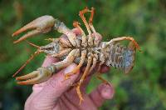
Clawed Crayfish (Kerevit, Turkish Narrow) is the only taxa observed in Turkey. Turkish Crayfish are also known as Turkish Narrow-clawed Crayfish and are usually about 15 cm long but can be up to 30 cm. Pale yellow to pale green in color. Sides of carapace are very rough. Two pairs of ridges are behind the eye sockets. Rostrum well developed with parallel sides and long apex. Claws: Long and narrow, upper surface rough, underside same color as body.

B) Representative species of flora.

At least eighteen species of flora have been observed in the ecosystem of the lake: Kızılçam (Pinus brutia), Meşe (Oak Tree), Sazlıklar (Reeds), Islak Çayırlar (Wet Meadows), Söğüt (Willow), Karaağaç (Ulmus), Defne (Laurus), Çınar (Platanus), Dut (Morus), Böğürtlen (Rubus), Ebegümeci (Malva sylvestris), Sarmaşık (Hedera helix hibernica), Zakkum (Nerium oleander), Isırgan (Urtica), Kuzukulağı (Rumex acetosella), Menekşe (Viola), Karanfil (Dianthus petraeus) and Lale (Tulipa).

Kızılçam – Pinus brutia
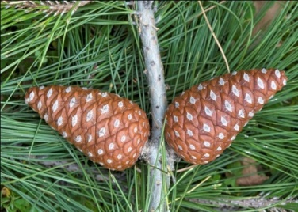
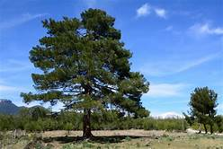
The Turkish pine is a tree to 27-35 m, with a usually open crown of irregular branches. The bark on the lower trunk is thick, scaly, fissured, patterned red-brown and buff, and thin, flaky and orange-red higher in the crown. The shoots are slender, 3-7 mm thick, grey-buff, and rough with persistent small decurrent scale-leaf bases. The winter buds are ovoid-acute, with red-brown scales with long free tips revolute and fringed with white hairs. The adult leaves are retained for 1.5-2.5 years, with a persistent 1-1.5 cm sheath; on most trees they are in fascicles of two, and 10-18 cm long. They are bright green to yellow-green, slender, about 1mm thick, with serrulate margins, fine lines of stomata on both faces, and several marginal resin canals. Primarily in Turkey and far Greece, secondarily in the Crimea, Caucasus coast, Azerbaijan, Iran, Iraq, Syria, Lebanon, Crete and Cyprus; primarily near coasts, in areas with a strongly Mediterranean climate. It grows at 0-1525 m elevation.

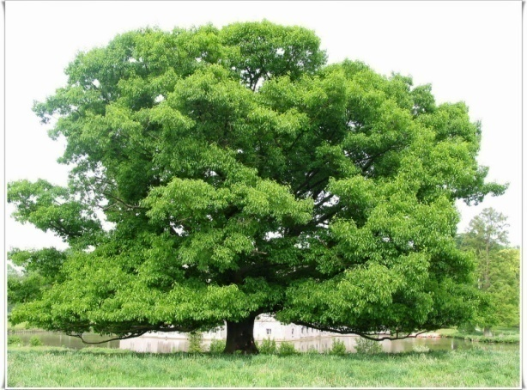
Meşe – Oak tree
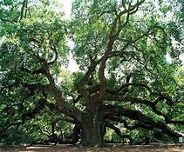
Oak trees are hard to miss. Their majestic branches cover a large area, though they are just one of the tree's most recognizable features. The oak's massive height is another key characteristic. Oak trees can grow to 100 feet tall, and have a spread of 150 feet across. Other notable traits of the oak tree include:
Leaves: The simple leaves consist of a single elliptical shape and a solid stem. They vary in size from two to five inches in length and rarely exceed two inches in width. The upper portion of the leaf is dark green with a shiny texture, while the bottom has a dull gray tone with a leathery feel. In the fall, oak leaves turn awe-inspiring shades of red, orange and yellow.
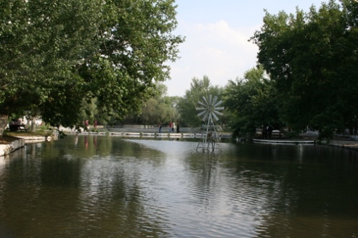
Bark: The oak's bark takes on a life of its own as it ages. While younger oaks feature a dark brown bark, older trees develop a red tinge and often turn black. In addition, as the tree matures its bark furrows and develops scaly ridges.
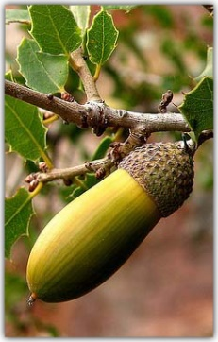
Fruit: The fruit of the oak tree is the acorn. The light to dark brown, bitter-tasting nut seldom grows beyond an inch and can be found attached to the tree by itself or in clusters of as many as five nuts. Generally, oak trees do not produce acorns for the first 20 growing seasons, though some have gone as long as 50 years before generating the popular nuts.
Turkey has a very rich fauna and flora. For instance there are at least 18 species of Oaks. They can be found in many situations, from sea level, up to an altitude of 2000m and from south to north part of the country. The species are adopted to different climatic and geological situations. Two of the Oaks species are endemic to Turkey. Quercus aucheri only exist in the south west part of the country in dry and hilly places. Often the trees are small and are a part of the typical maccia vegetation found in the coastal areas of the Mediterranean region. Quercus aucheri have dark green, small and leather like leaves with a strong pubescens making them look grey in distance (Turkish Oak Habitat Project, TOHP).

Sazliklar - Reeds
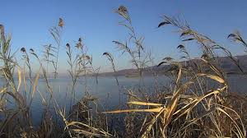
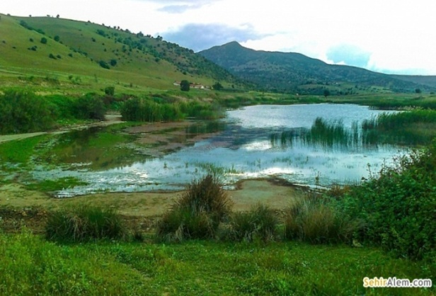
Situated in Western Anatolia, Lake Marmara is a shallow freshwater lake and is among Turkey’s 184 Important Bird Areas (IBA). Until 1950 it was a natural lake when it was intended to be transformed to a reservoir via the construction of a retention wall in the southwestern part of the lake in order to prevent floods and to meet the needs of the regions agricultural water. Despite these developments, extensive reed beds located in the north of the lake provides an important feeding, sheltering and breeding habitat for many water birds. Herons and cormorants that breed in colonies nest on the willow trees in this region. Globally threatened Dalmatian Pelican (Pelecanus crispus) winters in great numbers in Lake Marmara during winter months.

Islak Çayırlar – Wet meadows
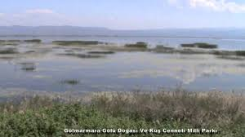
Wet meadows are a type of marsh that commonly occurs in poorly drained areas such as shallow lake basins, low-lying farmland, and the land between shallow marshes and upland areas. For most of the year wet meadows are without standing water, though the high water table allows the soil to remain saturated. A variety of water-loving grasses, sedges, rushes, and wetland wildflowers proliferate in the highly fertile soil of wet meadows.
During periods of high rainfall, wet meadows collect runoff, reducing the likelihood of seasonal flooding to downstream low-lying areas. In the process of collecting and storing runoff, the vegetation of wet meadows removes the excess nutrients accumulated by the water, acting as a natural filter. This nutrient rich environment provides vital food and habitat for many insects, amphibians, reptiles, birds, and mammals.

Söğüt – Willow
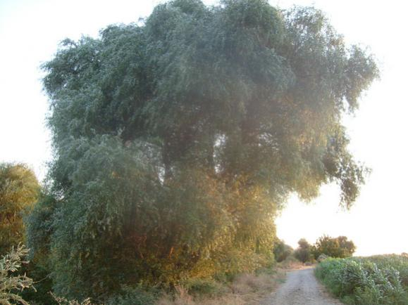
The willows are deciduous trees and shrubs in the genus Salix, part of the willow family Salicaceae.
The leaves are deciduous, often elongate but round to oval in a few species, and with a serrated margin. Willows are dioecious with male and female flowers appearing as catkins on different plants; the catkins are produced early in the spring, often before the leaves or as the new leaves open. The fruit is a small capsule containing numerous tiny (0.1 mm) seeds embedded in white down, which assists wind dispersal of the seeds.
Willows are very cross-fertile and numerous hybrids are known, both naturally occurring and in cultivation.

Karaağaç - Ulmus
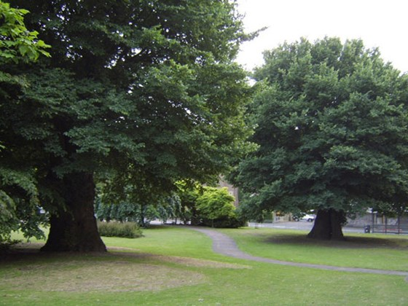
Overview: mature trees grow to 30m and can live for more than 100 years. The bark is grey brown, rough and fissured, often with suckers growing from the base of the trunk. The twigs are finely hairy. Buds are oval, pointed and hairy.
Leaves: smaller than those of the wych elm at 4–9cm in length. They are round to oval, toothed with a rough, hairy surface. They have a characteristic asymmetrical base and taper to a sudden point at the top.
Flowers: English elms are hermaphrodites, meaning both male and female reproductive parts are contained within the same flower. Flowers are dark pink to red and hang in tassels, appearing in February and March.
Fruits: once pollinated by wind, the flowers develop into tiny winged fruits, known as samaras. These are dispersed by wind.
Many birds eat elm seeds and the leaves provide food for the caterpillars of many moths, including the peppered, light emerald and white spotted pinion moths.

Defne - Laurus
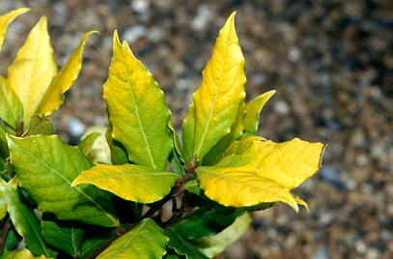
- Family: Lauraceae
- Trees of Genus Laurus are dioecious evergreen or large shrubs, with leathery aromatic leaves and small yellow flowers followed on female plants by black berries.
- Details. 'Aurea' is a large evergreen shrub of broadly conical habit with leathery, aromatic, golden-yellow leaves, brightest in winter and spring, and dense clusters of small, greenish-yellow male flowers in spring.

Çınar – Platanus
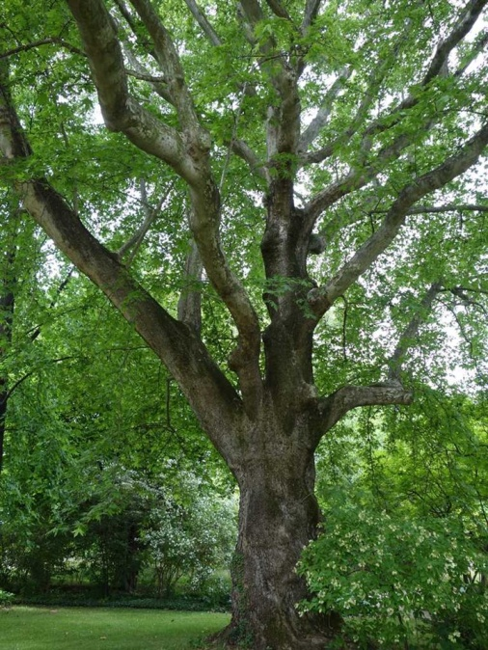
Platanus orientalis, commonly called Oriental plane tree or oriental sycamore, is a deciduous, usually single-trunk tree with distinctive, flaky, brown-gray-cream bark, large maple-like leaves and spherical fruiting balls that persist into winter. The creamy bark on mature trees facilitates identification from great distances. It is generally regarded to be the most massive shade tree indigenous to the area of its native range extending from southeastern Europe into western Asia. It typically grows to 60-80' (less frequently to 120’) tall with horizontal branching and a rounded habit. Large, dark green leaves (4-10” wide) with 5-7 palmate lobes have coarse marginal teeth. In fall, foliage typically turns an undistinguished yellow-brown. Small, non-showy, monoecious flowers appear in small rounded clusters in April. Female flowers give way to bristly, long-stalked, spherical fruiting balls (to 1 3/8” diameter) that ripen to brown in October and persist into early winter. Fruiting balls typically appear in groups of 3-6.

Dut - Morus
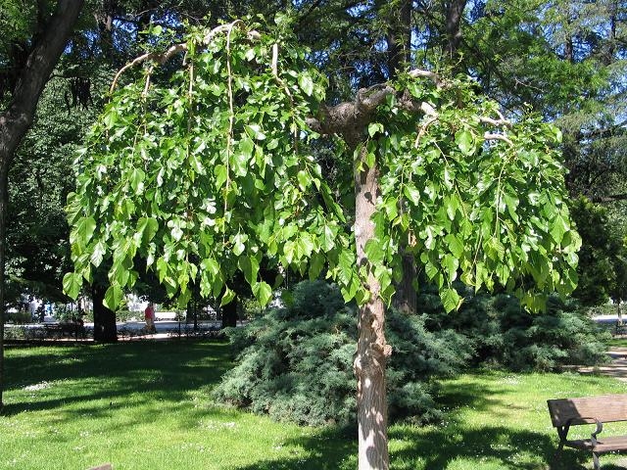
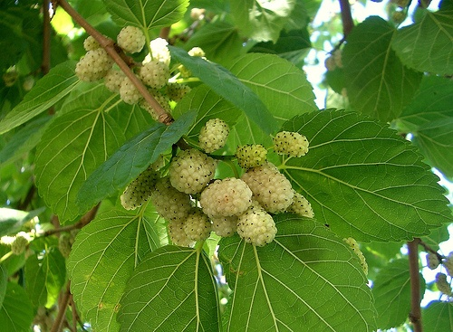
Morus, a genus of flowering plants in the family Moraceae, comprises 10–16 species of deciduous trees commonly known as mulberries, growing wild.

Böğürtlen - Rubus
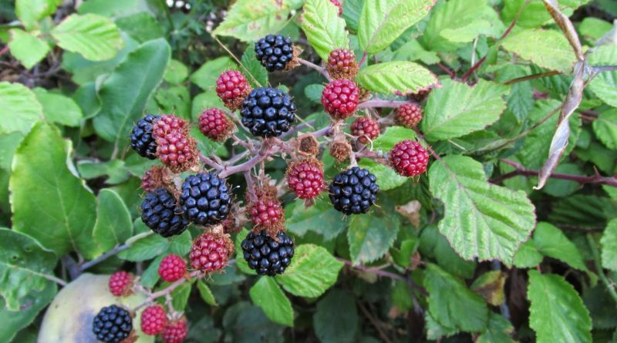
Rubus is a large and diverse genus of the Rosaceae subfamily Rosoideae. Main crops of Rubus include red raspberry (Rubus idaeus), black raspberry (Rubus occidentalis) and blackberry (Rubus spp.) Black raspberries are also known as black caps. The subgenus Idaeobatus contains red raspberry and black raspberry, two diploid species (2n = 14) with a haploid number 7 and a genome size of 240 Mb.

Ebegümeci - Malva sylvestris
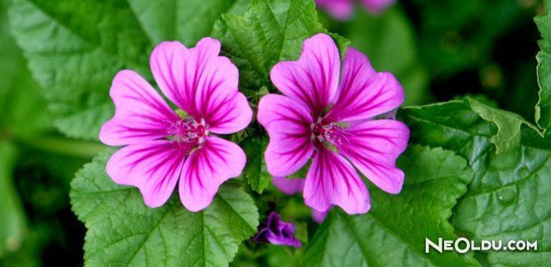
Malva sylvestris has an importance on the creation of the humus soil and recovery of the soil besides being the food of many species. They grow bushy in the rainy and cool seasons. Snails and insects live in the bushy branches of it. It dries and rots in the soil which makes the soil more fertile.

Sarmaşık – Hedera helix hibernica
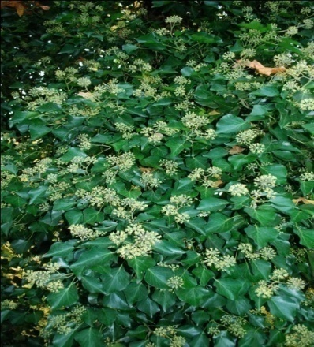
English ivy is an evergreen climbing vine in the Araliaceae (Ginseng) family. It has historically been a common garden ornamental and has more than 400 cultivars. It has escaped cultivation to become highly invasive in forests and natural areas. These plants are characterized by long viny stems reaching up to 30 m in length, with aerial, clinging small roots. covers trees making them more susceptible to wind fall due to the additional weight of the ivy in the trees as well as the additional drag of the evergreen leafy vines.

Zakkum – Nerium oleander
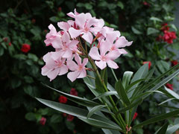
Nerium oleander is an evergreen Shrub growing to 4 m (13 ft) by 4 m (13 ft) at a fast rate.
It is in leaf all year, in flower from June to October.
Suitable for: medium (loamy) and heavy (clay) soils, prefers well-drained soil and can grow in heavy clay soil. Suitable pH: acid, neutral and basic (alkaline) soils. It cannot grow in the shade. It prefers dry or moist soil and can tolerate drought. The whole plant is very poisonous. Skin contact with the plant can cause irritation whilst ingestion of only one leaf has led to death in children.
Isirgan – Urtica
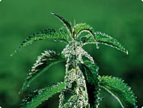
The elongated, egg-shaped leaves are heart-shaped or rounded at the juncture between stem and leaf; the edges are roughly serrated and the leaves are arranged alternately along the stem. The plant flowers from July to September.
The stinging nettle is a widespread plant; it can be found all over the world in temperate regions. It is a ruderal plant, which means that it often grows on waste ground or contaminated areas. As a nitratophile plant, it grows close to human dwellings, flourishing in particular on soil which has been fertilized or contaminated either by human or animal excrement. It is harder to find the plant in unspoilt or untouched areas of the countryside.
The nettle is regarded as a very good source of iron; on account of its ability to regulate the iron content in the soil it has a positive influence on all plants that grow in the same area - iron being a prerequisite for the formation of chlorophyll needed by all plants. The nettle is a light-sensitive plant; photosynthesis enables it to exist in very different light conditions.

Kuzukulağı - Rumex acetosella
Rumex acetosella is a dioecious, herbaceous perennial with creeping rhizomes. This plant measures 10-40 cm (4-16 in.) in height and the roots can reach depths of 1.5 m (5 ft.). The stems of this plant are slender and reddish in color. All the leaves have an ocrea at their base which is a thin, membranous sheath that surrounds the stem where the petiole meets it. The flowering stalks of these plants can be half as long as the plant. The flowers appear from late May to June. The shiny, golden brown achenes of this plant are 3-angled and measure around 1.5 mm (0.06 in.) in length. The plant fruits from June to October.
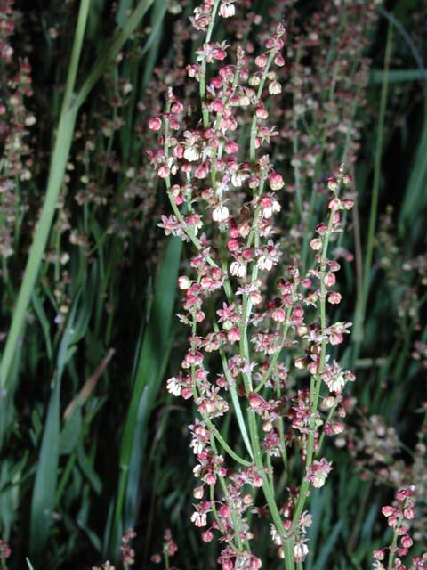

Menekşe - Viola
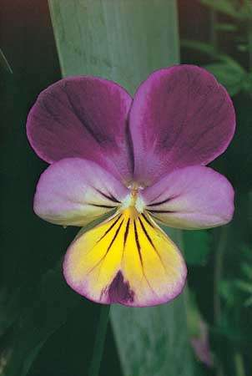
Viola is genus of about 500 species of herbs or low shrubs, including the small, solid-colored violets and the larger-flowered, often multicolored violas and pansies. Viola occurs naturally worldwide but is found most abundantly in temperate climates. The flower, variable in color, but not red, usually grows singly on a stalk and has five petals. Typically, Viola grows in meadows or damp woods. All wild species bloom early in the spring, but some cultivated varieties bloom later. Many species have two types of flowers. One type is showy and appears in the spring but often does not produce seeds in some species.
Karanfil - Dianthus petraeus
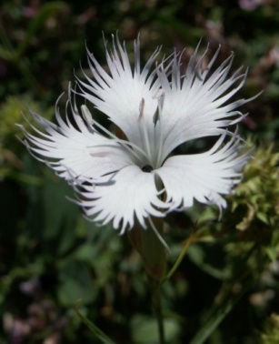
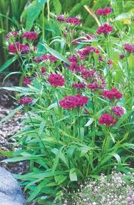
Intricate, frilly and powerfully fragrant the pure white flowers of this species pink are a delight. Forming tight colonies of fine deep green foliage it spreads slowly to form a clump up to 1' wide. Flowers appear from late May to July on wiry stems to 10" tall. Pure white snowflakes powerfully scented of cloves they make wonderful small cut flowers.

Lale - Tulipa
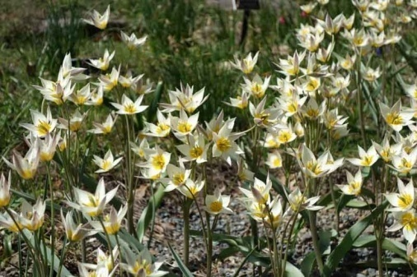
Named of its place of origin, Turkey, award-winning tulip is a wild looking species with gray-green leaves, and up to 12 star shaped white flowers born on 10 inch (25 cm) stem. It performs best in full sun to light shade, in rich, fertile, medium moisture, well-drained soil.

