CROATIAN RECIPES

OCTOPUS SALAD
Ingredients:
2.5 kg medium or large octopus – cleaned
1.5 kg boiled potatoes
1 large onion, finely sliced
2 cloves of garlic, finely sliced
Extra virgin olive oil
Parsley, finely chopped
Bay leaves
Salt and pepper
Wine cork

Instructions:
In a large pot cover generously with water the octopus and bay leaves. Add salt and pepper and the wine cork to the water and bring to the boil.
Reduce the heat and simmer until tender (around 20 minutes or so).
In another pot boil the potatoes. Once they are done cut them into small cubes.
Drain the octopus and clean the head. Cut the meat of the octopus into small pieces.
Add the potatoes with the octopus and finely chop an onion, garlic and add.
Dress the salad with extra virgin olive oil, salt, pepper and parsley

Photo taken from webpage: www.one-croatia.com
SHRIMP RISOTTO
400 grams of cleaned shrimp
1 diced onion
2 cloves of garlic – diced
100 ml white wine
1 tbs chopped parsley
3 cups of rice
Extra virgin olive oil
Butter
Salt and pepper

Instructions:
Put olive oil in saucepan and add diced onion over medium heat.
Add garlic after a couple of minutes
Add rice and mix it all around
Start adding the seafood stock; as the stock is absorbed by the rice keep adding more stock and continue to stir
Add cleaned shrimps after a couple of minutes – do not overcook them
Add butter and let it sit for a few minutes
Add parsley

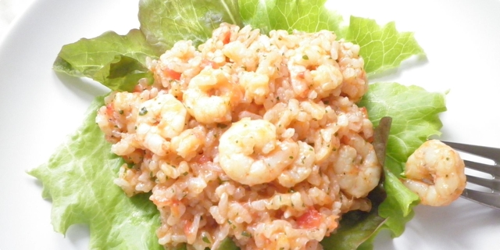
Photo taken from www.coolinarka.com

