Truta à moda de Coura (Trout Coura Style)
Ingredients:
-1 Trout
-1 Lemon
-Corn Flour
-Salt
-Black Pepper
-Oil

For the sauce:
-10 g of butter
-20 g of chourizo
-1 garlic clove
-1 teaspoon of vinegar
-salt
-black Pepper

Preparation:
Wash the trout well (without scaling). Then remove the guts and put the chorizo in the middle of the trout, seasoning with salt and pepper. Rest for an hour. Cover the trout with the cornmeal and fry it in hot oil. Put on a platter and accompany with boiled potatoes.
Sauce:
Put a frying pan over the heat with butter, the clove of chopped garlic. Let it fry lightly and add the vinegar, salt and pepper to taste.

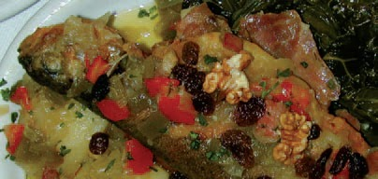

Bacalhau à Miquelina (Codfish Miquelina Style)
Ingredients:
-0.5 kg of cod
-0.5 kg of potatoes
-800 g of green peppers
-4 medium onions
-2 cloves of garlic
-2 eggs
-2 dl of milk
-1 table spoon of butter
-2 table spoons of olive oil
-grated cheese
-salt
-pepper

Preparation:
Bake the cod fish in a pan with water (after soaking).
After boiling, remove the skin and pimples and cut into small pieces.
Fry the potatoes in sticks.
On the stove in a low heat or on an electric grill the peppers until they have a slightly burnt cover.
When they are baked, place the peppers in a bowl of cold water.
Take off the cover and clean the peppers and finally cut in thin strips.
In a large pot chop the onions and garlic and take to the fire with olive oil stirring always.
Add the strips of peppers and let it boil a little.
In a pyrex, spread in the bottom the previous sauce, and on top the chips and the cod fish (If necessary add a little more olive oil).
Aside, in a cup, the eggs are beaten with the milk, salt and pepper and put it on the pyrex, adding bits of butter, grated cheese and bread crumbs.
Take to the oven and as soon as it gains color, serve.
