TAJEDDRA
Tajeddra is a typical dish of the Salento tradition that combines rice, mussels and vegetables. Tajeddra was the name used for the terracotta high edge handicraft pan .

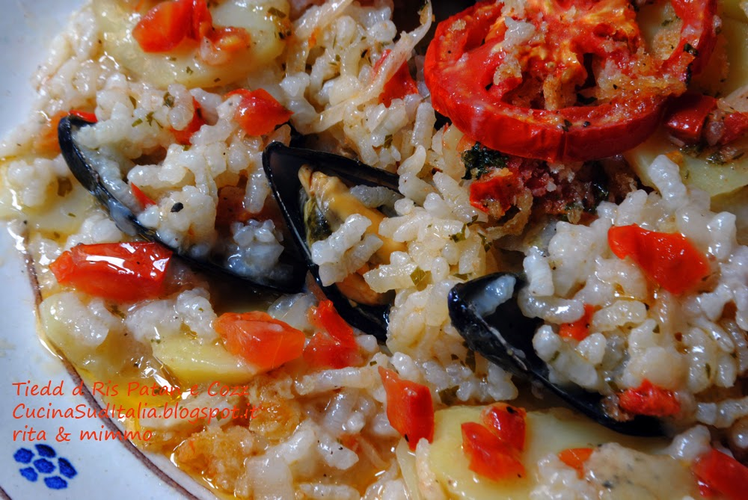

INGREDIENTS FOR FOUR SERVINGS

1 kg of mussels
150 g of rice
600 g of potatoes
300 g of tomatoes
200 g of zucchini (optional)
An average onion
Two cloves of garlic
Parsley
Oregan
50 g of grated pecorino cheese
Olive oil
salt
pepper
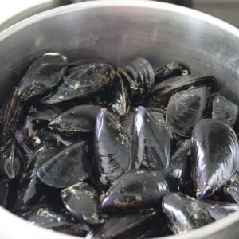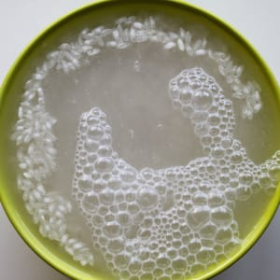
Clean the mussels and put them to cook to make them open.
Once opened, collect the water to use it later.
di Prezzemolo - una manciata Pecorino g
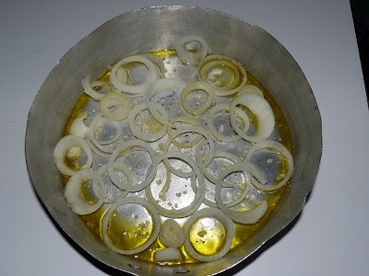 Oil a baking dish and arrange thin slices of onion

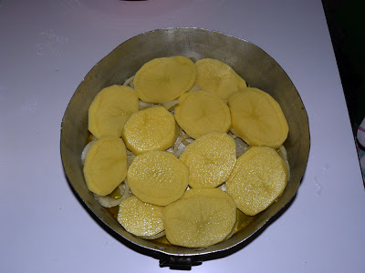 Add the potatoes cut thinly and lightly salted

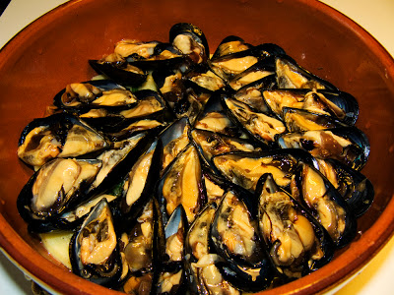Spread the mussels with the valve on the potatoes, add chopped parsley with garlic, oregano, slices of tomatoes and season with oil and pepper.

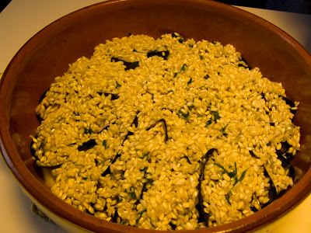
Cover the mussels with lightly salted raw rice and add a little cheese and oil.

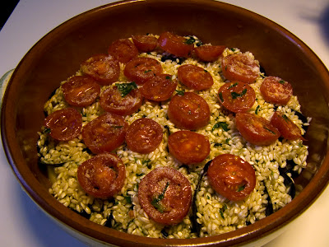 Add slices of tomato
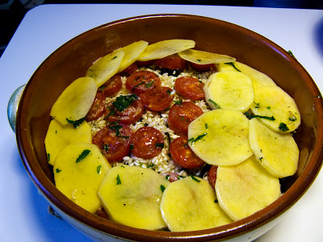 Cover with a layer of lightly salted potatoes
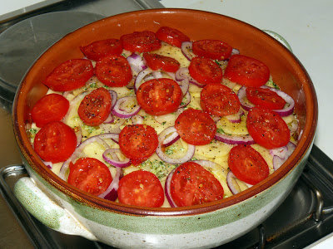
Complete with tomato and onion. Sprinkle the surface with breadcrumbs mixed with cheese and pepper and season with oil.
Finally add the filtered mussels water and put aside, until you reach the last layer of potatoes, to allow the rice to cook.
Usually the zucchini is added to the potatoes.
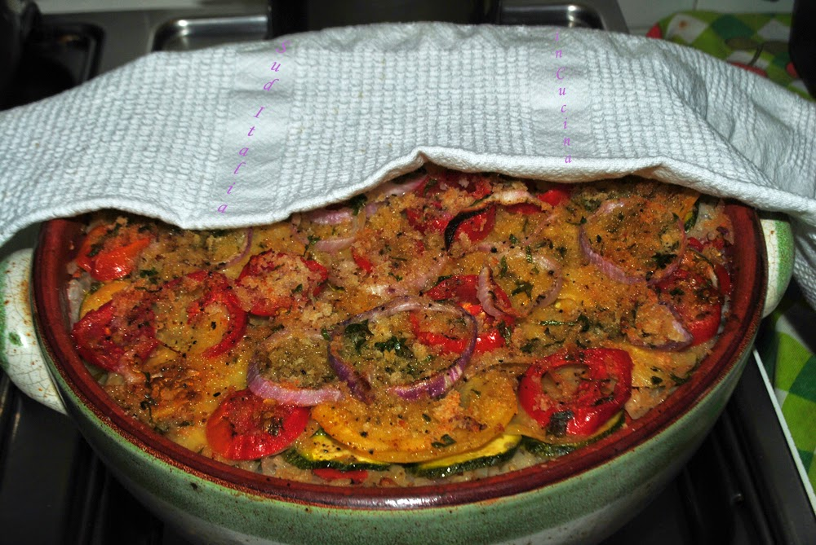
Bake at 200 ° C for 45-60 minutes.
Serve lukewarm

