‘Water unites us’ project is funded by European Comission in the framework of Erasmus+ Cooperation and Innovation for Good Practices.




The Most Common Flora of the
Nature Reserve Melnais Lake Mire

Olaines 1.vidusskola 2018

The swamp is the upper part or plot of the ground which has some typical features:
- Periodical wetness;
- Specific flora;
- Accumulation of peat moss.
Peat is more or less decomposed plant (humus) material that has accumulated in a water-satured environment aand in the absence of oxygen.

The swamp can be formed in two ways:
- It forms where water collects on, near the surface of the soil, and it does not drain
away and dry out.
- It forms overgrowing the water body.

Swamps occupy 10 % of the territory of Latvia but only 4.9 % are undamaged swamp areas.

Swamps have a number of wildlife species that have specifically adapted to living in them.

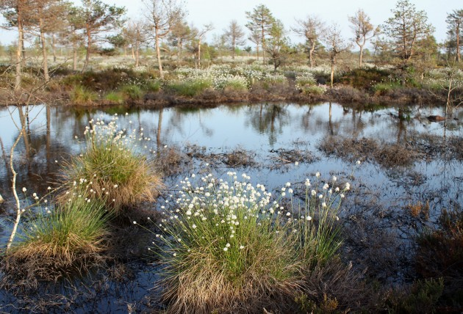

Established - 2004
Total area 317 ha
It is especially protected nature area in Latvia – nature reserve.
Included in European network of protected territories Natura 2000.
Location - Olaine Municipality of the Olaine District.
The mire has started to develop 5000–6000 years ago.
Maximum thickness of peat layer 5 m.
The main nature values:
- Raised bog with hummock-bog pool complex (36 %)
- Dystrophic lakes (6 %)
- Permanent shallow lakes that have developed in place of the previous peat fields and are important for birds (12 %)
- In total,17 especially protected bird species
- Especially protected habitats (84 %)

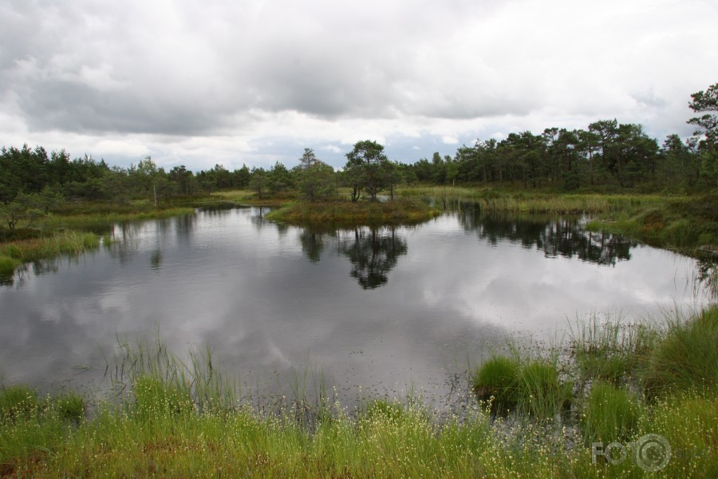

MIReS Melnais Lake Mire has preserved as a small nature ‘oasis’ within an intensively managed area. Most probably, the small territory around the lake remained intact among the vast fields of peat extraction due to its richness in water and many pools. Approximately 60 % of the territory is covered with 3 especially protected mire habitats of European importance that bear the human influence to the diff erent extent:

Intact raised bog occupies 35 % of the nature reserve. Vegetation characteristic of the raised bogs dominates in the part that is less influenced by melioration. Despite various negative influences, the mire is rich in water in some parts, and several lakes and pools occur there.
Transition mire and quacking bogs have developed in small areas near lakes and pools. In places, this habitat has developed due to the lowering of water level of the lakes; as a result the lake has filled-in with Sphagnum mosses and sedges.
Degraded raised bogs, where natural regeneration is possible or takes place covers 25 % of the territory of the nature reserve. Due to drainage, the mire has become dry and fi re-hazardous – several fires have occurred in the territory, degrading the vegetation furthermore. In many European states almost no intact mires have remained. With the help of special management activities, the influence of drainage can be diminished and restoration of the mire favoured, therefore this habitat is especially protected in the European Union.

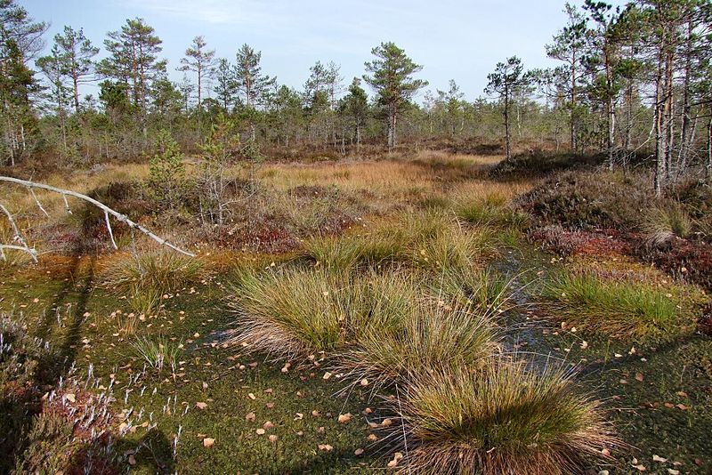

The flora of the swamps is very specific – species, which are fully adapted to the wet habitat, grow here mostly. There are no special rarities in the flora. Sphagnum species make a dense moss cover and dominate in the vegetation of the swamps. The presence of Sphagnum moss is the main characteristic feature of raised bogs. When the lower parts of Sphagnum species decay, peat develops. And, while peat is developing, the mire is ‘alive’ and the layer of peat grows.

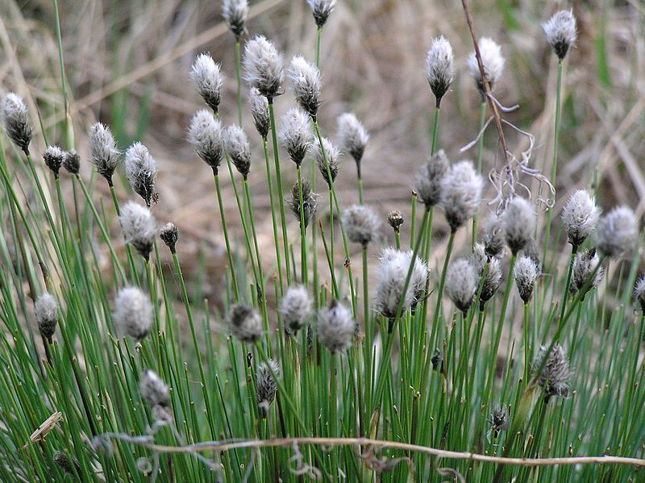
Tussock cottengrass

It is a species of perennial herbaceous flowering plant in the sedge family Cyperaceae. It is native to bogs and other acidic wetlands. It is a 30–60 cm high tussock-forming plant with erect solitary spikelets.

Brown bog sedge

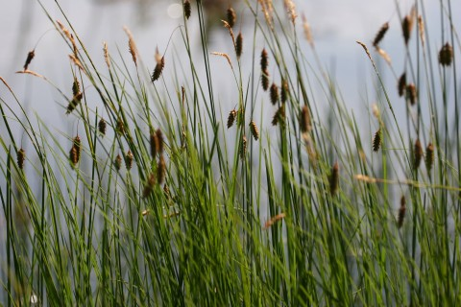

A widespread sedge with circumboreal distribution, brown bog sedge occurs in wet, often calcareours sites. This plant gets its specific epithet – Buxbaumii from Johann Christian Buxbaum (1693 – 1730), a German botanist who collected them in Greece, Middle East and Russia.

Scottish heather

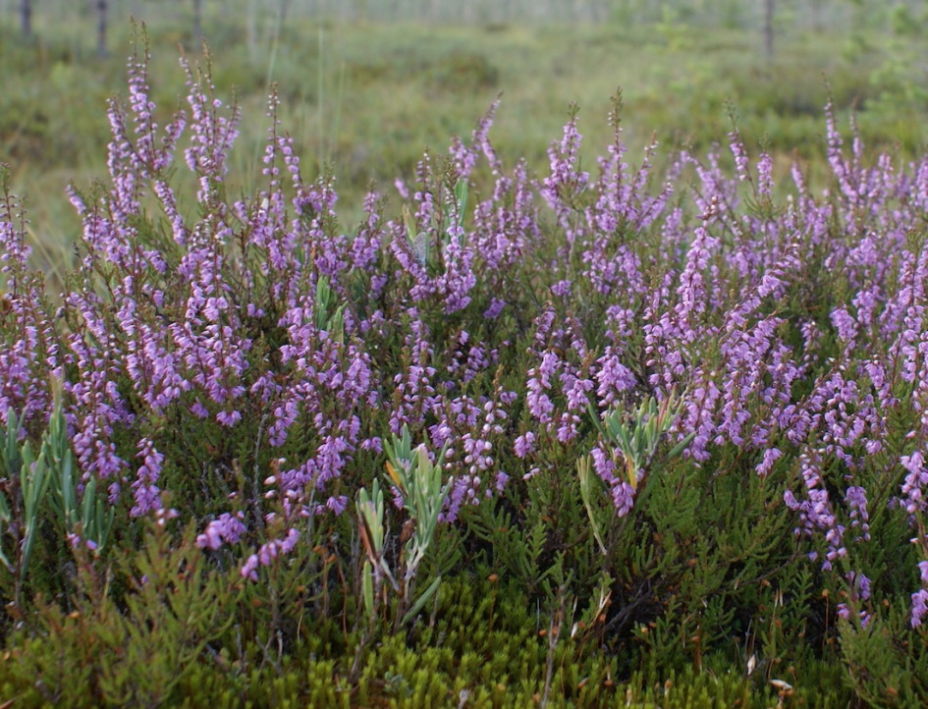

It is a low-growing perennial shrub growing to 20 to 50 centimetres tall, rarely to 1 metre and taller. It is found widely on acidic soils in open sunny situations and in moderate shade. It is the dominant plant in most heathland, moorland and in some bog vegetation and acidic pine and oak woodland.

Marsh labrador tea
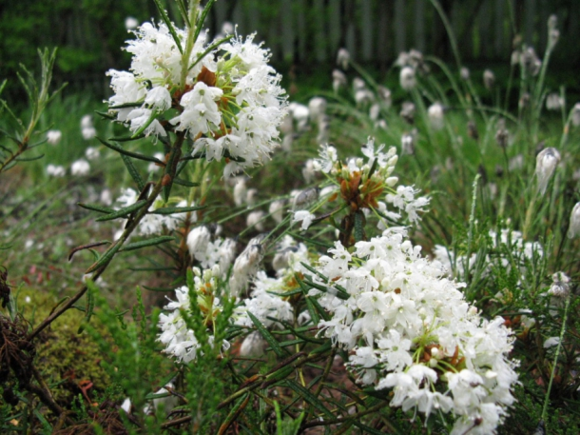

It is a low shrub growing to 50 cm, rarely up to 120 cm tall with evergreen leaves 12–50 mm long and 2–12 mm broad. The flowers are small, with a five-lobed white corolla, and produced several together in a corymb 3–5 cm diameter. They emit strong smell to attract bees and other pollinating insects. It grows in peaty soils, shrubby areas, moss.

Cattail
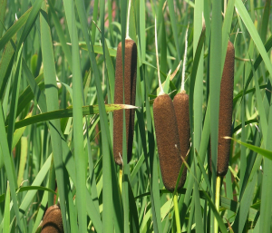
It grows in open wet areas, wet thickets, swamps, ditches, and moist fields. It has a brown cigar-shaped head that stands atop a very long, stout stalk. Young shoots first emerge in spring and once fertilized, the female flowers transform into the familiar brown "cigars" also called candlewicks that consist of thousands of tiny developing seeds.

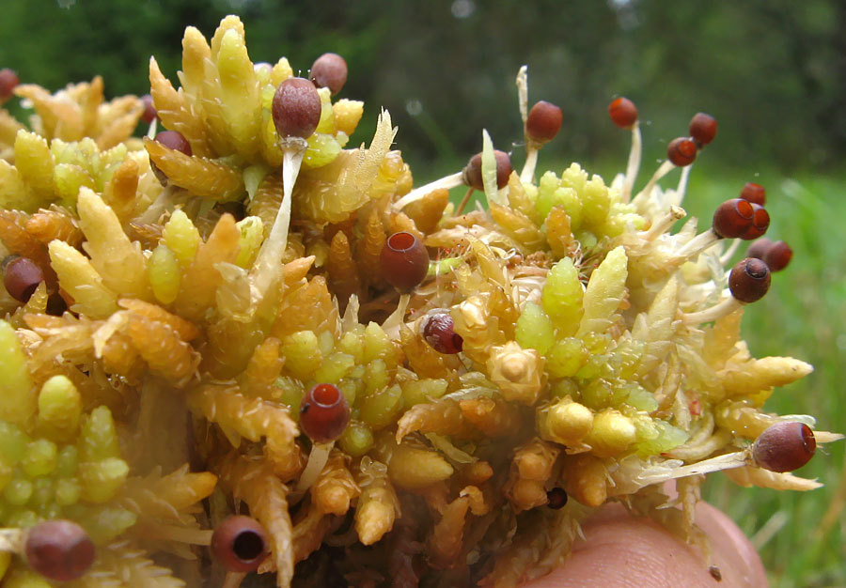
Sphagnum

Sphagnum is a genus of approximately 380 accepted species of mosses, commonly known as "peat moss". Accumulations of Sphagnum can store water, since both living and dead plants can hold large quantities of water inside their cells. Plants may hold 16–26 times as much water as their dry weight, depending on the species.The empty cells help retain water in drier conditions.

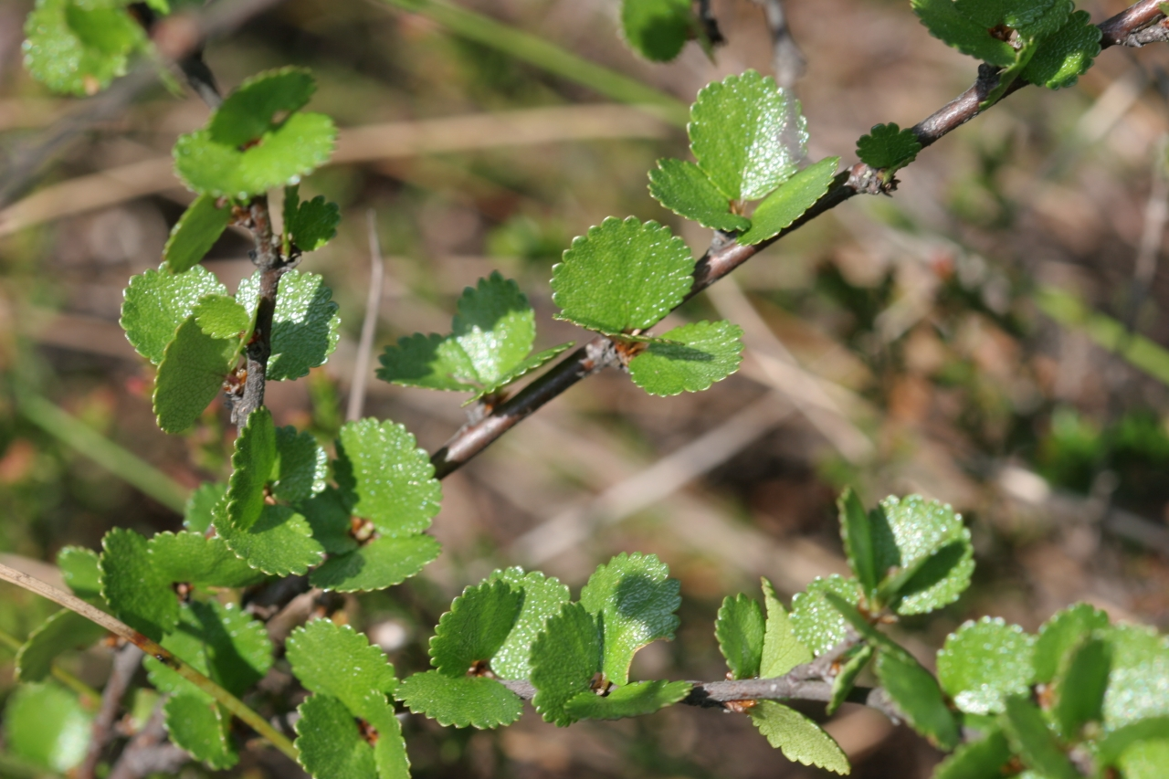
Dwarf birch tree

Dwarf birch tree is found on boggy sites. It is up to 1–1.2 m high. Dwarf birch tree has got rounded leaves, these tress are food sources for birds and grazing animals.
Especially protected Flora in Latvia.

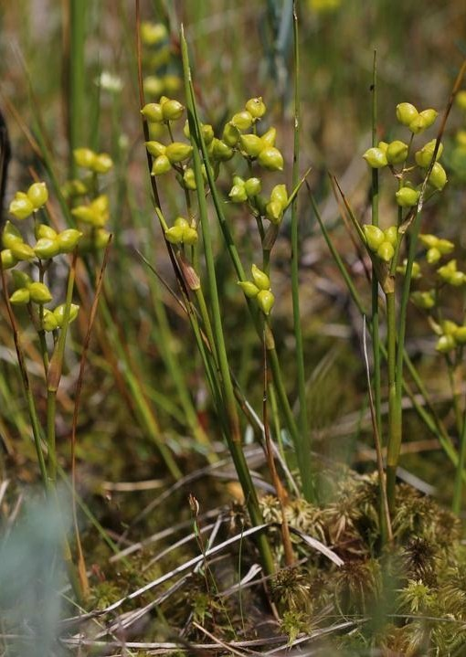
Rannoch-rush Scheuchzeria palustris has totally adjusted to the wet conditions and can be found nowhere else but in mires. It is easier to notice it in the second half of summer, when the small, green fruits can be seen in the wet hollows of the mire.

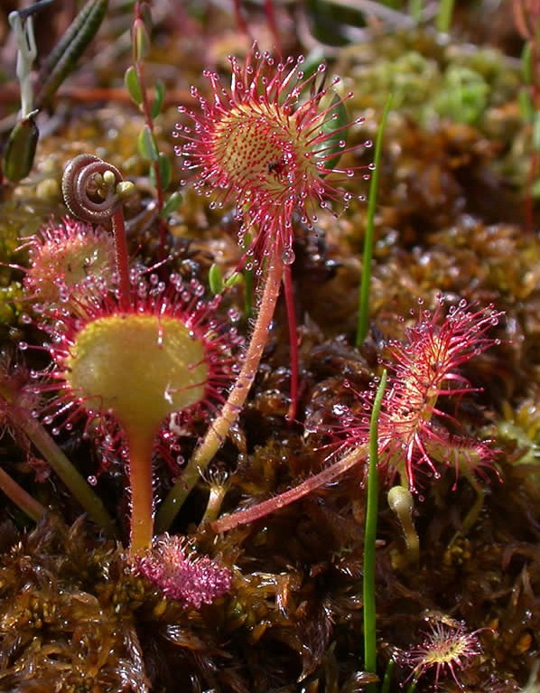
Round-leaved Sundew Drosera rotundifolia and Great Sundew D. anglica grow only in mires, especially in the wettest habitats. The small insectivorous plants root in Sphagnum moss; however, due to poor nutrition in the mire, sundew feeds from the insects caught with its leaves as well.

Lingonberries
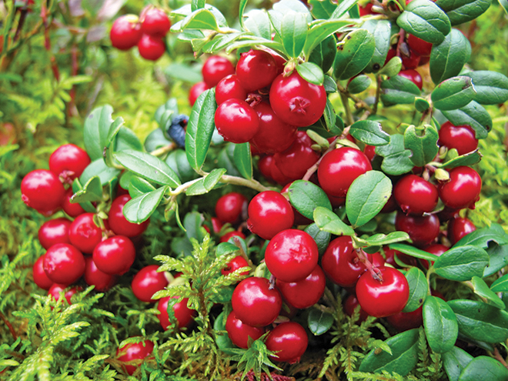

Lingonberries grow on low dark evergreen shrubs and it spreads by underground stems. The leaves are 5–30 mm long and dark green. The plant is similar to the bilberries but with darker and shinier leaves. The plant can withstand temperatures down below -35°C.
Lingonberries contain flavonoids and lignans which both are said to prevent cancer. The berries also contain high levels of magnesium, vitamin A, vitamin C and a fairly high level of fiber. It naturally contains benzoic acid which is commonly added as a preservative to many other fruit and berry products.
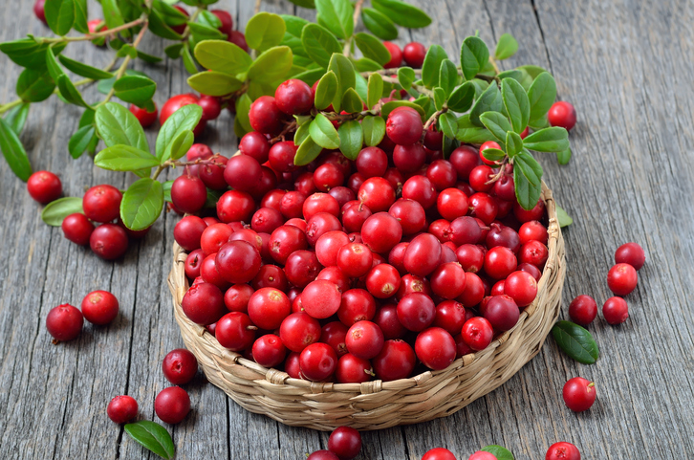

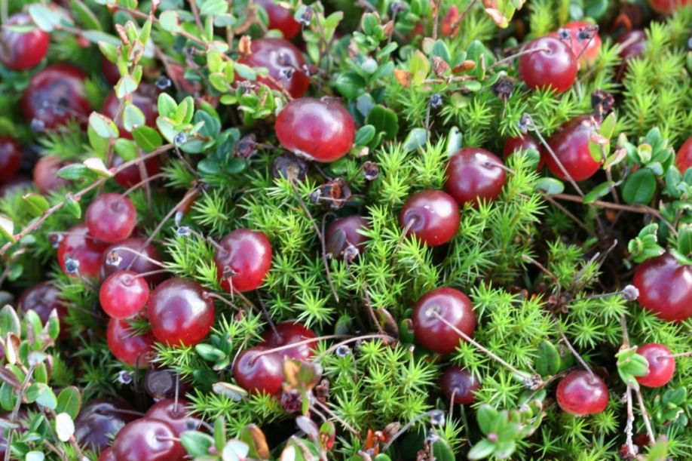
Cranberries

Cranberries are low, creeping shrubs or vines up to 2 meters long and 5 to 20 centimeters in height; they have slender, wiry stems that are not thickly woody and have small evergreen leaves. The flowers are dark pink, with very distinct reflexed petals, leaving the style and stamens fully exposed and pointing forward. They are pollinated by bees. The fruit is a berry that is larger than the leaves of the plant. It is initially light green, turning red when ripe. It is edible, but with an acidic taste that usually overwhelms its sweetness.
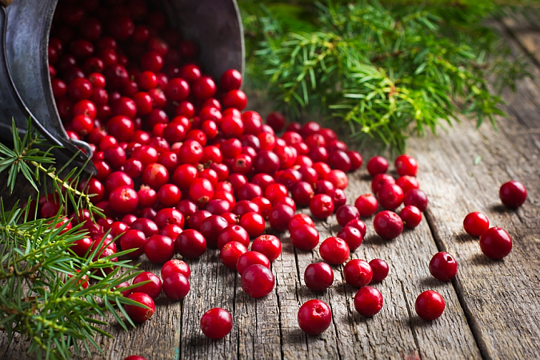
They are low in calories and high in vitamin C, vitamin A, and vitamin K.

