COURA RIVER
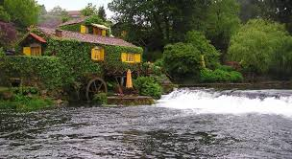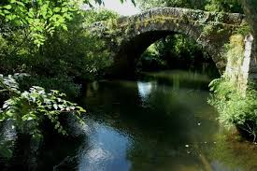
Length: 50 km
Source: Paredes de Coura
Mouth: Minho
Country: Portugal

Famous for its abundance of trout. It passes Paredes de Coura, Vilar de Mouros (remains of Celtic, Roman and Sueva civilizations) and flows into the River Minho.

Fauna
Water snake - "Water snake" is used as a descriptive term for any snakes that spend a significant time in or near fresh water.
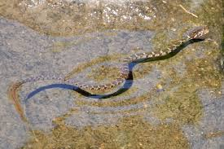
Iberian Frog - or rana patilarga (Rana iberica) is a species of frog found in Portugal and Spain. Its natural habitats are rivers, mountain streams and and swamps. 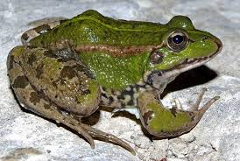
Trout - is the common name for a number of species of freshwater fish belonging to the genera Oncorhynchus, Salmo and Salvelinus, all of the subfamily Salmoninae of the family Salmonidae.
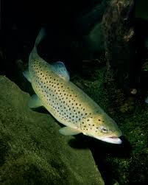
Boga – river fish.
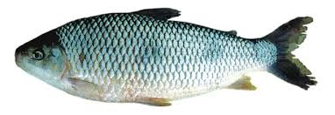

Royal Crane - of the family, the Gruidae, of large, long-legged, and long-necked birds in the group Gruiformes.
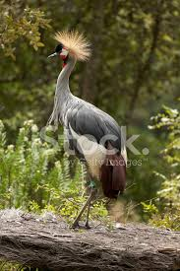
Kingfisher - or Alcedinidae are a family of small to medium-sized, brightly colored birds in the order Coraciiformes.
