SEAFOOD RECIPES FROM TURKEY

Tahin Soslu Levrek

(SEABASS WITH SUSAME SAUCE)

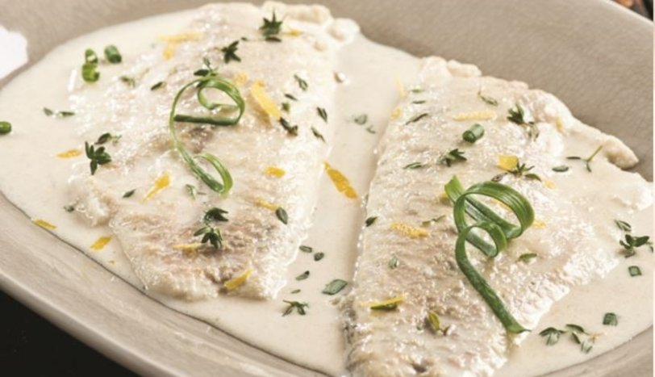

INGREDIENTS
2 filets of seabass without bones
2 soupspoons of susame oil
1/2 packet of cream,
1 teaglass/cup of milk
1 teaspoon grated lemon peel
salt, blackpepper
To serve: 1-2 branches of fresh onion (chopped )

HOW TO COOK

In a large pan, put the cream and milk. Cook for a short while and take it from the oven before it boils. Add susame oil, salt, blackpepper and grated lemon peel and stir the mixture. Then place the fillets of seabass into the mixture and cook it around 8-10 minutes at low heat. Serve it with the chopped onions on the top.

