LU PURPU ALLA PIGNATA
The “pignata octopus” is an ancient recipe from Salento whose name derives from the typical terracotta pot in which it was cooked, the pignata.
In “pignata octopus” the octopus cooks with its own water, and this is the main rule to follow for a perfect cooking.
Remember not to add more salt because the octopus is quite savory. The recipe for “pignata octopus” is very old and, as in all these cases, each family handed down its own version from generation.

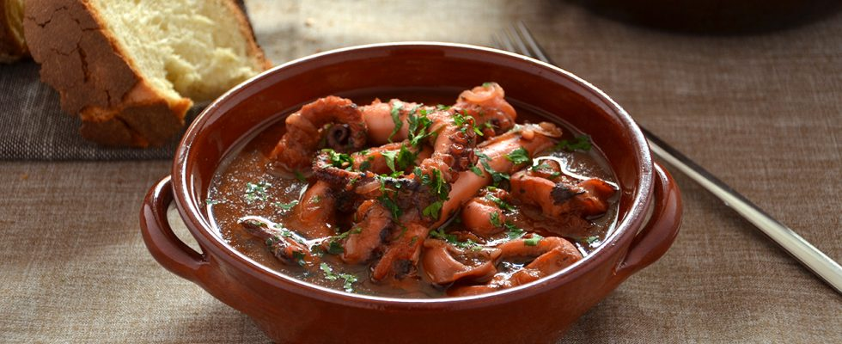

INGREDIENTS (4 servings)

• Octopus 1.2 kg
• Ripe tomatoes 400 g
• Onion 80 g
• Extra virgin olive oil
• Garlic
•Bay leaf to taste
• Chili Pepper
• Parsley
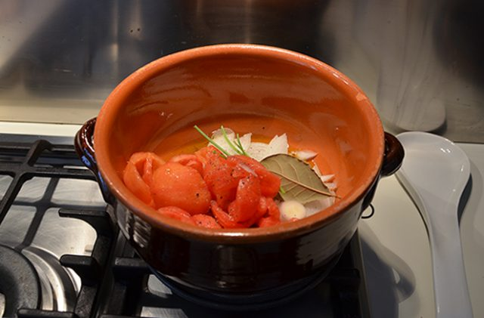
Wash the tomatoes and remove the peel and seeds (you can blanch them for a minute so as to eliminate it more easily), peel the onion and cut into thin slices, peel the garlic. Pour the oil into a terracotta pot and pour in the tomatoes, onion, garlic, chili pepper, bay leaf and parsley stalks.

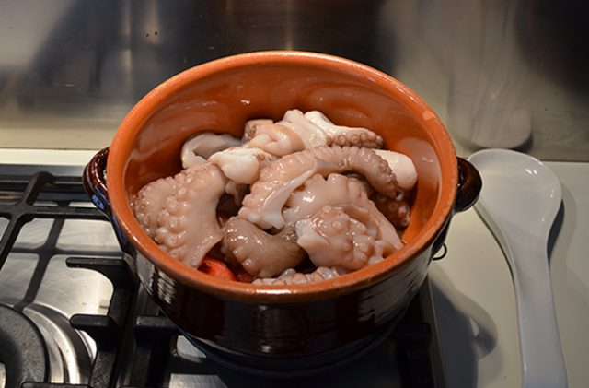
Add the octopus, clean and cut into little pieces.
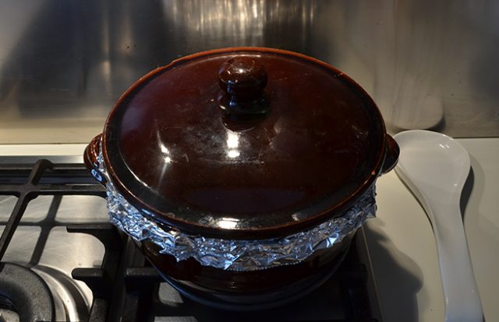

Place an aluminum foil on the pan and cover with the lid.
The aluminum will not allow heat and humidity to disperse during cooking.

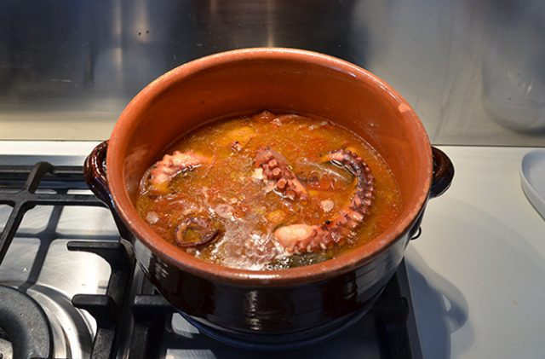
Cook in its own stock for about an hour and a half, then remove the lid and cook for another 30 minutes.
Serve the octopus with a handful of fresh minced parsley.

