SEAFOOD RECIPES FROM TURKEY

Hamsi Tava

(ANCHOVY IN PAN)

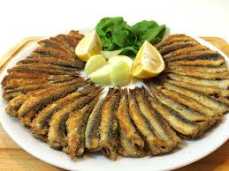
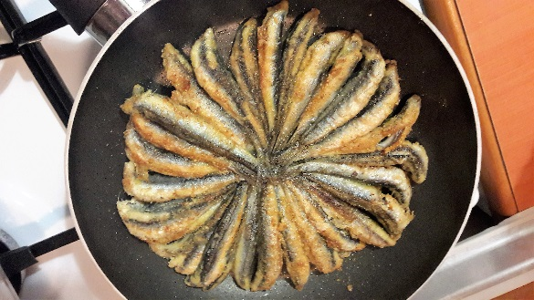

INGREDIENTS

ACHOVY

CORN FLOUR

OIL
SALT

HOW TO COOK

First, cut the head of the anchovies, take out the iner parts of them and wash them clearly. Then add some salt on them. Then, in a seperate bowl put some corn flour and put the anchovies in the corn flour, make sure that each anchovy is completely covered with the flour. After that, put little oil in a pan and place the pan on the oven. After the oil get hot enough, place the anchovies as in the picture and fry them until their bottom parts get fried, then turn all the anchovies at once with the help of a completely flat pot lid (There are special pans with lid for this in Turkey). Fry the other side of the anchovies and when they are done, serve it with lemon and onions. Bon apetite!!

