I The Phoney War

In 1929, still traumatized by the dreadful experiences of trench warfare, France began to build an eastern line of defence, the Maginot Line, named after the French Minister of War, André Maginot. It was a line of concrete fortifications, obstacles and weapon installations to stop an invasion by Germany, stretching from Nice in the south to Dunkirk in the north.
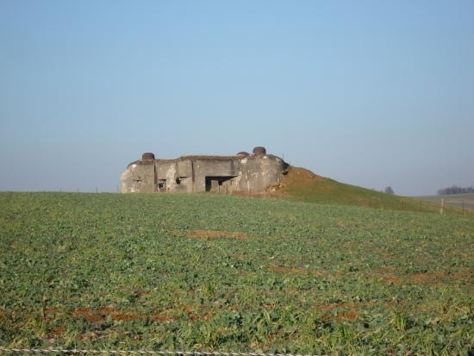
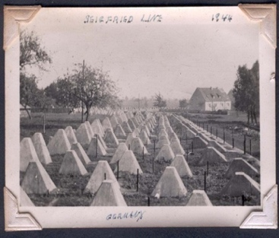
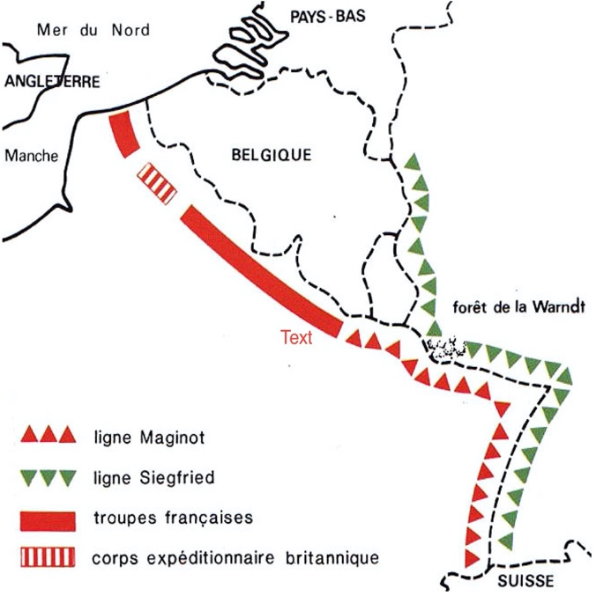
In the 1930ies the Germans also built a defensive line in the west against France and its allies opposite the French Maginot Line known as Siegfried Line or Westwall, which stretched for more than 630 kilometres from Kleve on the border with the Netherlands in the north along the western border down to the border with Switzerland in the south and featured more than 18,000 bunkers, tunnels and tank traps.
Then, on September 1st 1939, Hitler's troops invaded Poland so that its kin-states (protecting powers), France and the United Kingdom, declared war on Germany two days later.Then French and German troops faced each other along the Maginot and Siegfried line, waiting for the great battle. But apart from only one military land operation on the western front, when in September 1939 French troops invaded Germany's Saar district but were defeated by Wehrmacht troops on October 17th, nothing happened. The Siegfried line soldiers faced the Maginot line soldiers and none of the armies even intended to launch an attack for eight months. So the French called that calm period »drôle de guerre«, the British spoke of a »Bore War«, the Americans created the term »Phoney War« and for the Germans it was a »Sitzkrieg«.
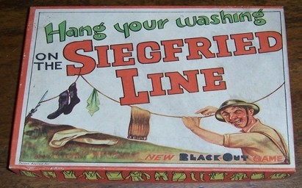
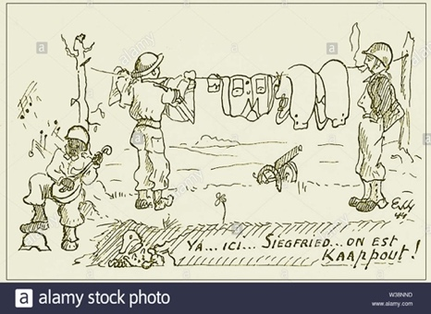

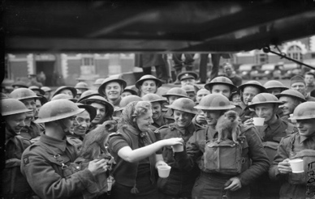

But away from the quiet and inactivity at this front the opponents of war were very active:

- On August 23rd, 1939 Hitler and Stalin signed the »Nichtangriffspakt« or »Hitler-Stalin Pakt« which enabled the German and Soviet invasion and division of Poland.
- On November 30th, 1939 the Soviet Union made an assault on Finland in Karelia.
- On April 10th, 1940 Germany started the invasion of Denmark and Norway to secure supplies of raw materials. Allied troops were landed but withdrawn in response to the German invasion of France.
- Minor dogfights between British and German fighter planes.
- The Royal Air Force (RAF) dropped propaganda leaflets on Germany.
- The first Canadian troops arrived in Britain.
- The Second Battle of the Atlantic was fought between British and German aircraft and battleships.

On May 10th, 1940 German troops marched into Belgium, the Netherlands and Luxemburg, marking the end of the Phoney War and the beginning of the Battle of France.

