Father’s Day 2020.
Implemetnig the project we started a nice tradition- to celebrate a Father’s Day in active competition between families.
It is a competition with a lot of positive emotions, activities and smiles!
1.Task
Kids say compliments about their dads, we make posters and create from them exhibiton. Fun support is very important in any competition.
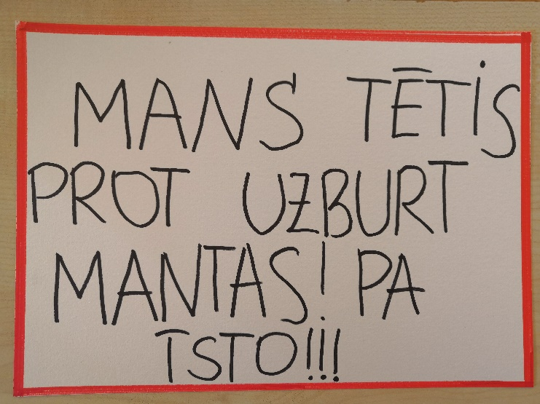
/My dad knows how to spell things! For real!!!/
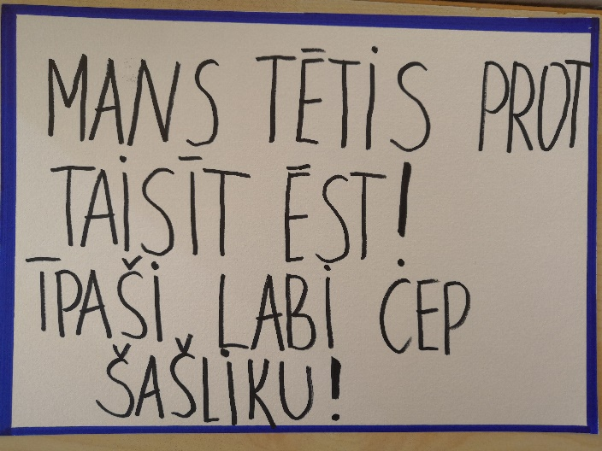
/My dad knows how to cook. Especially good he grill steak./
2.Task Kids draw dad portraits as a present for them. Kids inspire their dads for athletic victories!
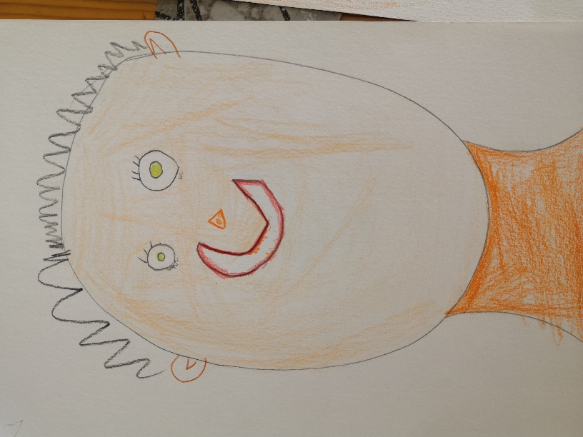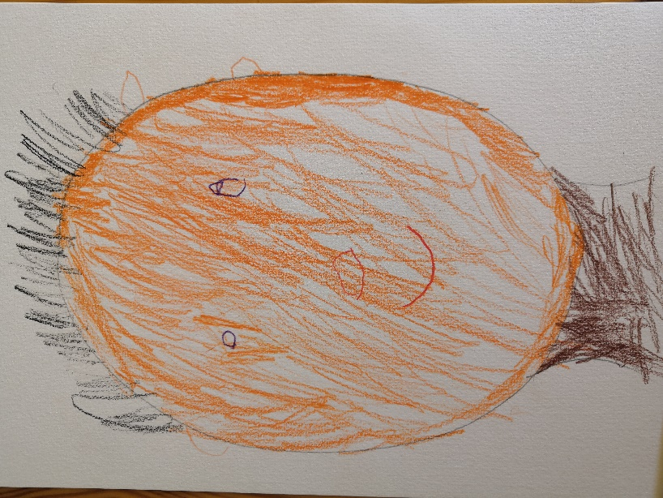
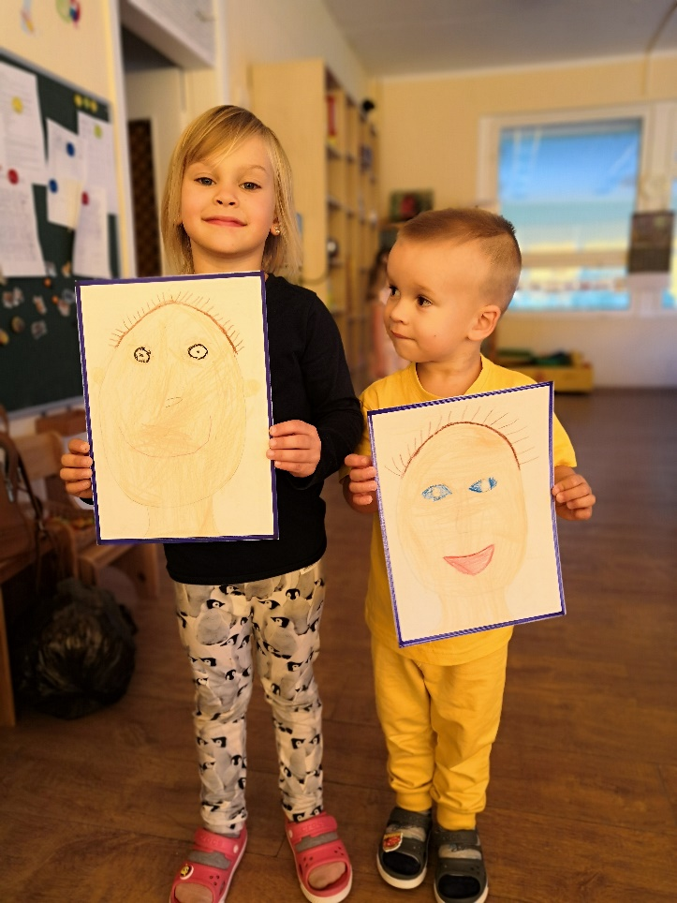

3.Task Create a medals for each participant of competition!

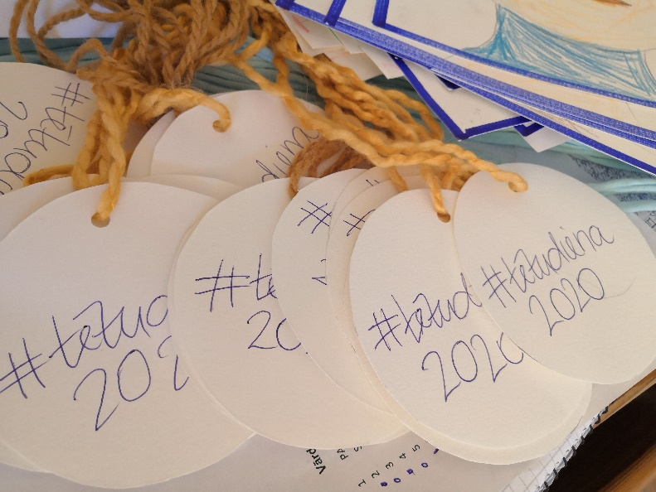
4. Task Family is a team. To successfully win the track you have to work together.

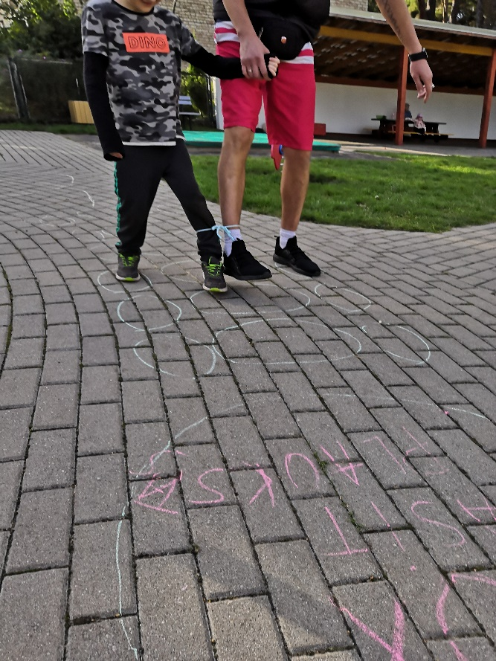
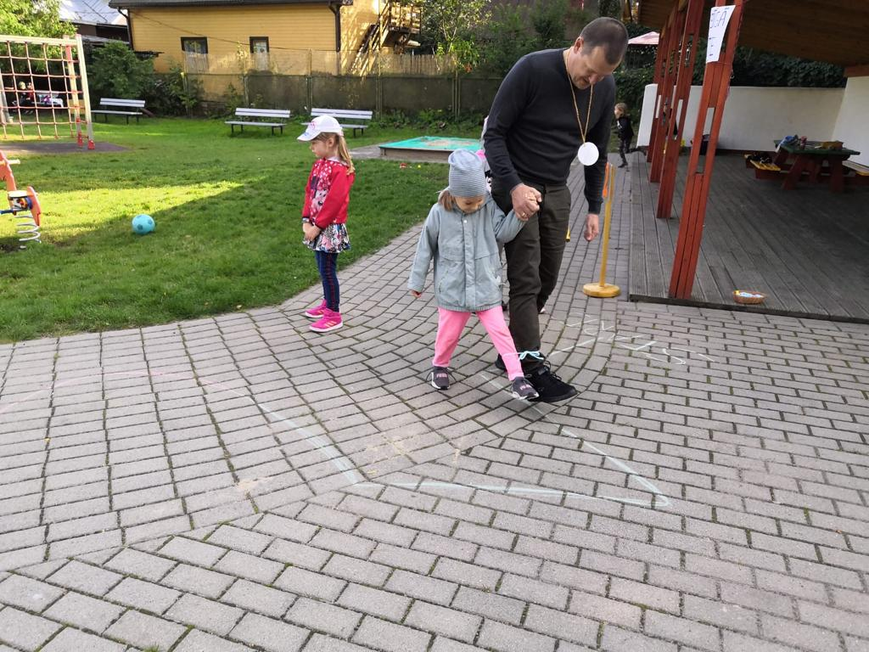
5.Task Another point of view! Put the kid on your shoulder and together win the race. Remember: safety first!
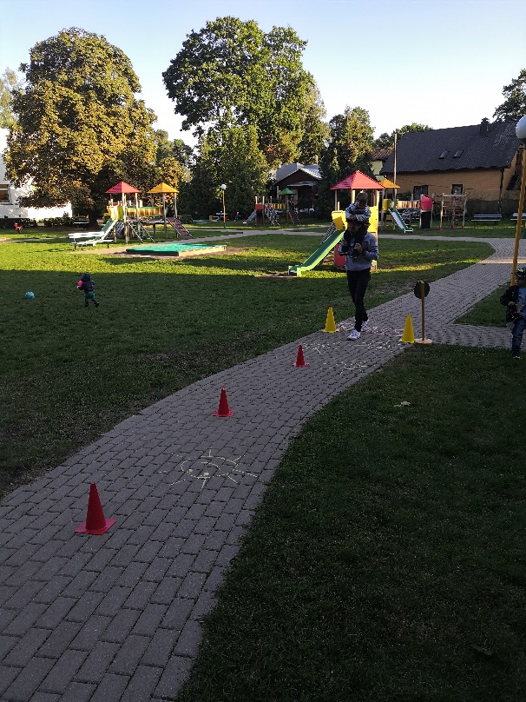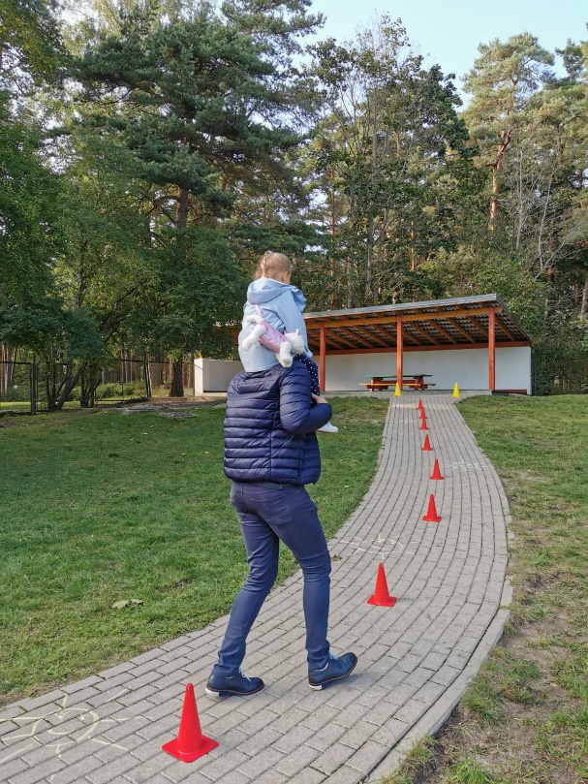

6.Task Funny dance. Every sporting event has a place for music an dancing. Let the rhythm of the music!
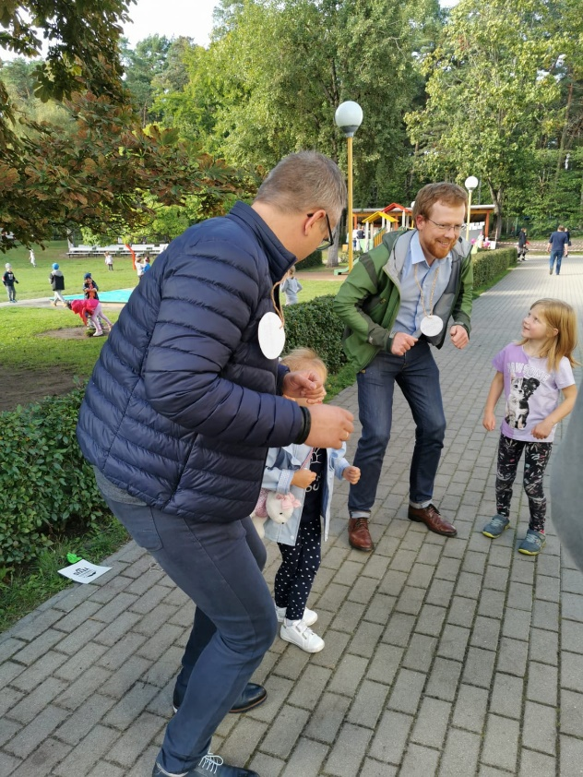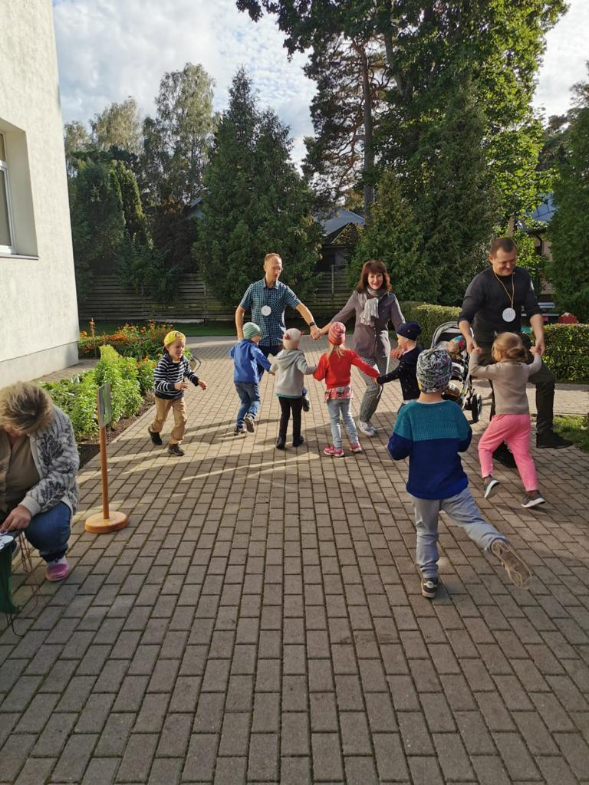

7.Task Bring joy to celebration, become a superhero in your child’s eyes and inflate the balloon for him.
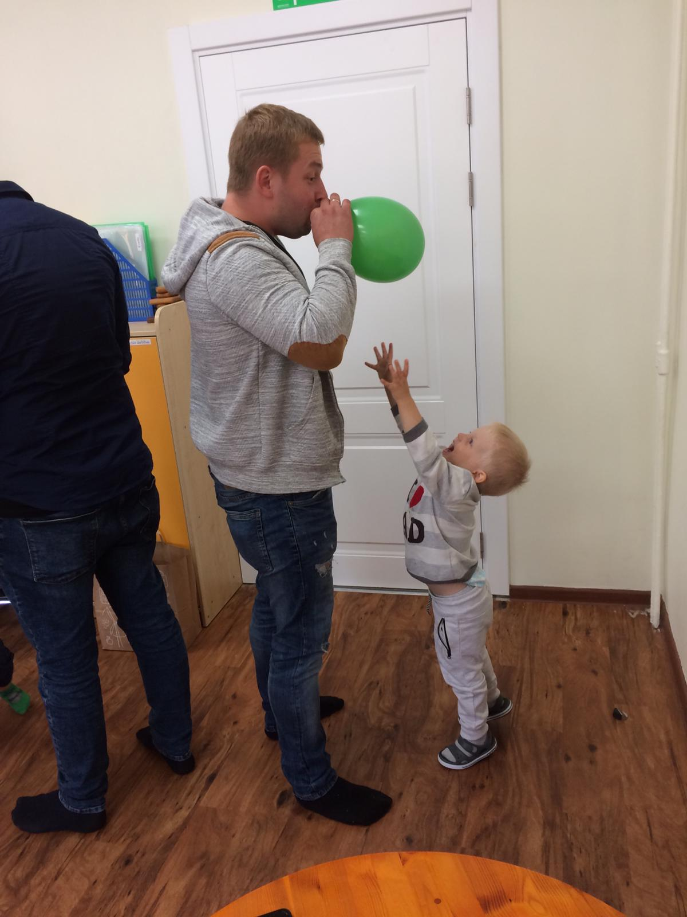

8.Task. Make delicious sandwiches with your child to regain strenght. Lots of fun and tasty meal guaranteed
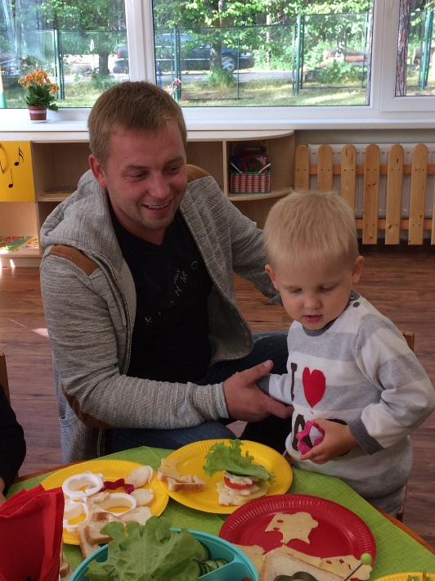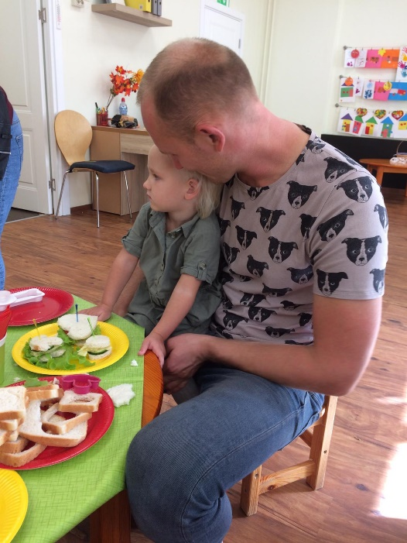
9.Task Just smile and be happy! Photographer will do the rest! Happy memories for family album!
