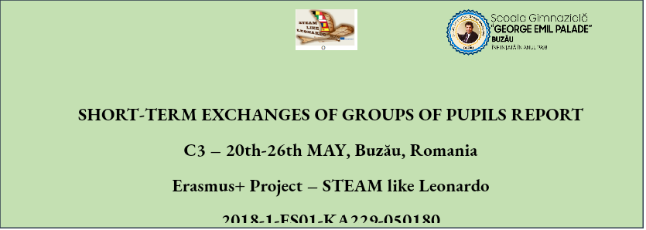

**The third mobility of the Erasmus+ project STEAM like Leonardo took place in Romania, between 20th-26th May, 2019, organized by Gymnasium School „George Emil Palade” Buzău. It consisted of a five-day programme of activities according to the project application granted by European Union within the Erasmus Plus Programme, under no. 2018-1-ES01-KA229-050180.**

**School „George Emil Palade” Buzău invited its partners, the four institutions from Belgium - School DVM Handels-, Technisch en Beroepsonderwijs, Onderwijsstraat 5, Aalst, Italy - Liceo Scientifico Statale Galileo Galilei Perugia, Poland - Zespół Szkół nr 1 im. Anny Wazowny PTTK 28, Golub- Dobrzyń and Spain - Institut Narcís Xifra i Masmitjà in Girona, Catalonia to attend this short-term exchange of groups of pupils.**

**On the first day, 21st May, the host institution, School „George Emil Palade”, opened the short-term exchange presenting to its partners informative materials about Buzău county and George Emil Palade scientist, the spiritual patron of the school.**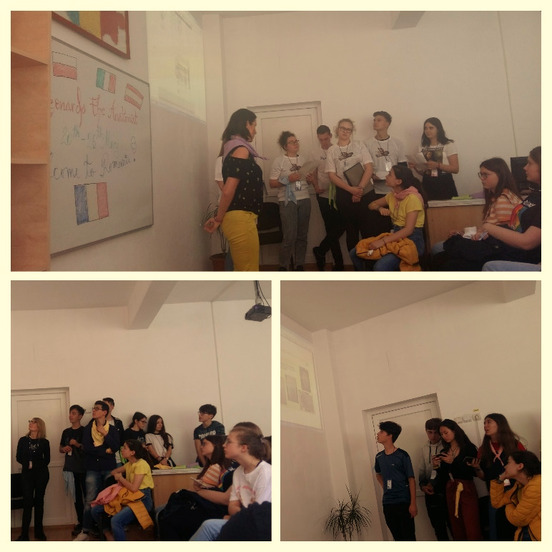

**All of the partners presented their educational products on the Leonardo the Anatomist topic, designed both in their schools and collaboratively, in mixed international groups, by using various ITC applications.**

**In the afternoon, two Art and Math activities were performed, The Glitter Canvas and The Golden Proportion, in mixed international groups, A1&A2, B1&B2.**

**As one of the main objective of the project is the interaction between the partners while solving different educational tasks applying CLIC approach, the pupils from all the five countries had to interact each other to gain the aims of the activities, overcoming the barrier of language.**

**A short exhibition of their products was realized and presented to the other students from school for dissemination.**

**On the 22nd of May, all of the participants went on a documentary visit to Bran Castle where the pupils had the possibility to use augmented reality (AR) which proved to grant students extra digital information about the topic, and make complex information easier to understand.**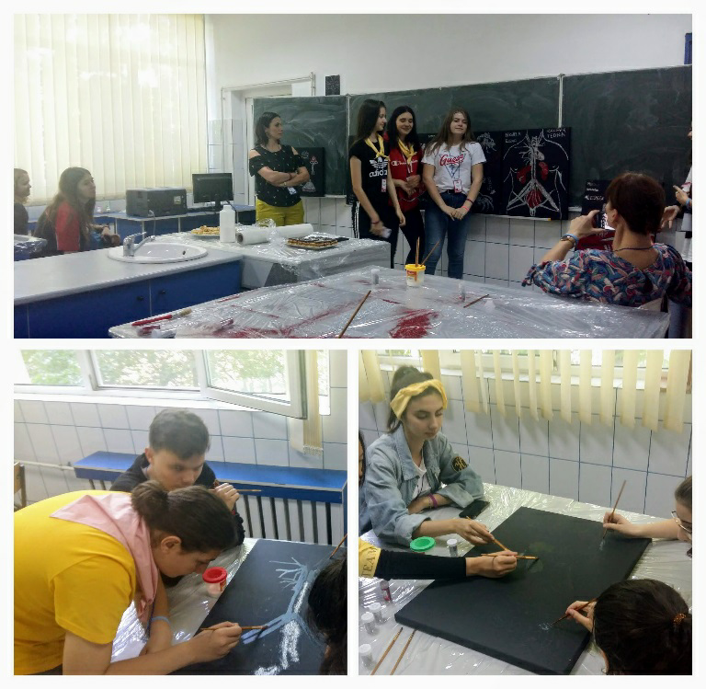

**As one of the objective of the project is to develop intercultural competences, digital and communication skills through ITC tools, the international groups used oral communication in problem solving the usage of cardboard camera apps. The Time Tunnel was an inspiring environment for AR learning.**

**The visit of the Brașov central square and the Black Church offered the participants the opportunity to get in touch with Cultural heritage of Romanian traditions and values.**

**On the 23rd of May the participants were involved in some other interactive activities on the topic of Leonardo the Anatomist: posters about Leonardo**̍ **s sketches and studies on human bodies, Advanced Electronic Learning activity on Leonardo**̍ **s scientific work on exploring the nature and its phenomena, Human Body Skeleton and Eco Cars.**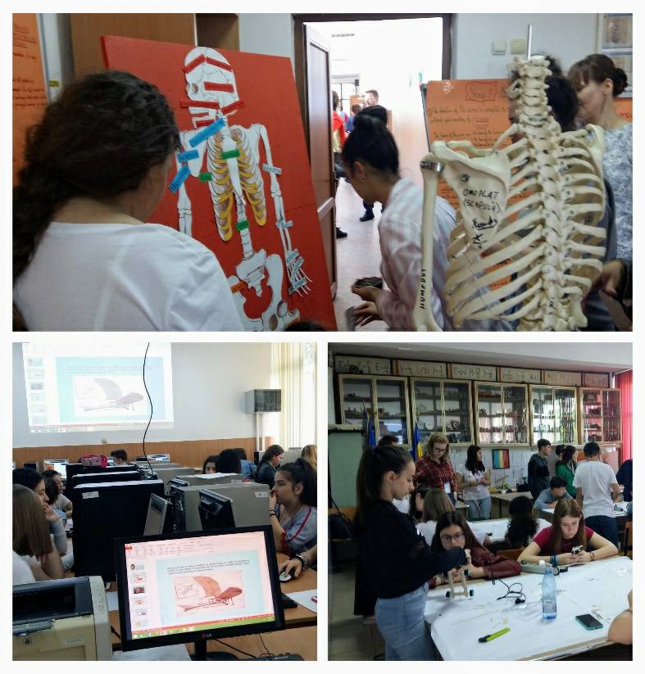

**Some of the main aims of all these activities were: to develop social and thinking skills while using problem-solving procedure, to discover how spring force and jet propulsion work on objects, to enrich their knowledge about human body skeleton, to use Canva application in order to design a poster.**

**All activities were performed collaboratively, in mixed groups, which changed their interaction in turns, so that the members had the chance to share their good practice experience and to foster their social and communication skills.**

**An exhibition of the designed posters was presented to the other students of the school for dissemination of the products made collaboratively during the mobility.**

**On the 24th of May the participants worked on an outstanding Art lesson - the participants were split in groups of four and worked on producing human body bas-relief using molds to get gypsum casts.** 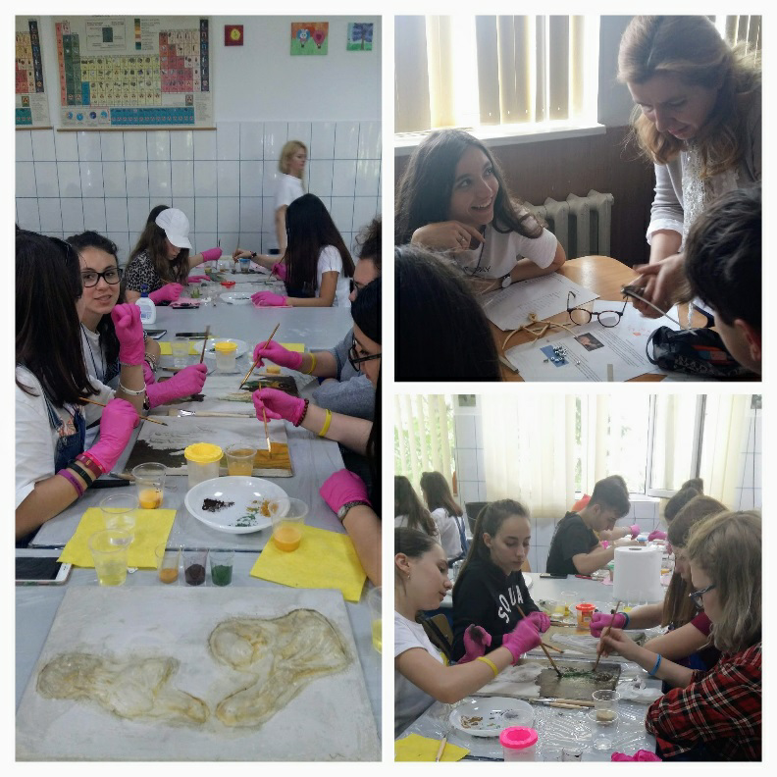

**The main aim was to share expertise in teamwork while achieving a common product on human body with focus on muscles.**

**In the afternoon, the participants in the mobility paid documentary visits to the most representative local institutions: The Town Hall, the Archbishop of Buzău and Vrancea and The History Museum.**

**While discovering the main historical events in the Buzău region development and the specific structure of an Orthodox Church, the participants encountered many opportunities to catch the hints about Romanian customs, practices, places, objects, artistic expressions and values.**

**On the 25th of May, all the participants went to discover the unique phenomenon of Muddy volcanoes from Pîclele Mari, Buzău county.**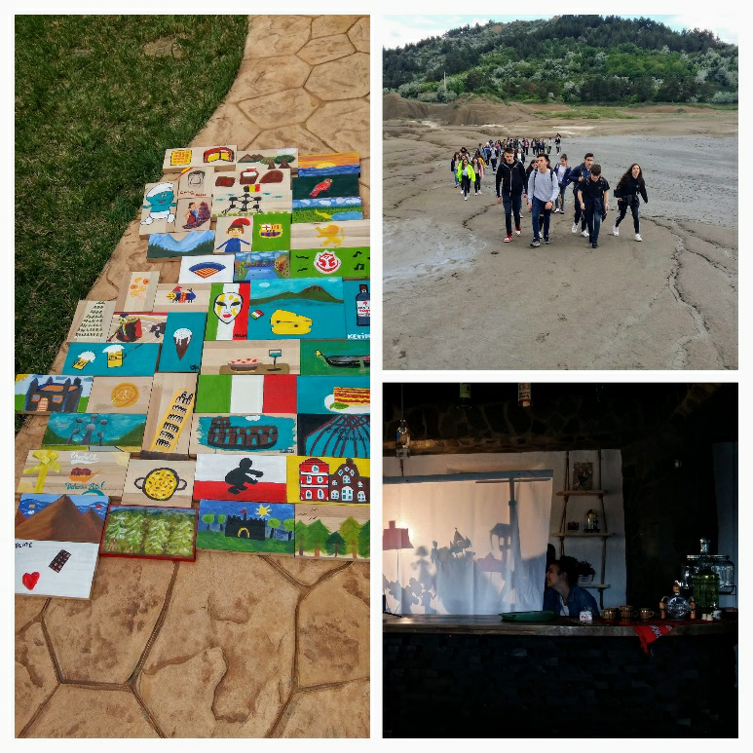

**The natural phenomenon was a starting point for the three STEAM activities which followed at Cob Village, an environmental-friendly place where the mobility came to its end.**

**The first STEAM activity aim was to discover the steps of the scientific phenomenon of lava eruption using every day materials. The participants had to think about the way in which they could recreate the natural eruption using their scientific knowledge and working in teams.**

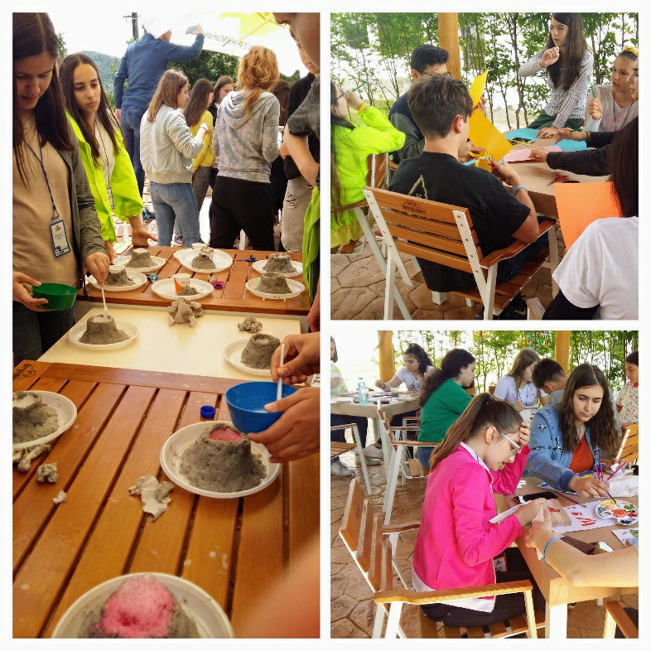

**The second STEAM activity aim was to enlarge the intercultural competences of the participants while producing paintings on pieces of wood whose topics were the icons of the guests’ countries – Belgium, Italy, Poland and Spain.**

**The third STEAM activity was a drama shadow whose topic was a script written in teamwork by using key words connected to the Romanian mobility: STEAM, Bran Castle, Black Church, teamwork, Leonardo**̍ **s heritage.**

**The coordinating teachers discussed and decided on the next tasks of the project according to its application and the proper procedures needed in order to achieve them collaboratively.**

**Every day finished with a short debriefing session and on the last day the certificates of the attendance were given to all the participants.**