Land Invasion

Land Invasion is an outside game where the goal is to invade land from the other players. There can be 3-5 players in this game. The playing time is decided in the beginning of the game (for example, 20 minutes).

Rules of the game

1.Draw a playing area (large circle) and divide it into as many sections as there are players in the game. Each player marks his/her area with initials or with his/her name.

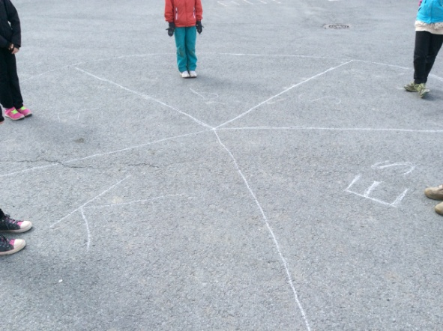
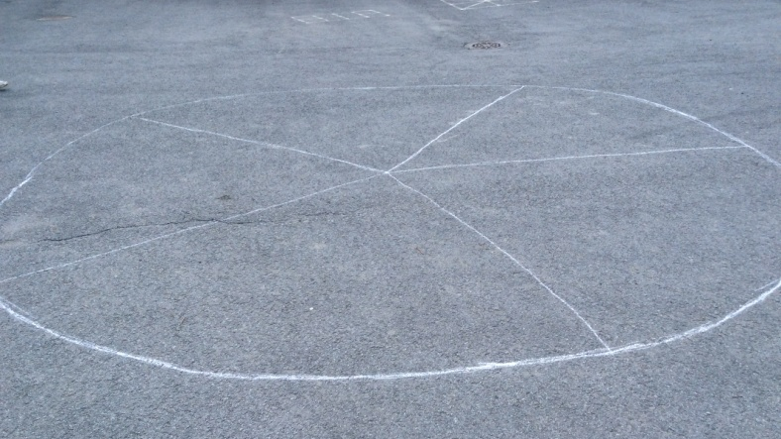

2. Find a small stick to play the game with.

3. At the start of the game, each player stands in his/her land.
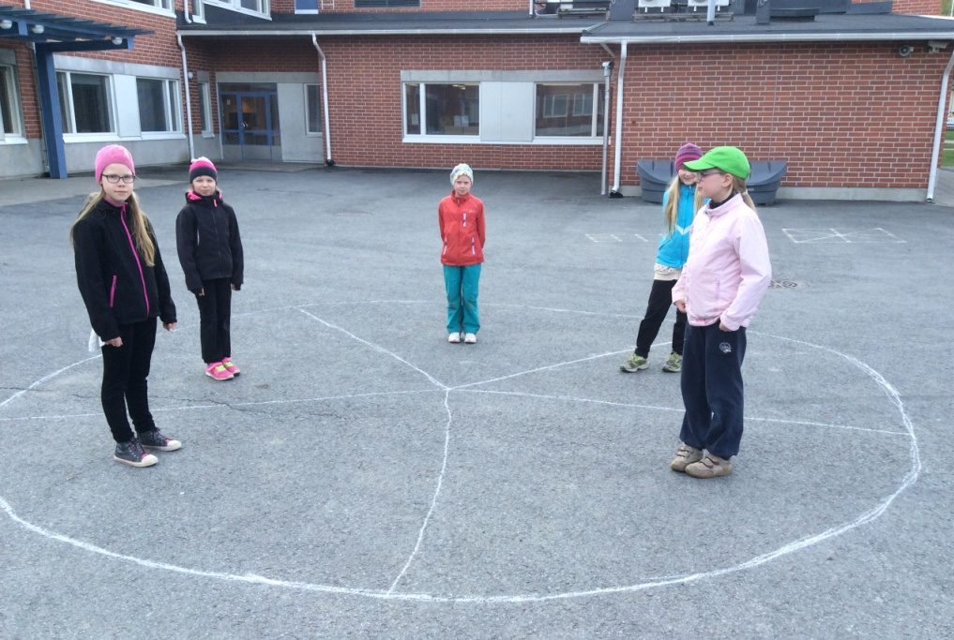

4. Decide who starts the game. The starter throws the stick to any of the opposing lands.

5. The player who owns that land makes five X-jumps while the other players run as far as possible.

6. After finishing the X-jumps, the player yells "Stop!" and the others stop and freeze.

7. The player asks the others "How many steps?" and they answer any number bigger than two.

8. The player runs once around the playing area and then takes as many giant steps towards the other players as they earlier said. After taking there steps, the player always takes two extra steps and settles down on his/her supporting leg.

9. The player throws the stick towards the other players (no higher than the waist) and
-> if it is a hit, he/she can invade land from that player
-> if it is a miss, the game continues according to steps 3-9.

How to invade land?

Stand on the border lines of your own land and reach as far over the land under invasion as possible. Invade land for you by drawing a line. Be aware that while invading, your both feet must stay on your border lines the whole time.

Winning the game

The winner is the player who has invaded the most land from the other players when the game time is up.

Please, watch also the video where 3A girls (Kia, Emma P., Petra, Emma S. and Susanne) from Metsäkylän koulu play the game

