Erasmus + project
“European media coaches in action”

We have based our training course on a program that was developed in the county of Baden-Württemberg in Germany by the State Media Center Baden-Württemberg (LMZ) :
Landesmedienzentrum Baden-Württemberg, Rotenbergstraße 111, 70190 Stuttgart.
Further details can be found on the following websites:
http://www.lmz-bw.de/
http://www.kindermedienland-bw.de/

You’ll find here a translation in English of the two main modules we used with our students in the six participating countries.

Copyright
All rights to this publication lie with the State Media Center Baden-Württemberg (LMZ). The use and / or duplication of the contents as a whole or in excerpts for demonstration and presentation purposes is possible on the condition that the source is mentioned. The use and / or distribution of the content for commercial purposes is expressly prohibited.

CONTENT

MODULE 1 / GROUP "How do I lead a group and resolve conflicts?"
At a glance
- The role of Media Mentors Tasks and motivations of the Media Mentors
- Important rules when speaking and listening The right way to work together
- Motivational Work How to motivate you and your group
- Group games getting to know each other / relax and cooperate
- Dealing with difficult situations Strategies and Solutions in Difficult Situations
- Rights & Duties of a Student Media Mentor

MODULE 5 / JMS "How do I deal responsibly with media?"
At a glance
- Legal basis Youth media protection in the law
- Youth media protection organizations Information from official bodies
- Communication Information for communication with the media
- Social networks What to consider when using social networks
- Social network tasks Information about you on the net
- Personal privacy settings on Facebook and friend lists
- The most important social networks and user numbers at a glance
- Mobile & Smartphone - Important information, tips and tasks to deal with
- Mobbing & cyberbullying General information and legal regulation
- Task on cyberbullying What can you actively do against moobing & cyberbullying?
- Privacy The informational self-determination and personal information
- Copyright on the Internet Illegal Downloads and Legal Use of Media
- Creative Commons Licenses Use of Media under CC Licence

17

MODULE 1 GROUP

The role of the student-media mentors
It is important, as a student media mentor, to have a guide that includes the key elements
in leading a group. A group can only be productive if the roles are clearly distributed and
the structure of the project is clear and visible. Mentors are not teachers, but learning
supervisors. A mentor has the task to share his / her own knowledge.

What makes a good student media mentor? Enter here the results of your collection from the SMEP course.
- Tasks of the media mentors could be:
- Bring together people with the same interests.
- Teaching your knowledge to other students.
- Lead a group and resolve conflicts.
- Provide rooms / equipment, etc.
- bear responsibility for the common result / product.
- Know the areas of youth media protection and act here as a "role model".
- Support teachers in the field of media and youth media protection.
What others do you know?
____________________________________________________________________________
____________________________________________________________________________

Why do I want to become a student media mentor?
____________________________________________________________________________
____________________________________________________________________________
Important rules for speaking and listening
Now it is your turn. Your task is to convey your knowledge. The students in your project are interested and motivated to work with the necessary media. So it is important that there is a concept for the topic to be conveyed. If you have prepared all this, it now only depends on the right speech. Listening and responding to questions are among your core tasks in the project. Some rules about speaking and listening will help you in this project.
Get to know your target group
➞ Formulate simple and short sentences.
➞ Set a goal in advance, what you want to say with the descriptions.
➞ see yourself as a transmitter of knowledge and receiver of questions of your group.
➞ Your group receives your messages, so expect their response.
Every contribution is important
➞ Listen to the others and make sure everyone is treated the same.
➞ Only speak when someone else has finished speaking.
➞ Please only short contributions! Only in this way can everyone actively participate in the group process.
➞ Do not go over too many points in one meeting. Offer breaks.
What are your own rules in dealing with each other?
___________________________________________________________________________

___________________________________________________________________________

___________________________________________________________________________

Motivational work
Too long lectures and theoretical parts in your project can tire your participants quickly. Theory and your lectures are but an important element of your SMEP course, after all, you also want to impart knowledge. Nevertheless, you have to think about how to motivate your group. Here is a guideline for group games listed, where you can orient yourself. Motivation work has something to do with trust, acceptance, dedication and a good deal of enthusiasm. If you can not build a good relationship of trust, you will not succeed in motivating everyone in your group.

What are motivational factors that you can use?
Objectives: The clearer and the more attractive the goal, the higher the motivation to reach this goal. Too high a bar (excessive demand) and too low a bar (requirement), however, are absolute motivational killers. Feedback: A positive feedback (feedback) spurs on. But it is also allowed to express criticism or recommendations if they are positively packaged and help the criticized. Responsibility: Give responsibility to your participants. This is a vote of confidence and at the same time motivating. See success: Let your participants see the success and share in the success. Without any prospects of success or lack of success, the motivation will subside.
Responsibility: Give responsibility to your participants. This is a vote of confidence and at the same time motivating. See success: Let your participants see the success and share in the success. Without any prospects of success or lack of success, the motivation will subside. Being a role model: If you want to motivate others to do something, you have to be motivated yourself. Group participants look very closely - who is not a role model himself, can not motivate the participants, even "exemplary" join. Scope: Not everything has to be done according to a well-defined pattern. Let your participants have the freedom and freedom to reach their own goal. Many roads lead to Rome!

Allow changes: If something always runs the same, that is demotivating. Therefore - wallpaper change. Routine is a motivational killer.

How do you motivate your group?
___________________________________________________________________________

___________________________________________________________________________

___________________________________________________________________________

Group Games
Basically, for playing in the group: games should always be fun for ALL. Your task as a group leader is that everyone stick to the rules and join as many as possible. If someone does not want to join, that's his / her decision and no one has to comment. Get to know fairy tales and truth
Tools: pens and paper
Rules: Everyone should write down three things that are important to him and that describe their own person or life situation. In addition, another issue should be invented, not true is. When imagining, the rest of the group should guess what is wrong. For example, "I'm honest," "I have a dog," "I like playing chess," "I've been sitting twice," etc.

My Picture Tools: Various pictures / photos from magazines (if possible without text, for example from advertising)
Rules: Everybody should choose a picture that suits him / her best and that suits him / her best. In the round, each participant should justify their choice: "I chose this picture because ....". Answers like "because it's beautiful" are not enough to justify it.

Zipp - Zapp Aids: No special aids Rules: All players form a circle. Everyone first learns what his neighbor is called to the left and to the right. A player stands in the middle and goes to one of the players seated in the circle and says either "Zipp", "Zapp" or "Zipp-Zapp": With "Zipp" the addressee has to say the name of his left neighbor, with "Zapp «The name of his right neighbor, in» Zipp Zapp «all players have to change places. If a player calls "Zipp" or "Zapp" the wrong name, he has to give his chair to the player in the middle. Even with »Zipp-Zapp« this can secure a place.

Of course, if you want to include other introductory games in your project, you can also do it yourself.

___________________________________________________________________________

___________________________________________________________________________

___________________________________________________________________________

Loosening Games
These types of games are especially useful if you have been concentrating and are now losing your attention. The games offer the opportunity to clear your mind and take a creative break. It is important that the game does not take too long and is exhausting again. Pay attention to the time and do not play with yourself, but head the action.

Gordian knot
Rules: All players stand in a circle with their eyes closed. On a command, all run with arms stretched forward in the middle of the circle. Each player grabs two hands. If everyone has found another hand, the eyes are opened again. Now we try together to de-node the node. The goal is to form a circle in which everyone holds hands.
Comments: It can happen that there are two circles in one another - but that's not bad.
Rules: Everyone in the circle secretly selects a person from the circle that he will imitate. So if this person moves in anyway, he has to join in this movement. However, the role models should not be obvious. Everyone stands in the circle, close their eyes, move slightly again and open them again. On a joint command, all change their position as their role model. In the end there is either a common position or two / three different positions. It is interesting to talk about what it was like to imitate the role model and when you noticed that you are imitated. In addition, anyone can say why he has chosen> his <role model.

Do you know any other games that you would like to bring to the relaxation?
___________________________________________________________________________

___________________________________________________________________________

___________________________________________________________________________

Cooperation Games
Collaborative games are there to further consolidate the group in the project. The games help the group communicate better, so they should be used in your project.

Together until 21
Objective: The group should count together from 1 to 21. The group should be as big as possible, but the game also works with groups under 10 participants. The game takes about 10-15 minutes.
Rules: For the game the participants are distributed in the room. The mentor starts with "1" and then there is no set order anymore. Each participant can decide himself when to say the next number. However, two people can not say a number at the same time. Then you have to start at "1" again.

Role playing game
Objective: To learn to express yourself more clearly and to practice dealing with criticism. The participants in the group should not be completely alien to each other (this is not a game to get to know each other!). The time frame is about 30 minutes.
Rules: The participants are divided into groups of four. In each group a member announces itself as a speaker (roles are exchanged later). The speaker chooses a topic that he wants to talk about for a minute. These can be personal experiences or summaries the project idea. What is special is that time is limited and one deliberately deals critically with the topic. Above all, it is important that the topic is clearly named beforehand.

Another member the group stops the time and takes over the role of the referee. The other members of the group listen to the speaker and report the following errors: repetitions, abortions, hesitations. If an error is detected, the speaker pauses and the referee decides if it was actually a mistake. Then the speaker starts over and keeps trying to talk for a minute at a time. The referee records all errors (number and type) of the speaker and informs him at the end about it. Then the roles change and another speaker and another referee come to the course. At the end there should be a short evaluation round. How were the speakers satisfied with themselves? Have there been disagreements over the mistakes? Was listening difficult when you had to look for a mistake?

Human camera
Rules: The participants form pairs and the game pair agree on who is blind first and who leads. The sighted person now leads their partner to a selected location and directs their camera to something especially worth seeing. The head of the "blind" person is aligned with the subject, then she can press the trigger (pull the earlobe slightly); Only then may the partner open his eyes for some time and enjoy the picture. During the game should not be spoken. In addition, different close and wide shots are to be made. Everyone has three shots.

Difficult situations
Here are some examples of how you can prevent potential problems in the project. If you look closely at the individual points, there should be very few situations where you could get into trouble.

You can prevent difficult situations Self-initiative:
Be creative, active and interested! If you are creative, active and interested yourself, the group can better engage and focus on the essentials.

Preparation:
Be well prepared every hour! Try technology before! Schedule breaks! Because too long lectures, missing or not working technology and boredom lead to unrest in the group.

Collaboration:
Try something together instead of just talking about it! Work together with the group instead of giving lectures.

Appreciation:
Write down (good) ideas of your project participants always! For example on cards, chalkboard, flipchart ..., then they are not lost and nobody feels 'unheard'.

Openness:
Stay open to the ideas of others!

Assertiveness:
Difficult groups split or busy (special task).

Togetherness:
No one has to solve any difficulties alone, and the others in the group can help.

Clarity:
Make clear statements so everyone in the group knows what, when, who to do.

Criticism:
Do not be offended and accept criticism! Ask how you could do it better. Search suggestions with everyone.

Rules:
Collectively establishes rules for dealing with the group. Do that right at the beginning and hang it up in the room. The rules also include the consequences of the rule break, z. B. Exclusion from the project for intentional destruction of equipment, violence, etc.

More ideas to avoid stress and conflicts:
___________________________________________________________________________

___________________________________________________________________________

___________________________________________________________________________

Cope with difficult situations Again and again, as a mentor you can get into unpleasant situations. The most important thing in such situations is that you tell yourself: I'm going to get over this situation! Over time, every student media mentor will develop strategies to survive even in awkward situations. Therefore, every difficulty is to be seen as an exercise.
There are no panacea for dealing with difficult situations, but the following stations can help to master the situation: First try

Listen actively. You should meet your interlocutor here at eye level and especially appreciatively. Create mutual trust by listening without equal value, show honest and open interest in your interlocutor.

Second try Submit to the group: "What do you think?" The group is stronger than individuals. (If she wants.)
Third try A private conversation sometimes works wonders. Try out!

Fourth try Escalation: Now it should not be your problem anymore. Notify the contact teacher for SMEP and return to the peaceful part of the group.

The last means You can also knock participants out after you have clarified it with the teacher. However, you also want to have participants in your project. Expulsion should therefore be the last resort.

Your own suggestions:
___________________________________________________________________________

___________________________________________________________________________

___________________________________________________________________________

Rights and Duties of a Student Media Mentor Before the projects can start, you have to clarify the legal framework. Your first task as a student media mentor is to clarify the following points with the school management and the contact teacher:

➞ How do you insure yourself when you offer a media project?
➞ Are all participants of the media project insured?
➞ Are all the devices you use for the media project insured?
➞ Do you need possibly still declarations of consent of the parents, if picture; Volume-; and video footage from the group members?

The following sentence applies to all students' events for pupils and originates from the Ministry of Education's Ordinance on Institutional Responsibilities and Student Responsibility (SMV VO) and means: If students supervise other students, rights and duties have been clarified with the school management, the supervised students do what the responsible student says.

“If students are entrusted with supervision, they must be obeyed by other students within their authority.”

Mentors have a duty to supervise If you have further questions about your rights at your own school, especially in the computer room or in the network, please contact the SMEP contact teacher and possibly the school's own network consultant.

Duties for action

➞ Know where the participants are
➞ Keep participants safe from danger
➞ Preserve generality from danger
➞ To warn
➞ To forbid
➞ Pronounce sanctions
➞ Mentoring teacher or teacher supervision
➞ Exclude from the offer

MODULE 5

How do I deal responsibly with media?

Legal basis
Jugendmedienschutz Staatsvertrag (JMStV)
The federal states of Germany have joined this state treaty and have thus created a uniform legal basis for your protection from offers in electronic information and communication media that can impair and endanger your development.

Further detailed information can be found under the following link:
http://www.kjm-online.de/de/pub/recht/gesetze_und_staatsvertraege/jugendmedienschutz-staatsvertr.cfm

Criminal Code (StGB)
Certain media content may not be published at all and some may not be disclosed to minors. Such media content is called content that is harmful to minors.

The following paragraphs of the Criminal Code (StGB) are particularly important:

- § 86 StGB regulates the prohibition of the propagation of propaganda of anti-constitutional organizations. This can be, for example, the promotion of radical right-wing groups but also of violent terrorist organizations that pose a threat to the democratic state.
- § 130 StGB incitement. This means asking people to commit violent acts against each other based on their origin and religion.

- 131 StGB depicting inhumane violence against people.
- § 184 StGB Dissemination of pornographic writings to minors under 18 years.

Further detailed information can be found under the following link:
http://www.gesetze-im-internet.de/stgb/ Jugendschutzgesetz (JuSchG)

According to §17 JuSchG, the Federal Examination Office for the Media at Risk of the Adolescents has the task of compiling age identifications and identifying them on films or computer games as well as carrier media (books, magazines, DVDs, CDs, Blu-Ray, videocassettes, game consoles, etc.).

Further detailed information can be found under the following link:
http://www.bmfsfj.de/BMFSFJ/Kinder-und-Jugend/kinder-und-jugendschutz.html

P 93
Youth Media Protection Organizations
State institutions (federal and state)
➞ Federal Examination Office for Media Harmful to Minors (www.bundespruefstelle.de)
➞ Jugendschutz.net (www.jugendschutz.net)
➞ Commission for Youth Media Protection (www.kjm-online.de)
➞ Voluntary self-regulatory institutions TV = FSF Movies = FSK Entertainment Software = USK
➞ Aktion Jugendschutz (in Baden-Württemberg: www.ajs-bw.de)

Jugendmedienschutz-Organisationen
Staatliche Institutionen (Bund und Länder)
➞ Bundesprüfstelle für jugendgefährdende Medien (www.bundespruefstelle.de) ➞ Jugendschutz.net (www.jugendschutz.net)
➞ Kommission für Jugendmedienschutz (www.kjm-online.de)
➞ Einrichtungen der freiwilligen Selbstkontrolle
Fernsehen = FSF
Filme = FSK Unterhaltungssoftware = USK
➞ Aktion Jugendschutz (in Baden-Württemberg: www.ajs-bw.de)
Wichtige Internetadressen zum Jugendmedienschutz und zur Sicherheit im Internet:
➞ www.mediaculture-online.de
➞ www.sicher-im-netz.de
➞ www.klicksafe.de
➞ www.surfer-haben-rechte.de
➞ www.polizei-beratung.de/medienangebot/jugendschutz.html
Jugendseiten:
➞ www.internauten.de
➞ www.watchyourweb.de
➞ www.datenparty.de
➞ www.handysektor.de
➞ www.time4teens.de
➞ www.netzcheckers.de
➞ www.checked4you.de

P 94
Communication
Letters were written yesterday, today chats online. Children and adolescents mainly use the Internet for communication and entertainment and a little less for obtaining information, says the JIM study from 2012. (see JIM study, page 32 - http://www.mpfs.de / index.php? id = 527)
The JIM study: "Youth, Information, (Multi) Media
The JIM study (Youth, Information, (Multi-) Media) has been conducted annually since 1998. There are more than 1000 young people between the ages of 12 and 19, all over
Interviewed Germany on the phone on various topics of their media use.
The JIM study is also of interest to you and provides many important information, e.g. How young people in Germany use and perceive media.
More detailed information about the JIM study can be found at the following link:
http://www.mpfs.de

Young people communicate in and with the media!
On the subject of communication, the JIM study (2012) says that teenagers prefer to meet friends / people in their free time, and that in real life. But most teenagers also meet with friends / people on the Internet, talk or play online.
And what about you?
Write down which digital communication media you use and how many hours (in brackets behind it) in the week you spend about it. The most important medium / device at the top:

1) ________________________________________________________
2) ________________________________________________________
3)________________________________________________________
4)________________________________________________________

Communication of young people on the Internet, according to the JIM study of 2012, mainly via social networks, read and write e-mails and through various chat rooms. Here are dangers such as advertising, the promise of free things and in retrospect cause significant costs, a problem.

Make sure you pay attention to what you click on the Internet and concludes, because that can have expensive consequences in rash action. You can easily avoid these problems through your own attention and above all through a critical attitude towards offers on the Internet, for example in advertising emails.
What problems can arise, especially when you communicate with friends and acquaintances or even unknown people in chat? Give a few examples and write them down on the following page. Afterwards you can exchange ideas in the SMEP group and determine the most important rules in order to avoid possible problems.
___________________________________________________________________________

P 95
___________________________________________________________________________

___________________________________________________________________________

___________________________________________________________________________

What are your 5 most important rules when communicating on the internet?
- ________________________________________________________

- ________________________________________________________

- ________________________________________________________

- ________________________________________________________

- ________________________________________________________

Information about communication and social media
Social networks
Meeting with your friends on Facebook is probably as much a part of watching as watching videos on Youtube, playing computer games, or just listening to music. The Internet gives you many opportunities for employment and communication. That's why social networks are so popular among teenagers. These social networks have important functions, say experts at least.

"Network platforms in interaction with other digital media and forms of communication are a very important space to work on development tasks of growing up."

Dr. Jan-Hinrik Schmidt - Wissenschaftlicher Referent für digitale interaktive Medien am Hans Bredow Institut – Hamburg
Quelle: „Computer & Unterricht 2012 – Jugend & Medien“, S. 35; Friedrich Verlag, Leipzig 2012

P 96
Media are important companions of growing up.
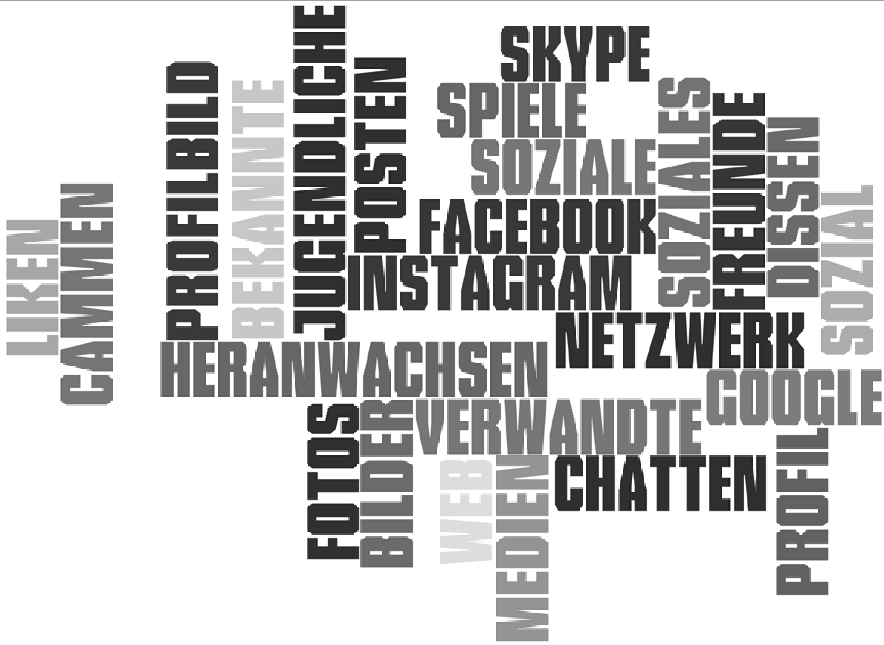
You probably like to use the Internet intensively as a communication platform, because you can easily and quickly make contact with others. (eg via instant messaging like WhatsApp), you can find peers or like-minded people on the Internet if you have personal problems or if you have questions that you would rather have answered anonymously (for example, on blogs and in forums).
The social web also offers new ways the confrontation with yourself and yours Environment and thus also in finding an identity. There are significantly more possibilities than in the real world. In social networks, identity testing is easy and with a few clicks in profile, you can try new roles. The net offers many opportunities for self-presentation, which are not so diverse in the real world. In the virtual world you can change your identity as often as you like. What does it look like in the real world? Why is it so important to orient your own identity to the real world?
In social networks, identity testing is easy and with a few clicks in profile, you can try new roles. The net offers many opportunities for self-presentation, which are not so diverse in the real world. In the virtual world you can change your identity as often as you like. What does it look like in the real world? Why is it so important to orient your own identity to the real world?

The relationships you make online can range from non-binding chat friends to social networking groups to real friendships. The playfulness of the net can be fun for a short time, but when it comes to one's own ideati- vity, real friendships that are always connected with who you really are are very important.

Online communication does not replace personal relationships, but ideally complements and deepens them. All social networks live from the joy of communication and presentation of their users. More than two-thirds of young people store photos and videos online in the profiles. (Source: JIM study 2012, p. 42/43 - https://www.mpfs.de)

Where is the problem? The internet is a network and do not forget anything!
The internet does not forget anything. One should always keep that in mind. Where is the problem, you ask yourself? Try a people search engine like www.yasni.de or www.google.com (especially image search). There you can find out what is in store for you. Not everything is cool, such as the photos from the F-youth in football or the primary school dance group that you do not want to see anymore. Individual information that you publish about yourself can be merged to give a very comprehensive picture of a person.

And this can also have an impact on working life: More and more employers, for example, use social networks to find out about applicants or to observe what their future employees are posting on the social networks.

Social networks and your role as an SMEP student.
The choice of the respective social networks on the Internet is open to everyone. Also, which personal information is set here, everyone can decide for themselves. However, as a media mentor you can be a helpful companion for the proper use of social networks for other students through the information gained here. It should also be clear that nobody has to join a network in their media courses in order to be able to use an uncomplicated and central communication platform as a group. Inform yourself about suitable mail distributors or decentralized networks (e.g., Diaspora) that do not store data.
P 97
Mailgroups or email distribution lists
Mailgroups are also called email distribution lists that you can set up with your email provider. If there is a school server, it is even better to create all participants with an e-mail address and create a distribution list with the participants in the SMEP project.

Decentralized network as an alternative to commercial networks
The decentralized network Diaspora is a good alternative if you do not want to communicate with others via a commercial platform on the Internet. Decentralized means that your data can not be stored and used on a server (for example, Facebook), but that all data always remain on your own computer.

Further information and registration options can be found at. https://www.joindiaspora.com What information do you find about you on the net?
Looking for your virtual footprint! Enter your name at www.google.de and / or www.yasni.de and document in the table, with the help of a tally, your hit rate

What information do you find about you on the net?
Looking for your virtual footprint!
Enter your name at www.google.de and / or www.yasni.de and document in the table, with the help of a tally, your hit rate

See table in the original German document

Could not you find any information about you on the net? Try it with public figures, e.g. the school principal or the mayor!

What did not you like, what is on the net about you / or others?
_________________________________________________________________
_________________________________________________________________
_________________________________________________________________

How do you want to handle the handling of your posts and data in the future? Make a few rules for yourself and try to avoid questionable content about you on the net.
_________________________________________________________________
_________________________________________________________________
_________________________________________________________________

P 98

How do I handle media responsibly ?

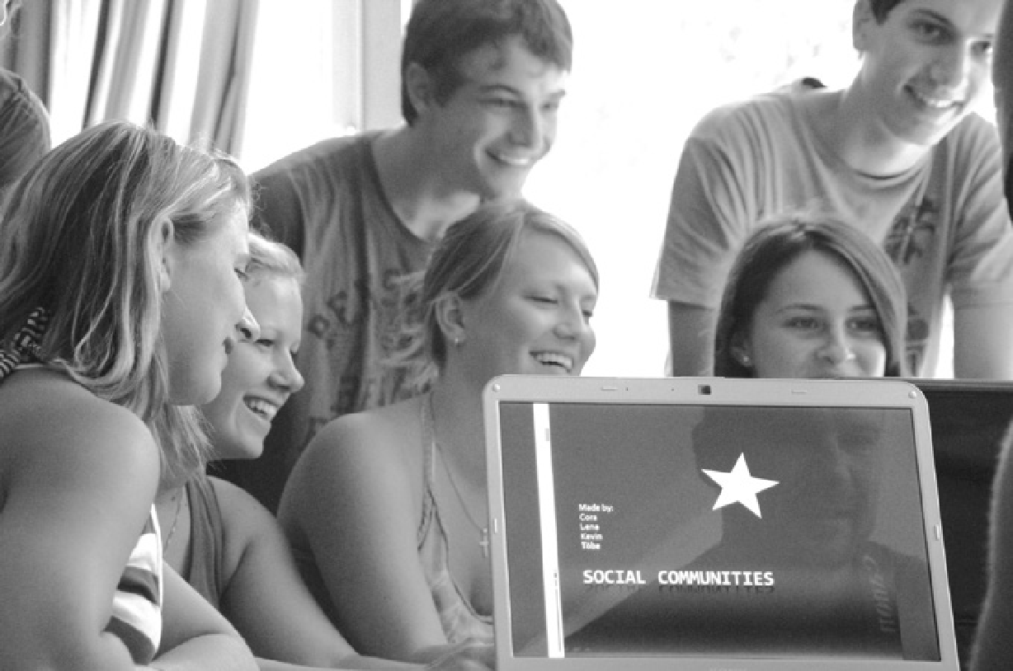
The small exercise for your virtual footprint will show you the already set information about you in the net. In the following section of SMEP, you can learn to use information about yourself in a meaningful way. That does not mean that you have to stop all internet activities right away. From the knowledge that you acquire here, many other students can benefit from your school.

You must be aware that all the information you put on the internet can stay there and be easily found. Privacy settings on Facebook and create friend lists!
The biggest problems currently facing people in social networks are the proper handling of privacy settings, e.g. on Facebook. Many put careless photos and information about your own person on the Internet. The setting of privacy and especially the creation of friend lists on Facebook should be no problem for you after the SMEP training. Because Facebook quite often the privacy settings changes, you should (if you use Facebook) you always keep up to date, for example as far as the friend lists or chronicles are concerned. Hereinafter Worksheet you can ever find the most important privacy information.
Often it can happen that you handle your data with great care and do not put any photos on the net. But as soon as others, for example classmates, put photos of you on the net you start again from the beginning. You should definitely react to this and inform the people that you have not given your consent to put those photos on the Internet.

Looking for suitable materials for privacy!
One of the best internet portals for the media use of young people is www.klicksafe.de. Search here for appropriate instructions for privacy settings on Facebook! Write down the corresponding links:

______________________________________________________________

_________________________________________________________________

TIP
Did you know that Facebook should only be used from the age of 13 Years?

P 99

And now you! Follow the instructions and, if necessary, make the right settings in your Facebook profile. You can get help on which areas in your profile should still be set on the following pages:
www.friend-inspector.org
www.daniel-puscher.de/fpw/
Did you create friend lists? Proceed as described under task 1 and note down links where you can find instructions for creating friend lists.
Tip: Look for instructions on www.klicksafe.de!
_________________________________________________________________
_________________________________________________________________
_________________________________________________________________

Social networks - billions of users mean billions of dollars in revenue!
"So nice, these networks! I do not have to pay anything and yet I am allowed to use a worldwide network. Every day! "This statement can be heard again and again. You probably already know the answer and you also realize why social networks like Facebook can be free. Find out in this movie why, for example, Facebook earns such high sums of money.
Is it really just the advertising or the way advertising can be placed?

"Facebook in the present and future - data sales and business models"

http://www.youtube.com/watch?v=YfkFuh8aW8I

P 100

SEE TABLE IN THE ORIGINAL GERMAN DOCUMENT

You can also find out which social networks are used by young people in particular and which services are also used here.
You can download the JIM study for free at this link: JIM study - Medienpädagogischer Forschungsverbund Südwest
http://www.mpfs.de/index.php?id=276

P 101
Mobile phones and Smartphones
Mobile phones and, increasingly, internet-enabled smartphones are now in the hands of almost every teenager. This is access to the World Wide Web, via smartphone, gives huge possibilities for communication. Use of these communication options can result in not only high costs incurred by smartphones, but also sensitive ones relating to data, as information about our life and our personal details is transmitted.
The diverse multimedia options of modern smartphones such as camera, audio recorder and video camera, are often used without thought and the results, such as videos of drunk friends or embarrassing pictures of classmates, can be put on the Internet quickly and easily.
However, few people know that if you do so you are committing a crime. Violent videos and pornography on your own mobile / smartphone are considered illegal. The transfer of pornographic content to minors under the age of 18 is a serious criminal offence. According to §131 of the Criminal Code, the "production and distribution of media, the cruel or inhumane acts of violence against people are forbidden "and their transfer via mobile phone is considered an act of distribution.
Apps - data theft on your own Smartphone
Modern smartphones offer almost infinite possibilities through apps. These applications or Apps can be used for navigation, social media, messengers or even for creative multimedia production.
Straight apps can store personal data stored on the smartphone, such as names, read addresses and telephone numbers. They may be able to read your address book, track your search history in the Internet and read your e-mail traffic. These are important features that can help the manufacturers of the apps to make money, as these data can be sold to third parties for advertising purposes.
To avoid this, it is essential to read the privacy policy of the provider. If there is an indication that "personal data should be transmitted" then you should not install the app.
Source: http://www.watchyourweb.de/p1841245406_491.html
For more information, especially on the excessive use of mobile phones and smartphones, there is a good documentary called "Madness cell phone".

You can watch the movie at home too. The movie is about 45 minutes long.
"Insanity Handy" - A documentation of the SWR
http://www.youtube.com/watch?v=wkE6xJAJeEU

P 102

Important tips for using mobile phones & smartphones
The communication via mobile phone and smartphone should be just as nice and friendly as real-life encounters. Therefore:
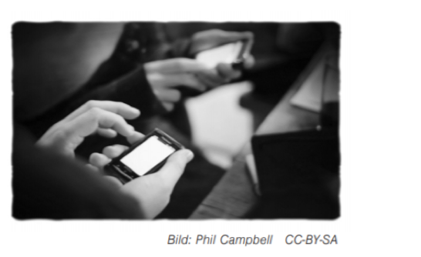
- Offending other people using your smartphone, even without meaning to, that's bullying!
- Quickly taking a photo / video and then posting it straight onto the Internet does not work!
Ask yourself before posting every photo or video
• Who can be seen in the photo & video?
• Do you have the consent of the person / s?
• Why does the picture / video have to go online?
GPS tracking
GPS tracking can be very useful for navigation and can show you the way better than everything else, however, it makes little sense.
The data collected will be your movement profile. It will show where you are staying and when you are moving from place to place.
➞ For all apps, check if GPS tracking is really needed.
➞ Turn on GPS location services only when you really need them.
Bluetooth
The Bluetooth feature can cause you problems because it allows friends to access your mobile network.
➞ Turn on the Bluetooth feature only when you need it.
➞ Pay attention to what content ends up on your mobile phone through Bluetooth!
➞ If you have a smartphone, also check here the (pre-) setting of Bluetooth!
WLAN
If you build your own WLAN via your smartphone, many can access it:
➞ If you are setting up a WLAN, encrypt the radio traffic with a password.
➞ Turn off the Wi-Fi if you do not need it.
➞ Pay attention to hotspots! Always find out how safe the hotspot is.
Password Security & Privacy
There's a lot of personal information on your phone that should be protected:
➞ Protect your phone from being accessed by strangers through a secure PIN.
Do not save passwords in your mobile phone (notes, etc.).
Porn and Violent Videos
Passing on prohibited content and having it on your mobile phone is punishable by law:
➞ Do not participate in the distribution of porn and violent videos!
➞ If you've seen disturbing content, talk about it with parents or teachers.
➞ You can also call the helpline: 0800 - 1110333 (free & anonymous).
Virus Protection & Costs
Advertising coming to you by e-mail or SMS, often hides viruses or cost traps:
➞ Only open mails on your smartphone if you know are certain that you know the sender.
➞ Do not subscribe via mobile phone.
➞ Pay attention to your right of withdrawal and make use of it in case of doubt!
P 103
How, when and why do I use my mobile / smartphone?
You probably always have the mobile / smartphone with you and you will also be using it a lot. Often, unconsciously you reach for the mobile / smartphone and switch it on. For you as a SMEP student itis interesting to know, how much time for which activities and at which time of day you are on mobile / smartphone.
Here is a little experiment:
Exercise 1 :
➞ Create a log sheet on an extra sheet of paper, here is a small example:
SEE TABLE IN ORIGINAL GERMAN DOCUMENT
➞ Write the day and date on the top of the sheet.
➞ It is also interesting for you to record one day in the school week and one day at the weekend. At the same time, completely different usage times will become clear.
➞ You can use the protocols in your SMEP course or in your own SMEP offer to discuss this and compare it with your classmates.
Exercise 2:
What did you notice when logging your mobile phone / smartphone usage?
Here you can write the feedback and record the discussion with each other, adding your experiences and make observations:
_________________________________________________________________
_________________________________________________________________
_________________________________________________________________
_________________________________________________________________
_________________________________________________________________
_________________________________________________________________

For more information about how to use your mobile phone / smartphone correctly, visit:
➞ http://www.klicksafe.de/smartphones/
➞ http://www.jugendschutz.net/pdf/handy-ohne-risk.pdf
➞ http://www.handysektor.de
➞ http://www.verbraucherzentrale.deuflagen when logging your mobile phone / smartphone use?

P 104

Mobbing & cyberbullying
"Cyberbullying or cyberbullying is the insult, threat, exposure or harassment of people using new communication media - eg. Via Smartphone, mobile phone, e-mail, websites, forums, chats and communities. "
Definition of the Federal Ministry for Family Affairs, Senior Citizens, Women and Youth
Source: http://www.bmfsfj.de/BMFSFJ/cybermobbing,did=168578.html
When people are bullied, this is usually done by writing and language. Threatening, denigrating and insulting are possible approaches of the perpetrators, with incorrect allegations and harassment used to purposefully humiliate victims over a longer period of time.
Cyberbullying is a new form of bullying, but usually only the so-called "top of the Bullying iceberg ". In cyber mobbing, the perpetrators use modern digital media and electronic means of communication to hunt down their victims. The victims are from these electronic attacks affect people in all areas of life, as seen in modern media and communications media reaches many people in a matter of seconds, spreading falsehoods.
Like all forms of bullying, cyberbullying can have serious mental and physical consequences. The fear it causes can lead to Identity and self-esteem crises. The perpetrators of cyberbullying on the net can be punished for this behaviour.
Cyberbullying and the law
Although cyberbullying is not a crime in itself, but individual manifestations such as insults, defamation or slander are criminally relevant and can be punished accordingly.
Your mentor trainer will play a movie in the SMEP group but you also have the option to watch the movie on the internet itself:
"Let's fight it together" - Childnet.com Spot
http://www.klicksafe.de/ueber-klicksafe/downloads/weitere-spots/
uk-childnet-lets-fight-it-together-english/

Moodle
In the SMEP Moodle module under Module 5 / JMS is a extensive work experience

PAGE 105
Task on cyberbullying
Together, you and your classmates watched the movie "Let's fight it together".
The movie is about massive cyberbullying. The culprits in this movie were likely not aware of the rights they are infringing.
Open the movie with your partner on http://www.klicksafe.de/ueber-klicksafe/downloads/
more spots / uk-childnet-lets-fight-it-together-deutsch/ and join us on the search for the individual legal violations committed by the perpetrators. You can also find good information on this at www.klicksafe.de under: http://www.klicksafe.de/themen/kommunizieren/cyber-bullying /what-says-the-law/
Perspective of the participants
In the film, different people play with. Now you should approach the figures.
Fill in the following table ("How" and "Why"):
see table in the original German document

Discuss now with your neighbour as you would have behaved. Afterwards you can exchange opinions in the group.
Legal perspective
In this protocol, you should also specify the time code (time in the movie - for example, 1:02), where it in the film has come to legal violations.

P 106
Cyberbullying - What can you do?
As you already know, cyberbullying is a form of bullying in which somebody exploits modern means of communication, such as Internet and mobile phone, over a longer period targeted. It differs from bullying by the following additional factors:
➞ Offensive and offensive posts cannot be removed or are difficult to remove from the net.
➞ Due to the dynamics of the Internet, content can quickly be distributed to an infinite number of people.
➞ There is no place to hide for the victim as it is caused by the modern technology is always available.
➞ Often it comes through the rapid posting of videos / photos via a smartphone.
These thoughtless posts and comments can quickly become a case of cyberbullying.
That's why:
• Always consider what consequences it may have before photos, videos and posts are posted online.
• To prevent cyberbullying in advance, you can become a SMEP mentor in the field of youth media protection so you can make an important contribution and classmates to the causes and consequences of cyberbullying. If necessary, you can also pass on information to parents and teachers.
How can you best behave in a cyberbullying case?
➞ If there is a case of cyberbullying in your environment, this should be taken seriously. Discuss with a trusted teacher (or another adult whom you trust) the further procedure and do not act on your own!
➞ Cyberbullying is a complex process involving many different people. Therefore it is necessary to keep calm, not to bring about (further) confrontation, but with develop a strategy with others.
➞ If someone who is or is the victim of cyberbullying talks to you, you can give some tips:
• No hasty and ill-considered actions! Do not retaliate!
• Take screenshots of cyberbullying attacks and collect evidence.
• If there are opportunities to report to the operator platform, do so first.
• Turn off all communication media and report the case.
• Involve an adult of your trust.
You can pass on information in sudden and immediate cases of cyberbullying to the
Advice centre of the State Media Center Baden-Württemberg.
For questions about media education, the LMZ is on hand to advise. The media education counselling centre is available by phone Mondays to Fridays from 9am to 4pm at (0711) 2850-777 or can be reached anytime by e-mail at beratungsstelle@lmz-bw.de
www.schulpsychologie-bw.de (School Psychology Counseling Centers)
On the website of the School Psychology Counselling Centre in Baden-Württemberg you find the addresses an advice centre in your region.

P 107
www.nummergegenkummer.de
If you or someone else needs support, turn to the freephone number
0800 111 0 333 (for children) and 0800 111 050 (for parents).
www.juuuport.de
On this page you can find help and support, if you or someone from your environment is bullied. The contact persons here are young people who have completed special training.
Useful links for information on cyberbullying
www.mediaculture-online.de
On the portal of the Landesmedienzentrum Baden-Württemberg you will find many links and materials which are regularly checked for their relevance.
www.klicksafe.de
The EU initiative provides extensive material for youth, teachers and parents to the area of protection of minors. Under Themes, there is a separate section on cyberbullying, where it gives practical tips for students and parents.
www.jugendschutz.net
You can report cases of cyberbullying via the hotline. The team of jugendschutz.net supports you with the deletion of the hurtful content.
www.mobbing.seitenstark.de
A good site for information on bullying, especially suitable for children.
Data protection
Privacy means that everyone has the right to self-disclosure and to determine the use of their data. In other words, privacy should protect citizens from curiosity, protect the state and the economy.
A person who uses someone else’s data must first ask for consent and explain the purpose of the data collection.
A collection or use of data for indefinite purposes is prohibited (prohibition of retention). Through the "right to informational self-determination" (fundamental right to data protection of every citizen in Germany) telecommunication providers must refrain from data retention.
Information from the official body on the fundamental right to privacy
http://www.bmi.bund.de/DE/Themen/Gesellschaft-Verfassung/Datenschutz/InformationelleSelbstbestimmung/informationelle-selbstbestimmung_node.html
However, no matter what we do, where we work or where we move, we leave data tracks everywhere behind us. When shopping on the net, we reveal our music or book taste, telephoning with a mobile phone lets us know where we are and in social networks we grant deep insights into our behaviour, our interests and our social environment. The networked, digital world is comfortable and fast, but users pay the price with their data.
Each query will give Google the hint, as the search results next time even better tailored to the user. In short, information that we leave on the net about ourselves are the raw materials and information with which companies secure their market share.
Source: State Media Center BW (ed.), Media but safe - A guide for parents Privacy and Personal Rights, p. 38 to p. 41)
P 108

Privacy and Informational Self-determination
Data protection is a topical issue, especially driven through discussions about IT giants like Google and Facebook. For example, Facebook is registered in the US and the data protection regulations apply which apply there are very different to those in Germany. Facebook ignores the German data protection law and the data protection laws of other European countries are also ignored by Facebook.
This limits the usability of the platforms of Google and Facebook, because there the protection German data is not guaranteed. These companies try to get as much personal information as possible since they sell these data to other companies (for example, advertising companies) or specifically to third parties to enable them to tailor advertisements to the user. This will earn them a lot of money. The extraction of personal data in social networks is contrary to the "fundamental right to informational Self-determination ".
Read Facebook's data usage guidelines. This will tell you about data you have shared and how your data from Facebook will continue to be used:
Data usage guidelines of Facebook
https://www.facebook.com/about/privacy/
Actually, it is up to each one of us to decide how much personal data we share. The subsequent use of personal data by the companies (sales, forwarding, etc.) must be approved by the user.
Especially in social networks, the consent of users is often hard to find in the Terms and Conditions.
Created user profiles.
Further information about data protection in Germany:
http://www.baden-wuerttemberg.datenschutz.de
http://www.vz-bawue.de/home

Personal data
If you learn to understand your data is a valuable asset and the more care you take in the internet that you do not give too much personal information, less annoying advertising emails, calls or ads with you receive.
Another problem that involves personal information is identity theft. In an identity theft, stolen personal information of a real and identifiable person used, for example, to get a loan. This loan will but then not paid to the owner of the personal data, but to the Identity thief. However, the debtor of the loan will then be the actual person whose data were stolen.
Examples of personal data:
➞ Name, first name, address, date of birth
➞ E-mail address / Internet address
➞ identity card number
➞ IP address (of the PC, smartphones ...)
➞ Details such as gender, title, height, hair colour, etc.
P 109
Examples of personal data of a particular kind:
- Ethnic Origin
- Political opinion
- Religion
- Union membership
- Sexuality
- Health information
These are all statements that provide information about a person and are determined by the amount of individual gave a very accurate and detailed picture of the person can draw.

Further information on the protection of personal data:
http://www.landesrecht-bw.de/jportal/?quelle=jlink&query=DSG+BW+§+3&psml=bsbawueprod. psml&max=true
Copyright on the Internet
In the SMEP modules 1 to 3 you have already become aware of the copyright and motivated above all to give your own creativity space and even to create media. For example, you can create music yourself to set your own video to music. If you still need audio or image files, you can always access media that have Creative Commons licenses.

Illegal downloads
Not everything that is technically possible is legally allowed. The access to downloads on the Internet is really easy and p2p (peer-to-peer) - file sharing is like sand on the sea. Exactly these exchange stock exchanges are often supervised by lawyer offices, which is why one can get warnings with illegal felicitous downloads and uploads with heavy fines. There is often a lack of awareness that a work (movie, music CD, pictures, etc.) of an originator also costs money. What if no-one produces such works anymore because artists no longer make money from them?

You have to make that clear when downloading!

- If downloads of popular artists or current movies are offered free of charge, you can assume that you violate the copyright when downloading.
- Internet exchanges and download portals are monitored very strictly and are in most cases illegal - or paid.
- Also, streaming services should not be used, as it is still unclear whether the streaming of current movies is a criminal offense.
- Download Youtube videos as mp3 files and play them only on your mp3 player for you is okay. But if you upload the downloaded files to the internet or send them to other people, this is illegal and therefore not okay.

Illegal uploads
Not only illegal downloads from the Internet, but also uploads, so content from other authors, you put back on the Internet (for example, product photos in an eBay offer, works of other authors, such as photos, music or videos) can lead to costly warnings. For example, you should not put current music hits under the self-created videos and then upload these audio-edited videos to Youtube.

P 110
At least you have to make these points clear before uploading!
➞ You must be the owner, the author, of all works (images, music and video) that you upload.
➞ You are not allowed to post any pictures that show people who did not agree to the publication of their picture. This also applies to your girlfriend or your best friend! All individuals have the right to their own image. So you must agree to the use of the image on which you are seen.

Further information, especially on the costs that can cause illegal uploads and downloads, shows the following video:
https://www.youtube.com/watchfeature=player_embedded&v=cz3a_dhml9o#t=28
Legal Downloads
More and more creative people are releasing their works for legal download on the Internet. Due to the possibility of Creative Commons licenses, also known as "everyone's licenses", creative persons can themselves determine the licenses of their works, ie regulate the rights of use and exploitation. Here you too can choose from a number of licenses that either completely release the use of your own works or bind a few editions to the use of the works.

Guidelines for using Creative Commons licensed media
If a creative mind is already providing its media, it is important to mention the name of the creator and also to point out the type of license the media file has. This is also important for other people who also want to use this file. In the following, the different "CC licenses" are listed and the corresponding icons are displayed. On the next page, you'll find an example of how the caption should look when using images with Creative Commons licenses.

Look here to know more about creative commons licenses :
https://creativecommons.org/about/cclicenses/

P 111

Here you can see how the name of the author / s is specified correctly and also referred to the license.

Search for Creative Commons licensed media
As in the SMEP modules 1 to 3, the search for media under CC licenses should be mentioned again. The most important page to search for media under CC licenses is the CC homepage at
http://search.creativecommons.org.
The different pages, such as flickr.com or Google.com, which are taken into account during the search, can be selected.

P 112

