Artist: Title:

1.-Gender of the character 8. - Skin colour of the character, tanned, dark
Male Female Fair Tanned Dark
2.-Body size / complexion of the character 9.- Clothing of the character
Slim Athletic Curvy Fat Undressed Half-naked Elegant
3.-Height of the character
Tall Short Medium
4.-Body proportion of the character
Slender Squat Well-proportioned
Disproportionate Harmonic Formless
5.-Age of the character
Adolescent Youth Adult Senior
6. -Hair colour of the character
Blonde Brown Red Black Other
7. - Hair style of the character
Loose Collected Groomed Unkempt

10. – Could you establish the somatotype of the character?
Ectomorph Mesomorph Endomorph

Ectomorph: a person with a long body shape and not much fat.
Mesomorph: a person with a strong, triangular body and hard muscles.
Endomorph: a person with a round body shape and with a lot of fat.
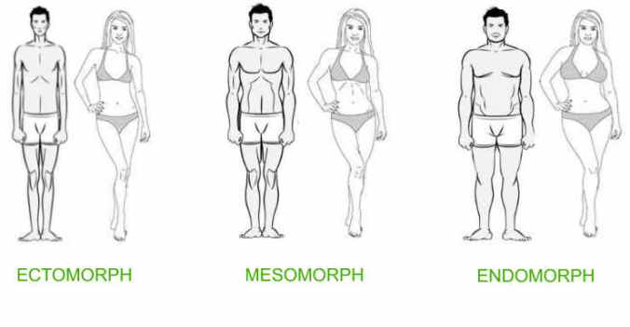

Women`s beauty canons through history
Prehistory (40.000-2000 BC): 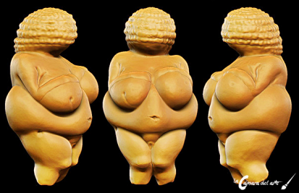
Tremendous breasts, belly, and hip. Twisted hair, sometimes gathered in a bun. Reproductive organs strongly marked.
Ancient Egypt (5.300-30 BC):
Slender, narrow shoulders, small breasts, high waist, symmetrical face, big eyes
Ancient Greece (1000-320 BC):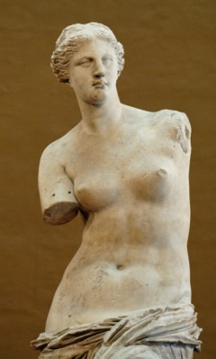
Plump full bodied and light skin. Beauty in ancient Greece meant plump and full-figured bodies. The standards of proportion and physical perfection were only for males. Women were considered deformed males.
Ancient Rome (400 BC-476 AD):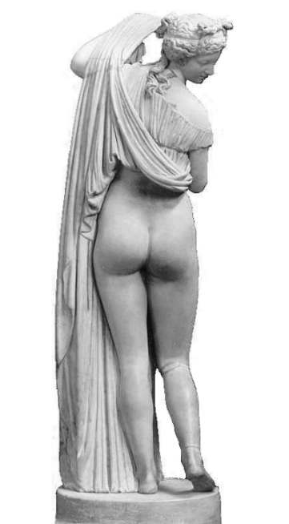
Flat curves, curly fair hair and white skin. Thin bodies were considered a sign of disease. Paleness of the skin was seen as a symbol of distinction.
Middle Ages (5th-14th centuries):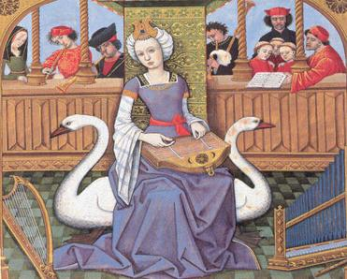
The ideal depiction of a woman had childish appearance: stylized silhouette, slender, without hips, with blonde hair and a bit bloated belly.
Renaissance (15th, 16th centuries):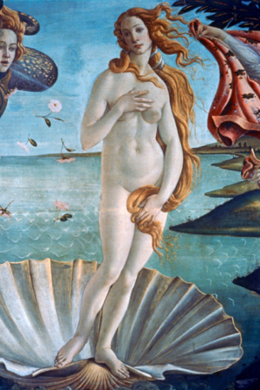
Renaissance in Italy meant a rounded body, including full hips and large breasts. Pale skin, strawberry blonde hair, and high foreheads were all thought of as the height of physical beauty.
Baroque (17^{th,} 18Th centuries): 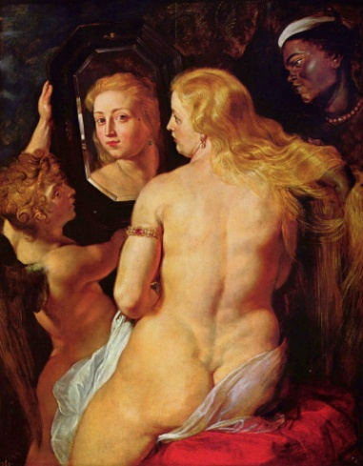
Thick hips, a rounded backside, large breasts and a non-narrow waistline. The corset appears and the hourglass-shape is imposed, that means narrow waist and rounded body.

Neoclassicism (1730-1820):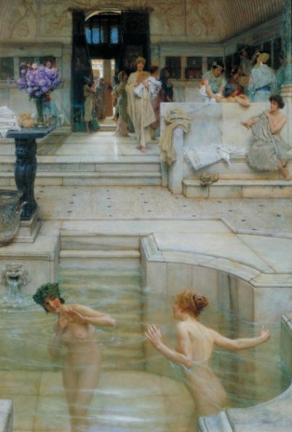
Large breasts, widen hips, and tight waist. The style of the time reflected women’s motherly position in society. Women wore corsets to clinch their waists as tightly as possible, creating an hourglass figure. These corsets physically restrained women’s range of motion, flaunting their separation from physical labor. Women also wore their hair long as a symbol of femininity.

Romanticism (from the late of 18th century until the middle of 19th century):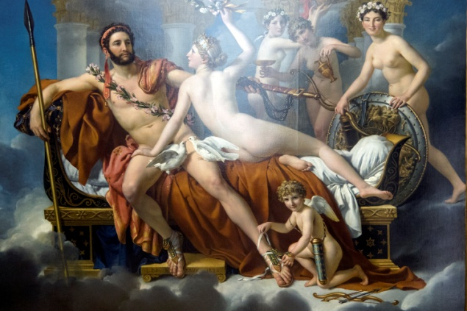
Bust and hips are likely to be the same width; legs tend to be longer than the torso, fragile figure. It highlights the delicate and pale appearance of the woman. Women drink large amounts of vinegar and lemon to fight the curves and to appear unhealthy.
Realism (19th century):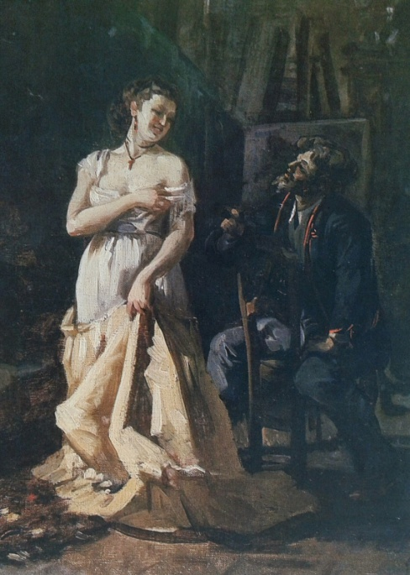
Attractive, healthy woman's figure, which was an hourglass shape and good shoulders. The exuberance of forms became a sign of welfare and respectability. With the industrialization the middle class improves its buying power that allows it to travel and to visit remote countries whose women will be represented in many paintings.
Cubism (1907-1914): 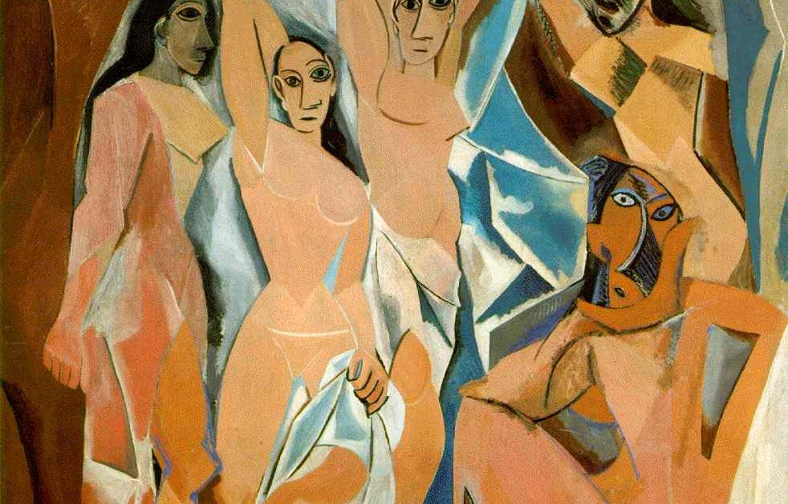
The female body is reduced to angular shapes where we can see: slim silhouettes, widen hips, tight waist, presence of breasts and the pubic area.

Roaring Twenties (c. 1920s)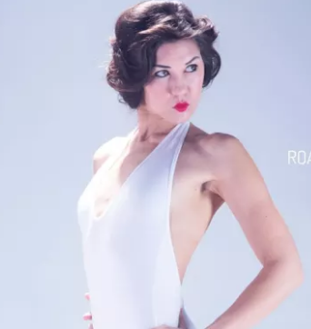
Flat chested, downplayed waist, short bob hairstyle, boyish figure, curve less.

Golden Age Of Hollywood (c. 1930s - 1950s)
Curvy, hourglass figure, large breasts, slim waist.

Swinging Sixties (c. 1960s):
Willowy, tall, tin, long, slim legs, adolescent physique.

Supermodel Era (c. 1980s):
Athletic, svelte, curvy, tall, toned arms.

Heroin Chic (c. 1990s):
Waifish, extremely thin, translucent skin, androgynous.

Postmodern Beauty (c. 2000s - Today):
Thigh gap, flat stomach, large breast and butt, healthy skinny. Women in the 2000s have been bombarded with so many different requirements of attractiveness. Women should be skinny, but healthy; they should have large breasts and a large butt, but a flat stomach.

Men`s beauty canons through history
Prehistory (40.000-2000 BC):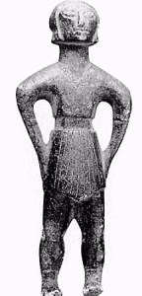
The ideal man at the time was heavy and strong.
Classical world: Greece and Rome 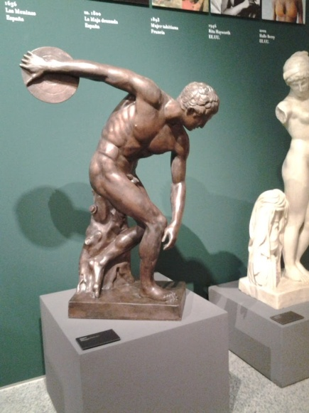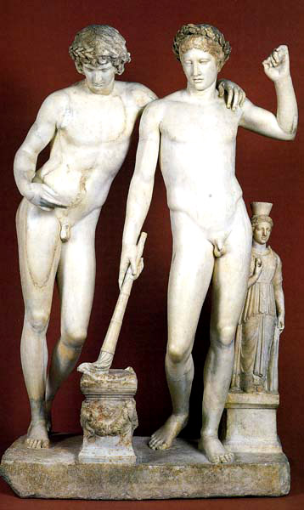
Lightly muscled, had low body fat, heavy shoulder musculature to keep weighty armor up. the ideal man was muscular and lean. An Apollo's belt (sometimes called Adonis belt) is that abdominal V muscle many guys try to achieve. You'll find a wide array of modern workouts that try to get 21st century men in the same shape as the ideal of ancient Greece.
Middle Ages (5th-14th centuries)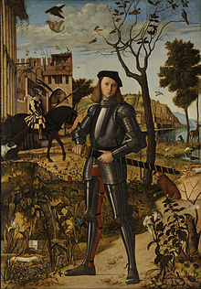
The style of masculine beauty tends to an almost angelically clear and smooth skin, with a slight fleshiness that belies poverty.
Renaissance (15th, 16th centuries):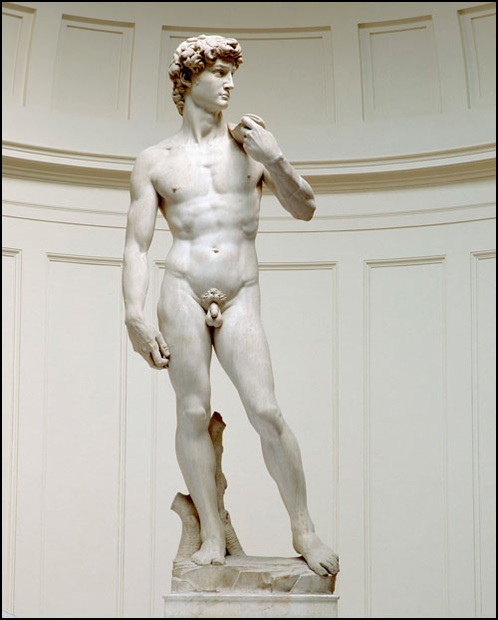
Return to classical ideals: body with perfect proportions.
Baroque (17^{th,} 18Th centuries):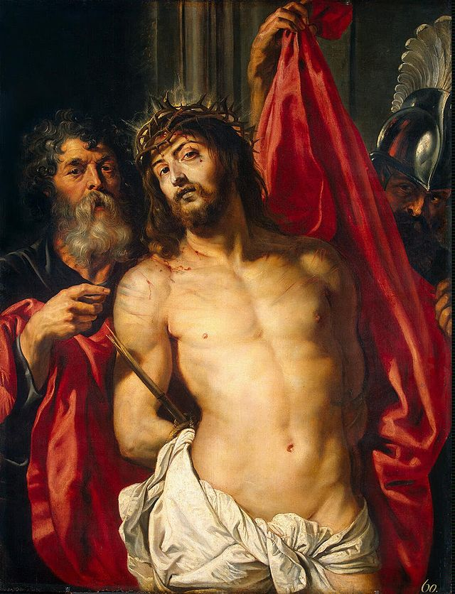
One’s duty is to look prosperous and well fleshed in clothing.
Neoclassicism (1730-1820):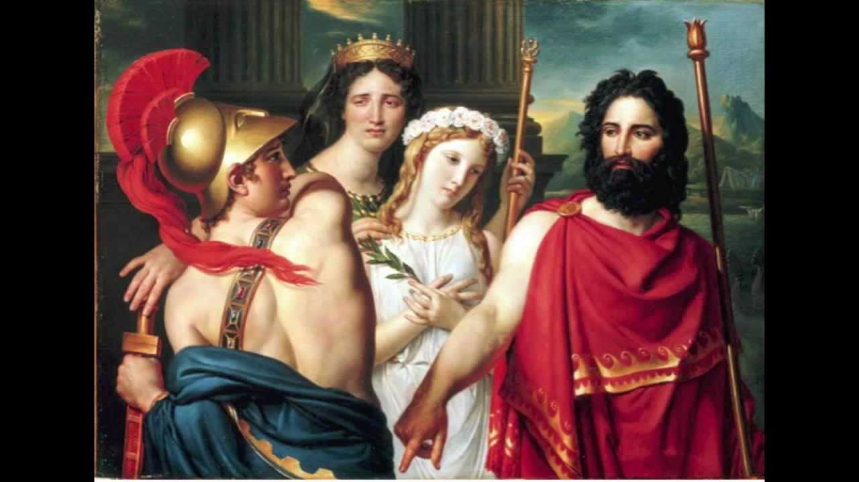 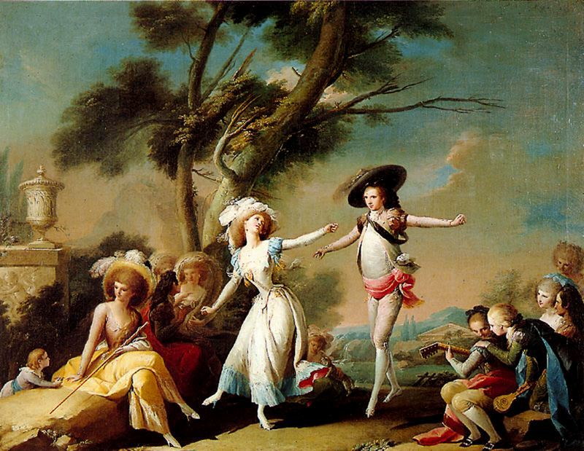
Appreciation of people being well fleshed to indicate prosperity. On the other hand, the Macaronis look became so extreme with huge wigs, heavily made up faces, and ornate and ridiculous accessories that by 1775 people began to describe the look as "effeminate."
Romanticism (from the late of 18th century until the middle of 19th century):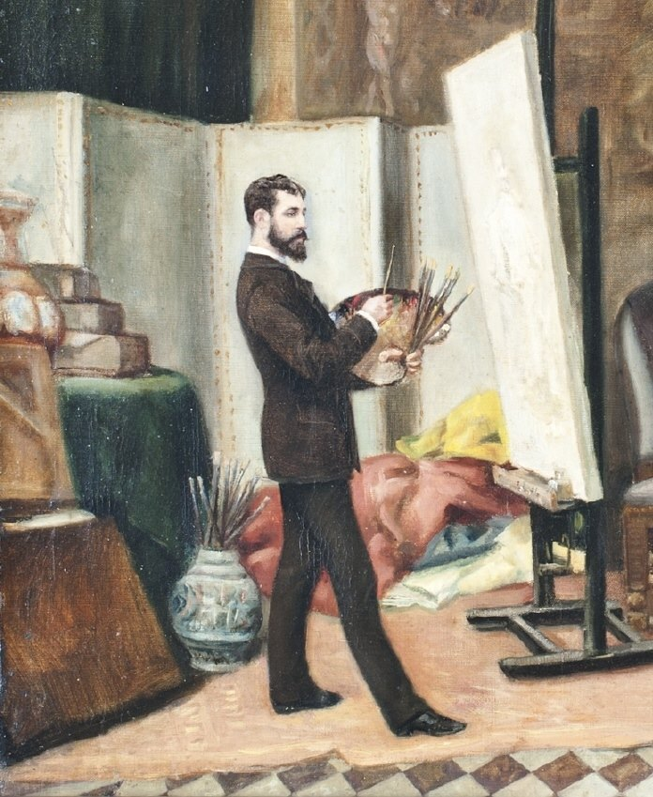
The men shown epitomise this physical aspect, it is almost effete and feminine, which would mean they’d have little time to build muscle — that was the preserve of those who had to work for a living.
Hollywood (1920s)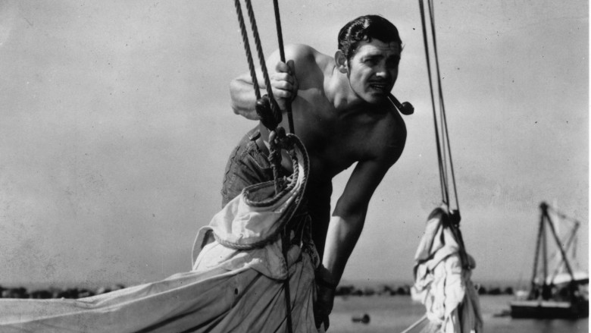
A slim dashing figure was all the rage.
Charles Atlas (1930s-40s)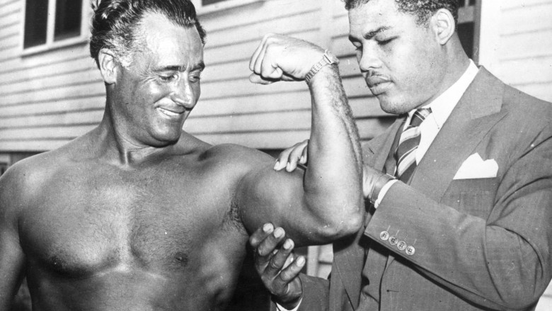
Charles Atlas built them back up. Atlas was the first fitness guru and he worked incredibly hard for his physique. The idea that physical size could give you confidence was a powerful message." This started the first real fitness movement and began the trend towards men wanting to build up their physiques.

The Executive look (1950s-early 1960s):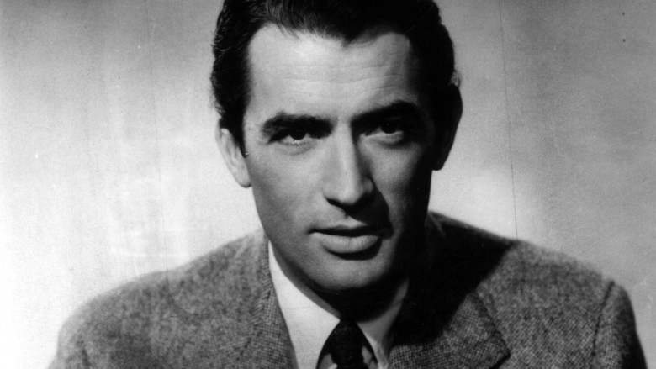
Now that the war and depression were over, men were slightly less concerned with looking strong, but they did want to look big. In came the era of the Executive look, where men aimed to pose large, imposing figures. Suit jackets and overcoats had large boxy shoulders and a much looser fit than we'd see today. There was some emphasis on a trim waist, but the biggest asset was broad shoulders on a tall build.
1960s: 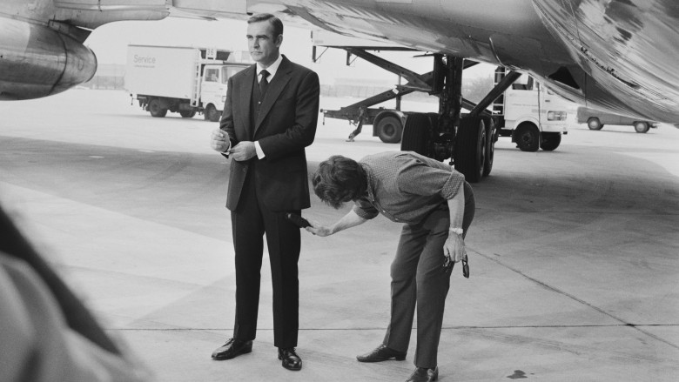
The '60s shook off some of the formal air from the previous decade and suave, stylish men became fashionable. Men should still have broad shoulders and a flat stomach, but cut biceps and a six-pack was definitely not required.
Late 1960s-early 1970s:
For the first time since the age of the Macaronis, a less ruggedly masculine look came into style. Androgyny was huge for David Bowie and even Mick Jagger, who according enjoyed playing with looks that were both masculine and feminine. A thin, lanky frame became popular for followers of this look. Though unisex clothes became popular, they didn't really affect gender roles or decrease the importance of having a perfect body. Not all men were into the gender bending idea. They sported mustaches and wholeheartedly embraced the new trend of bell bottoms. Men's clothes were tighter fitting than years past, so a reasonably toned physique was in fashion.
1980s: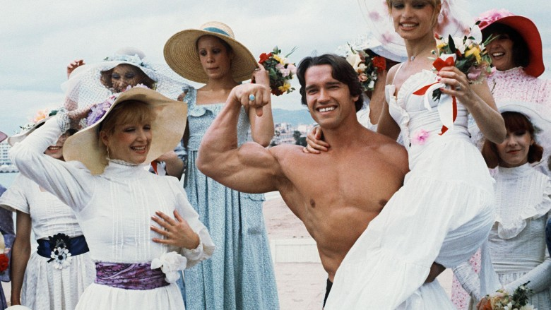
Men's style went in two completely different directions in the '80s. One path had the hard bodied men exemplified by action heroes like Sylvester Stallone and Arnold Schwarzenegger. In her book Hard Bodies, Susan Jeffords wrote that the action films of the time mixed with Reagan's "return to values" perfectly defined the masculine ideal of the '80s. For this decade, having broad shoulders but a bit of a pudge wouldn't cut it anymore. The Reagan era brought in a new wave of heightened masculinity where hitting the gym hard made you more of a man.
More and more muscular (1990-2017):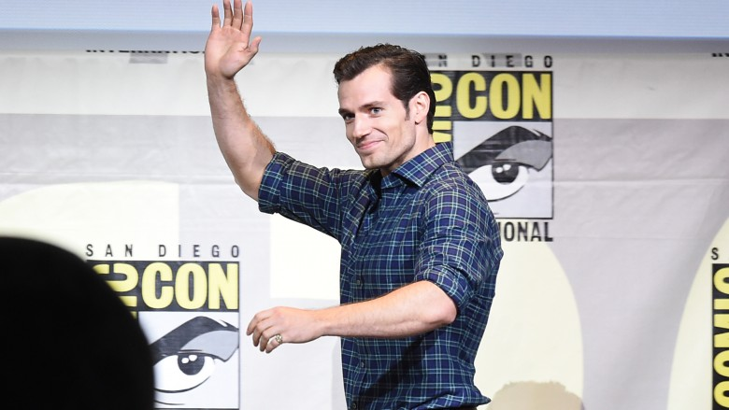
With its beginning in the '80s, the idea of a cut, very muscular man being the ideal has only increased over time. You can see this in the timeline of superhero movies.
Though this is something women have been dealing with for decades, men are now getting near equal media pressure to have unattainable bodies. And they might be able to blame Superman.

