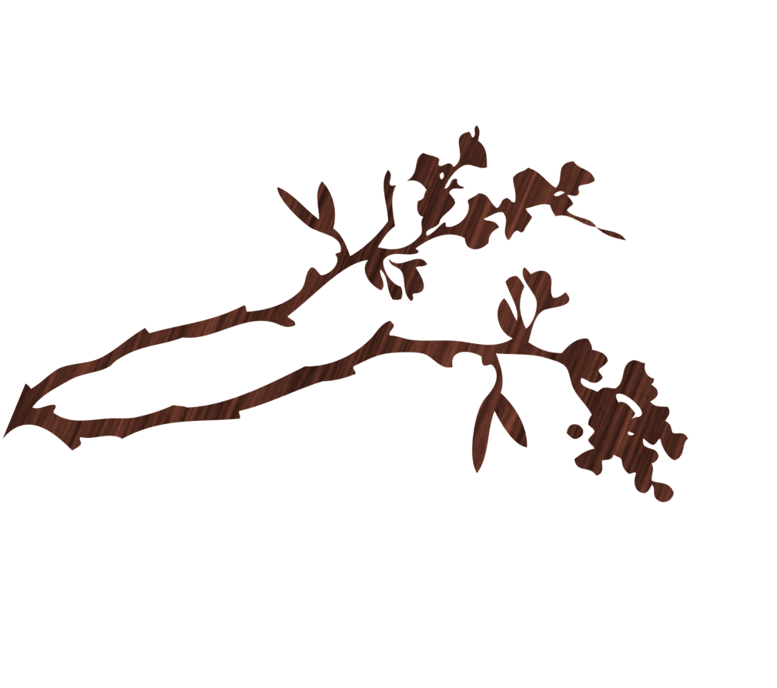B.I.S. (BEAUTY IS SUBJECTIVE)
Erasmus+ BIS project (COFUNDED BY THE ERASMUS+ PROGRAMME OF THE EUROPEAN UNION)

erasmus+ PROject
Logo contest
1. - Contest is open to all students of three High Schools (ATHENEUM POTTELBERG in Kortrijk, Belgium; TITO LIVIO in Milan, Italy; URBI in Basauri, Spain)
2. - Contestants may submit up the original entries. Submission of entries is up to the 30 November, 2017.
3. - Logo should embody or portray the content of BIS Project: BEAUTY CANONS THROUGH HISTORY.
4. - Each entry may be picture or text-based or in combination. Entries may be done by free-hand in markers, ink, oil or acrylic or by computer. There are no color restrictions. File formats: gif, jpeg, png, raw,tiff, bmp. In DINA5.
5. - Each logo should be accompanied with a brief explanation/ description to provide context to the suggested logo (i.e. explanation of the colors, symbols used, pictures, images, etc.)
6.-The logo should carry the name of the artist. The design of the logo must be certified original. The designer is responsible for proving its authenticity, should any complaints may arise due to similarities, likeness or comparison of the designs.
Erasmus+ BIS project (COFUNDED BY THE ERASMUS+ PROGRAMME OF THE EUROPEAN UNION)

7. - Winning entry will be used as the official logo of BIS ERASMUS+ Project. It will appear in every single document related to the Project.
8.- The BIS ERASMUS+ project representatives of the target students and the key teachers reserve the right to disqualify any entry for different reasons such as offenses, rude words, not adequacy with the content of the Project…
9. - In order to choose the winner, the presented logos will be voted during the first two weeks of December, 2017.
10. - The representatives of the target groups will decide the final winner.
11. – The logos will be displayed in the websites of the three High Schools (Atheneum Pottelberg, Titol Livio, Urbi) and other social media accounts.
12. - 100 euros cash prize awaits the winner and the diploma.
13. - Logos may be submitted in an envelope to the box in the hall of the school with the label FOR LOGO DESIGN CONTEST, with the name and contact number of the author. Logos may send too through these email address: biserasmus1719@gmail.c0m

