INCLUSION THROUGH EDUCATION AT SCHOOL
By Giorgia Bossini and Chiara Capuzzi, Liceo “Bagatta”, Italy

Toledo guiding principles on teaching about religions and beliefs in public schools. (2007) It is important for young people to acquire a better understanding of the role that religions play in today’s pluralistic world. The Toledo Guiding Principles have been prepared in order to contribute to an improved understanding of the world’s increasing religious diversity and the growing presence of religion in the public sphere. (a European Legislation Act) .
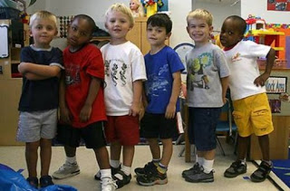
School is recognized as the best environment helping children and teens to develop the social value of education and the crucial role of school in education; everyone may interface with different kinds of diversity. One of the main purposes of education is to create thoughtful citizens. Education has to teach how to live well together across religious, ethnic and other cultural differences.
Starting from nursery school, Italy has a special teaching plan finalized to integration of foreign children, who grew up in a different socio-cultural background. They need open-minded educators with deep intercultural knowledge and they need to be respectful of diversity. Catholic Religion is taught two hours per week at Primary school and one hour per week at the Middle School. All the students whose religion is different from the Catholic one can choose to attend another subject called Alternative Activities to Catholic Religion.
In the last few months the Italian Minister of Education, Mr Bussetti, has been preparing a new bill which includes 33 hours a year of civics and an exam concerning this subject at the end of high school. Civics main target is promoting tolerance, lack of prejudice and broad-mindedness to increase bilateral partnership and mutual development of people inside the community they live. Students are involved to become active citizens, aware of their rights and capable of taking and their community responsibility in their own nation, Europe and worldwide.
In conclusion, the European Union is dealing with refugees and their inclusion in the society from their early days at school, a foundation for a peaceful and united world.

