PORTUGUESE CHRISTMAS EVE COD RECIPE

INGREDIENTS
- 2 pounds salt cod, cut into 6 or 8 fillets
- 1 1/2 pounds potatoes, boiled in their skins and peeled while still hot
- 1 large head cabbage, cut into 8 pieces, blanched until just tender
- 12 hard-boiled eggs, sliced in half
- For the sauce
- 3 tablespoons olive oil, per person
- 1 clove garlic, per person, minced
- 1 teaspoon wine vinegar, per person (or less to taste)

How to prepare the meal

- 1. Rinse the cod under cold running water to remove any surface salt. Place the fish pieces in a large nonreactive pot, cover with water and refrigerate (covered) for 24 hours, changing the water several times.
- 2. Pour off the water, and refill with enough boiling water to cover the fish by several inches. Cover the pan with a heavy dishtowel and leave the cod to soak in the hot water for 30 minutes. (If the fish isn’t cooked fully, simmer gently until finished.) Drain the cod, and remove any bits of skin or bone.
- 3. To make the sauce, bring the oil and garlic to a boil in a small saucepan, remove from the heat, add the vinegar, beat well and serve in a sauceboat.

NOTE
- All these items must be cooked at the last minute, just before serving, so as to be brought to the table at their best.

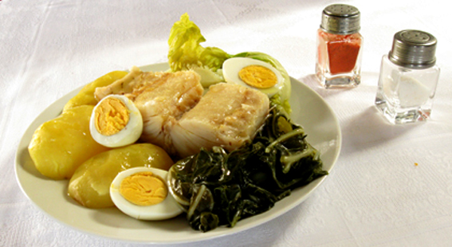

SONHOS – PORTUGUESE CHOUX PASTRY
DREAMS

INGREDIENTS
- 6 extra large eggs
- 2 cups flour
- 3/4 cup water
- 3/4 cup milk
- 1/2 tsp salt
- 1/2 stick butter or margarine
- 1 slice lemon rind
- Sugar and Cinnamon for topping

How to prepare the Meal
- In a large heavy pan, place the water, milk, butter, lemon rind, and salt over medium heat and bring to boiling point.
- Stir in the flour and stir with a wooden spoon until the flour becomes a soft dough which turns into a ball shape that separates from the sides of the pan. This is similar to a basic Choux paste that is used for baking eclairs and cream puffs.
- Remove the dough from heat and place into a medium bowl. Let the dough cool for a few minutes.
- Beat in one egg at a time making a smooth batter.
- Heat the oil to 365 degrees.
- Shape the dough into round doughnuts by using 2 large tablespoons.
- Fry the dough by 4 or 5 pieces at time until golden brown while keeping the heat at a steady temperature. NOTE: If you find the dough is turning brown too quickly reduce the heat to a lower setting. They should cook slowly.
- Pierce the sonhos slightly as they cook. NOTE: If you find they are too dark and still raw in the middle, lower the heat so they cook through at a slower temperature.
- Drain on a new clean brown paper lunch bags or on paper towels.
- While still hot, roll the sonhos in a mixture of sugar and cinnamon.

LEITE CREME – PORTUGUESE MILK CUSTARD

INGREDIENTS
- 2 tablespoons of Corn starch
- 5 tablespoons of sugar
- 3 egg yolks
- 2 cups whole milk
- 1/2 stick of cinnamon
- 1 slice lemon peel

How to Prepare the meal
- In a medium bowl, beat the eggs and the milk with a whisk until well incorporated.
- Add the cornflour and sugar and mix well.
- Add the lemon peel and cinnamon stick and heat in a saucepan on low – medium heat stirring continuously. Do not let the custard boil. If it begins to boil remove from heat to cool down while stirring.The custard should be thick enough to coat the spoon like pudding.
- Pour into a serving platter or individual ramekins and let cool to room temperature.
- When the custard has cooled, sprinkle sugar on top and brown slightly in oven broiler or with a cooking torch.

