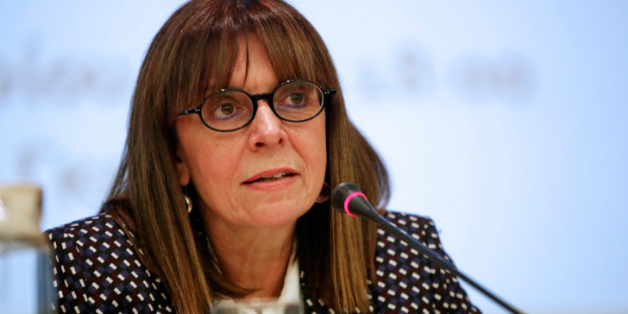

The new President's first message:

"It is time for women to realize that they can reach whatever goal they want by their own right, without being hindered only in the fact that they are women".

However, this is not the only "first" for the new President of the Hellenic Republic, as she has also been the first woman to be President of Greece's Supreme Administrative Court (Counsil of State) since October 2018.

