THEODORA
E1
2 P.S. ARTEMIDOS
GREECE
2021

JANUARYY

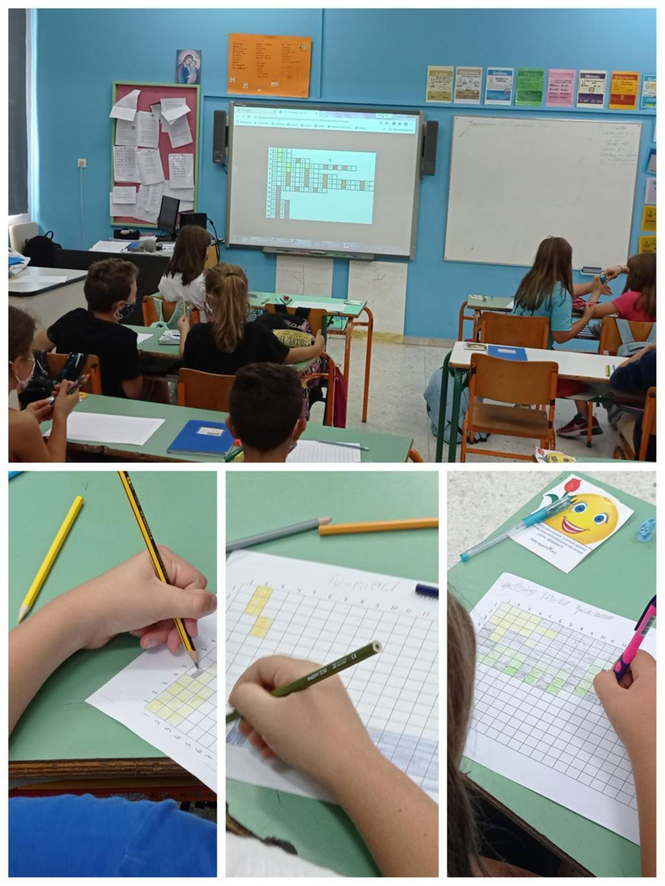

M | T | W | T | F | S | S
 |  |  |  | 1 | 2 | 3
4 | 5 | 6 | 7 | 8 | 9 | 10
11 | 12 | 13 | 14 | 15 | 16 | 17
18 | 19 | 20 | 21 | 22 | 23 | 24
25 | 26 | 27 | 28 | 29 | 30 | 31

1st January | New Year’s Day
30th January | Three Hierarchs Day
2021

FEBRUARY

M | T | W | T | F | S | S
1 | 2 | 3 | 4 | 5 | 6 | 7
8 | 9 | 10 | 11 | 12 | 13 | 14
15 | 16 | 17 | 18 | 19 | 20 | 21
22 | 23 | 24 | 25 | 26 | 27 | 28

2021

MARCH

M | T | W | T | F | S | S
 | 1 | 2 | 3 | 4 | 5 | 6
7 | 8 | 9 | 10 | 11 | 12 | 13
14 | 15 | 16 | 17 | 18 | 19 | 20
21 | 22 | 23 | 24 | 25 | 26 | 27
28 | 29 | 30 | 31

15th March | Ash Monday
25th March | National Holiday

=

2021
APRIL

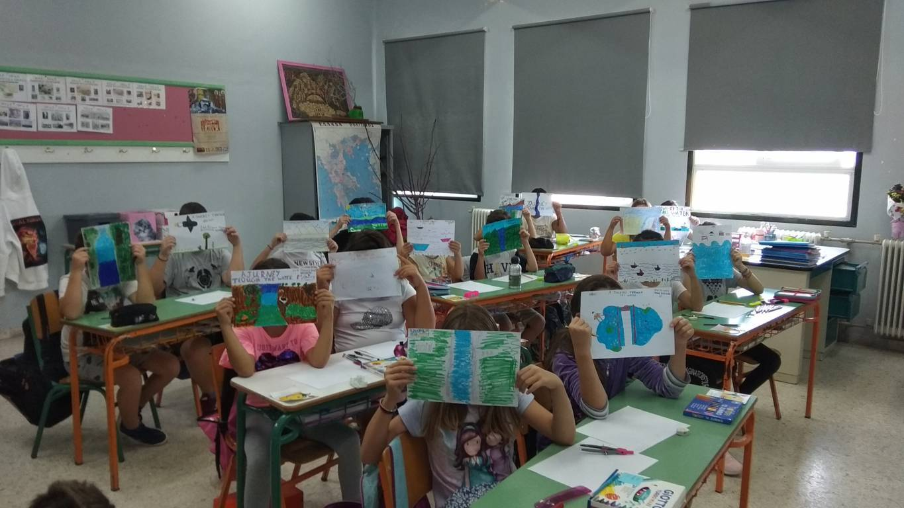

M | T | W | T | F | S | S
 |  |  |  | 1 | 2 | 3
4 | 5 | 6 | 7 | 8 | 9 | 10
11 | 12 | 13 | 14 | 15 | 16 | 17
18 | 19 | 20 | 21 | 22 | 23 | 24
25 | 26 | 27 | 28 | 29 | 30

30th April | Good Friday

2021

MAY

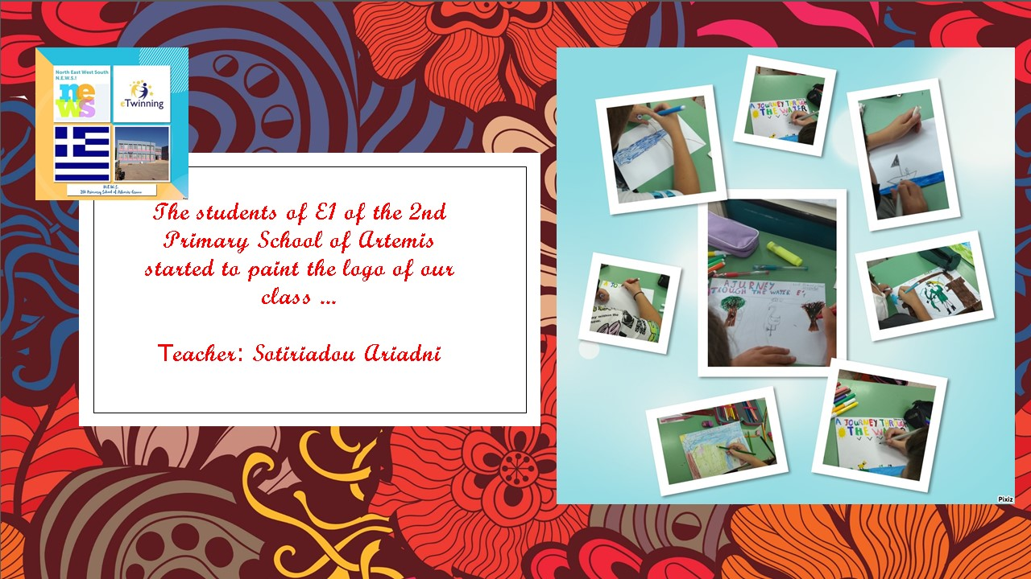

M | T | W | T | F | S | S
 |  |  |  |  | 1 | 2
3 | 4 | 5 | 6 | 7 | 8 | 9
10 | 11 | 12 | 13 | 14 | 15 | 16
17 | 18 | 19 | 20 | 21 | 22 | 23
24 | 25 | 26 | 27 | 28 | 29 | 30
31

 | 1st May | Good Saturday-Labour Day
 | 2nd May | Easter
3th May |  | Easter Monday
2021
JUNE
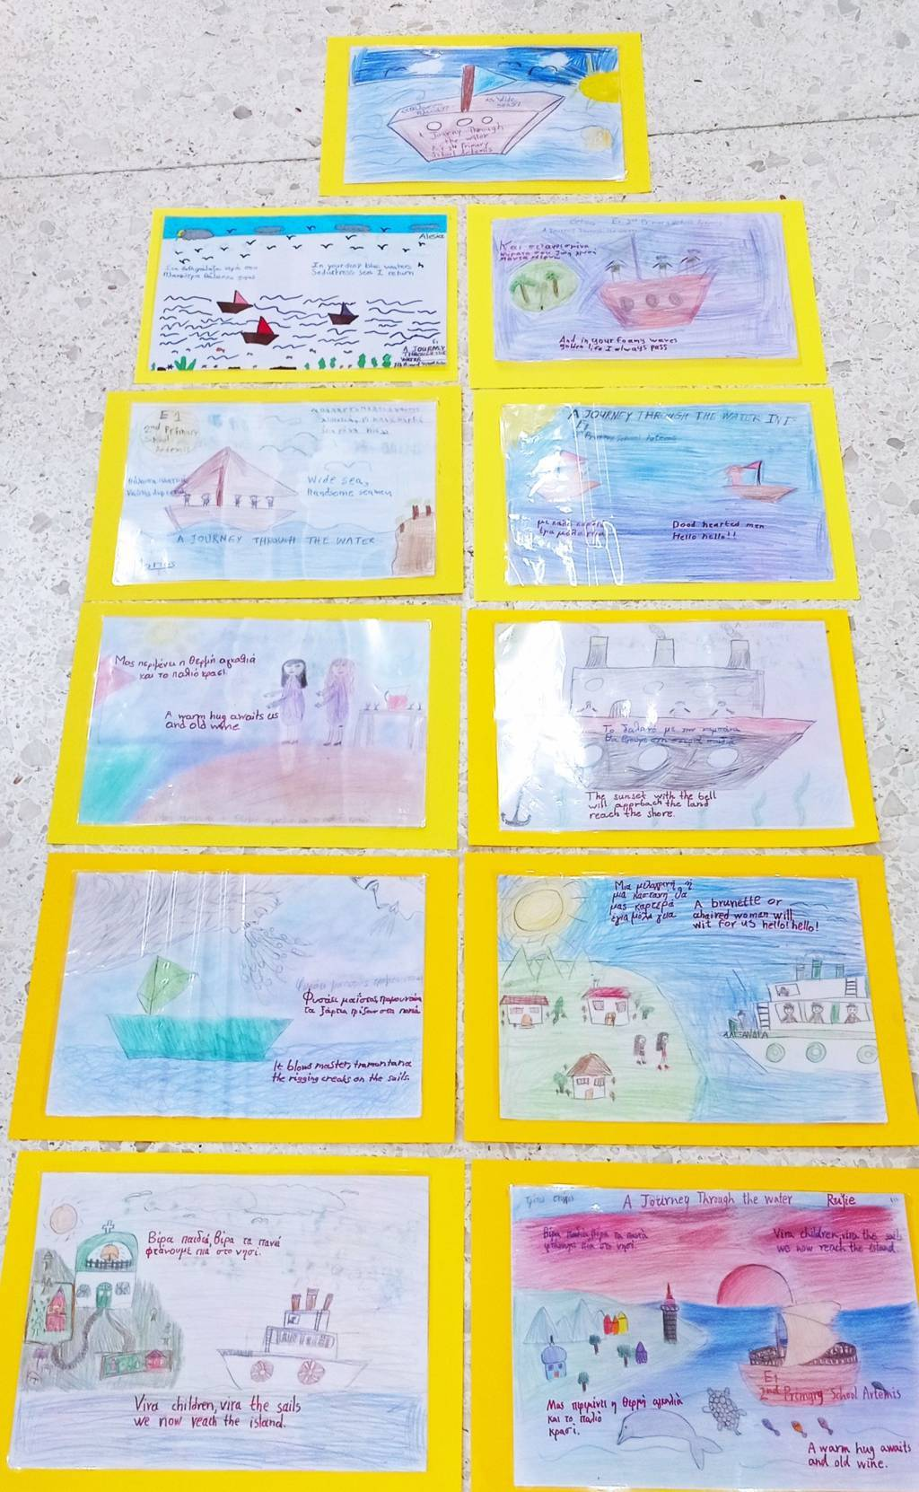

M | T | W | T | F | S | S
 | 1 | 2 | 3 | 4 | 5 | 6
7 | 8 | 9 | 10 | 11 | 12 | 13
14 | 15 | 16 | 17 | 18 | 19 | 20
21 | 22 | 23 | 24 | 25 | 26 | 27
28 | 29 | 30

21th June | Whit Monday
2021
JULY

M | T | W | T | F | S | S
 |  |  | 1 | 2 | 3 | 4
5 | 6 | 7 | 8 | 9 | 10 | 11
12 | 13 | 14 | 15 | 16 | 17 | 18
19 | 20 | 21 | 22 | 23 | 24 | 25
26 | 27 | 28 | 29 | 30 | 31
2021
AUGUST

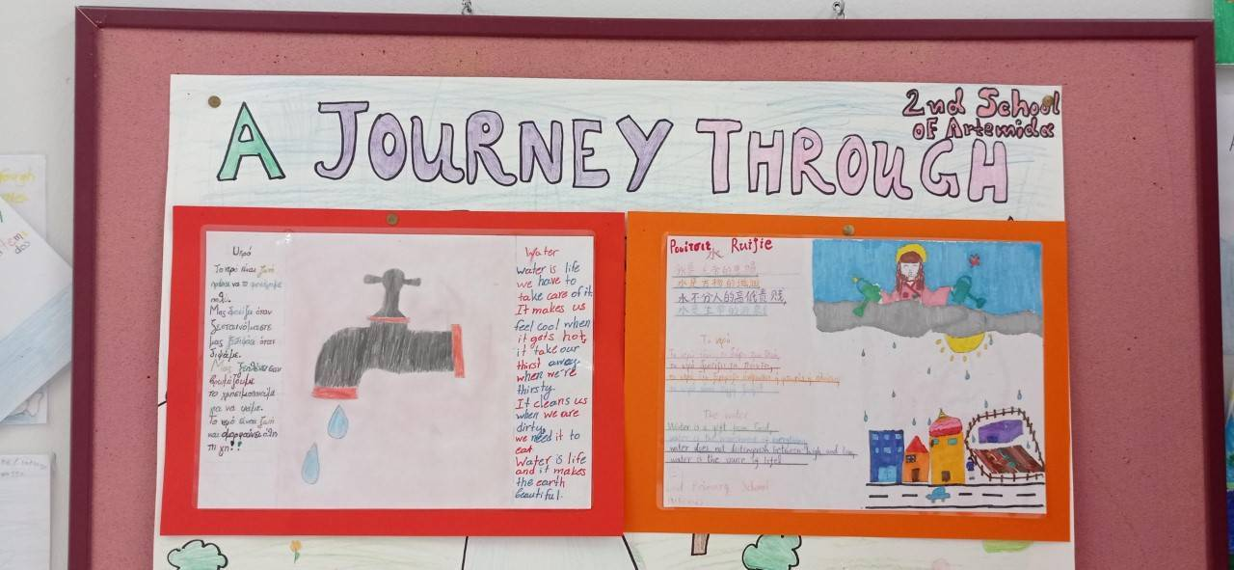

M | T | W | T | F | S | S
 |  |  |  |  |  | 1
2 | 3 | 4 | 5 | 6 | 7 | 8
9 | 10 | 11 | 12 | 13 | 14 | 15
16 | 17 | 18 | 20 | 21 | 22 | 23
24 | 25 | 26 | 27 | 28 | 29 | 30
31

15th August | Assumption

2021

SEPTEMBER

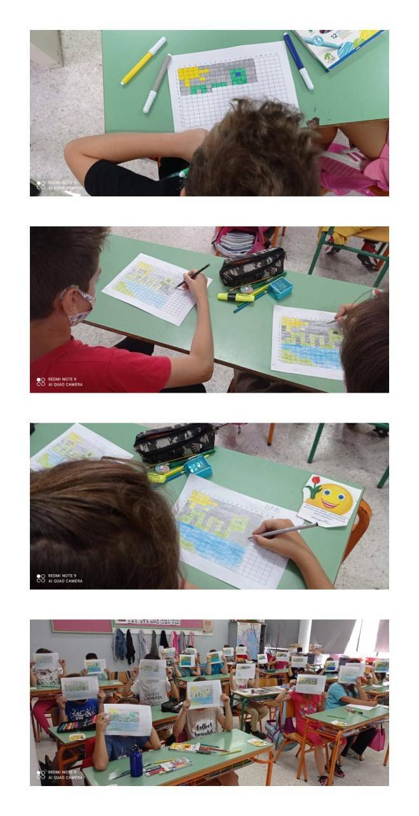
M | T | W | T | F | S | S
 | 1 | 2 | 3 | 4 | 5 | 6
7 | 8 | 9 | 10 | 11 | 12 | 13
14 | 15 | 16 | 17 | 18 | 19 | 20
21 | 22 | 23 | 24 | 25 | 26 | 27
28 | 29 | 30

OCTOBER
2021

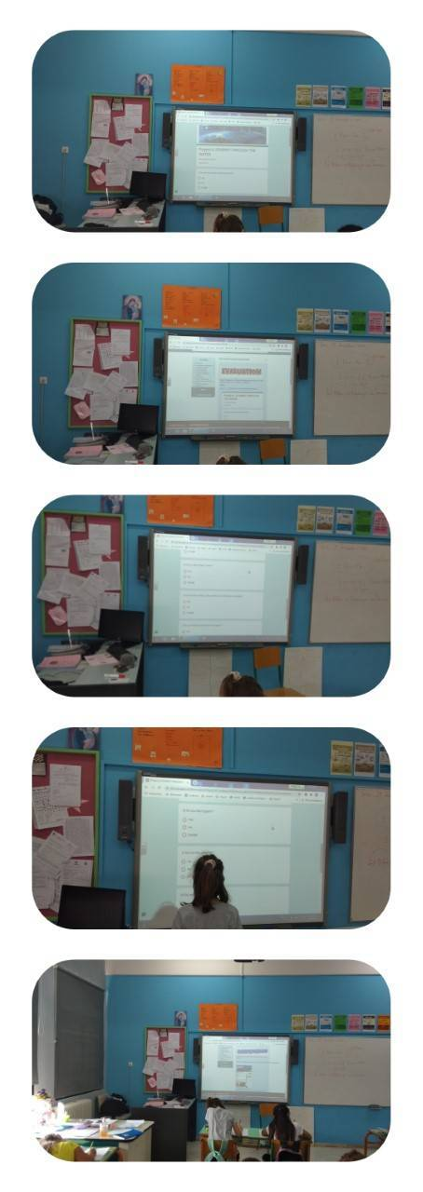

M | T | W | T | F | S | S
 |  |  | 1 | 2 | 3 | 4
5 | 6 | 7 | 8 | 9 | 10 | 11
12 | 13 | 14 | 15 | 16 | 17 | 18
19 | 20 | 21 | 22 | 23 | 24 | 25
26 | 27 | 28 | 29 | 30 | 31

28th October | National holiday
2021
NOVEMBER

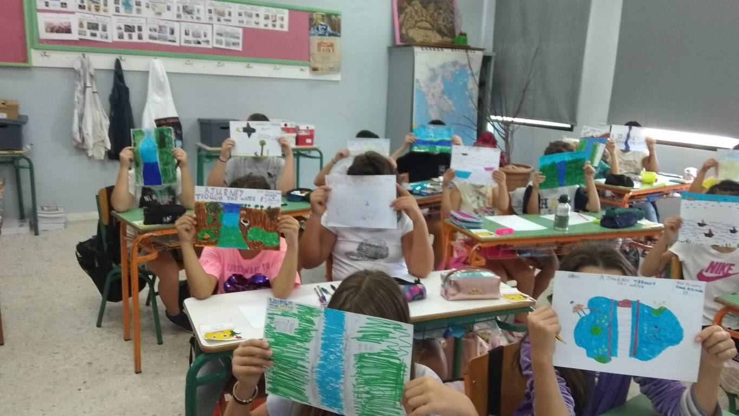

M | T | W | T | F | S | S
 |  |  |  |  |  | 1
2 | 3 | 4 | 5 | 6 | 7 | 8
9 | 10 | 11 | 12 | 13 | 14 | 15
16 | 17 | 18 | 19 | 20 | 21 | 22
23 | 24 | 25 | 26 | 27 | 28 | 29
30

17th November | Aniversary day of polytexneio
2021
DECEMBER

M | T | W | T | F | S | S
 | 1 | 2 | 3 | 4 | 5 | 6
7 | 8 | 9 | 10 | 11 | 12 | 13
14 | 15 | 16 | 17 | 18 | 19 | 20
21 | 22 | 23 | 24 | 25 | 26 | 27
28 | 29 | 30 | 31

25th December | Christmas
26th December | Boxing Day

