MYRTO- E1
2 P.S. ARTEMIDOS
GREECE
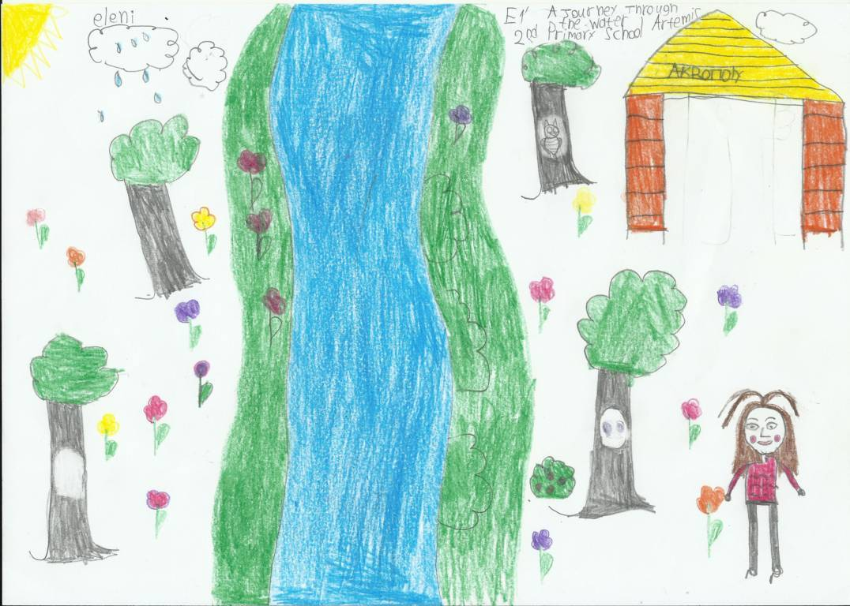
JANUARY
2021
Monday | Tuesday | Wednesday | Thursday | Friday | Saturday | Sunday
 |  |  |  | 1 | 2 | 3
4 | 5 | 6 | 7 | 8 | 9 | 10
11 | 12 | 13 | 14 | 15 | 16 | 17
18 | 19 | 20 | 21 | 22 | 23 | 24
25 | 26 | 27 | 28 | 29 | 30 | 31

January 1: New Year
January 6: Epiphany
January 30: Three Hierarchs

FEBRUARY
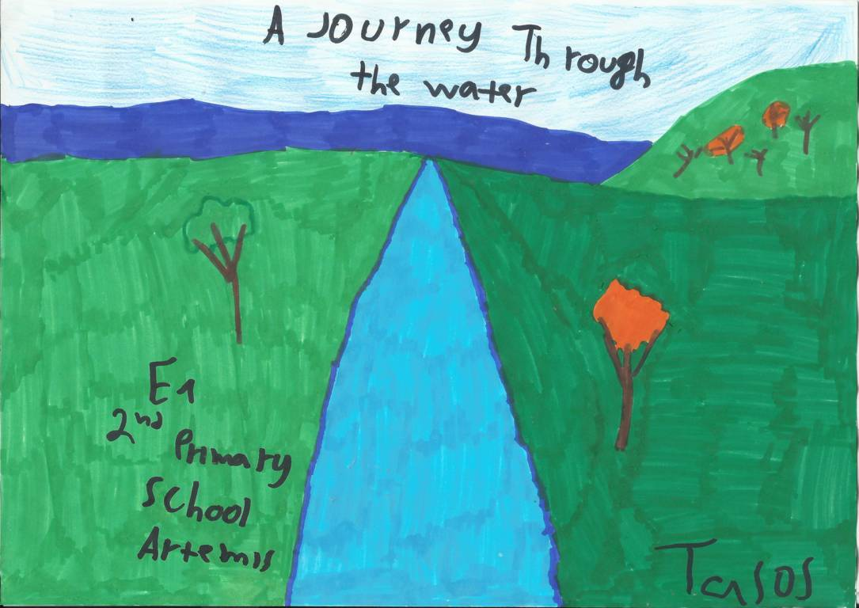

Monday | Tuesday | Wednesday | Thursday | Friday | Saturday | Sunday
1 | 2 | 3 | 4 | 5 | 6 | 7
8 | 9 | 10 | 11 | 12 | 13 | 14
15 | 16 | 17 | 18 | 19 | 20 | 21
22 | 23 | 24 | 25 | 26 | 27 | 28

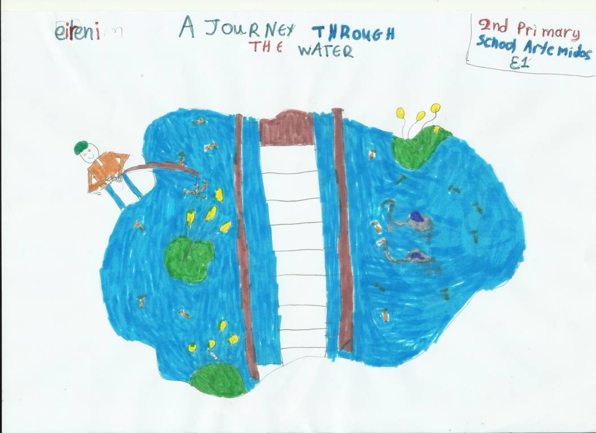
MARCH

Monday | Tuesday | Wednesday | Thursday | Friday | Saturday | Sunday
1 | 2 | 3 | 4 | 5 | 6 | 7
8 | 9 | 10 | 11 | 12 | 13 | 14
15 | 16 | 17 | 18 | 19 | 20 | 21
22 | 23 | 24 | 25 | 26 | 27 | 28
29 | 30 | 31
March 15: Shrove Monday
March 25: National Holiday

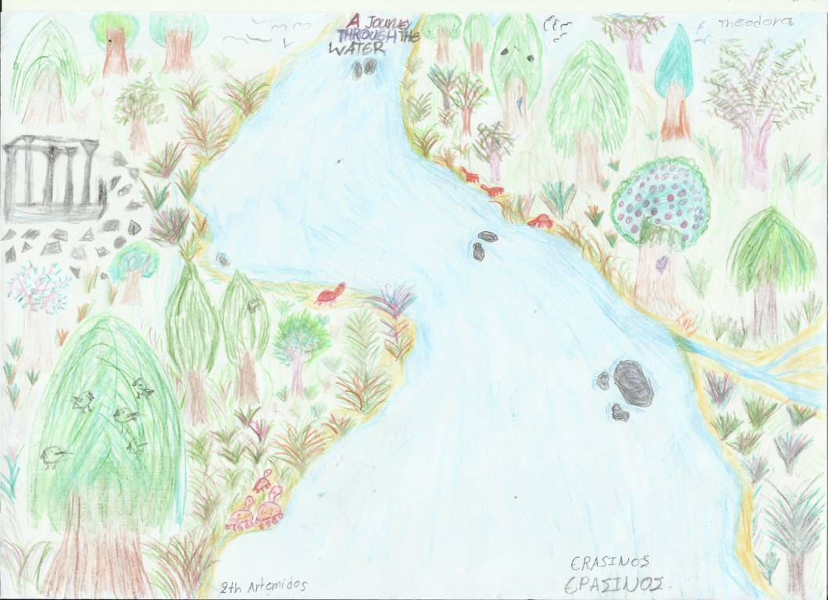
April

Monday | Tuesday | Wednesday | Thursday | Friday | Saturday | Sunday
 |  |  | 1 | 2 | 3 | 4
5 | 6 | 7 | 8 | 9 | 10 | 11
12 | 13 | 14 | 15 | 16 | 17 | 18
19 | 20 | 21 | 22 | 23 | 24 | 25
26 | 27 | 28 | 29 | 30

April 30: Good Friday

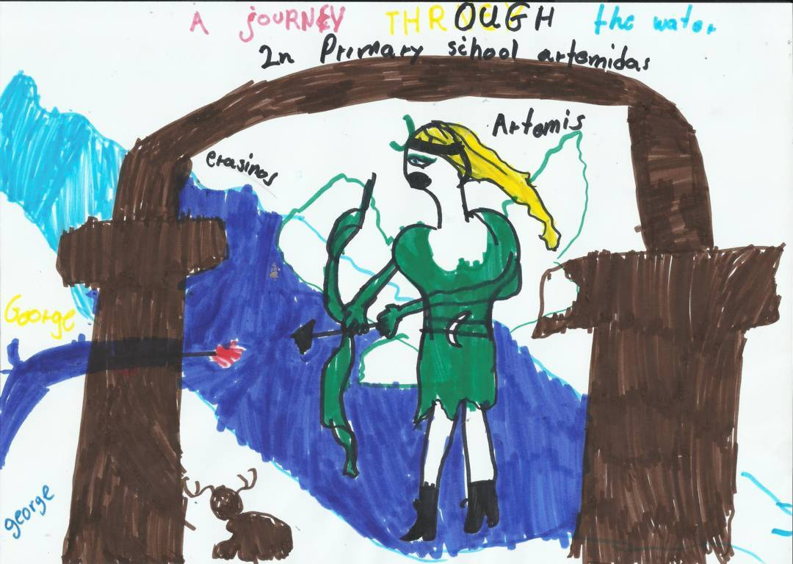
MAY

Monday | Tuesday | Wednesday | Thursday | Friday | Saturday | Sunday
 |  |  |  |  | 1 | 2
3 | 4 | 5 | 6 | 7 | 8 | 9
10 | 11 | 12 | 13 | 14 | 15 | 16
17 | 18 | 19 | 20 | 21 | 22 | 23
24 | 25 | 26 | 27 | 28 | 29 | 30
31

May 1: Holy Saturday and May Day
May 2: Easter Sunday
May 3: Easter Monday

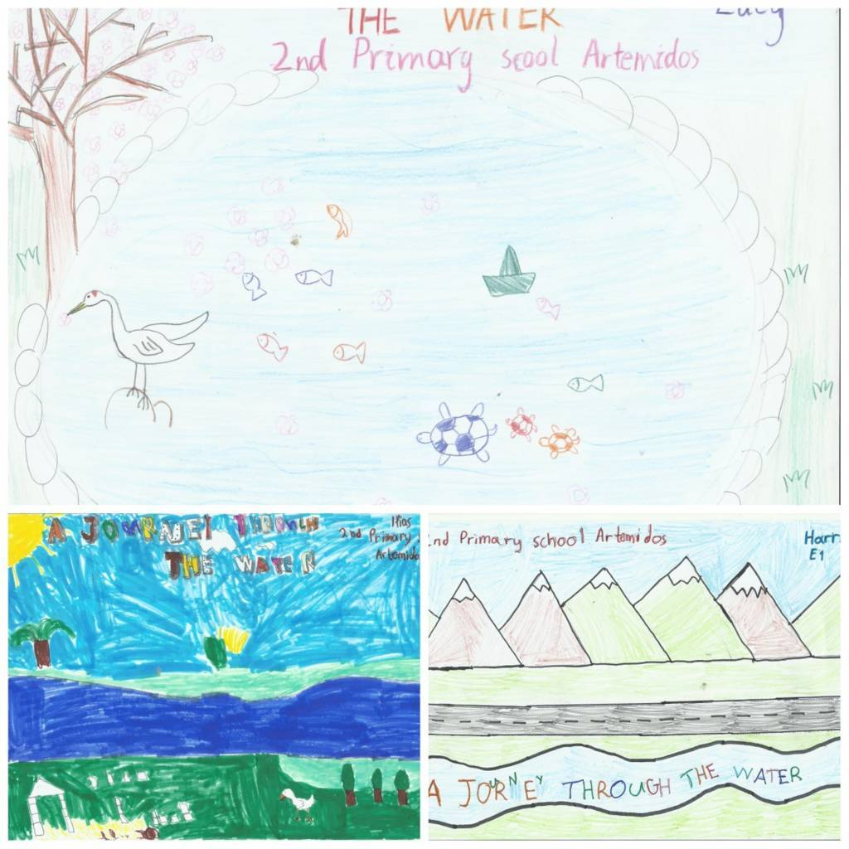
JYNE

Monday | Tuesday | Wednesday | Thursday | Friday | Saturday | Sunday
 | 1 | 2 | 3 | 4 | 5 | 6
7 | 8 | 9 | 10 | 11 | 12 | 13
14 | 15 | 16 | 17 | 18 | 19 | 20
21 | 22 | 23 | 24 | 25 | 26 | 27
28 | 29 | 30

June 21: Holy Spirit

JULY

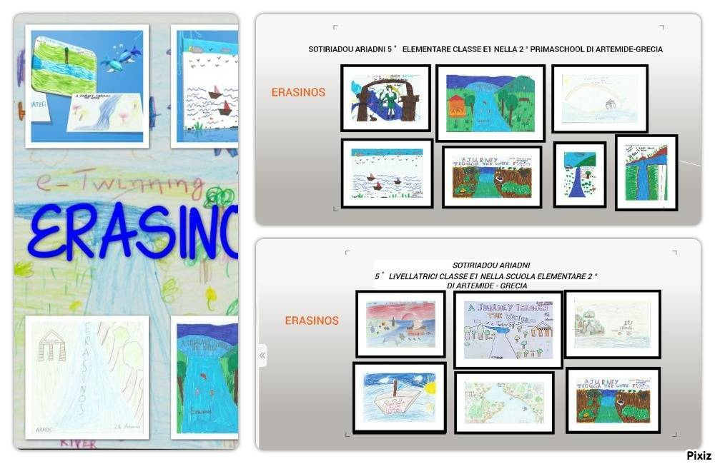

Monday | Tuesday | Wednesday | Thursday | Friday | Saturday | Sunday
 |  |  | 1 | 2 | 3 | 4
5 | 6 | 7 | 8 | 9 | 10 | 11
12 | 13 | 14 | 15 | 16 | 17 | 18
19 | 20 | 21 | 22 | 23 | 24 | 25
26 | 27 | 28 | 29 | 30 | 31

AUGUST

Monday | Tuesday | Wednesday | Thursday | Friday | Saturday | Sunday
 |  |  |  |  |  | 1
2 | 3 | 4 | 5 | 6 | 7 | 8
9 | 10 | 11 | 12 | 13 | 14 | 15
16 | 17 | 18 | 19 | 20 | 21 | 22
23 | 24 | 25 | 26 | 27 | 28 | 29
30 | 31

August 15: Assumption of the Virgin

SEPTEMBER

Monday | Tuesday | Wednesday | Thursday | Friday | Saturday | Sunday
 |  | 1 | 2 | 3 | 4 | 5
6 | 7 | 8 | 9 | 10 | 11 | 12
13 | 14 | 15 | 16 | 17 | 18 | 19
20 | 21 | 22 | 23 | 24 | 25 | 26
27 | 28 | 29 | 30

OCTOBER
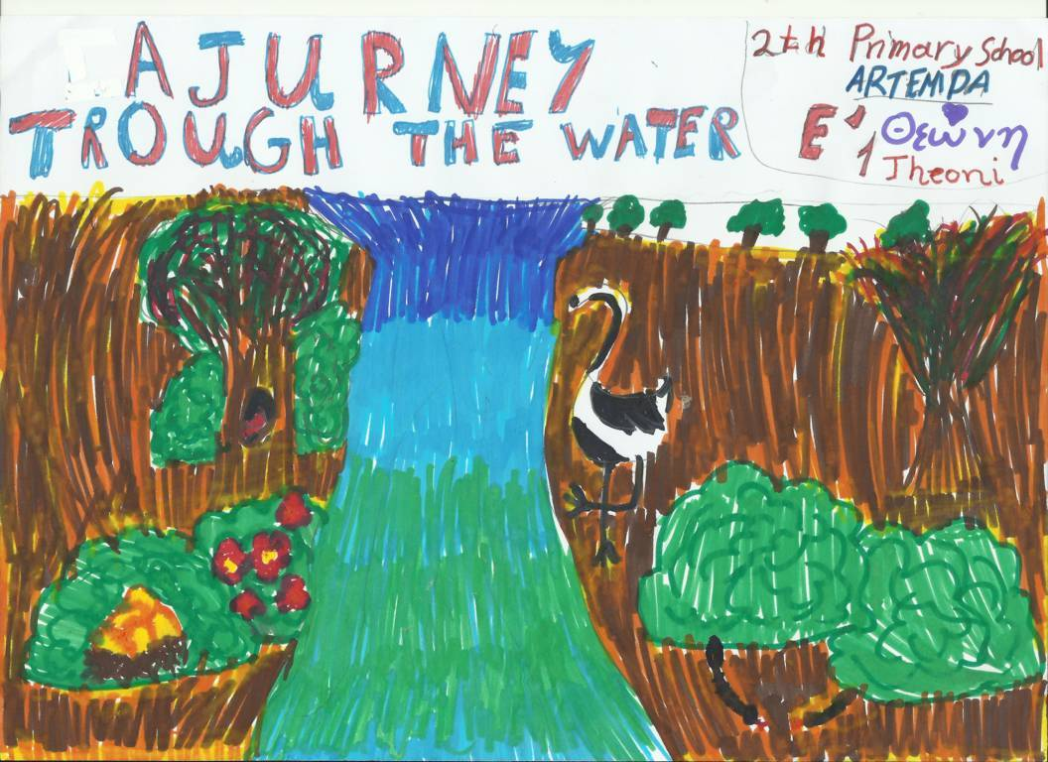
Monday | Tuesday | Wednesday | Thursday | Friday | Saturday | Sunday
 |  |  |  | 1 | 2 | 3
4 | 5 | 6 | 7 | 8 | 9 | 10
11 | 12 | 13 | 14 | 15 | 16 | 17
18 | 19 | 20 | 21 | 22 | 23 | 24
25 | 26 | 27 | 28 | 29 | 30 | 31

October 28: National Holiday

NOVEMBER

Monday | Tuesday | Wednesday | Thursday | Friday | Saturday | Sunday
1 | 2 | 3 | 4 | 5 | 6 | 7
8 | 9 | 10 | 11 | 12 | 13 | 14
15 | 16 | 17 | 18 | 19 | 20 | 21
22 | 23 | 24 | 25 | 26 | 27 | 28
29 | 30

November 17: Anniversary of the Polytechnic

DECEMBER

Monday | Tuesday | Wednesday | Thursday | Friday | Saturday | Sunday
 |  | 1 | 2 | 3 | 4 | 5
6 | 7 | 8 | 9 | 10 | 11 | 12
13 | 14 | 15 | 16 | 17 | 18 | 19
20 | 21 | 22 | 23 | 24 | 25 | 26
27 | 28 | 29 | 30 | 31

December 25: Christmas
December 26: Compilation of the Virgin Mary

