TASOS E1
2 PS ARTEMIDOS GREECE



M | T | W | T | F | S | S
 |  |  |  | 1 | 2 | 3
4 | 5 | 6 | 7 | 8 | 9 | 10
11 | 12 | 13 | 14 | 15 | 16 | 17
18 | 19 | 20 | 21 | 22 | 23 | 24
25 | 26 | 27 | 28 | 29 | 30 | 31

January 1: New Year
January 30: Three Hierarchs School Holiday

FEBRUARY

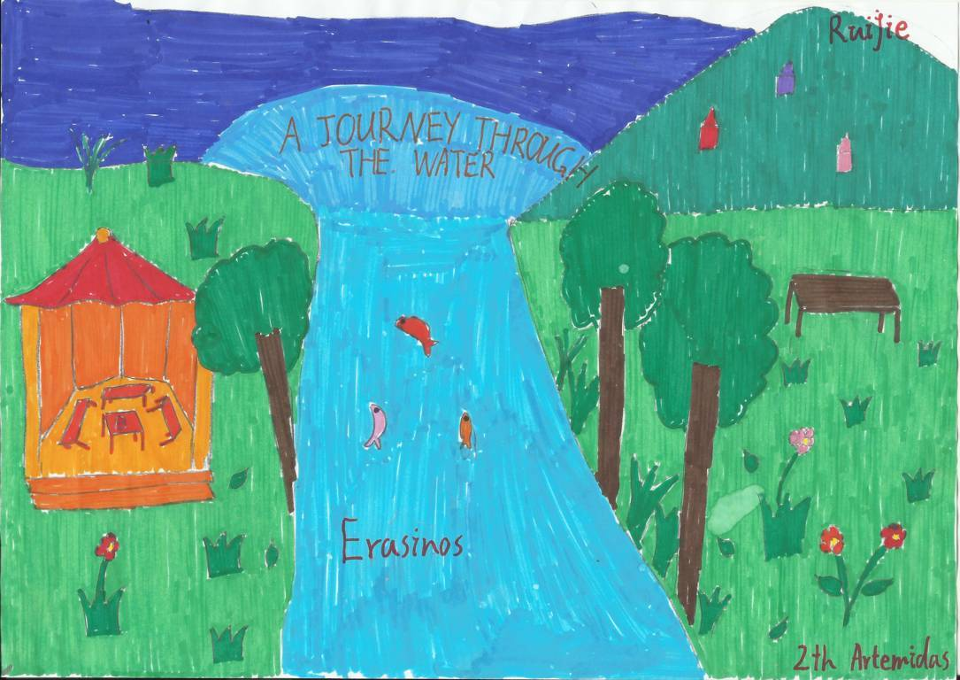

M | Τ | W | T | F | S | S
1 | 2 | 3 | 4 | 5 | 6 | 7
8 | 9 | 10 | 11 | 12 | 13 | 14
15 | 16 | 17 | 18 | 19 | 20 | 21
22 | 23 | 24 | 25 | 26 | 27 | 28



M | Τ | W | T | F | S | S
1 | 2 | 3 | 4 | 5 | 6 | 7
8 | 9 | 10 | 11 | 12 | 13 | 14
15 | 16 | 17 | 18 | 19 | 20 | 21
22 | 23 | 24 | 25 | 26 | 27 | 28
29 | 30 | 31

March 15: Shrove Monday
March 25: National Holiday
APRIL

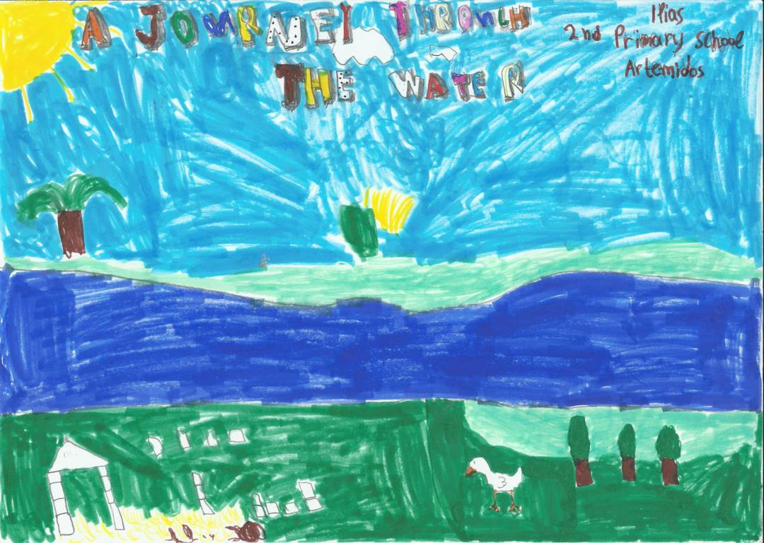

M | Τ | W | T | F | S | S
 |  |  | 1 | 2 | 3 | 4
5 | 6 | 7 | 8 | 9 | 10 | 11
12 | 13 | 14 | 15 | 16 | 17 | 18
19 | 20 | 21 | 22 | 23 | 24 | 25
26 | 27 | 28 | 29 | 30

April 30: Good Friday

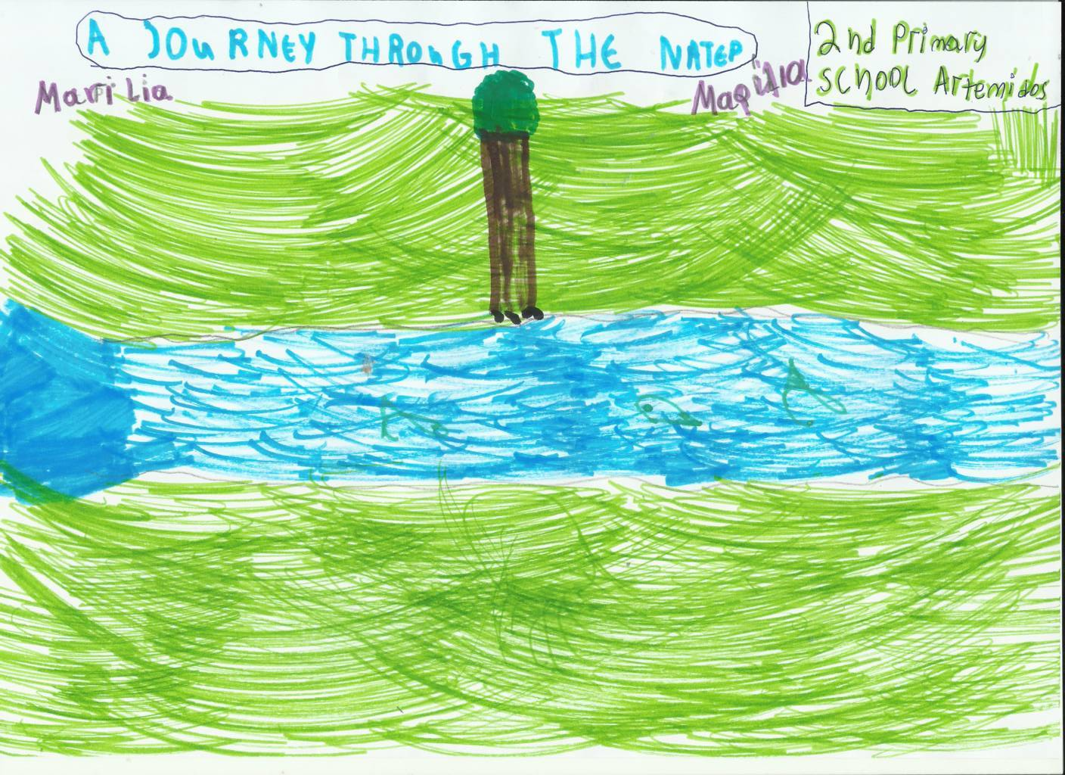

M | T | W | T | F | S | S
 |  |  |  |  | 1 | 2
3 | 4 | 5 | 6 | 7 | 8 | 9
10 | 11 | 12 | 13 | 14 | 15 | 16
17 | 18 | 19 | 20 | 21 | 22 | 23
24 | 25 | 26 | 27 | 28 | 29 | 30
31

May 1: Holy Saturday and May Day
May 2: Easter Sunday
May 3: Easter Monday
JUNE



M | Τ | W | T | F | S | S
 | 1 | 2 | 3 | 4 | 5 | 6
7 | 8 | 9 | 10 | 11 | 12 | 13
14 | 15 | 16 | 17 | 18 | 19 | 20
21 | 22 | 23 | 24 | 25 | 26 | 27
28 | 29 | 30

June 21: Holy Spirit

M | Τ | W | T | F | S | S
 |  |  | 1 | 2 | 3 | 4
5 | 6 | 7 | 8 | 9 | 10 | 11
12 | 13 | 14 | 15 | 16 | 17 | 18
19 | 20 | 21 | 22 | 23 | 24 | 25
26 | 27 | 28 | 29 | 30 | 31

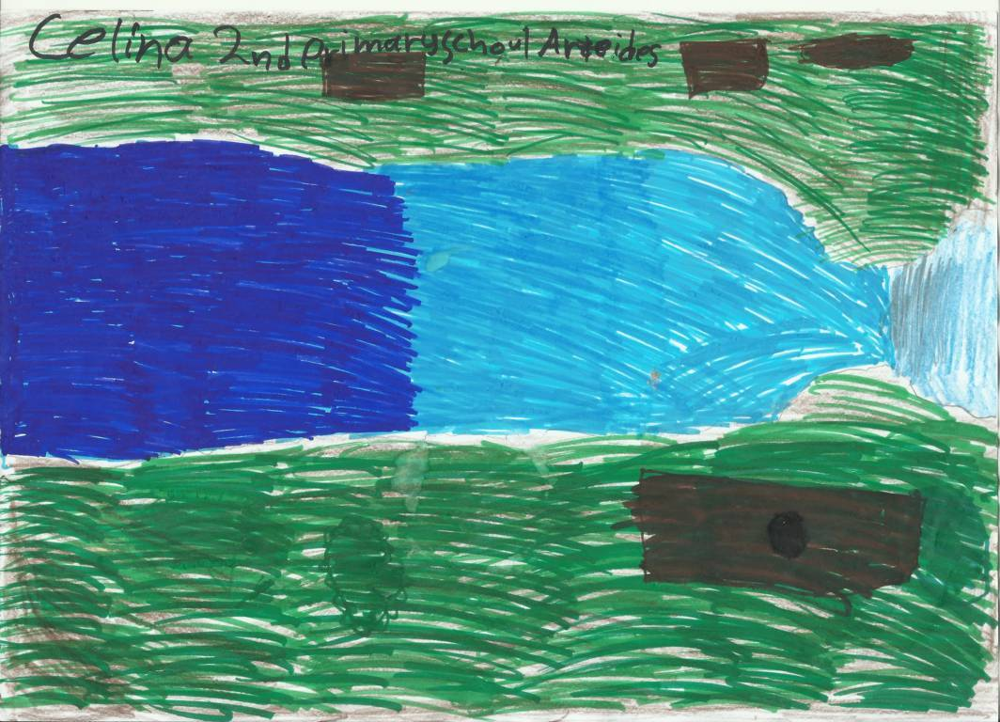

M | Τ | W | T | F | S | S
 |  |  |  |  |  | 1
2 | 3 | 4 | 5 | 6 | 7 | 8
9 | 10 | 11 | 12 | 13 | 14 | 15
16 | 17 | 18 | 19 | 20 | 21 | 22
23 | 24 | 25 | 26 | 27 | 28 | 29
30 | 31

August 15: Assumption of the Virgin

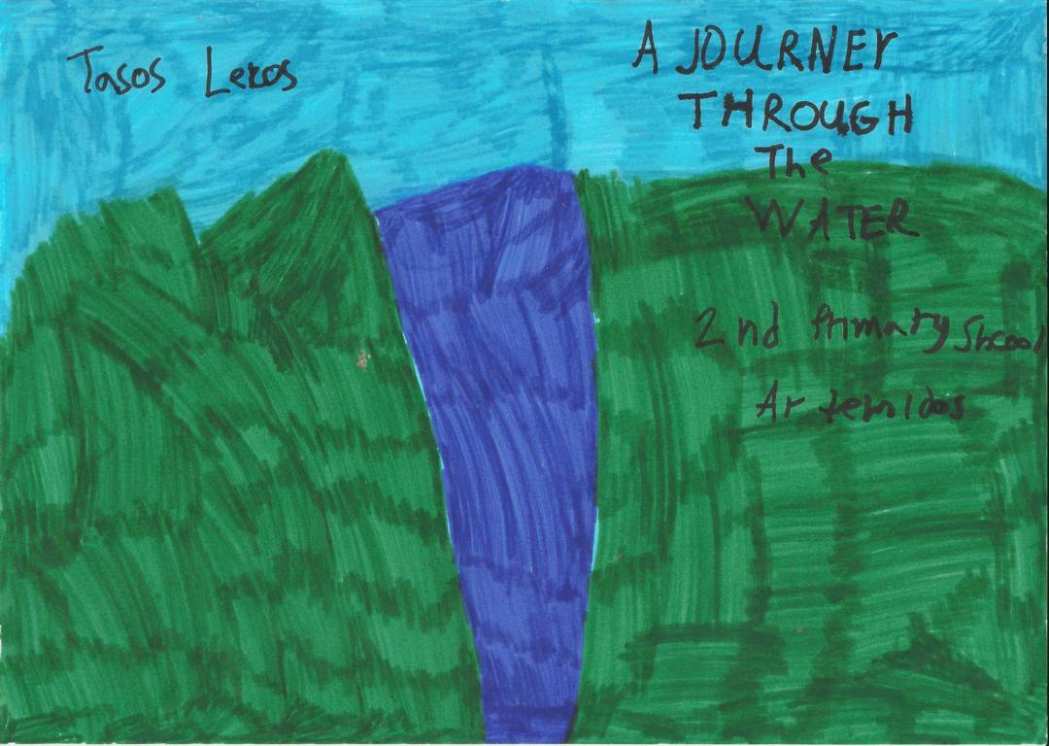

M | Τ | W | T | F | S | S
 |  | 1 | 2 | 3 | 4 | 5
6 | 7 | 8 | 9 | 10 | 11 | 12
13 | 14 | 15 | 16 | 17 | 18 | 19
20 | 21 | 22 | 23 | 24 | 25 | 26
27 | 28 | 29 | 30

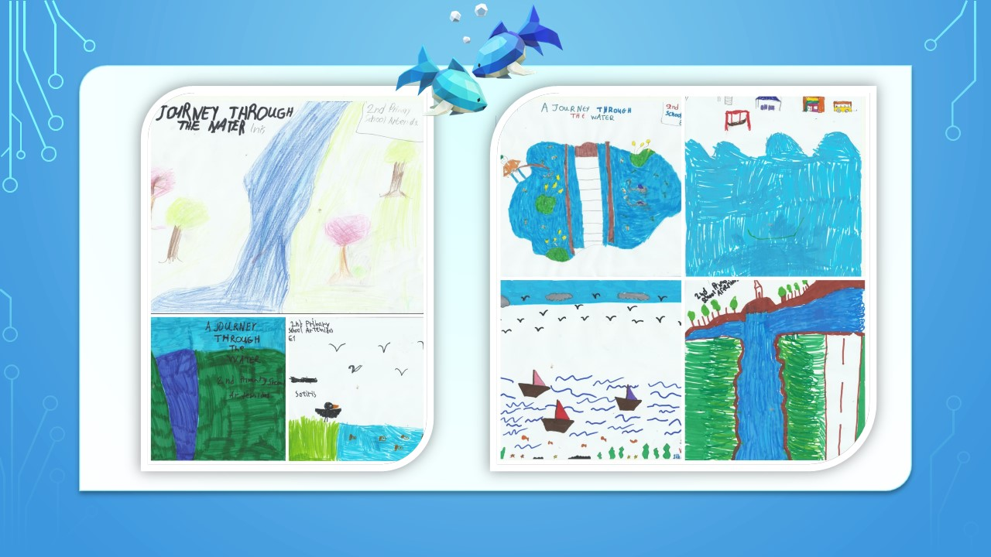

M | Τ | W | T | F | S | S
 |  |  |  | 1 | 2 | 3
4 | 5 | 6 | 7 | 8 | 9 | 10
11 | 12 | 13 | 14 | 15 | 16 | 17
18 | 19 | 20 | 21 | 22 | 23 | 24
25 | 26 | 27 | 28 | 29 | 30 | 31

October 28: National Holiday
NOVEMBER



M | Τ | W | T | F | S | S
1 | 2 | 3 | 4 | 5 | 6 | 7
8 | 9 | 10 | 11 | 12 | 13 | 14
15 | 16 | 17 | 18 | 19 | 20 | 21
22 | 23 | 24 | 25 | 26 | 27 | 28
29 | 30

November 17: Anniversary of the Polytechnic

DECEMBER

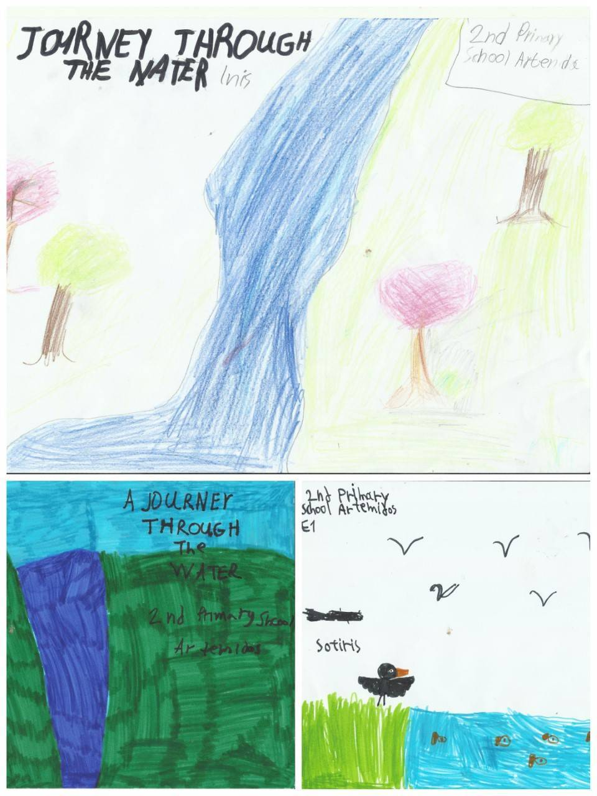

M | Τ | W | T | F | S | S
 |  | 1 | 2 | 3 | 4 | 5
6 | 7 | 8 | 9 | 10 | 11 | 12
13 | 14 | 15 | 16 | 17 | 18 | 19
20 | 21 | 22 | 23 | 24 | 25 | 26
27 | 28 | 29 | 30 | 31

December 25: Christmas
December 26: Compilation of the Virgin Mary

