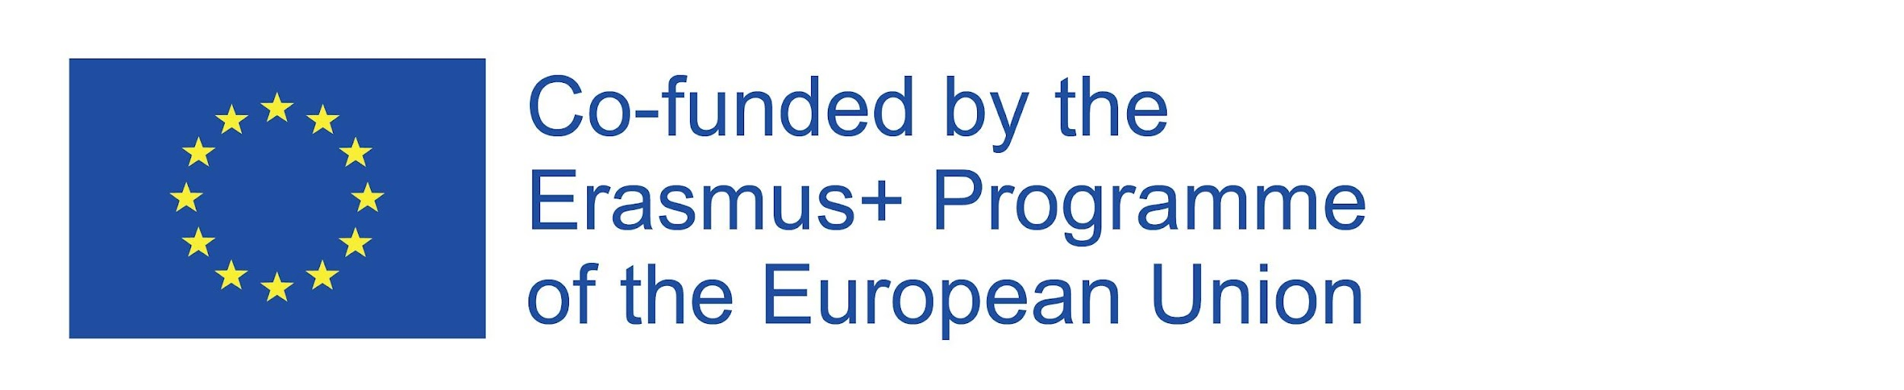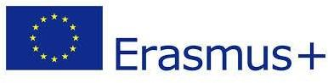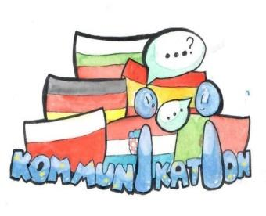

Partnership “[kɔmunikaˈt͡si̯oːn] - Kommunikation“
Project number: 2019-1-DE03-KA229-059859

C4
06 – 11 Dezember 2021
Host Institution: Szkola Podstawowa im Wincentego Pallottiego (Ożarów Mazowiecki, Polen

C5
21 – 26 Februar 2022
Host Institution: ,,Dimitar Dimov“ Foreign Language School- Pleven, Bulgarien

C6:
5. – 10. Juni 2022
Host Institution: Grundschule Bijaći, Kaštel Novi, Republika Kroatien

Criterion I. Motivations for participation
What are your motivations for participating as a teacher in the second part of this project?
To learn from good practice abroad, to learn new things | ۷
To share good practice, my own knowledge and skills with other teachers regarding the design and implementation skills of learning activities | ۷
To improve my knowledge about international words in German language and in English language | ۷
To gain new skills and competencies regarding the design and  implementation skills of learning activities that contribute to the development of social, civic and intercultural competences among pupils | ۷
To exchange experiences and best practices on the implementation of European projects | ۷
To enriched my competencies in designing the learning activities centered  on the promotion of communication | ۷
To develop my intercultural competences and a better understanding of  cultural and linguistic diversity | ۷
To develop social skills | ۷
To improve my communication skills in English or in German | ۷
To make new contacts | ۷
To increase my job satisfaction | ۷
Comments/Observations:
The teachers are motivated in the second half of the project by all indicators.

Criterion II. Motivations for participation
What are your motivations for participating as a student in the second part of this project?
Opportunity to develop my skills/competences | ۷
Opportunity to improve my communication skills in English and German | ۷
Opportunity to learn new things | ۷
Opportunity to meet new people | ۷
Opportunity to experience different learning activities | ۷
Opportunity to develop personal skills, such as adaptability | ۷
Opportunity to develop my civic and social skills | ۷
Opportunity to develop my intercultural competences and a better understanding of cultural and linguistic diversity | ۷
Opportunity to travel abroad for the first time
Opportunity to try new experiences | ۷
Opportunity to develop myself | ۷
Opportunity to increase motivation
Opportunity to increase my confidence in my own person
Comments/Observations:

Criterion III. Impact of partnership activities on professional and personal development of the TEACHERS from the project team: knowledge, skills/ abilities/competencies and attitudes.
To what extent do you consider that the activities carried out during the second part of the project contributed to ...
 | Strongly  agree | Rather  agree | Neither agree  nor disagree | Rather  disagree | Strongly  disagree
Improved my knowledge about common international words in German language and in English language |  | ۷
Improved my knowledge about culture and civilization of the host  country | ۷
Improved the design and implementation skills of learning activities that contribute to the development of social, civic and intercultural competences | ۷
Developed my team work abilities | ۷
Developed my communication skills in English or in German | ۷
Improved my knowledge and skills regarding the design and implementation of European  projects | ۷
Become more motivated to carry on developing my professional skills | ۷
Learn from good practice | ۷
Shared my own knowledge and skills with other teachers | ۷
Been able to experiment and develop new learning practices and teaching methods | ۷
Build up new contacts |  | ۷
Improved my knowledge of education systems in other  countries | ۷
Improved my awareness of  competences acquired in formal and informal learning context | ۷
Improved emotional skills (e.g. having more self-confidence) | ۷
Improved my practical skills (e.g. planning and organizing, project management etc.) | ۷
Comments/Observations:
Teachers developed their skills, knowledge and communication skills across all indicators.

Criterion IV. Impact of partnership activities on professional and personal development of the STUDENTS from the project team: knowledge, skills/ abilities/competencies and attitudes.
To what extent do you consider that the activities carried out during the second part of the project contributed to ...
 | Strongly  agree | Rather  agree | Neither agree  nor disagree | Rather  disagree | Strongly  disagree
I have improved my knowledge  about communication | ۷
I understand better the types of communication |  | ۷
I am more interested in international words in German language and in English language |  | ۷
I am more aware of social and political concepts like democracy, justice, equality, citizenship, civil  rights |  |  | ۷
I have improved my knowledge  about culture and civilization of the partners countries | ۷
I have improved my communication skills in English and in German |  | ۷
I learned more how to communicate and express myself in my mother tongue |  |  | ۷
I have developed my civic, social and intercultural competences:
a) my abilities to participate in different communication situations |  | ۷
b) my teamwork skills and I learned more how to cooperate in teams |  | ۷
c) I have gained a better understanding of cultural and linguistic diversity |  | ۷
d) I am more tolerant towards other persons' values and behavior, being more flexible |  | ۷
e) I learned more how to see the value of different cultures |  | ۷
f) I am more able to adapt to and act in new situations, to participate in different communication situations, to adapt to a new cultural environment |  | ۷
g) I am more interested to develop relationships with people from other countries, to learn through interaction with people from other countries | ۷
h) I am more able to cooperate with people from other backgrounds and cultures |  | ۷
i) I am more open-minded and curious about new challenges |  | ۷
j) I intend to participate more actively in social and political life of my community |  | ۷
I have developed my intellectual work skills and my transversal skills
a) searching for information from various sources, structuring and the information based on certain requirements, ability to reflect, formulate own opinions, arguments and interpretations |  | ۷
b) I learned more how to use internet, social media and PCs e.g. for my studies, work and personal |  |  | ۷
c) I learned more how to develop an idea and put it into practice |  | ۷
d) I learned more how to plan and organize tasks and activities |  | ۷
e) I learned more how to plan and carry out my learning independently |  | ۷
f) I learned more how to think logically and draw conclusions (analytical skills) |  | ۷
g) I am more able to think and analyze information critically  (critical thinking skills) |  | ۷
h) I find solutions in difficult or challenging contexts  (problem-solving skills) |  | ۷
i) I learned more how to plan and organize tasks and activities |  | ۷
j) I am more aware of the importance of lifelong learning |  | ۷
I have developed new attitudes
a) I am more confident and convinced of my abilities |  | ۷
b) I have developed positive attitudes towards the communication | ۷
c) openness to link with people belonging to other cultures, respect and empathy towards other cultures |  | ۷
d) I feel more responsible |  | ۷
Comments/Observations/:
Among the students, the trend after analyzing the indicators is that they have improved their skills to better understand the ways of communication, to speak in German and English, their knowledge of the culture and civilization of the partner countries. Participants improved their social skills as well as intellectual work and transversal skills.

Criterion V. Developing on the competences - TEACHERS
By participating in transnational activities in project "Kommunikation" in the second part I believe I have developed the following competencies:
Key Competence¹ | Strongly  agree | Rather  agree | Neither agree  nor disagree | Rather  disagree | Strongly  disagree
Literacy competence² |  | ۷
Multilingual competence |  | ۷
Mathematical competence and competence in science,  technology and engineering |  |  | ۷
Digital competence |  | ۷
Personal, social and learning to learn competence |  | ۷
Citizenship competence |  | ۷
Entrepreneurship competence |  | ۷
Cultural awareness and expression competence | ۷
Comments/Observations:
The trend in improving teachers' competencies is similar to that of the first part of the project, most have improved, only mathematics is at the same level.

¹COUNCIL RECOMMENDATION of 22 May 2018 on key competences for lifelong learning
²Literacy is the ability to identify, understand, express, create, and interpret concepts, feelings, facts and opinions in both oral and written forms, using visual, sound/audio and digital materials across disciplines and contexts. It implies the ability to communicate and connect effectively with others, in an appropriate and creative way

Criterion V. Developing on the competences - STUDENTS
By participating in transnational activities in project "Kommunikation" in the second part I believe I have developed the following competencies:
Key Competence¹ | Strongly  agree | Rather  agree | Neither agree  nor disagree | Rather  disagree | Strongly  disagree
Literacy competence² |  | ۷
Multilingual competence |  | ۷
Mathematical competence and competence in science,  technology and engineering |  |  | ۷
Digital competence |  |  | ۷
Personal, social and learning to learn competence | ۷
Citizenship competence |  | ۷
Entrepreneurship competence |  |  | ۷
Cultural awareness and expression competence |  | ۷
Comments/Observations:
The students improved their social competences the most, and their mathematical ones the least.

Criterion VI. Impact of “Kommunikation” project activities on school.
To what extent do you consider that the project activities carried out during the second part of the project contributed to ...
 | Strongly  agree | Rather  agree | Neither agree  nor disagree | Rather  disagree | Strongly  disagree
Creating opportunities for me to share the knowledge acquired through my participation with  colleagues | ۷
Creating opportunities for the  planning and development of new educational activities | ۷
Reinforcing a positive attitude of my school towards European projects | ۷
Improving the visibility of my school in educational community | ۷
Strengthening the cooperation with the schools partners in this project | ۷
Strengthening my school efforts to internationalize its activities | ۷
Starting and joining new European/international projects | ۷

 | Criterion VII. Satisfaction  General impression/satisfaction of  transnational activities | 1  worst | 2 | 3 | 4 | 5  best
 |  |  |  |  |  | ۷
Lessons learned

SWOT analysis of the first year of the project
Strengths / Positive Aspects | Weaknesses / negative aspects
According to the respondents, knowledge and communication skills, knowledge about the European Union, about the different participating countries and their customs, language and specific clothing, peculiarities of communication have improved. | Impossibility of attendance of some students due to the epidemic situation.
Opportunities | Threats
- Maybe the time has come for us to review the classic relations between teachers and students, approaching a “fair trade-off”: the first have knowledge of the subject to share, the second can make the most of gadgets. Why not seek the support of your students? Sincere interest in what students are doing best engage them even more than any interactive teaching strategy. | - To apply in the learning process different ways of communication, both between students and between the teacher and his students

