Classic rhodope patatnik on a pan
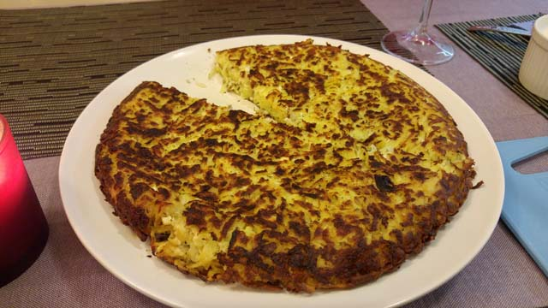
You need the following products for 1 patatnik:
700 grams of potatoes or 5-6 medium potatoes
2 eggs
50 grams of cheese
1/2 teaspoons dry mint
1/2 teaspoons salt
1 small onion
60 grams of butter

Preparation takes about 20+ minutes and the whole process with preparation takes about 40 minutes.

First peel and grate the potatoes on a coarse grater. Salt well and let rest for 5 minutes. Then squeeze them well with your hands from the water they let out.

The next step is to add an egg. The recipe is 1, but with 2 is tastier. Finally, add the dried mint and finely chopped onion, stirring the whole mixture well. The onions become slightly crunchy, so you can sauté them in a pan beforehand, in case you don't like their more intense taste.

On a well heated griddle, melt half the butter and melt the other half for the second side of the patatnik. Bake each side for 10-12 min. on a lower setting so it doesn't burn and more possibly put a lid on the pan to steam. It's really important to bake on low to make it perfect. Maybe it looks like pan frying, but I think it's more like sautéing and steaming, which is not so harmful.

To make sure you don't ruin everything up when flipping, you need to put a plate over the pan. Melt the other half of the butter and slip the patatnik to brown the other side.

It is best served warm with a small bowl of yoghurt.

The recipe is quite easy, even for beginner cooks, and most importantly, it does not take long to prepare.

