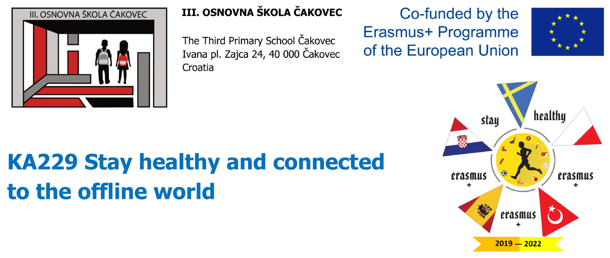
TedTalk: Physical activity = more concentrated students

The main issue of this meeting is to deal with the assumption that engaging students with some sort of physical activity during the school breaks and their free time rather than spending all the spare moments and hours in of their mobiles and other screens, goes along with boosting their concentration at lessons, increasing their active listening. Students and teachers are going to be acquainted with some brain gym techniques which can also be implemented during lessons or long hours at school when students feel tiredness but are unable to exit the classroom and take up a physical activity.

PRIOR TO THE MOBILITY: Each school takes up a one-week challenge:
Eight students involved into the mobility spend their breaks between lessons engaged in some kind of physical activity rather than using their mobile phones, as they used to. Afterwards, they discuss their experience and prepare a Tedtalk on the topic.

TASK 1 (5 - 6 minutes)
Each team will prepare a public speech with the aid of images or videos. The speech is going to be carried out by at least two students from each team.
The speakers are going to explain which physical activities the participants of the challenge were engaged in. Was it difficult to endure and spend the week without using their mobile phones during the breaks? Did any of them fail? What conclusion did they come up with? Does physical activity boost their concentration making them more actively listening at lessons?

WORKSHOP ON BRAIN GYM
After the public speches have been held, mixed groups of students are going to get a set of instructions how to perform various brain gym exercises in case when they feel overwhelmed, tired and deconcentrated either during lessons or long school days when it is impossible to conduct any physical activity. The groups have to mime the brain gym exercises according to the instructions given and record them with their mobile phones.
Afterwards the Croatian school is going to blend all the videos into one so that every school has their collection of brain gym exercises to try out at their schools.

POST-PRODUCTION
Each school tries to implement the brain gym. They take photos while students performing them in different classrooms, subjects and make a powerpoint presentation with the photos.

Erasmus + KA2 - Stay healthy and connected to the offline world
Second Meeting - Čakovec

