The 8th of March

Objectives
- Make people laugh and give a smile.
- Congratulate girls and women with the International Women's Day.

Implementation
- We organized competition between boys and girls to identify who is better.
- There were 5 contests, which were based on laughing. For example: sang popular songs; arranged a fashion show; asked each other to the dates in funny ways.

Results / impact
- All this time they were evaluated by judges and in the end they got an assessment of everything that did and found out who won.
- Everyone was happy, and still remember this day with a smile.
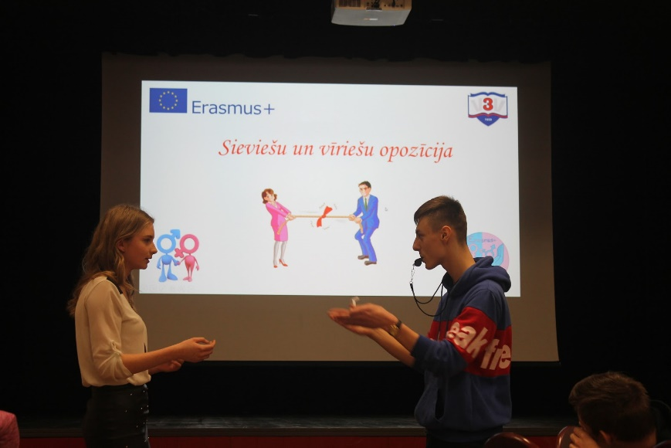
Presentation and video about activity: https://docs.google.com/presentation/d/12VcZ0O7HAAhEY_7oDOeFKp9mQWBhQbQznaYN2YKgge0/edit#slide=id.p

