The Three Little Pigs by Panagiotis, Spyros, Thanos
One day there were three little pigs and they talked with their mother about their life. Their mother said: ‘Now you have grown up you must leave our house and go out to get to know the world’. While the three little pigs were wandering, they saw a roving merchant who was selling straw. One of the pigs asked for some to build his house. Some hours later the rest of the pigs saw another merchant who was selling sticks. The second pig bought some to build his house. Later on the third pig met a merchant who was selling bricks. So he bought some to build his own house. A bad wolf, who was following the three pigs, saw everything that was happening. He destroyed the two houses of the first two pigs but didn’t manage to destroy that of the third pig. All the pigs were now safe together in the brick house!
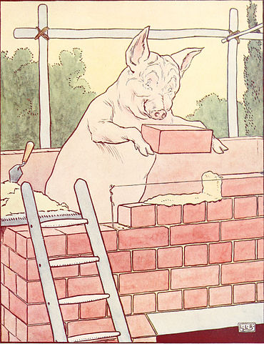
Image credit: Public Domain, https://commons.wikimedia.org/w/index.php?curid=183847

