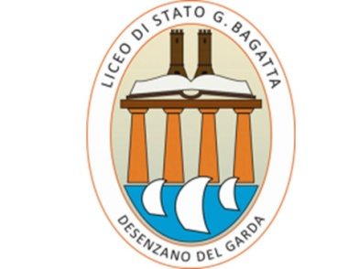

Erasmus Plus Project 2015-1-NL01-KA219-008877_4
Europe 2100:
A Sustainable Future for European Youth
Second Short-term Student Exchange
Sustainable Food Production and Transport
Desenzano del Garda, It
7th-11th March 2016
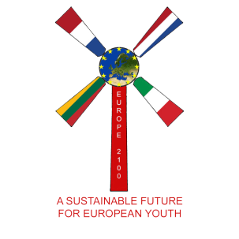
PROGRAMME

Monday 7 March
08.00-09.30 STUDENTS: ICE BREAKING ACTIVITIES
TEACHERS: Start at 9.30
09.30-10.30 OPENING CEREMONY
Headmaster's Official Welcome
Introduction of Partner Teams
Project update: partners’ Reports
Info about the Programme
Slow Food Interview
10.30-11.05 Tour of the school Coffee Break
11.05-11.50 Presentation of Milan Programme: Cenacolo vinciano, City centre
11.50-12.00 Introduction of Fish Hatchery
12.00-12.30 Free time in the town centre
12.30 BUFFET LUNCH for Teachers and Students
13.30-14.00 Walk to the Fish Hatchery
14.00-16.00 DESENZANO FISH HATCHERY Visit and Presentation in the Conference Room
16.30-18.00 LEARNING PORTAL WORKSHOP for teachers and ICT expert students
Free evening

Tuesday 8 March
08.30 DEPARTURE FOR BRESCIA from Desenzano-Stazione
09.30-13.00 CONFERENCE at University of Brescia
Prof. Ing. Maurizio Tira, Università degli Studi di Brescia
“Sustaining Sustainable Transport: Walking and Cycling in a Safe and Healthy Urban Space”
Lunch at the University Cafeteria
14.30-16.00 VISIT Brescia Metro System
17.00 Expected arrival at Desenzano-Stazione
Free evening

Wed 9 March
08.00 DEPARTURE FOR MILAN by bus from Desenzano-Porto
11.15-11.45 Booked visit Leonardo’s Last supper
https://en.wikipedia.org/wiki/The_Last_Supper_(Leonardo_da_Vinci)
11.45-15.00 Walking tour: San Satiro, Scala, Galleria, Duomo. (Box lunch.)
15.00-17.00 Castello Sforzesco, incl. Michelangelo’s Pietà Rondanini and Leonardo, Sala delle Asse
http://www.sforzesco.com/it/da-non-perdere
19.00 Expected arrival at Desenzano-Porto
Free evening

Thu 10 March
08.00-09.00 STUDENTS Mercato contadino for local products
09.00-12.30 VISIT Pozzolengo Centro Carni Castrini
12.30 LUNCH - free time
15.00-18.00 PROJECT WORKSHOPS Producing video documentaries and learning objects related to the conferences and the visits
19.00 ZERO-MILE DINNER AT THE CATERING SCHOOL for teachers and students

Fri 11 March
09.30-12.30 CONFERENCE at Palazzo del Turismo
Prof. Ettore Capri, Università Cattolica di Piacenza
“Novel food: a way toward a sustainable Planet diet?”
13.00 LUNCH at school
13.30-15.00 STUDENT WORKSHOPS continued if necessary
15.00-16.30 WORKSHOPS PRESENTATIONS Award for the best group!
CONCLUSION Prize-giving, Certificates Ceremony, Evaluation Survey
Free evening

