Water consumption at home
Annuals:
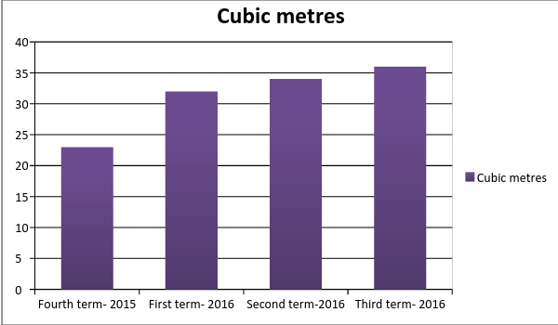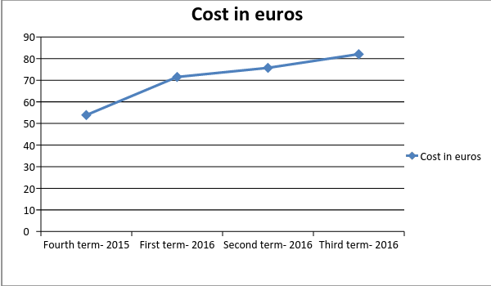
$\frac{{125m}^{3}}{3peoples}=41,67lapersonyearey$
$\frac{41,67m^{3}}{12months}=3,47lapersonmonthly$
$\underline{x}=31,25m^{3}quarterly$ $\underline{x}=10,42m^{3}monthly$
$\underline{x}=70,78€quarterly$ $\underline{x}=23,59€monthly$
d.t= 11,70 c.v= 17%

