Poland by Boyer Thomas, Leichnig Myriam:

The capital of Poland is Warsaw.
After being wiped off the map for more than 120 years.
Poland was then Prussia.
Poland entered the European Union and experienced a significant economic development.

Flag of Poland: Location:
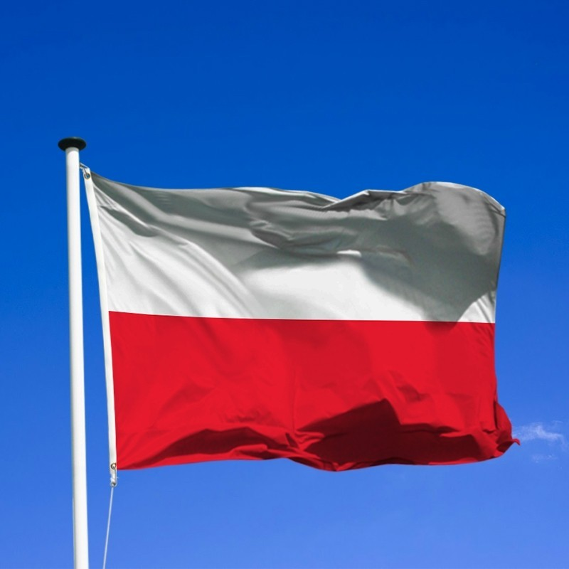
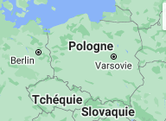

The official money of Warsaw is the zloty (PLN):
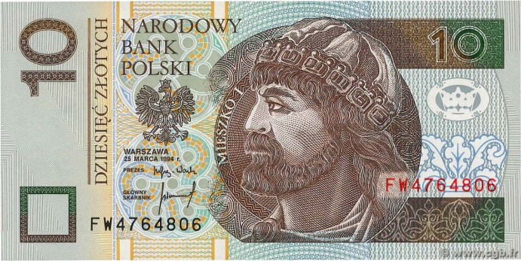
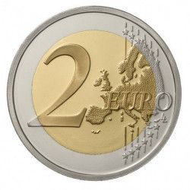
Approximately equal to 2 euros.

The typical food of christmas in Poland :
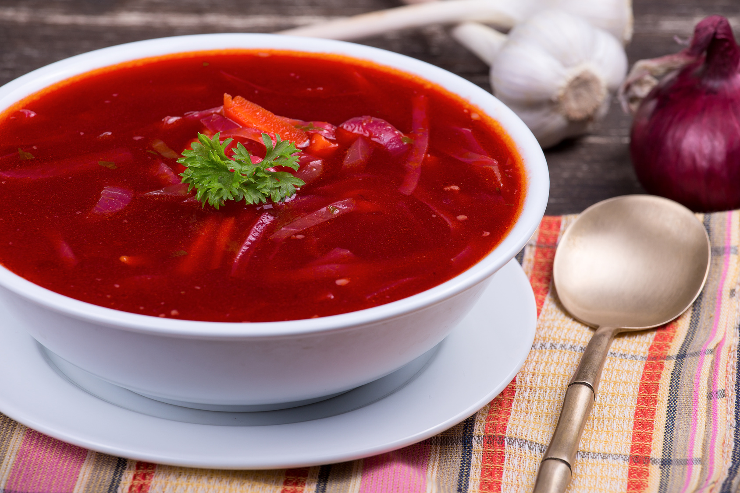
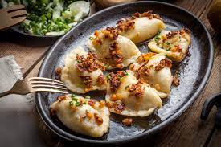

The bortsch red The pierogi

Christmas tradition in Poland:
Christmas Eve is preceded by the preparation of the Christmas tree and the family cot.
The table is set once the first star has appeared in the sky.
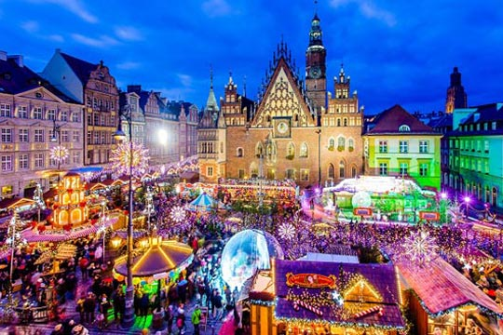
There are even big and beautiful Christmas markets for example in Wroclaw.

(All images were taken from Google)

