Snapshots that shook the world

1 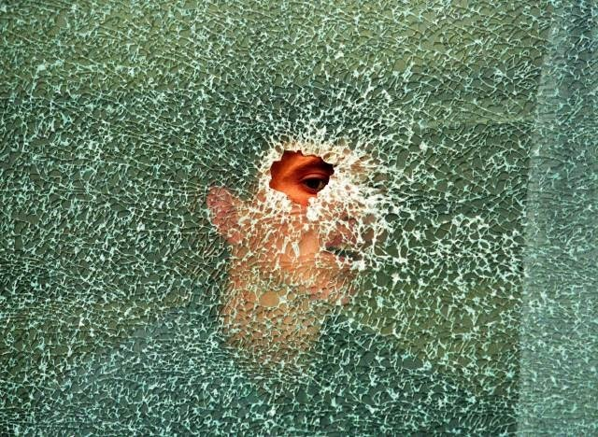
jotted by: Evangelia Anagnostaki
The glance through a shattered world.
1998. Kosovo War. Thousands of civilians were killed. Many cities and villages were bombardised and many war atrocities took place.
The outstanding Greek photojournalist Yiannis Behrakis, who worked for Reuters and was awarded with numerous prizes for his powerful photos, took this photo depicting a Kosovar boy who is looking through a bullet hole in a bus window. His village had been levelled. Many of his beloved people were dead and he is hiding in his uncle's bus waiting until he is safe enough to go out. His world is shattered, his dreams too. The horror of war is everywhere.
This meaningful photo can be a symbol of our shattered world. Yet, there is always an opening where our glance can pass and seek the truth. Our world is certainly not an ideal place to live in but becoming aware we might avoid the old same mistakes of humanity and struggle for a better future.
Photo: Photo by Yiannis Behrakis

2 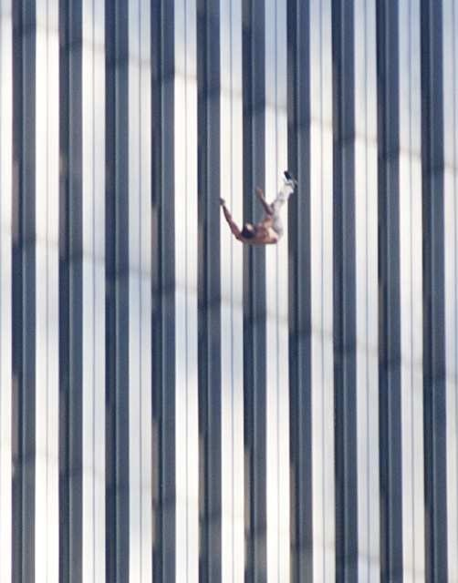
jotted by: Jim Tasios
9/11 Twin Towers Attacks - Who can forget?
On Tuesday, September 11, 2001 an attack took place in the United States Of America. The Islamic terrorist group Al-Qaeda hijacked four passenger airlines in purpose of a suicide attack into the twin towers. The first two planes were crashed into the North and South towers. Within two hours those two towers collapsed and they caused fires so all other buildings around were collapsed too. The third plane crashed into the Pentagon and the fourth crashed into a field in Shanksville after passengers tried to overcome the hijackers. A serious damage was caused to the economy of U.S.A (an estimated $10 billion) but most importantly 2,996 people were killed. For some days buildings, shops and streets such as Wall Street were evacuated because of the fear of further attacks. Most of the places were reconstructed by the next years and many memorials were constructed but pain still remains for thousands of families who mourn the loss of their beloved.
Photo: Photo: Under Creative Commons

3 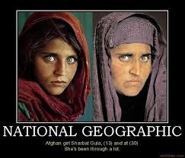
jotted by: Nancy Rekoumi
THE MOST FAMOUS SEA-GREEN EYES EVER.
Nasir Bagh refugee camp.Pakistan 1984
The Afghan girl was inside the refugee school when the photographer Steve McCurry noticed her first. The 12-years-old girl was shy and he approached her last. The photographer could never imagine then that his picture would become the ''most recognized photograph'' in the history of National Geographic and a symbol of the refugee situation all over the world. For 17 years no one knew the real name of the 'Afghan girl'. It was then that McCurry and a team from National Geographic started to search for the girl with the sea-green eyes. They showed her picture to many people and the girl was found back in Afghanistan, married with 3 children. When McCurry saw her, he understood that he had found the girl with green eyes. Her name was Sharbad Gula. She knew nothing about her famous portrait. The reunion between them was strange. The power of those green eyes explains how her picture has touched so many people worldwide. Photo: by Steve McCurry

4 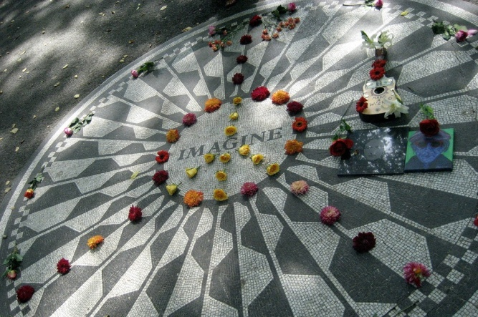
jotted by: fenia
Strawberry fields Memorial. A tribute to a legend.
It was 11 o'clock before midnight and John Lennon and Yoko Ono left the studio, after he had finished the recording of his songs. Outside his house one of his fans asked for an autograph. Without hesitating Lennon stretched out his hand to give the autograph. It was only a few minutes after this scene that Lennon was shot 6 times by the man who was supposed to be his fan .The name of his murderer was Marc Chapman. It was 11:20 when he was taken to hospital where his death was confirmed.
There are many reasons for what led Chapman to commit this crime. He believed that if he killed Lennon he would become the person of the day. But he was wrong. Taking into consideration the fact that he was alcoholic with psychological problems, we can easily understand his problematic nature and how easily he could be influenced by Nixon's propaganda against John Lennon's activism against the Vietnam war. J. Lennon might have been a dreamer but his dream for a better world still remains.
Photo: Free of copyright image

5 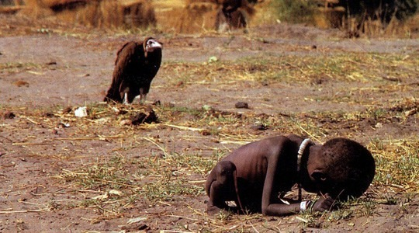
jotted by: Antonia
The girl and the hooded vulture
In March 1993, while on a trip to Sudan Kevin Carter photographed a starving toddler trying to reach a feeding center when a hooded vulture landed nearby. The face of the animal it's shocking while waiting for the child to die and finally eat it. The photographer took the picture and left. He was told not to touch the children for fear of transmitting disease. It is unknown whether the girl managed to reach the feeding centre. In April 1994, the photograph won the Pulitzer Prize for Feature Photography. He committed suicide 3 months later.
The question is: What's the limit between a photographer's duty and a human's responsibility?
Photo: by Kevin Carter
6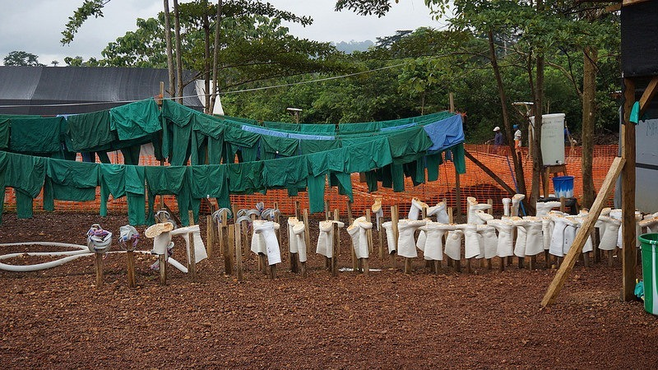
jotted by: Dimitris Psaradellis
The fight against Ebola
Sierra Leone , 2013. Ebola quarantine centre. Here hundreds of sufferers , isolated from the rest of the world are fighting with death minute after minute. Are they going to recover from the lethal disease?
Statistics show that this is the worst outbreak of Ebola ever, 15,963 reporting cases resulting in 6,003 deaths so far.
The symptoms for this virus are: fever, sore throat, muscle pain and headaches. Then, vomiting, diarrhea and rash usually follow. At this time people begin to bleed. The disease is so strong that most of the people, who have been infected with the virus, have passed away.
No specific treatment or vaccine for the virus is currently available, although some treatments are being studied and doctors in the USA announced that very soon the vaccine will save lives.
Thanks to hundreds of doctors, nurses, volunteers who risk their lives every moment, there is a hope.

7 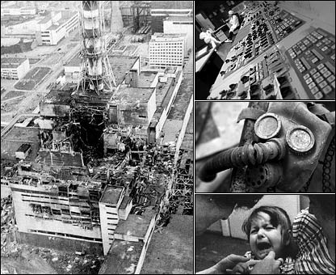
jotted by: Sayat Hamamcıyan
World's Worst Nuclear Accident
In the early hours of 26 April 1986, one of four nuclear reactors at the Chernobyl power station exploded.
Moscow was slow to admit what had happened, even after increased radiation was detected in other countries.
The lack of information led to exaggerated claims of the number killed by the blast in the immediate area.
Contamination is still a problem, however, and disputes continue about how many will eventually die as a result of the world's worst nuclear accident.
8 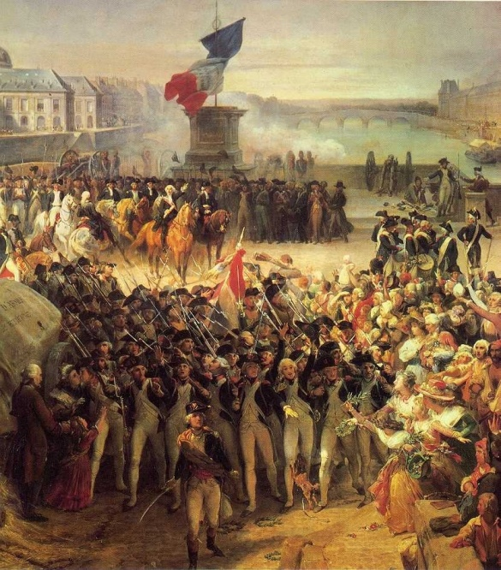
jotted by: Sarkis Hacaduryan
The Beginning of Modern Nations
A watershed event in modern European history, the French Revolution began in 1789 and ended in the late 1790s with the ascent of Napoleon Bonaparte. During this period, French citizens razed and redesigned their country’s political landscape, uprooting centuries-old institutions such as absolute monarchy and the feudal system. It caused cultural, social, financial, political and economic changes. Although it failed to achieve all of its goals and at times degenerated into a mess bloodbath, the movement played a critical role in shaping modern nations by showing the world the power inherent in the will of the people.
The French Revolution is so important because it is the most famous revolution in the history of the world.

9 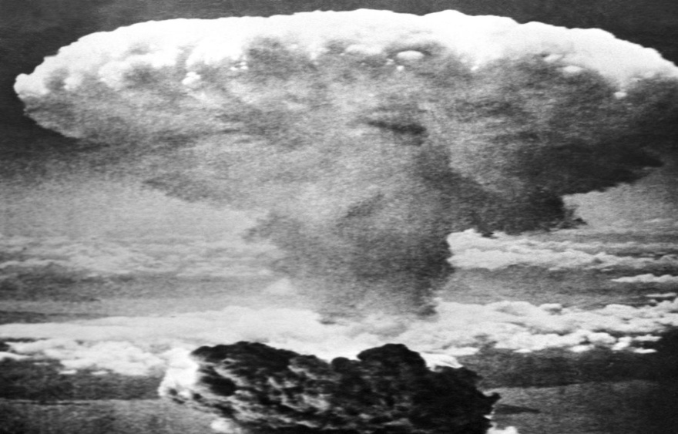
jotted by: aylin
10 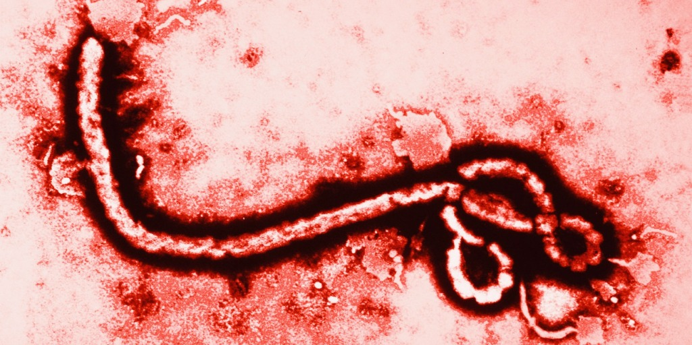
jotted by: Natali Sarıaslan
ALERT FROM DEATH
Ebola virus disease, or simply Ebola, is a disease of humans and other primates caused by ebola viruses. Signs and symptoms typically start between two days and three weeks after contracting the virus as a fever, sore throat, muscle pain, and headaches. The World Health Organization explained that approximately most of 1900 people died from Ebola virus. But the first human that survived from Ebola was a Spanish woman Teresa Romero.

11 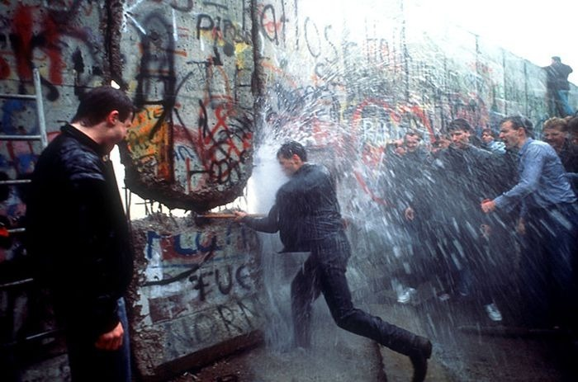
jotted by: Margarita Sardaryan
THE BERLIN WALL
The Berlin Wall was a barrier that divided Berlin from 1961 to 1989. The wall was 46 metres. It constructed by the German Democratic Republic starting on 13 August 1961 that completely cut off West Berlin from surrounding East Germany and from East Berlin until it was opened in November 1989. It demolition officially began on 13 June 1990 and was completed in 1992.
I think it was unnecessary to build that wall. We are all free to live where we want. No one can limit our rights.
12 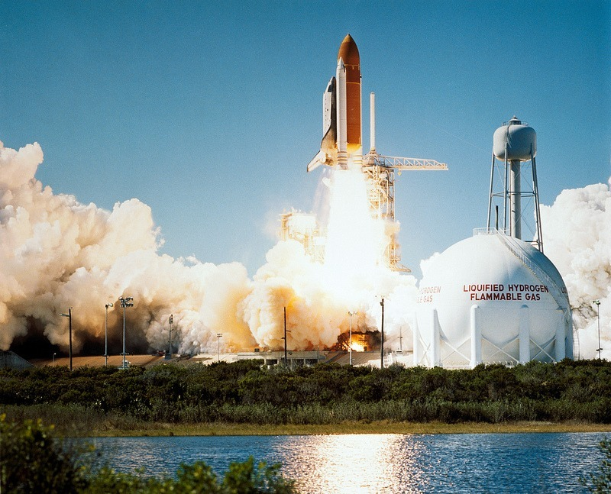
jotted by: Helen Fragkaki
How vain human beings are?
January 28, 1986. The Space Shuttle Challenger was the spacecraft, which failed to complete its mission successfully, because, 73 seconds after the launch, it exploded and was destroyed. The result of this disaster was the death of the seven members of its crew. This flight was the first American mission of the manned spacecraft’s' flights, which lifted off and eventually failed. According to the Rogers Commission, the disaster of the Space Shuttle Challenger was caused by the failure of a stabilization ring on the right of the solid rocket boosters.
Facts:
- 17 percent of American citizens watched the launch live.
- Among the crew members there was a teacher named Christa Mc Auliffe, who would have been the first teacher in space.
- The Challenger disaster has been used as a case study in engineering safety.
The photo is still there to make us wonder: Is space exploration a step towards human evolution but at what risks? Photo under cc

13 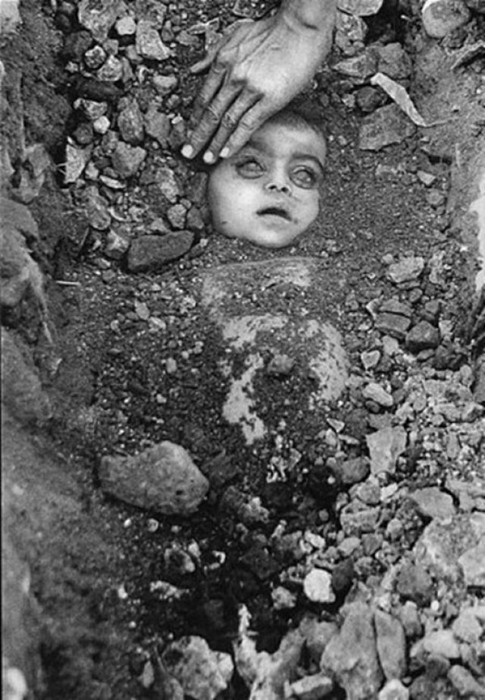
jotted by: Joanna
The Bhopal gas tragedy
It was a cold night of December in 1984, a huge cloud of poison gas spread in the air. In Bhopal, India, a pesticide plant leaked toxics gases and spread horror, pain and thousands of deaths and injuries in the area. The weather condition was extremely dangerous but enough to carry the gases over Bhopal. The situation was getting even worse due to the mushrooming of the slums in the vicinity of the plant. People woke in their home with coughs, eye irritation , stomach pains and a feeling of suffocation. The following day thousands were found dead and disabling injured.
This is one of the baby victims whose picture shook the world. The picture was taken by Raghu Rai on the morning of December 3rd, 1984, after the night of horror in Bhopal. A heartbreaking picture that makes you tum your glance away on a hideous incident we should never forget.
Photo by Raghu Rai
14 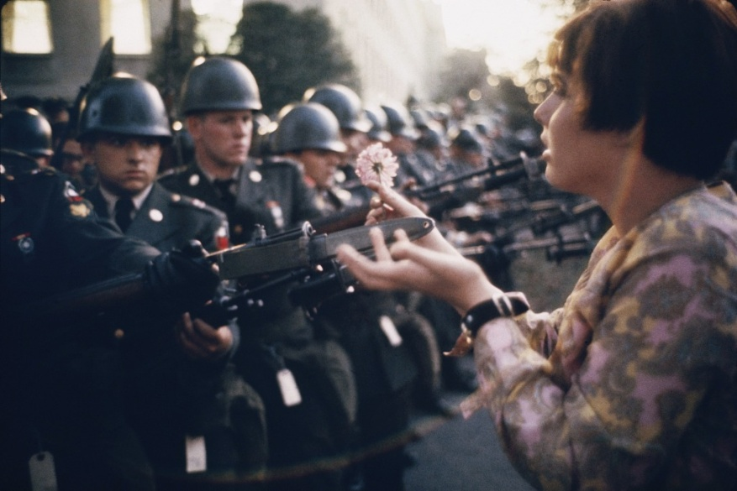
jotted by: Athina Georgiadi
Flowers Do Not Hurt
October 1967. One of the largest anti-Vietnam war protests outside the Pentagon. The French photojournalist Marc Riboud noticed a lone girl approaching the soldiers. His picture provides a clear juxtaposition of the armed force and the flower child innocence. It soon became a defining image of the antiwar era. The girl, Jan Rose Kasmir, was 17 when the picture was taken, a high-school student.
This picture greatly catches a snapshot which expresses the need of reconciliation and peace among people. It's no matter if these people represent different views and have a different background. Αctually, everybody wants to live in peace, away from divisions, even if this person is a soldier or a marshal. The girl in the picture tries to bridge the gap between common people, who want a world surrounded by love and solidarity, and soldiers who are sent to commit war. This venture takes shape by offering a flower, a flower that never hurts οr kills instead of a gun.
Photo by Marc Riboud
15 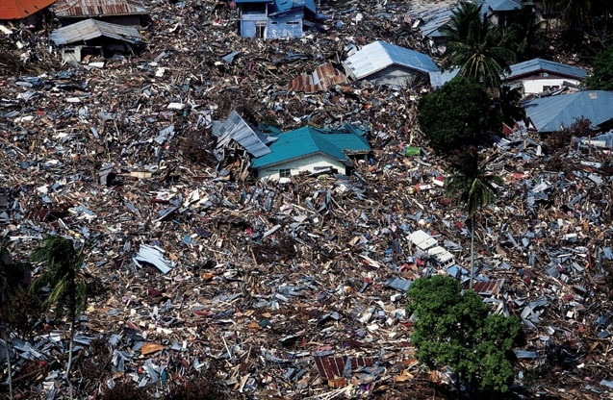
jotted by: Stijn STEVENS
Pitiless killing waves
Everybody heard about the tsunami that occurred in Indonesia. It was one of the most powerful tsunamis ever, its waves could at least travel 3,000 miles and still had enough power to destroy everything on its way. It is difficult to imagine but the earthquake that caused the tsunami had the equivalent power of 23,000 Hiroshima-type atomic bombs. On that day many people died, there were at least 227,898 of them. The most surprising is that the ones who survived where animals it was reported that people saw them fleeing for high ground minutes before the tsunami arrived. A tsunami is faster than people can imagine as the speed of one of those killer waves can reach up to 800km/h and a height of up to 30 metres. These killer waves were a drama for many countries, as it destroyed many lives and many properties and these countries will never forget any detail of it. It is a very sad event as nobody could ever avoid this type of disaster.

16 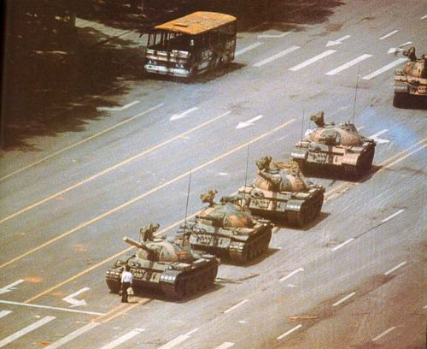
jotted by: RosalieLitzler
Humanity versus Violence, who wins?
The Tiananmen Square protests of spring 1989 were student-led popular demonstrations in Beijing. Some students, intellectuals and Chinese workers denounced corruption and demanded political democratic reforms. They received broad support from city residents. The protests were forcibly suppressed by hardline leaders who ordered the military to enforce martial law in the country’s capital. Retaliation that initiated on June 3 and 4 became known as the Tiananmen Square Massacre as troops with assault rifles and tanks inflicted casualties on unarmed civilians. In this picture a man stood in front of a column of 17 tanks after the Chinese military had suppressed demonstrations by force. He became known as ‘’The Tank Man’’. The picture is considered one of the iconic images of the 20th century. It is fluently used to symbolize the courage and the strength of non-violence in the face of armed repression. I think this picture is the symbol of non-violence, I admire this man.

17 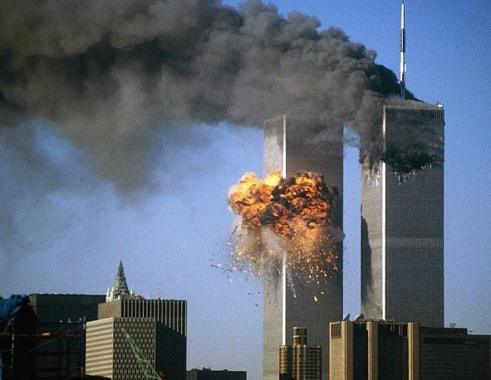
jotted by: hugues volpato
The biggest terrorist attacks ever : WTC
The September 11 attacks were a series of four coordinated terrorists attacks launched by the Islamic terrorists group Al-Quaeda upon the United States in New York City and the Washington, D.C. metropolitan area, on Tuesday, September 11, 2001. The attacks killed 2,996 people and caused at least $10 billion in property and infrastructure damage. Four passengers airliners were hijacked by 19 al-Qaeda terrorists so they could be flown into buildings in suicide attacks. Four planes crashed in interval different on 2 towers and had to create the total panic for the inhabitants. The destruction of the Twin Towers and other properties caused serious damage to the economy of Lower Manhattan and had a significant effect on global markets. To my mind, that event was traumatic because it created panic, chaos and a deep psychosis in American people.
18 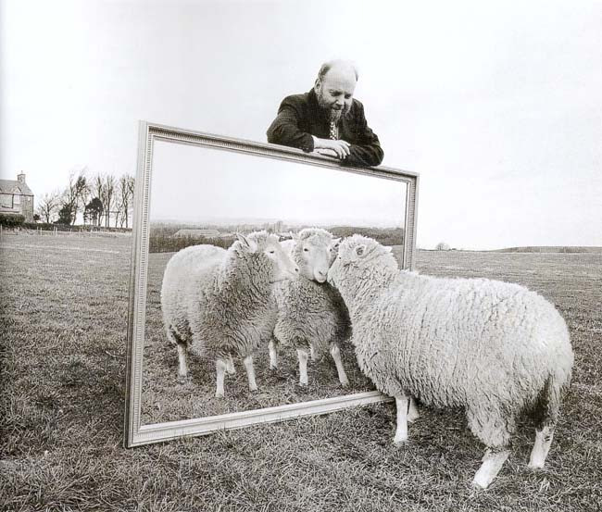
jotted by: Mathieu Werra
An important technology innovation
On 5 July 1995 was born the first mammal to be cloned from an adult cell, its name was Dolly, created by the Roslin institute in Great Britain.
Dolly was not the first animal to be cloned, it gained this attention in the media because it was the first to be cloned from an adult cell. This sheep was a victory for science because Dolly lived 6 years and produced 6 lambs with normal sheep, but on 14 February 2003, Dolly was euthanized because it had a progressive lung disease and severe arthritis.
This experiment is good for the human population because with cloning we have “unlimited food” but cloning should not be developed for humans otherwise it will change the interest of cultural diversity.

19 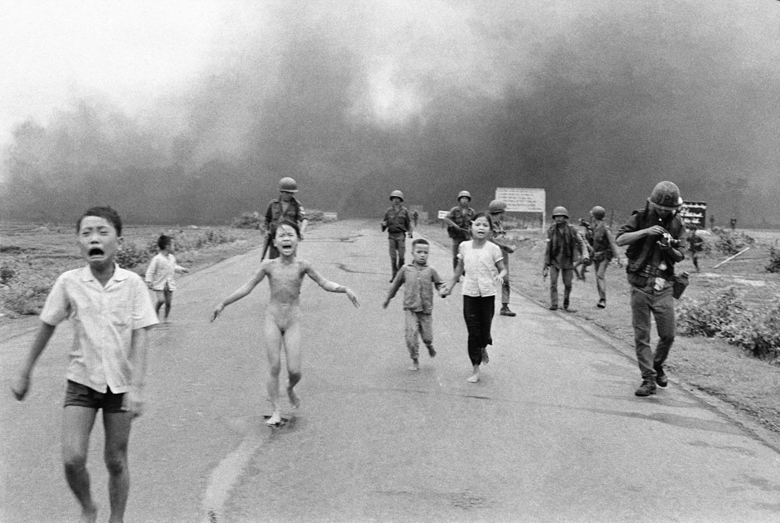
jotted by: Sarah
The sad story of war
Kim Phúc was born on April 2, 1963 in Trảng Bàng, Vietnam. On June 8, 1972, the Vietnam War started. Kim, two of her brothers, cousin and grandmother were refugees in the temple of Cao Dai. But in 1972, an air attack by US forces on the village of Trang Bang force them to leave their refuge. Kim was traumatized. On this road, all were affected by a napalm bomb.
Nick Ut, a young war photographer, was also on the road when the bomb exploded: He is the author of this photo. He therefore saw a little girl out of a cloud of flames and black smoke: she ran to him, terrified and visibly burned, her clothes almost consumed and open arms as crucified. She was an innocent 9-year-old girl caught in the horrors of war. Today, Kim and her family live in Canada with the aftermath of the Vietnam War.
People who wage wars should think more about innocent people like children. It is unnecessary to fight with guns.
20 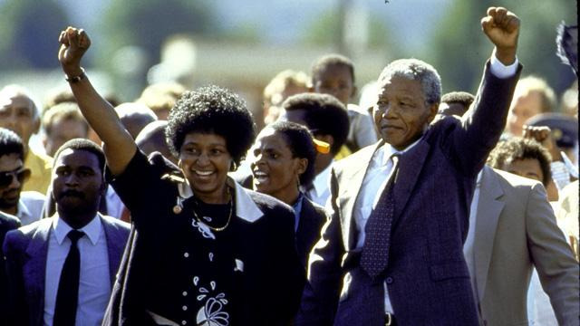
jotted by: halbeisen.camille
Climax of years of fighting
February 11, 1990: Nelson Mandela (18/07/1918 - 05/12/2013), the most historic leader of the struggle against apartheid was released after 27 years in prison. Millions of people followed the event through the world and discovered his smiling face in South Africa, accompanied by his wife Winnie.
He engaged in politics with the friends he met. He founded in 1944 the African National Congress (ANC). This organization advocated peace and abolition of apartheid laws.
Nelson Mandela reached the head of the ANC but the situation was getting worse in South Africa and the peaceful opposition was not effective.
Press related his actions and achievements, Nelson Mandela was arrested in 1962 and his comrades in 1963. He was then sentenced to life imprisonment.
This event represents the strength of hope, freedom and maintains the idea that you should never give up the fight against all forms of racisms.
21 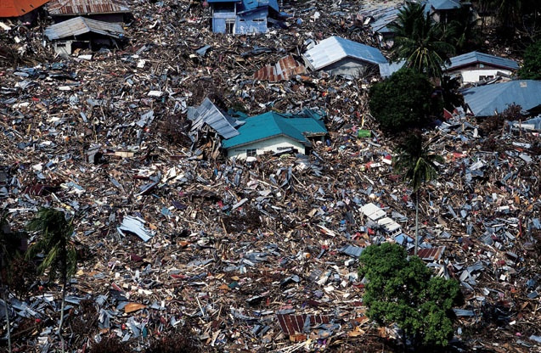
jotted by: xdl07
The most devastating tsunami in modern times
In 2004, The Indian Ocean Tsunami caused by a 9.0 magnitude earthquake, killing more than 250,000 people in fourteen countries in a single day is the most devastating tsunami in modern times. It was given various names like “the Boxing Day tsunami,South Asian tsunami”.
It traveled 375 miles in 75 min,leaving more than 1.7 million homeless. Tsunami is an ever-present and real threat for the these islands of the Indian Ocean due to the presence of a tectonic interactive plate.
Despite a lag of up to several hours between the earthquake and the impact of the tsunami, nearly all of the victims were taken completely by surprise because there were no tsunami warning systems in place.
In all the worldwide community donated more than $14 Billion in humanitarian help.
26 December 2004 was a historical moment that we will never forget because of its gravity and horror.
Events like that prove that we can’t do anything against the nature.

22 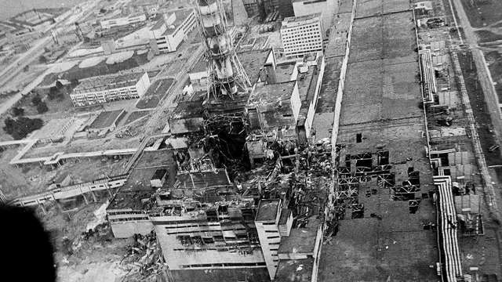
jotted by: arthur68
The Chernobyl accident
The Chernobyl disaster was a catastrophic nuclear accident that happened on 26 April 1986 at the Chernobyl Nuclear Power Plant in Ukraine. This tragic event was the worst nuclear accident in history in terms of cost and casualties.
In the night an explosion and fire released large quantities of radioactive particles into the atmosphere. 31 died within the first three months due to the radiations. The town of Pripyat was evacuated on 27 April.
The next task was cleaning up the radioactivity on the spot. About 600,000 people called « liquidators » from all over the Soviet Union were involved during 1986 and 1987 and later. They received high doses of radiation, but most of them received only low radiation doses. Nowadays cancers and deformities are still being accounted for.
This accident has had a huge impact on people’s health, nature, and on the neighbouring countries, in my opinion one of the biggest world disasters.

23 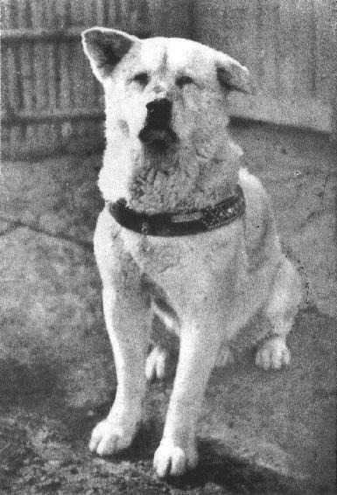
jotted by: Joanna Chrysomalli
" Hachiko : A Loyal Dog "
In 1924 a professor Hidesaburo Ueno in the agriculture department at the University of Tokyo took Hachiko, an Akita , as a pet. During Hidesaburo's life, Hachiko greeted him at the Shibuya Station each day. But one day in May 1925 professor Ueno didn't return. Hidesaburo had suffered a cerebral hemorrhage and died, Hachiko was waiting at the train station every each day for the next nine years. Hachiko died on March 8,1935 and was found on a street near in Shibuya Station. In April 1934 a bronze statue in his likeness was erected at Shibuya Station. Each year on April 8 Hachiko's devotion is honored with a solemn ceremony at Shibuya Station and hundreds of dog lovers often turn up to honor his memory and loyalty. In August 2009 an American movie starring actor Richard Gere was released about Hachiko and his relationship with an American professor and his family following the same basic story. In my opinion Hachiko is a symbol of loyalty and dedication

24 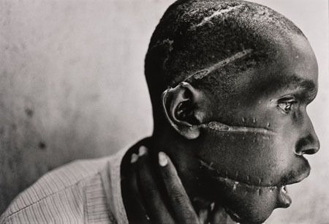
jotted by: manonvalentin29
Merciless war
This Picture was taken during the Rwanda genocide in 1994.The genocide killed 800,000 Tutsi and Hutus between April and July 1994 without saving women and children. A death imposed by their own neighbors trained for several months. The genocide was started after the attack of the Rwanda president. It was a pretext to start a genocide. It lasted hundred days. It was the fastest genocide of the history and that of bigger scale.
I think this photo is shocking and moving.

25 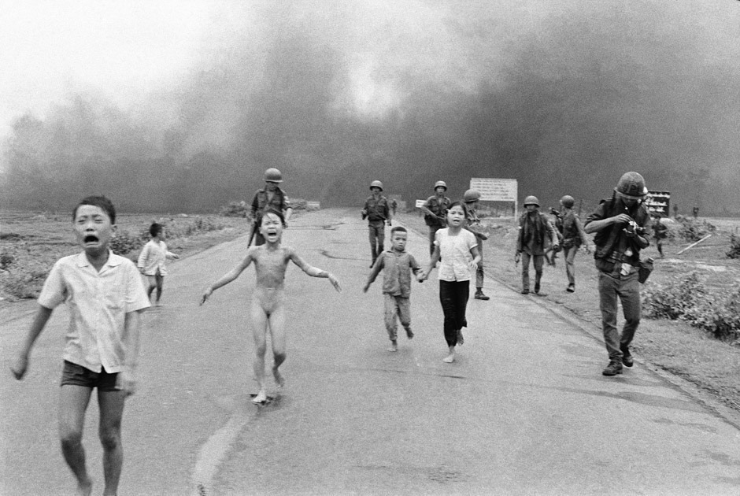
jotted by: Beri-van
South Vietnam,1972
A girl flees from a scene of napalm dropping in South Vietnam. In the picture, the girl was 9 years old and she wailed "too hot, too hot!" as she ran down the road away from her burning Vietnamese village. It was taken during the American bombing of the village of Trang Bang.
A south Vietnamese place accidently dropped its flaming napalm on South Vietnamese troops and civilians.
The journalist who took this photograph was Nick Ut. After taking the shot, the journalist used his media pass to get to the naked girl, Phan Thi Kim Phuc, and other children admitted into hospital. Nick and Kim stayed in touch over the years.
I communicated the horrors of the Vietnam War in a way words never could, helping to end one of the most divisive wars in American history and later becoming a symbol of the cruelty of all wars for children and civilians victims.
26 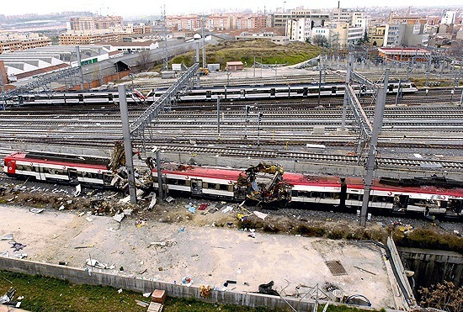
jotted by: AnnaG
THE BLOODEST COUP – MADRID
On 11th March 2004, as every day, the inhabitants of Madrid came to station to go to school, work. Nobody expected that for some of them it would be the last journey…The terrorists planted explosives in four passenger trains. All exploded at around7.40 p.m. 10 bombs were detonated (3 failed) in trains located at the following stations: Atocha, El Pozo del Tio Raimundo and Santa Eugenia.
The assassination resulted in a total of 191 victims, most of whom were Spanish (142 citizens). People from 17 countries of the world died. The attack resulted in the extremely large number of wounded: about 1900. That tragic event was to be related with Al-Qaeda fas a revenge for the intervention in Iraq. I think that this terrosist attack left a huge mark on the whole world.
Photo by: EMILIO NARANJO

27 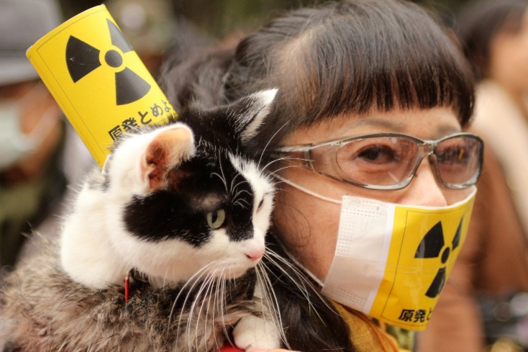
The tsunami, which changed the whole world!
11 March 2011.There was one of the strongest earthquakes in the history. Then 12 meter-high tsunami flooded the northeast coast of Tohoku region of Japan and the Fukushima - the nuclear reactor. About 20,000 people died and other ones lost their homes. The nuclear reactors exploded 2 times.The first time the hydrogen exploded. In December the nuclear reactors were recognised as turned off.
What were the negative results of this catastrophy?
Plenty of radioactive water poisoned the Pacific Ocean. The percentage of people who might suffer from cancer and other diseases increased. It has been a very expensive catastrophy for the Japanese goverment. They must build new hauses for their citizens and provide them with medical care.
The whole world feels effects of Fukushima explosion.

28 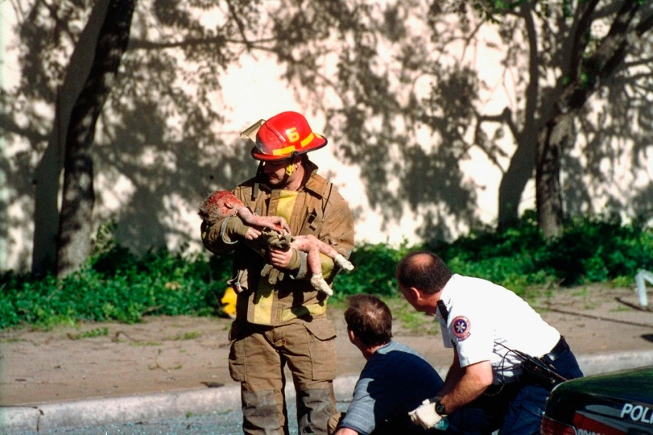
jotted by: Natalia Dykas
The dying child as a symbol of cruel terrorism
19 April 1995, 9:00. Everything was quiet and nobody expected such a huge tragedy. At 9:02 it was all over. A truck filled with dangerous ANFO exploded. Seven-story federal building in Oklahoma City collapsed. More than 1/3 of it immediately ceased to exist. During this outbreak 168 people lost their lives, 700 people were injured. What was the cause? A revenge on the government for the siege in Waco. Responsible for the coup was Timothy McVeigh. Alive people were extracted from the rubble. At some moment, Sergeant Avera – a firefighter - found the body of a child. He was shouting ‘I have a fatal accident!’ and he quickly moved towards the medical services. At that time,25-year-old amateur Charles Porter took a photo of the firefighter with a small baby in his arms. Doctors did their best, but unfortunately Baylee Almon, who the day before had her first birthday, died. This picture circulated throughout the world. Avera was called as a hero and McVeigha was sentenced to death penalty.

29 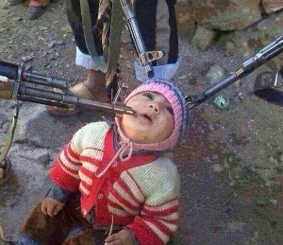
jotted by: Klaudia
Don’t close yours eyes!
Nowadays in Iraq Christians are murdered - only because of the fact that they are Christians. They are murdered cruelly. Right next to our civilized world terrible crimes inflicted on humanity happen. Mothers are raped, their husbands arehanged, and what about their children?
Could this innocent child defend itself from attackers?
Why no one who would defend the baby from their presecutors was found ?
Where are the parents of this child?
Whether they live or not ?
In the name of which reasons the child had to die?

30 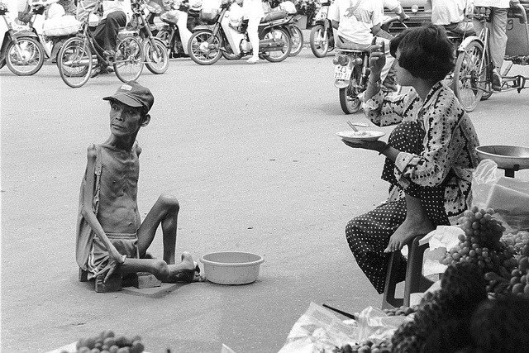
jotted by: Laura Kieltyka
Vietnam, the place where effects of war are still alive
In the years 1959-1975 the war in Vietnam. took place. It was a military action on the Indochina Peninsula in which participated: South Vietnam (supported by the Americans) and North Vietnam (supported by the Soviet Union). The cause of the war was the failure of the provisions of the Geneva conference. During the fighting, in addition to the bombing of Vietnam's population, biological and chemical weapons were also used. This was one of the worst solutions. The number of victims was dramatic.
Unfortunatly, the effects of the use of biological weapons are seen to these days. A lot of people are born with deformed parts of the body. Innocent people have to suffer because of mistakes made by their ancestors.
Is it fair? … They don't ask this question. They accepted the fact, because they know that history cannot be changed.

31 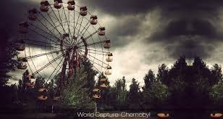
jotted by: nickos.rinis
A city that will never be the same again!
The Chernobyl disaster was a catastrophic nuclear accident that occurred on 26 April 1986 at the Chernobyl Nuclear Power Plant in Ukraine.An explosion and fire released large amounts of radioactive particles into the atmosphere.During the accident itself, 31 people died, and long-term effects such as cancers and other disabilities.The explosion was caused from one of the reactors accepted a huge power increase which caused chained explosions and also released huge quantities of radioactivity.The city is still abandoned today,but tests are being tryed every day in order to see the progress and if the city will ever be the same.
32 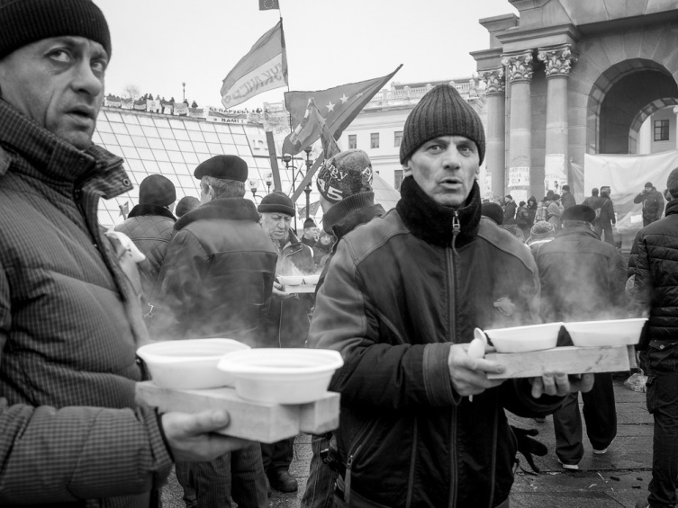
jotted by: Justyna Augustowska
Protests on Ukraine
Protests on Ukraine had been taking place for a long time before on 21stNovember 2013 the arrangements to singan the Association Agreement and the Agreement on the establishment of a free Trade zone was stoppedby the Government. Then a thousands of protesting people arrived on Majdan square in Kijew. Protesters said that they would stay at the main place of Kijow untill decisions were changed by the government. Apart from the protests there were a lot of riots which took place from 18 to 20 February 2014 .Street Fightings cost the lives and health of hundreds of people but resulted in reaching the turning point in situation of Ukraine. President Viktor Yanukovych, under the pressure the West as well as due to the wave of indignation in the country, decided that the constitution of 2004 will be restored and early elections took place. February 21 military forces have been removed from the streets of Kijow and Yanukovych left the capital.

33 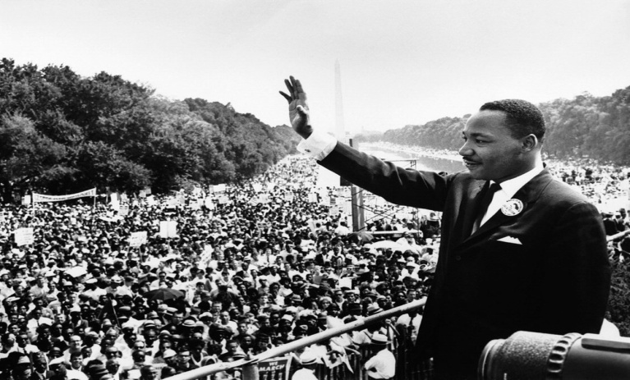
jotted by: Solenne
Words are mightier than any sword.
"I Have a Dream". This is the name of the public speech delivered by American civil rights activist Martin Luther King Jr. on August 28, 1963, in which he calls for an end to racism in the United States. Delivered to over 250 000 civil rights supporters from the steps of the Lincoln Memorial during the March on Washington, the speech was a defining moment of the American Civil Rights Movement.
Toward the end of the speech, King departed from his prepared text for a partly improvised peroration on the theme "I have a dream", prompted by Mahalia Jackson's cry: "Tell them about the dream, Martin!" In this part of the speech, which has become the most famous, King described his dreams of freedom and equality arising from a land of slavery and hatred.
I find that this photo conveys many feelings and I have a lot of admiration and respect for this man, he brought so much to the humanity. To me, he is the ultimate proof that simple words can upset the course of the History.

34 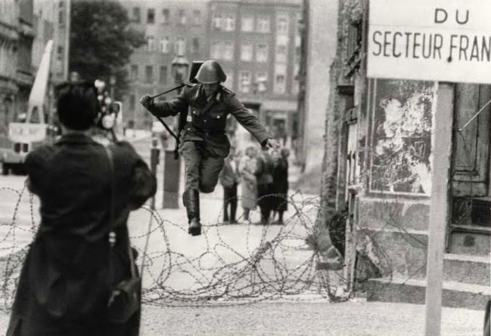
jotted by: Markella Sena
A leap into freedom
On 15 August 1961, the 19-year-old Schumann was sent to guard the Berlin Wall . At that time, the wall was only a low barbed wire fence. From the other side, West Germans shouted to him, "Come over!". Schumann jumped over the fence and managed to pass through. The West German photographer Peter Leibing photographed Schumann's escape. His picture has since become an iconic image of the Cold War era .
On 20 June 1998, suffering from depression, he committed suicide, hanging himself in his orchard near the town of Kipfenberg in Upper Bavaria.
In May 2011, the photograph of Schumann's "leap into freedom" was inducted into the UNESCO Memory of the World programme as part of a collection of documents on the fall of the Berlin Wall.
The Berlin wall is a black page of human history.Schumann was brave and lucky because he managed to escape but on what price? He lived away from his relatives and that cost him his psychological health and eventually his life.
Photo: Photo by Peter Leibing

35 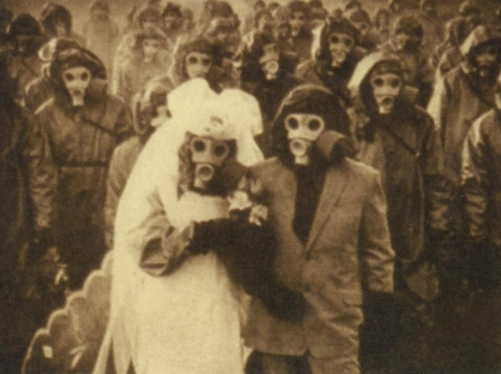
jotted by: Alexandra Fratila
☢❣The "gas mask" wedding .❣☢
This picture was taken in the Izu Island of Japan. This island have a unique problem while it's near Tokyo. There is an active volcanic chain that has erupted six times in the last century. The high concentrations of poisonous gasses is what matters the most. In 2000 the residents were evacuated due to ectremely high levels of toxic gas in the area. They were finally allowed to return back home in 2005 though they are forced to carry a gas mask with them all the time. But as you can see people got used to ot. Love is love so they do not care about the gasses. This couple got married anyway. ❤ Another amaizing thing is that tourists can visit the island which is full of natural beauty but the first thing they have to do is to buy a gas mask.☢☠
Photo under Creative Commons. (Atlas obscura)

36 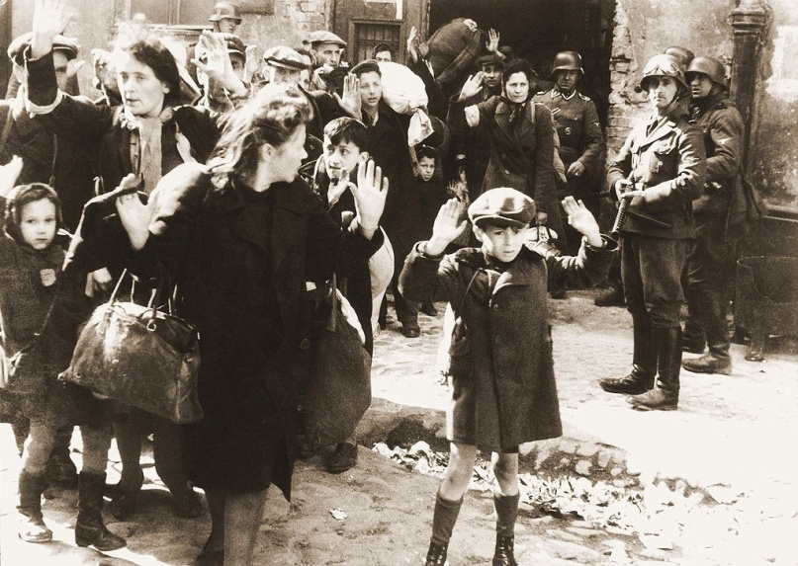
jotted by: Vasiliki Christopoulou
The Holocaust. Should we remember?
World Warll. The Holocaust was a gerocide in wich approximately 6 million Jews were killed by Adolf Hitler's Nazi regime and colloborators. Jewish people were brought to Concentration Camps where they were forced to do hard work. The weak were killed. Some would be led to gas chambers to be killed with poison gas. Non-Jewish victims of broader Nazi crimes include Gypsies,Poles communisists,homosexuals,soviet POWs and the mentally and physically disabled. In total,approximately 11 million people were killed including 1 million Jewish children alone. Jewish armed resistance to the Nazi occured thoughout the Holocaust. An estimated 20.000 to 30.000 Jewish partisans actively fought the Nazis and their colloborators in Eastern Europe. The Holocaust is one of the most terrible events in human history. Should we forget? We'd rather not. Memory should make us alert to human insanity.

37 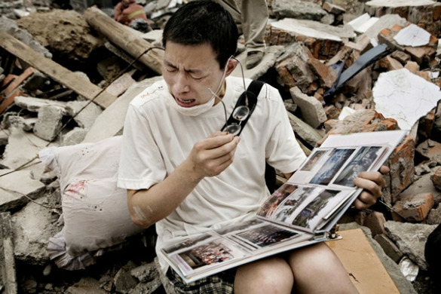
jotted by: elena tafa
Earthquake in Sichuan
Mads Nissen is a world-famous photographer from Denmark. He has worked for the Danish newspaper Politiken and for others newspapers. His picture "Earthquake in Sichuan" received a second prize in the "Best Foreign News Picture Story". On May 12, 2008 a 7.9 earthquake hit Sichuan in Western China killing about 87.000 people. Some of them were missing. 4.800.000 people were homeless. Villages and towns were destroyed and many schools were collapsed. The moment which is captured in the photo is the desprerate cry of a survivor of the earthquake who found a family photo album. It is the only thing that remained from that disaster, and it shows the power of nature and how human existence and happiness can be ruined in a few minutes.
Photo by Mads Nissen.

38 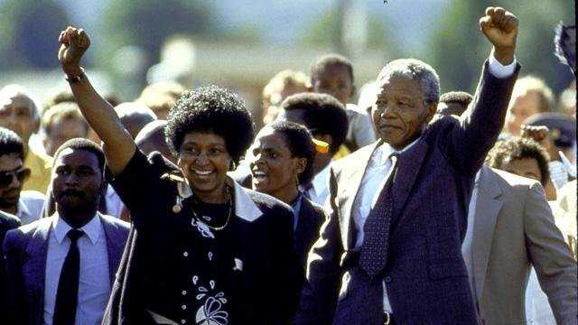
jotted by: So-nia
A historical legend finally claim victory
In this picture, we can see the release of Nelson Mandela he was a South African state; it was one of the historical leaders of the struggle against the institutional political system of racial segregation he became president of South African from 1994 to 1999. Nelson Mandela joined the African National Congress (ANC) in 1943.He was a lawyer. On 5 August 1962, he was arrested by the South African Police indication of the CIA, and then sentenced to prison and hard labor for life at the Rivonia Trial. Therefore, it became a symbol of the struggle for racial equality and enjoys a growing international support. Mandela was released February 11, 1990. With the whole community behind he looks very happy and determined. In 1993, he was awarded with the latter the Nobel Prize for Peace jointly and peacefully ended the apartheid regime and laid the foundations for a new democratic South Africa.

39 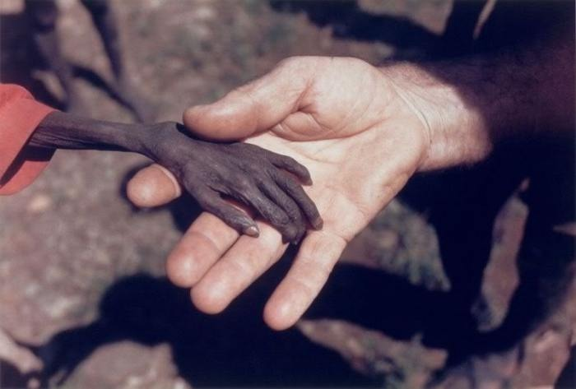

jotted by: Markos Plakou
The contrast speaks louder than any words.
Uganda 1978, a terrible war broke out between Uganda and Tanzania. This war kept for about a couple of years and caused dramatic consequences for the two nations. Thousands of people were dying every day, others lost their properties and others lost their families. Uganda wasn't the WINNER of the war and the following period was pretty chaotic because of the riots and the famine that led thousand of people to starvation. The authorities were to busy to take action and urest ruled everyehere. The victims were the helpless children, who were dying owing to the medical lack, the hunger and the poverty. This prized photo is taken in Karamoja district by the photographer Mike Wells who admitted that he was ashamed to take it. The contrasting hands of a starving boy and a missionary speak louder that any words. Do something now!!
Photo by: Mike Wells

40 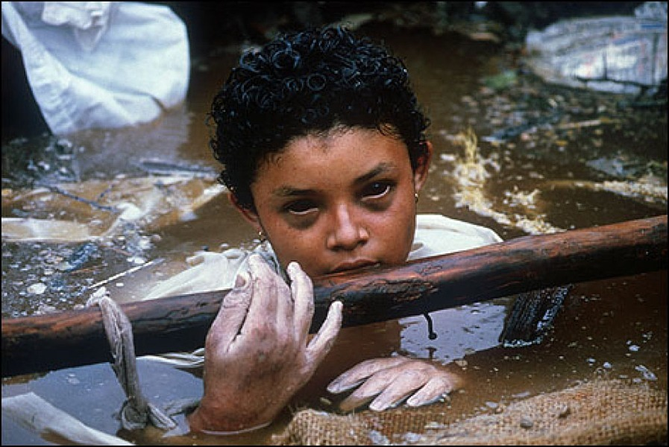
jotted by: Eirini Simiti
The agony of Omayra Sanchez
Omayra Sanchez Garzon (August 28,1972-November 16,1985) was a Colombian girl killed in Armero,Colombia by the 1985 eruption of the Nevado del Ruiz volcano when she was 13 years old.The volcanic debris, mixed with ice rushed down the valleys and killed nearly 25,000 people,destroying Armero and 13 other villages.After her house was demolished ,Sanchez became pinned beneath the debris of her house, where she remained trapped in water for three days.Her struggle to survive was documented.Her courage and dignity touched the journalists and relief workers,who put great efforts into comforting her.After 55 hour of struggling,she died,as a result of either gangrene or hypothermia.Her death highlighted the failure of officials to respond promptly to the threat of the volcano,contrasted with the efforts of volunteer rescue workers to save the trapped victims. Why is life so unfair to some people??
Photo: Frank Fournier
41 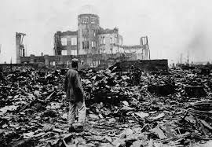
jotted by: stamos.petroulias
The Atomic Horror
1945.Final stage of World War 2.The United States dropped atomic bombs on Japanese cities of Hiroshima and Nagasaki after the Japanese refusal to accept unconditional surrender.The two bombs killed at least 129.000 people. Half of the deaths occured on the 1st day and the rest from burns and radiation sickness.In this photo we can see one of the few buildings which survived after the explosion.The results of the explosion are obvious but there are many more that we cannot predict if we are unaware of how harmful radioactivity to the environment and humanity is!The man in the picture is staring at his destroyed city,which is almost abandoned and full of dead bodies and collapsed buildings.This picture shook the world because it shows the despair and terror of war!!!

42 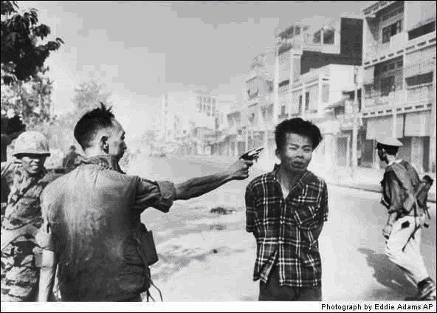
jotted by: john.psomas
Photo-Symbol of atrocities during the Vietnam war
1968 Vietnam."Saigon Execution" is one of the most famous photographs in the military history and it played an important role in turning public opinion against the Vietnam war.A Vietnamese officer fires a bullet into the head of a man who appears to be a civilian.The photo shows an act of brutality.What is the truth behind it?The man who was shot (BayLop) was the leader of an assassination team and had killed thousands of people.The shooter general Loan shot that man because he knew that he was in Lop's assassination list and he had killed one of his friend's family members.The photo had a great impact and won the Pulizer .The photographer, Eddie Adams had later said that he was sorry he took it because it didn't tell the truth.Whatever the truth is,it is shocking to see how war can affect people's characters and makes them 'beasts'
Photo: Eddie Adams

43 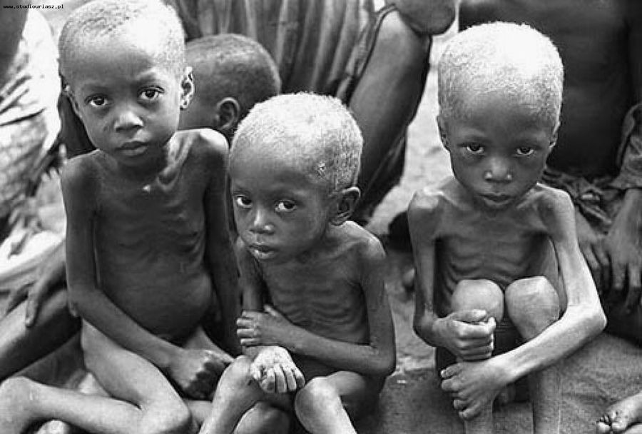
jotted by: Nick Poulos
Famine in Uganda
This photo was taken in 1980 during one of the worst famines in history.According to statistics, 21% of the population died that year in Uganda and out of that percentage, 60% were infants.The photo was taken in Karamoja district.Karamoja are a nomadic people and their region has the driest climate in Uganda.At that time, Karamoja were dying of starvation and drought.A lot of people know about this period of famine because of its fatalities.Even though this is a worldwide known period, famine, ethnic violence and drought in Karamoja continue to this very day as they do not receive aid from anyone.
44 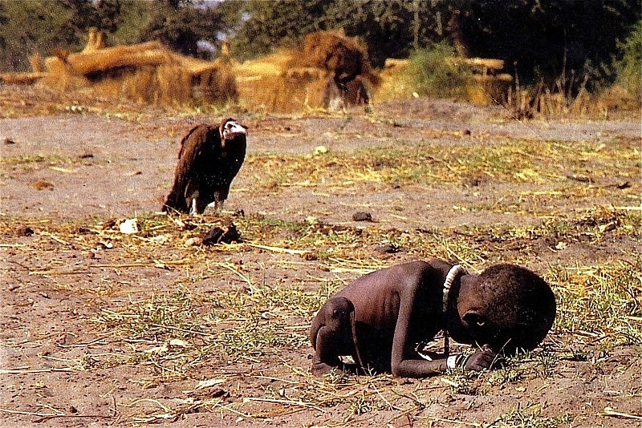
jotted by: ANNE-SOPHIE LEBORGNE
A SAD REAL STORY
In March 1993, photographer Kevin Carter made a trip to southern Sudan, where he took iconic photo of a vulture preying upon an emaciated Sudanese toddler near the village of Ayod. Carter said he waited about 20 minutes, hoping that the vulture would spread its wings. It didn’t. Carter snapped the haunting photograph and chased the vulture away.
The photograph was sold to The New York Times where it appeared for the first time on March 26, 1993 as ‘metaphor for Africa’s despair’. Practically overnight hundreds of people contacted the newspaper to ask whether the child had survived, leading the newspaper to run an unusual special editor’s note saying the girl had enough strength to walk away from the vulture, but that her ultimate fate was unknown.
I think that the photograph wanted to show the world what happened in Sudan. But this photo touches me deeply. It makes me want to help them.

45
jotted by: Houseyin Chasan
Hachiko The Faithful Dog
One day a Japanese Professor Hidesaburo Ueno was coming back home from his work by train.As he got off the train he found a dog.He took it home and looked after it and one day he discovered that the dog was not at home but it was waiting for him at the station. Since that day, the dog waited for his master to come back. One day the professor did not turn up but the dog continued to wait. It lasted for 9 years when the dog died.This is the story of one ofthe mos famous dogs in history for his loyality. The dog managed to touch thousands of people who brought him treats and foof to nourish him.When Hachiko died, Japanese people honoured him as a symbol of faith.
46 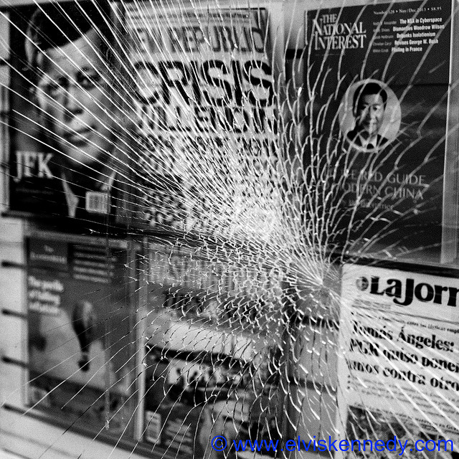
jotted by: sifis lalas
J.FKennedy'sassassination
John Fitzerald Kennedy was the 35th President of USA. He was assassinated at 12:30pm ,Central Standard time on Friday, November 22, 1963, in Dealey Plaza, Texas .John was shot in the head by a sniper rifle while he was travelling with his wife Jacqueline , John Connally and Connaly's wife Nellie,in a presidentiol motorcade.Kennewas assassinated by Lee Harvey Oswald,who was killed by Jack Ruby two days later.Kennedy's death was a very tragical moment for the USA.Also tragical was the words from his wife at the moment he was assassinated.She said:" they have killed my husband and i have his brains in my hands"
His tragical death has produced a lot of conspiracy theories .Did Oswald kill Kennedy by himself if or other were involved too? Sceptics still doubt.
Photo (cc) by Elvis Kennedy

