Walking down the streets in other people's shoes

jotted by: Evangelia Anagnostaki

Monasteraki square, Athens, Greece.
Who are all these people?
Where do they come from?
What is the path of their life like?
What are their stories?
Are they city dwellers, locals, migrants, tourists, passers-by..? Are they strangers or just our next door neighbours?
Look for the people's identity. Invent their stories and reveal the culture, lifestyle and history of your countries.
This topic is mostly addressed to students from Greece, Turkey, France and Poland who participate in the Etwinning project 'A picture is worth a thousand words'.
Photo: E.Anagnostaki
1
jotted by: Joanna from Greece

A busker's life...!
Alex Nikolaou is a busker who lives in Athens and he hangs out in the centre of the city. He was born with a talent and everybody used to regard him as a gifted child. From an early age, he loved singing. As he was growing up, Alex was constantly nagging his parents about buying him a guitar and take him to a conservatory but his destitute parents could not afford to. He grew up and he still wanted to make his dream true, to be a musician. So he somehow managed to find a guitar, he left his home and started wandering here and there playing some melodies he had learned. As the days were going by, Alex was becoming even better. He is enjoying his life as it is. He knows he entertains people and he declares that the money he raises is nothing compared to the praise of somebody.
2 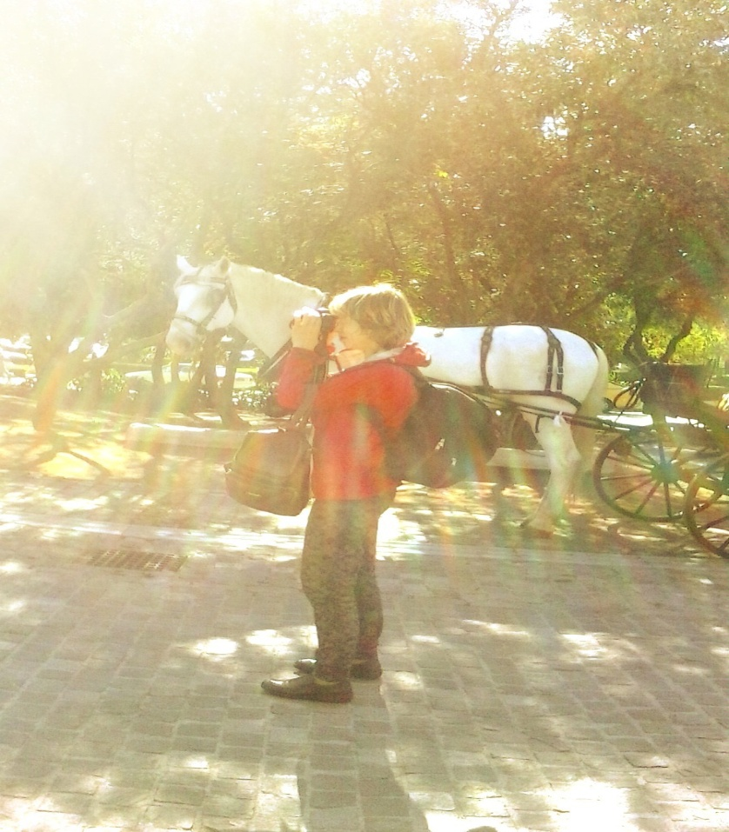
jotted by: Nancy Rekoumi

A photographer in action!
Mary Larrow lives in Thisio, Athens. She was born and studied in London. When she first travelled to Greece, she loved the beauty of this country. So, Mary decided to settle down here. From the first moment, she understood that the country's magic would be very helpful to practise her job. Nowadays, Mary is a very successful photographer. She loves Thisio and Monastiraki, so every day she walks in these places in order to photograph different aspects of Greek reality. Mary feels very lucky about her life. Her photographs are very important for her. ''These are my spiritual children'', she says. Mary regrets not having her own family and children. As a result her gaze is full of an indescribable sadness and melancholy. Mary is thinking of going back to London but at the same time she can't imagine her life without the sun and the sky of Greece. She keeps saying to herself: ''Wherever I go my soul will belong to this redemptive Greek light where my mind cannot escape''!
3
jotted by: stamos.petroulias

John Papadopoulos and his life!!!
John Papadopoulos is a middle aged man who lives in
Athens, Greece. He has been married for ten years and has two little twin boys, who attend the first class of primary school. He loves his wife very much and he is quite sad because he cannot support appropriately the family needs as he has been unemployed for two years. Before the economic crisis in Greece, he was working as a travel agent and he was a well-paid employee. However the agency went bankrupt and he was fired. Nevertheless he never put it down and he continues to be looking for a job in the newspaper and on the internet. In the future he is planning to move to his parents' house in a village, if he doesn't manage to cope with the economic crisis, in Greece.
4 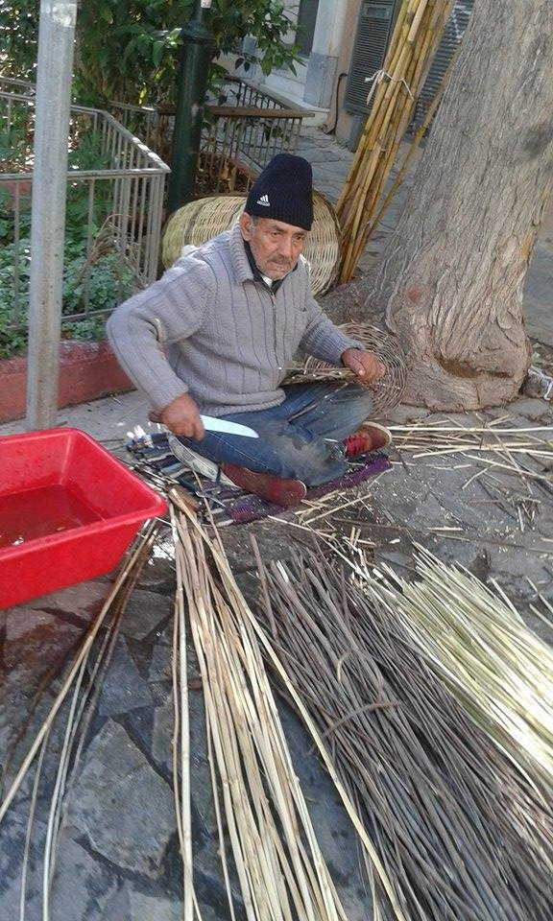
jotted by: Jim Tasios

Back in time
Petros Papadopoulos is 72 years old and lives in Athens, Greece. He is a basket weaver and works in Monastiraki. When he was young, Petros wanted to be a football player but life had other plans for him. His grandfather was a basket maker and he taught him the job very well. When he was 15 years old Petros had an accident that caused him a problem in his right leg. That means that he couldn't play football for the rest of his life. So he decided to follow his father's craft. When he reached 40 he had already a family consisted of him, his wife and their 3 children. When he was 45 he broke up with his wife and after that his life was miserable. In his free time he goes to Monastiraki and teaches other people the job of basket weaving for free. There are many people, Greek and tourists who admire him and want to be taught by him.
5
jotted by: sifis lalas

Magic steps in the streets
Antonis Lalas is a street dancer who lives in Athens. When he was young he used to hang out with his friends every day. At the age of 16 he dropped out from school but he kept on dancing from day to night in the streets. Now he is a professional dancer as you see. He dances all styles like latin, hip-hop and break dance. Everyone in the area knows him. He is a very sociable person and very friendly. Antonis is well of now because he has taken part in many music video clips, and he has worked with other famous dancers. The knit cap he always wears belonged to his dad. His dad died when he was 4 years old and that's the reason why he never takes it off. Although Antonis' only goal is to become the greatest street dancer and be on top of the world, deep inside he sometimes painfully regrets not being able to finish school.
Photo: Lalas-Houssein Iosif
6 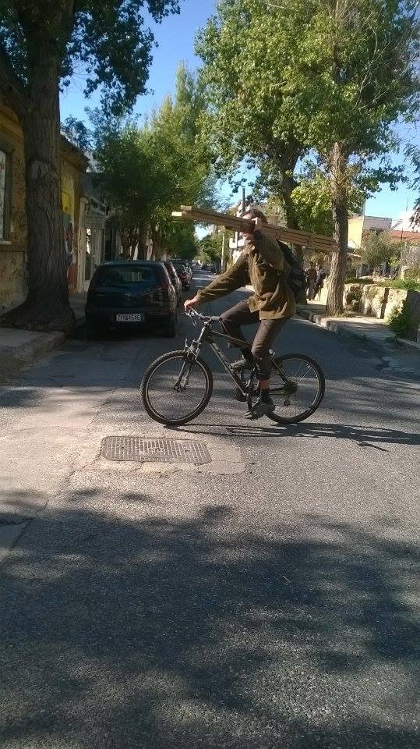
jotted by: Eirini Simiti

Brighter days to come ?!
George is 38 years old, he comes from Bulgaria and he came to Greece, because he couldn't find a better job in his country. He has two children with his wife Maria. Although he wants to find a job, he hasn't finished school. Furthermore, no-one wants to hire him, due to his origin so, George carries some logs to warm himself in his shelter. He barely makes ends meet. Many times he searches the garbage to find things that could be valuable to him. He never stops dreaming however of brighter days to come. And he knows that will not take long from the moment a Greek man, named Kostas invited him for a drink the other day. A new friend who might help him to find a job. A new story in his life begins...
7 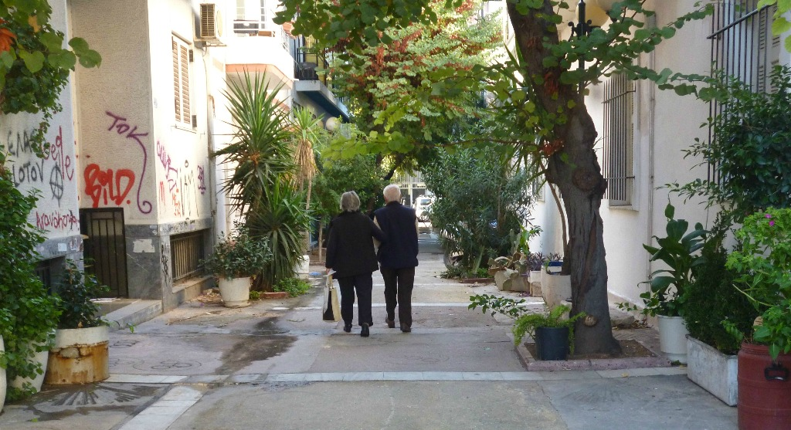
jotted by: Joanna Chrysomalli

Love And Memories In The Streets Of Athens
This cute couple is Mr Achilleas & Mrs Electra. They are both 76 years old and they've been together since they were seventeen. It's said that love fades away as time goes by but they're in love as the first day they met each other in their village. Mr Achilleas and Mrs Electra live in Athens since they got married because this was her dream, to stay in Athens with her husband .Everyday they go for a walk together at the beautiful old streets of Athens. These streets reminds them of their youth when the old Athens looked more like a village. At that time there didn't use to be so many cars and so population as today and everyone knew and talked to each other. Things might have changed and the modern pace of life is so stressful but still you can find people seeking their memories in the streets of the city.!
8 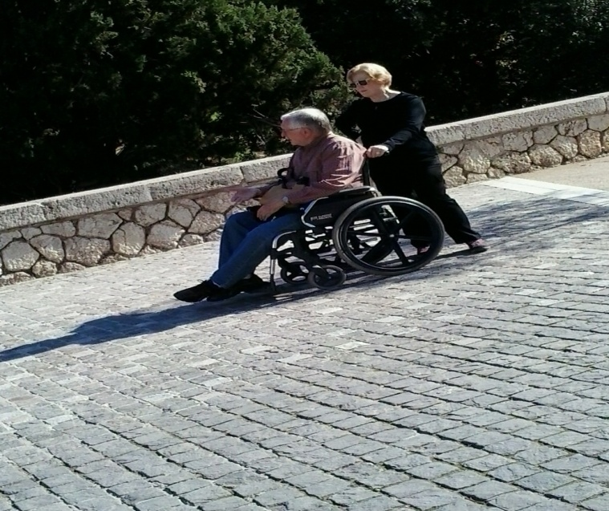
jotted by: Markella Sena

Love for ever
Odysseas Grigoropoulous and Daphne Asimakopoulou live in Athens, Greece and they are together nearly 30 years. They met when they were both very young and fell in love at first sight. When Odysseas was 20 had to join the army and fight but he got wounded and he came back home as a disabled man. Daphne continued to love him more than anything and she promised to him that she will take care of him until her last breath. After a while they got married and had two children. Now they are both 75 and they are really head and heels in love like teenagers. And it’s so wonderful that they are in love as many years have passed and it’s so rare these days to have real love. Finding out the story of these two amazing people we can start to believe in true love.
9
jotted by: Stijn STEVENS

Protest against the fusion
This guy was protesting against the fusion of the Alsace region with the Lorraine region, he didn’t really know what to do to protest and given that he was bald he thought a little paper with « Don’t touch my Alsace » would stick on his head. The government is now thinking about not to make the fusion, this guy is very happy with that, but still keeps his piece of paper on his head to make sure the fusion will not take place. On his paper he chose to put a pretzel because he likes them and has just eaten one.
He thought that paper was not enough. He also made a make-up with red and white stripes, these are the colors of the Alsace as he wants them to be kept. He thinks that if the Alsace will fusion with Lorraine his region will lose a piece of history, so he said that if it takes place he will increase the protesting and cut his beard off and stick another paper on it.

10
jotted by: RosalieLitzler

E&E Friends For Life
November the 7th , Eleanor and Elena go back home after work. They have been roommates for 6 years. They have known each other since primary school. They are more than just best friends it is unspeakable. They work in the same company as secretaries in Colmar, Alsace. Today it is snowing so they take Elena’s umbrella not to be covered with snow. They start to talk about their unbearable boss, things they have done today, they laugh, it is the routine. A day like any other. The sidewalk is totally white, a beautiful day in November. It is almost Christmas, Eleanor’s favorite period, she is so excited and Elena knows it. She prepared a lovely and wonderful surprise for Eleanor to celebrate their 20-year-long friendship. This year they decided to spend Christmas Eve together. Naturally, Eleanor starts to talk about the 24th December and what they will do. Imagine the difficulties Elena has to keep her secret. They continue to walk on the street among other people who also have a story.
11
jotted by: xdl07

A Man, a Life, a Town, a Story
On a sunny day of June around 6:30pm, a man called Wesley Jordan is standing in the street, he’s watching the population and traffic jam. Just next to him, a lot of stores. After waking up he was in a pretty nice breakfast lounge, he took some croissants with an delicious apple juice. Then he went to a park. It’s for him a way to be cut out of the reality. By looking at the nature, the animals, running, having fun with his friends. Then he was in a restaurant with his girlfriend, he’s crazy about good food and he wants to make his baby happy. Later in the day, he’s gone to a studio to play music, he doesn’t make music for money, it’s obvious he earns money by making music but it’s not the most important thing for him, he makes music to make people happy and to give smiles to them. He wants to share his different moments in his life by the lyrics in his songs. In the middle of the afternoon he searched his son John at school. He always worked hard to have what he has today.
12 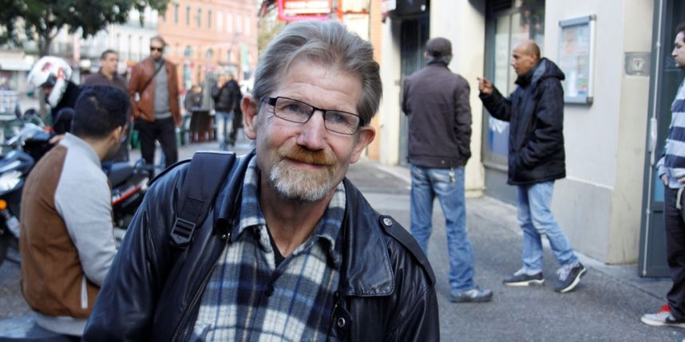
jotted by: arthur68

Bernard, an ordinary guy
This guy is Bernard, Bernard is 60 years old, he has lived in Strasbourg, in the Alsace region since he was born. Bernard did several jobs during his career, he was firstly a bus driver, then he was a tour guide in his city, Bernard also worked for a local newspaper as a reporter for a short period. Bernard enjoys traditional Alsatian food such as the sauerkraut or the different Alsatian cheese. Bernard also loves photography. Bernard has always tried to escape, discover new countries, new people, new ways of thinking. Bernard has been in different countries, like in China, Peru, or India, always trying to discover new landscapes, to live new adventures. Alone or with friends Bernard has always traveled. But now he is back in France, the country of wine and cheese, he changed his vision of the life and decided to stay in his hometown with his family for a while waiting until his next trip. That was the story of Bernard.
13 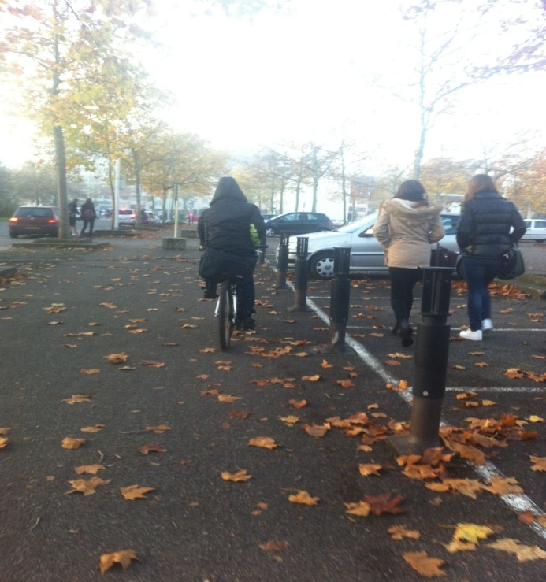
jotted by: So-nia

Story about a photo
On this picture we can see a woman on a bike. We see that she is on the way to her high school. This woman is called Marie Lebert , she is 40 years old and she has been a History teacher for 15 years in Camille See high school . Marie is married and has 2 kids. She has always lived in France in the Alsace region ; she never wanted to move elswhere because she is very attached to this place that she never left . She decided to become a History teacher because for her it is important to know the story of the country or the region we live in. So she wants to share it , particularly significant stories of the world that fascinates her. When Marie is retired she plans to visit the whole of France and why not a part of the world.
14
jotted by: Beri-van

Free man in the mountains
On the picture we can see a guy hiking in mountains. This guy is annoyed by the fact he can't find his way home. he likes to walk alone in the nature because he thinks it's relaxing and keeps him calm. He is not used to these mountains. he tried these mountains because this is one of the most beautiful in Alsace,Massif des Vosges.
Despite that he is lost, He admires the landscape. He does not think to his situation and forget everything for a long and good moment.
He thinks that to be lost is the biggest liberty in the life because nobody disturbs you.
He is only opposite to this and he thinks that the mountains are bigger than all people who make problems.
15
jotted by: Giulia

The daily Pedro
On this picture you can see Pedro Martinez, a young student who studies Art in Strasbourg university. He lives in Turckheim, Alsace. Perdro is going to a Chinese restaurant in Colmar.
He enjoys spending time with friends, partying with them, eating with them. His friends are his life. It’s a boy who is very independent and he loves escape. What he loves most is the food, that is why the photo was taken in front of a Chinese restaurant. In this restaurant Pedro eats five courses and I think it’s too much. This is a boy who makes jokes he makes everyone laugh, but this can be heavy. In this picture he is happy because he loves Chinese food, he could eat it every day.
That there is no Chinese restaurant in Alsace, there are many Specialities eg wine and especially the mulled wine in winter. Sauerkraut is a traditional dish as flammkueche. Alsace is a very beautiful city, especially during the Christmas period.
16 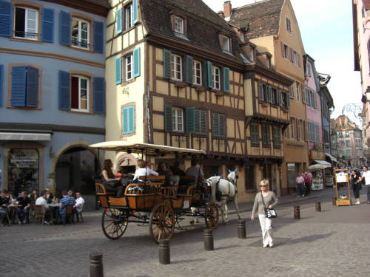
jotted by: hugues volpato

A lucky woman ! Colmar is beautiful !
She works in a bar-restaurant next to the church because she loves eating and preparing mainly culinary specialties of ALSACE.
She likes walking on Colmar streets to admire half-timbered houses which are typically Alsatian.
But today, her day is going to be unusual. In the middle of the afternoon, then she is walking on the Rue des clefs in Colmar she finds an envelope with approximately 3000 euros. But at the time, she can’t believe it. She watches around her if nobody pays attention to this lucky discovery. She takes the envelope and she leaves fast in a place which is more discreet. There is no description on the envelope so she doesn’t know where the money comes from.
Totally ecstatic, she decides to spend the money.
She wants to travel in France to discover all regions because she loves knowing and learning specificities of all regions like the Lion de Belfort, the Mont ST-Mich.
17 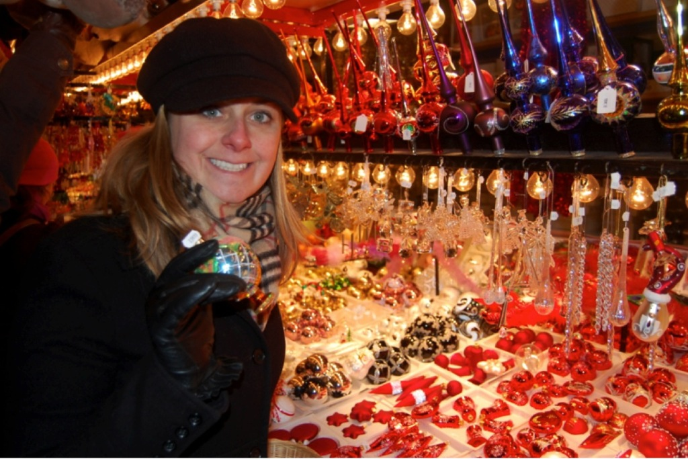
jotted by: ANNE-SOPHIE LE BORGNE

The Trip in Alsace
This women is called Katarina Ruskov, she comes from Moscow, she is 36 Years. Her hobbies are to travel a lot, because she has the funds, to discover many countries and traditions where she is going to. Here, she was in holidays in the east of France, especially in Colmar, to the Christmas market, last year. This women is fizzy, she is a party girl, and when she goes somewhere she tries to get information about evenings there may be.
She thinks that France always has a nice welcomes to all tourists, and the people are very pleasant. She said that in France, there are many beautiful places.
What she liked the most at Christmas period where the markets in Colmar, because it feels right in the right atmosphere, and always with good humor. So many small delicious bredeles to savor. And the fact of tasting good wine, you always want to go back and taste new other things from the nice area of Alsace.
18
jotted by: fenia

It looks different but it isn't
Odysseas Athanasopoulos is a young man with a unique style in which his hair makes the biggest impression. It's really long and it's all rasta. Needless to say, a man with this kind of hair has to have matching clothes. In addition, we can imagine what kind of music he listens to, of course, that's reggae music.
Apart from his appearance, his everyday life is the same as an ordinary man. He likes going for a walk in Monastiraki and Thiseio because mainly in these areas everyone can enjoy the beauty of Athens. The fact that Athens combines ancient and modern life is something that can give him pleasure and, moreover, he feels proud of being Greek.
Odysseas has a really interesting lifestyle. He works in a record shop and he spends most of his free time with his girlfriend and their dog. He believes that we should remain calm no matter what.
19 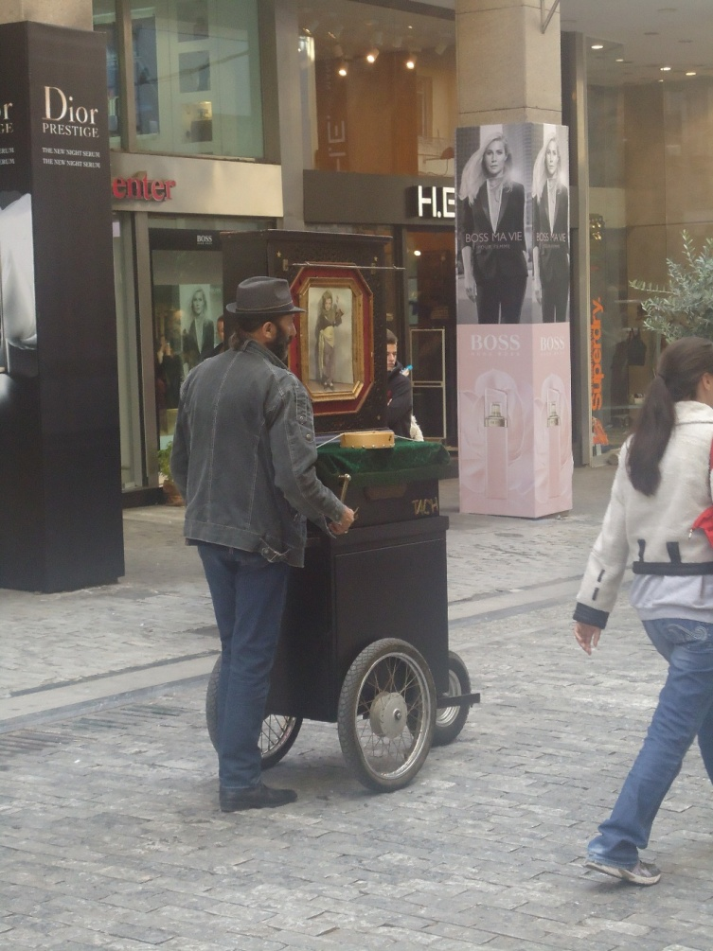
jotted by: Helen Fragkaki

A sweet melodic latern, a bitter story
Rafaello Gorno is an Italian who lives in Athens, Greece. Although he comes from Italy, his grandmother, Maria, was Greek. During the Italian occupation, she met Rafaello, an Italian soldier, they got married and after the war they moved to Italy with their son, Jovanni. Jovanni had three children with his wife, Lucia, but he was laid up and died. The loss of Jovanni was a heavy blow for Lucia and she died, too. Rafaello, who was the oldest son, had to work and raise his sisters. When they grew up and got married, they left him alone. Rafaello was really disappointed with them and he decided to go to Greece, his grandmother’s birthplace, in order to forget the past. He worked in a factory, got married and had two children. Unfortunately, he lost them on a road accident and, four months later, he lost his job due to the financial crisis. So, today he is wandering alone through the streets of Athens with an old latern, he is looking stealthily at the sun and he hopes for a better future.
20 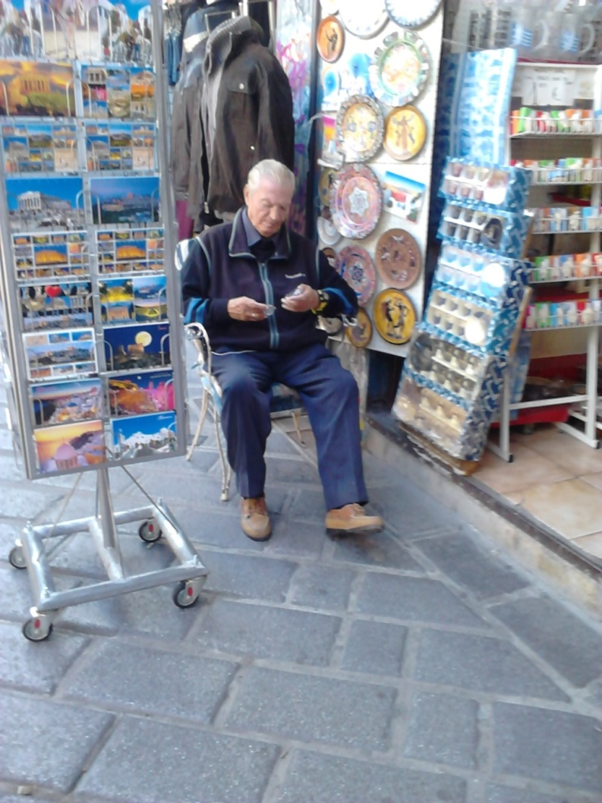
jotted by: nickos.rinis

A soccer legend

John Stathopoulos is seventy years old and he owns a little souvenir shop in Thisio, Athens. He might look as an ordinary old man but Mister jonh is a former soccer player of Atletico Madrid. Since he was a little kid he used to play football all day with his friends. Even though his family were poor he managed to enter a little soccer club which was in the area. After a month, great teams from Greece asked him to join their club. He said no to all of them ,the reason ?He said his goal was to go to Spain and play for Atletico Madrid. Everybody laughed at him saying that he would never make it. Only his family and especially his grandfather believed in him and gave him just enough money so he could go and join the tryouts of Atletico. When he reached Spain he saw great monuments and places when he finally attempted the tryouts. To everyone's astonishment he succeeded. He had a great career and when he retired he opened the store with the souvenirs back in his hometown, Athens.
21
jotted by: elena tafa

A better future for children
Maria is a 35 years old woman who lives in Athens. She is tall with long blonde hair and green eyes. She was born in 1979 in Xanthi. Her father was a merchant and her mother was a house keeper.
She was the seventh child of the family. Her parents were gypsies and very poor and decided to move to Athens when Maria was a baby.
Maria and her brothers and sisters never went to school. She got married when she was 17 years old and had two children a girl and a boy who are now six years old.
Maria and her family lives in a small house in Ano Losia now. Her husband is a merchant and works about twelve hours every day. Maria stays at home and spends her time cooking and looking after her children. She is usually shy and doesn’t speak a lot.
Last week she met a social-worker who will help her family. Maria hopes that her children will be able to go to school this year and this makes her happy.
22 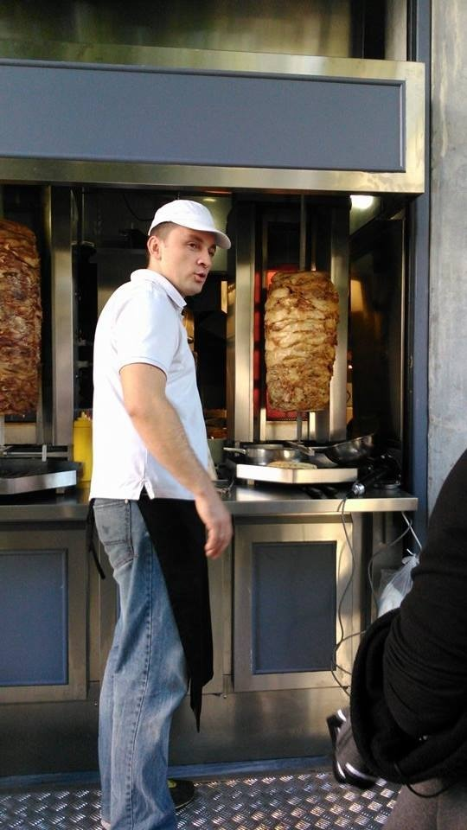
jotted by: Dimitris Psaradellis

Pindos(grill shop)
The best visit in the centre of Athens is in Plaka, the most picturesque area in the city. There are a lot of shops, cafes, shops with souvenirs and many others to buy different things. One of the most interesting attractions in my mind is a grill shop with the name ''Pindos''. This shop is on the hand of Mr. Jim Savanos, for 25-30 years. Now, he is 45 years old. Jim's wife and his three sons, Peter 23 years old, Spyros 20 and George 18 also work there. Mr Jim, used to work as a sailor in a ship, years ago. Now, he is working all day in his grill shop and he has decided to dedicate all his life to this restaurant. ''Athens is my hometown, '' he said and he seems moved. The grill shop has very good prices and I think it is the most successful and appealing food shop in Plaka. Go there and see!!!
23 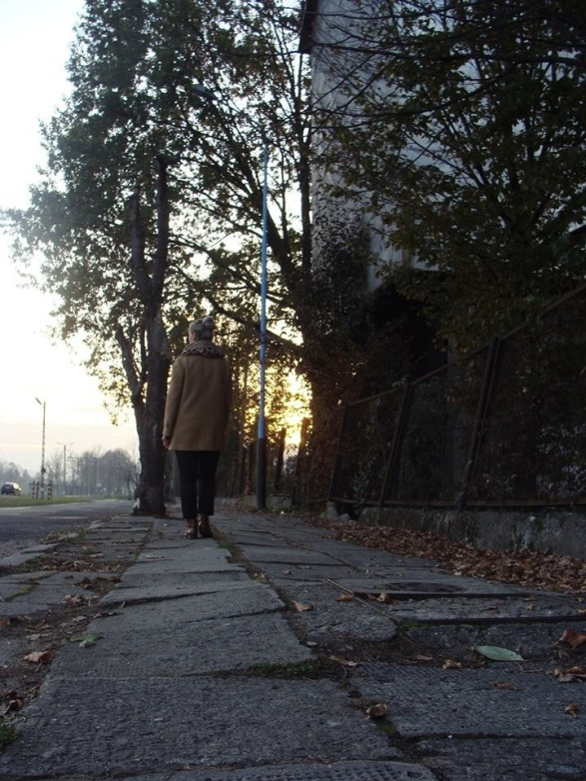
jotted by: Laura Kieltyka

Hard decision
Anastazja is a resident of a Biecz in southern Poland. She is a woman at the age of forty. She is married and has got two children. When Anastazja was young, she dreamed of being a teacher and her dream came true. Now she is teaching in primary school so she is very happy because of it. She has got a lot of friends and leads a successful life. Her relationship with family members are perfect.
In the picture she is walking on her favourite street – 3 Maja. Actually she is thinking about her future. Anastazja must make a decision, because she got a job offer in another city. She became intimate with the city and its residents as a result it is a hard decision for her. What should she do ? Is it a good for young children to change the place of residence ? Will she and her family turn up in another city ? These are the questions that constantly preoccupy her thoughts . What would you do, if you were she ?
24 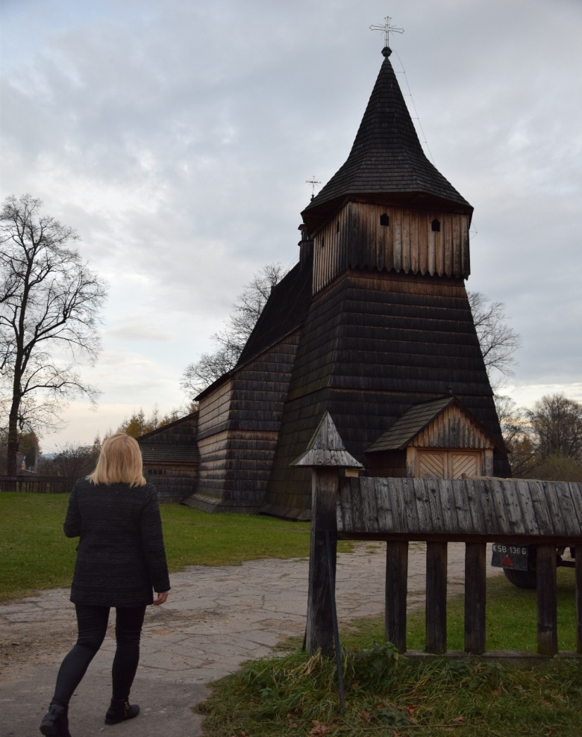
jotted by: Natalia Dykas

An ordinary woman
A person in the picture is a young woman. Her name is Agnieszka and she is in her early twenties. She is tall, slim with blond, short hair. The woman lives in a beautiful village – Libusza. She is an ordinary adult, who has got the same interest like the other young people. Agnieszka is interested in fashion, good music and travelling to the different places on our planet - this things really make her happy. But she is able to appreciate her homeland and the place where she lives, especially the culture and history which are full of interesting events and monuments, like the old church in this photo, which was burnt several years ago. Otherwise, she is very friendly and loyal person with a loving family and the circle of crazy friends. She had just finished the university. One of her dreams is a work for a big company, where she can expand knowledge and develop skills. In the future she wants to be a fulfilled woman with her own family, a house in the English style and a big dog.
25 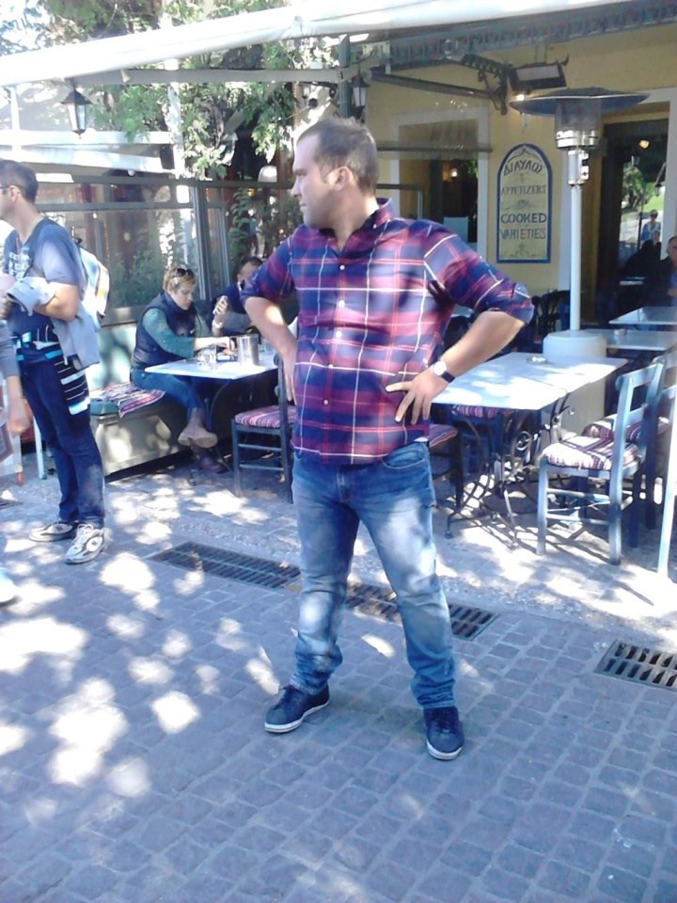
jotted by: Nick Poulos

A young man with ambition
This is Philippos Makris. He is 25 years old and he lives in Athens, Greece. He has been helping his father by working at the family restaurant for the past 2 years. However, working in the family business is not the only thing that Philippos has on his mind. He's been trying to save money so that he can go to Law School and study to become a lawyer. He claims that he would really like to keep working at his father's restaurant, because of his family's tradition, but he wants to make a difference. Although Philippos wants to study to become a lawyer, he doesn't want to leave Greece or his hometown Athens as many other young people do because of the economic crisis and unemployment issues. According to him, Greece is the greatest place on earth. In addition, he says that he wouldn't want to leave the most important people to him: his friends and family.
26 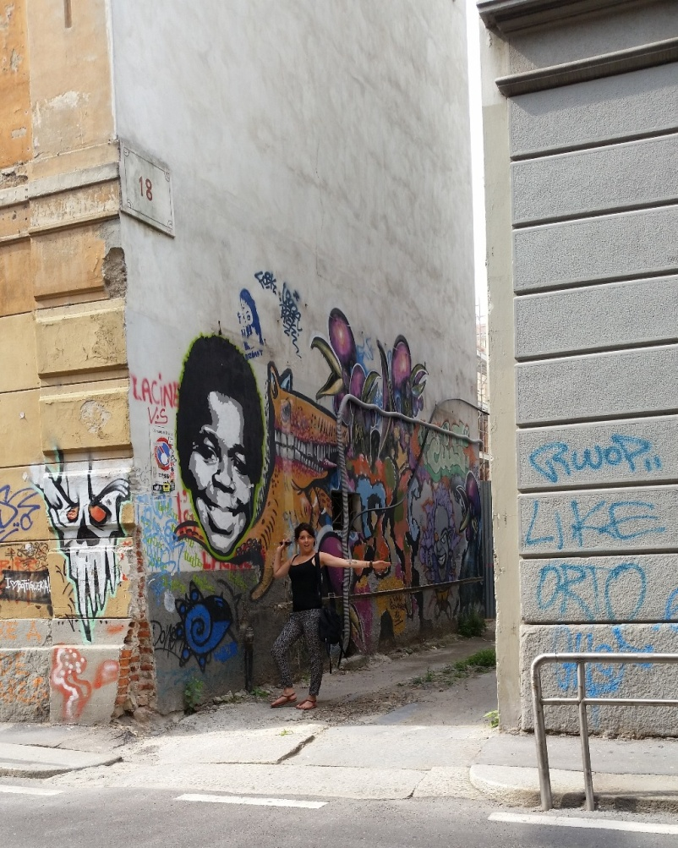
jotted by: halbeisen.camille

The walls talk
On this picture we can see Jessy, a young student who lives in Colmar, Alsace.
She often dreams of escape and hopes to leave the city soon to join England after her graduation.
Jessy enjoys going out at night with friends, going to bars, eating in good restaurants ... She spends a lot of money and is very generous with others. She loves street art, which explains her big smile on the picture. This one will be put in her photo album.
This day she went shopping in town. After 3 good hours in stores, and ten packets in hands, she is starving, so she decides to go to a traditional Alsatian restaurant to take her favorite meal : roeschti with Munster cheese ; She is really greedy !
27 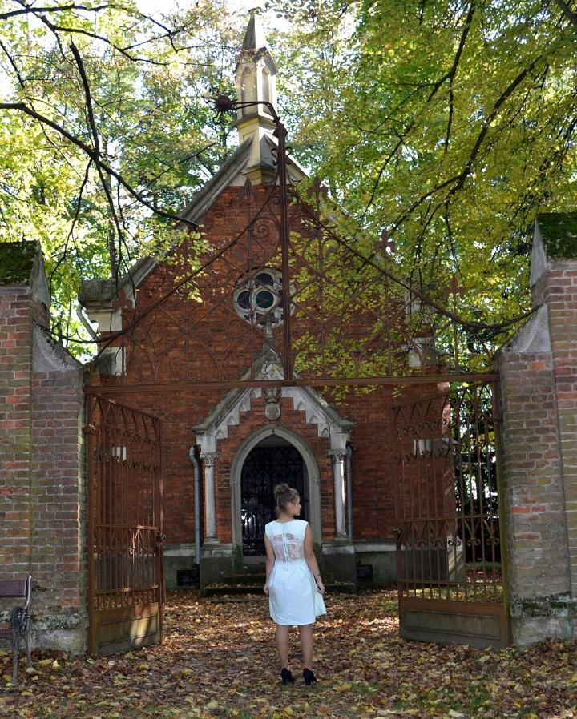
jotted by: Justyna Augustowska

A young girl

On this picture is a young girl Paulina who I meet in one of November day. She lives in Binarowa in Poland. She is a beautiful girl with strong character, brave. She is a person who knows what she wants but also who something still miss. She has got something mysterious which is hard to describe. She is wearing a pretty mint dress. She seems to be dressed like on a date. However she is staying alone next to entry to old, abandoned church. Maybe she wonders if she should go there or maybe she waits for someone. She is looking on the one side then on the second. In her I see uncertainty and fear which could evidence that she is scared of this place or maybe she is connected with this place. She could come back to the old memories. She could also be there for the first time and she is curious what is that place. A while later, she is coming to the church.
28 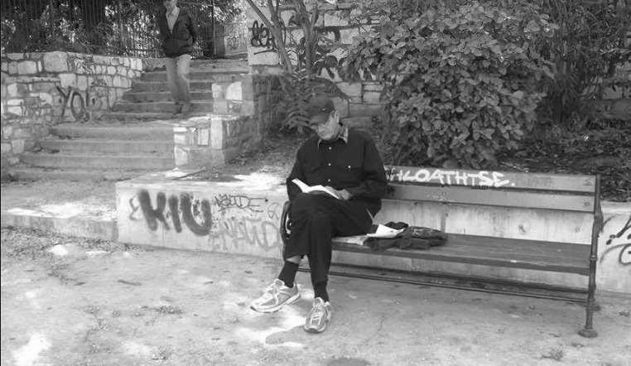
jotted by: Markos Plakou

What about Nick?
Nick is a 65 year old man who lives in Athens, Greece. No, he is not retired. He actually is a victim of economic crisis. He used to work as an assistant in a lamp shop. He has a large family. Specifically, Nick has 3 children, two daughters named Natalia and Euridiki and a younger son named Vasilis. Unfortunately, he is widower and his children have their own families now. He is alone and he has a lot of free time. He likes caring his plants and reading literature books. He actually loves it. You see, books have the magic ability to travel us and make us forget our own problems for a while. This is why Nick loves books. In this photograph, he is reading a literature book named ''The secrets of Samantha''. Apart from books and his beautiful plants, he really enjoys cycling. You may see him cycling in Ermou, Omonoia, Thisio or Monastiraki, so watch out!

29 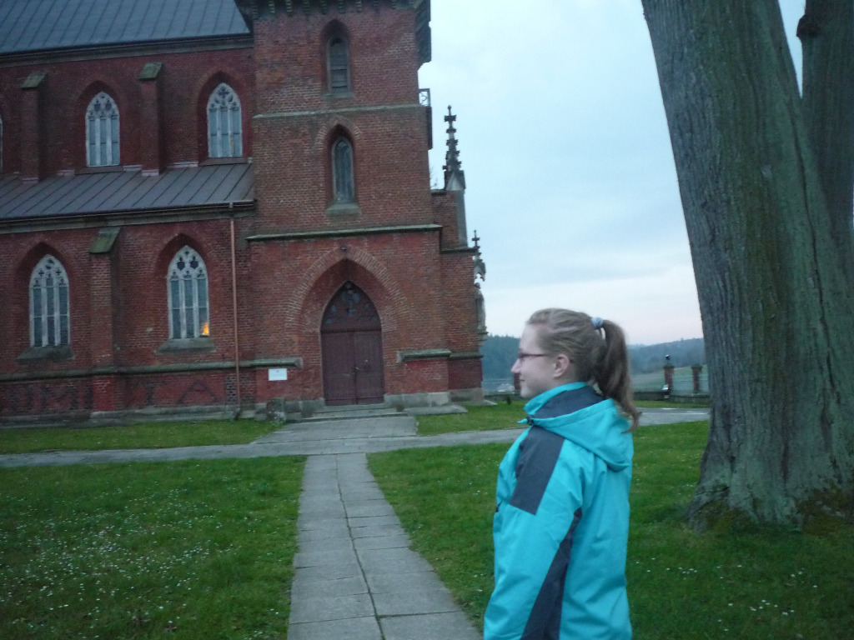jotted by: AnnaG

The story of stranger girl
She is a teenager who probably lives in my village. The girl might be a student of lower secondary school. She seems to be a nice person because she is smiling. I think she is optimistic and modest. She must be a Catholic because she is going to church. I suppose she often goes to church because she is going there despite the fact that it is Monday. In Poland most people are Catholics and they go to church every Sunday. I think the girl from the picture is a religious person because it is not common for young people to go to church on weekdays. They prefer spending time at discos and clubs or they stay at home. For them the most important things are mobile phones. The girl I took the photo of must be a special teenager and a good young woman. In my opinion she likes living in her village because she looks satisfied and cheerful. If she didn’t like her hometown, she wouldn’t be so happy. She seems to be a very interesting person and it would be a pleasure to have a friend like her.
30 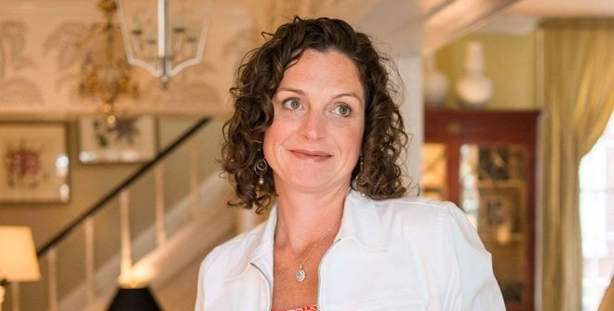
jotted by: Sarah

Emila from Warsaw
This woman is called Emila, she comes from Warsaw, she is 34 years old. She was married during 6 years but she divorced. She has a daughter, called Maria who is aged 19 and is doing studies staying in Warsaw.Emila has gone through Europe to arrive in Alsace to find Katia, her mother who abandoned her at the age of 5 years old in Warsaw, her birthplace. When she found her mother she noticed she was the owner of a popular restaurant. So she decided to apply in the restaurant to know more about her mother and try to confess she is her daughter which is difficult for both.
Now she works in a small restaurant with her mother. The restaurant serves sauerkraut. It is very popular in the Alsace, like fleischnakka and Alsatian decoration.
She now lives with her mother and stepfather in an Alsatian village. Her daughter comes to visit them regularly. Maria is very happy for them.
31
jotted by: Aleksandra Gazda

Part of the nature
In the picture I can see a girl in a white dress with the hat on her head. She's standing on the footpath and she's looking at the sky. Who's she? She could be just a girl who wants to be alone and admire the beautiful views. Maybe she wants to escape from the ordinary life, problems and concerns which are really hard to get by for young person. She's looking at the sky - she may look for some inspiration. The girl seems to be very mysterious and unearthly. So, maybe she's a fairy tale who gets lost in one of the Biecz's forests? And she is looking at the sky calling her sisters to help her get back to her magic house? I can't see her face, so I can just imagine how she looks like. Her white dress and pale skin suits to the light which surrounds this place. She seems to be the part of the forest, the part of its nature.
32 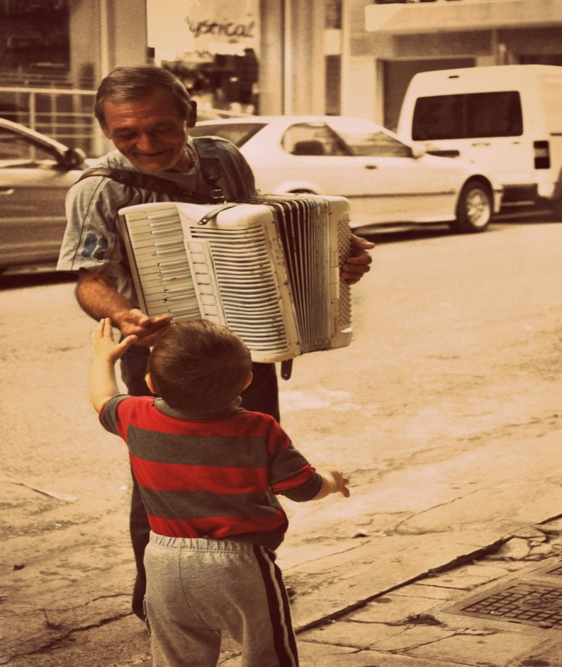
jotted by: Antonia

Little George's action of kindness
Little George was playing football with his friends in the street near to his house. It was early evening when he heard a melody playing as he was kicking the ball. From the street's corner was coming an old man who George had never seen before. He was playing with his accordion a song which his mother sings from time to time. He run straight away to his mother asking for some money for the street-musician. His mother gave him some coins and he run back to the old man. The man when saw the generous little boy smiled with kindness. ''Well'' he thought, ''Nowadays, most of the people avoid me . It's nice to see that solidarity still exist in the little ones!''.

33
jotted by: Alicja Topczyj

The lucky one.
Let me introduce you Diana! She studies in Cracow, where she lives now. She’s originally from Biecz. Diana loves to read. Everything. One boy lost his head over her in high school, but he was the bad one and she was the smart one. Nobody knows how it happened, but he changed for her. They’re a perfect couple now. They want to travel the world together. She likes taking photos, drawing and cooking. She also loves every type of art. However, she still doesn't know, what she’s going to do in the future, all she knows is she’ll live in a small flat in a big city, have a dog and furniture from IKEA!

34
jotted by: Magda Wal

Look at the sky! Maybe you will see something amazing.
Can you guess who is in the picture? When I didn’t know, I’ll tell that she is professional gymnast. But this is Katherine, she is 15 years old, lives in village near Biecz in Poland, she learns very well in school and her passion is everything what concerns sport and music. She dances ballrooms dancing, exercises in trampoline and newly she goes to the aerobics. Moreover, she finished musician school and she plays in keyboard, guitar and saxophone. The best is that, more things she learns herself. The future she wants study mathematics and physics, but she also is thinking about develop her hobby. I think she is very apt person and I admire her, because she has a lot of interest. Instead of sitting at computer she is developing her skills.
35 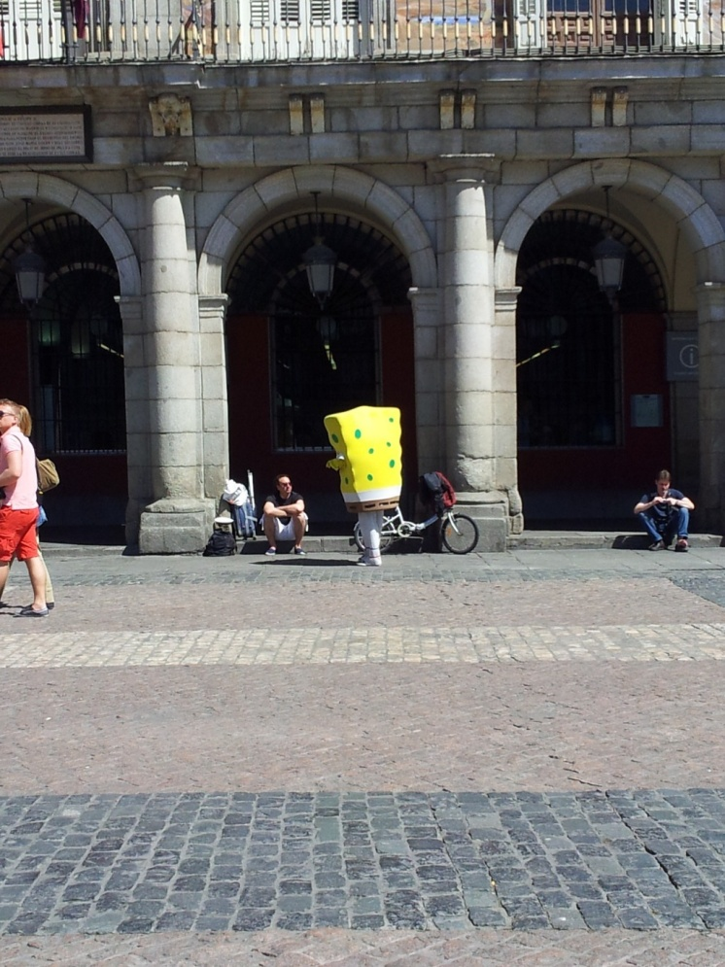
jotted by: Solenne

Sponge Bob the explorer
Liam Summers is a teenager who lives in Strasbourg and attends Kléber High School. He was born in the USA and has chosen to study in Strasbourg because he loves the Alsatian culture, moreover he goes to the Wine Festival of Alsace every year to party but also to rediscover the specialities of the region, like the famous Flammekueche or simply tarte flambée, Bretzels, Schnapps but especially the wine, obviously. Liam adores the French gastronomy and is fascinated by the history of France.
He has child's soul and spends his time to watching cartoons and reading comics, and sometimes he enjoys even disguising as his favorite characters (e.g. Sponge Bob), he is a fan of cosplay (costume play). Later, Liam dreams to become a comic strip writer. But before, he wants to go round the world to explore all the countries, all the cultures and all the languages !
36
jotted by: Dominika Ryba

The moment which changed everything
Sebastian is 18 years old man. He live in northern Poland where he is studying and working. He had a beautiful childhood, with loving relatives and friends. He had own hero who was his father. All of what he taught is from him. They spent a lot of time together.
Everything was wonderful until that they. His father like every day went to work but he never came back to home. While working in the forest, branch fell and killed him. This event changed Sebastian's and his family life. His mother stopped look after him. He didn't have money for necessary things like food. He took a job to earn for living, but it was still hard. He really thought if his life has meaning...
One moment made him new, full of love, determined man. He fell in love. This girl changed his attitude to the life which finally made sense.
Nowadays he has own dreams and life's cells. Sebastian and his true love are still together. He owes her whole happiness and changes for the better.
37
jotted by: Joanna Soczek

Story about little girl with a big talent !
Kamila is a Polish girl who lives in Binarowa in southern Poland. She is a small girl at the age of ten. She has a sister who is older than her by 7 years. Her parents forced her to constantly practice swimming but her dream was to play the violin. She asked her grandparents to arrange violin lessons for her and to buy her first violin so she could pursue her dreams. She did not want her parents to know about her violin lessons because they thought it was a waste of money and time. One day Kamila forgot to hide her violin and left it in her room. While she was out her parents went to her room and noticed the violin. Kamila had to explain why she had not told her parents about her violin lessons, and that she didn’t want to swim anymore. Her parents had to accept her choice and let her continue to go to violin lessons . When her parents finally noticed her great talent, they held a concert in their local church so that everybody could hear how beautifully she plays .
38 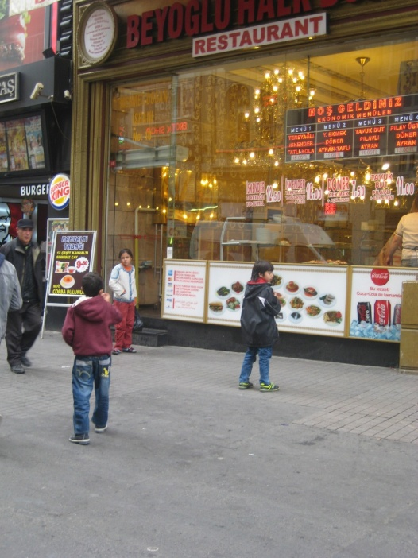
jotted by: aylin

THE STORY OF THEIR LIFE
These children are Syrian refugees. The girl's name is Akmar. She is 11 years old. She has to look after her brothers. Her brothers are twins and 9 years old. In Syria they were poor but happy. They had a small house and they could go to school. Now they're in Istanbul, Turkey and they live in difficult conditions. In this picture, an old man sees them and he wants to buy some food. They feel startled and they cry. They enter the restaurant and start eating meat, pasta and drinking ayran ( a favourite drink with yoghurt).
This was the happiest day ever since they came to Istanbul. And they never forgot that man.
39
jotted by: Margarita Sardaryan

A Brave Man
Murat Fıstıkçı is a 45 year old man who lives in Gümüşsuyu in Istanbul. He has two children and they go to school. He cleans Istiklal Street every day which is the most crowded street in Istanbul. There are many pubs , cafes, shops, restaurants and beautiful colorful streets. A lot of tourists come here to see this street.Murat starts work every morning at 7am. He had a big dream.He wanted to be a pilot when he was in high school, but he couldn't fulfill his dreams so now he cleans the streets. He's happy with his life which makes him stronger. The other thing which makes him stronger is his family. He loves his wife, his children . That's why he could do everything for them.
40
jotted by: Klaudia

The dark soul in the form of innocence...
She is young. Young and ambitious. Perhaps a little too confident. Definitely too much unscrupulous. But first of all very street-wise. Lie is her middle name. Born under a dark star.
She is going her home after a well - done job. In her wallet there is large amount of money. Today she was on a meeting with one man.. She even doesn’t know him, but it isn’t important. Important is that he took drugs without any complaint on a fake goods. Amateur.
Today she drove to nearby town and went to the park, when she was walking with her dog. Youngsters were playing on the playground, birds were singing on the treetops. A young man approached to the dog of drug dealer. He went over it and started stroking the pet. Trembling of his hands revealed nervousness, when he was feverish looking for a small parcel which was attached to dog’s stomach. Trained animal was standing motionless. An idiot! Probably at home he saw that the white powder was ordinary flour.
41 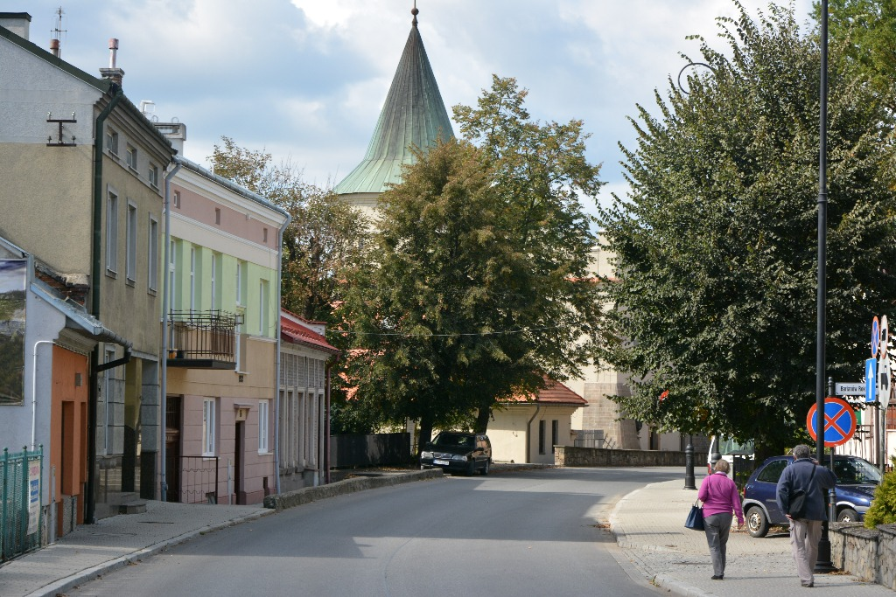
jotted by: joannaja

The brave marriage couple !
In the bottom right-hand corner we can see the married couple. Her name is Nina , His name is Tom and they are 65 years old. They come from Poprad, Slovakia. They met them when they were 20 in the USA because Tom and his family lived there and Nina was on the trip with her friends there.
Hardly had she gone for a walk when the Tom fell. She helped him and they fell in love at first sight.
It was very hard to meet each other for them so they got married in 1972 and they moved to Slovakia then. In 1975 Nina gave birth to a child, there was in Poprad.
When their daughter was 9 , they decided to travel all over the world. They were in Arfica but there wasn't the successful journey. The mosquito had bitten their child and after 5 days she died. The parents came back Slovakia but they were devastated. Fortunately, they have had the five children yet.
Now they are a happy family with five grandchildren. Nina and Tom are visiting the new places like Biecz.
42 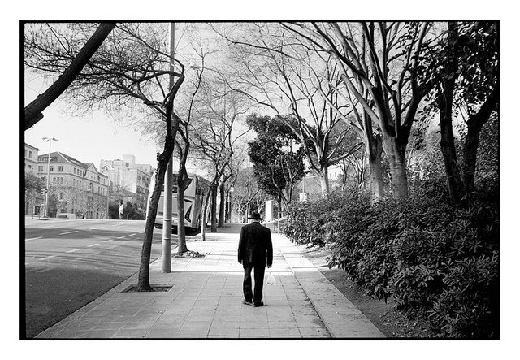
jotted by: r.iamundo

A man like another
A day like another, Aaron walking alone in the street deserted. People do not go out probably anymore because of the delinquency and criminality that he made reign in the city. This guy was a rejected person, by people and society. Her mother who adored her son, commits suicide because of the problem that the father which made her, when he was only 15 years old. His father, then remarried cause him lots of problems, the teenager don’t support the new wife of his father, he fires him of the family house, the guy end up alone. At school and out the boy did not have friends, everybody laughed at him, no girls wanted him, yet it was a boy like another. The guy did not succeed at school because of his problems and his life, “like another”. Alone, Aaron lives of things that he robs, the man takes his revenge, killing everyone who hurt him, and even his father, here is how a man can lose the reason, this man rejected, yet it was a man like another.
43
jotted by: Alexandra Fratila

∞If nothing lasts forever,will you be my nothing?❣∞
This is Dimitris and Maria Diothes. An old couple who live in Athens. They are just taking a break from their daily routine walking down an old pedestrianized street in the centre of Athens, where everything is possible. They had a very interesting story full of passion, faith, hope and pain. They are together from High School and they will be together even after death as they have promised each other. Their life has never been easy. They both are pensioners now and they can hardly make ends meet. They are just the two of them without any children. The future they can think about is near each other, no matter how long it will be. Their whole life was based on loving and respecting what they have. So economic crisis does not seem to affect them.
Nice to meet you, Dimitris and Maria!ツ♥
Photo: Alexandra Fratila
44 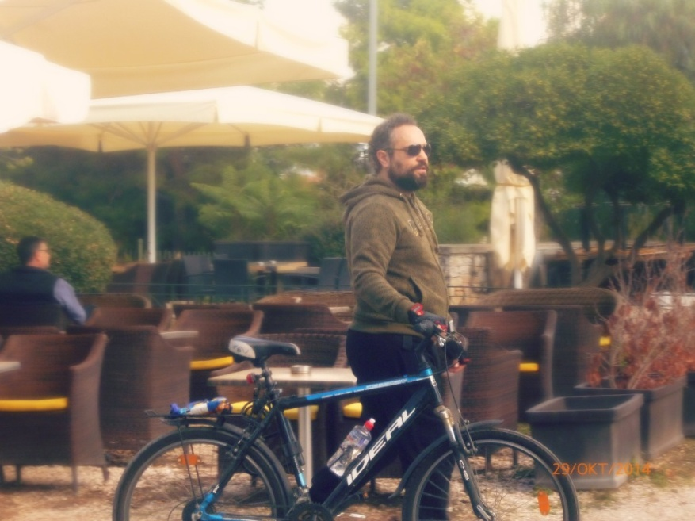
jotted by: Vasiliki Christopoulou

John needs time to recover, but WHY? ツ
John is 50 years old. He was born in Limnos. He finished the school with flying colours and went to study in England. He stayed in England for 20 years. He married Mary and they had 2 children, a boy and a girl. His wife who used to be friendly and dedicated to her family was also a lawyer. In 2011 they returned to Greece and they opened a law firm. Unfortunately last year his wife died after a serious disease and John was devastated. He abandoned his job and he spends hours cycling in the streets of Athens without an aim. His children are worried but he says he needs his time to recover.
Good luck John! ✌
45 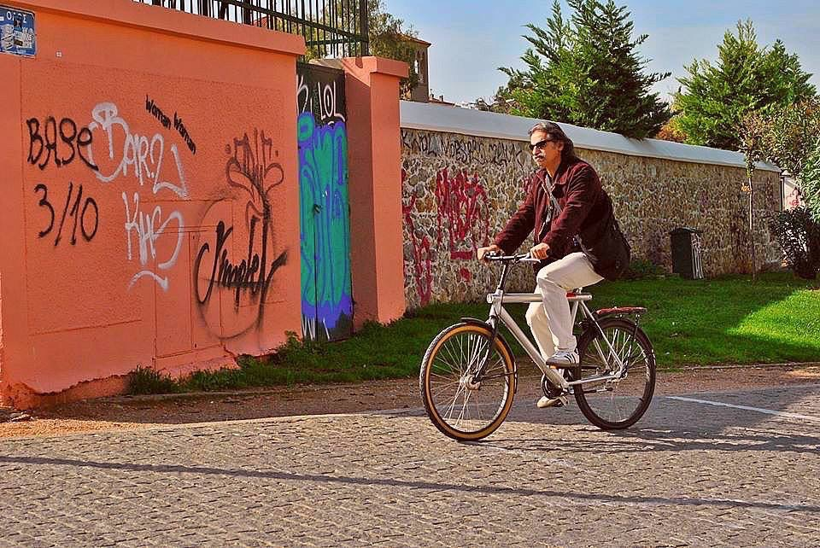
jotted by: Athina Georgiadi

The rider.
His name is Miltos, he is 52 years old and bachelor, he lives in Athens. He is not a social and extrovert person. Most of times he stays at home listening to classical music and trying to solve mathematical riddles. He rides his bicycle every day in a standard and special hour, his favourite route is down the Acropolis. When he strolls in the centre of Athens, he stands and notices the people's shoes and he imagines how their life can be. He only uses his bike to commute and he cannot part with his sunglasses. Absolutely, he is an interesting guy.

46 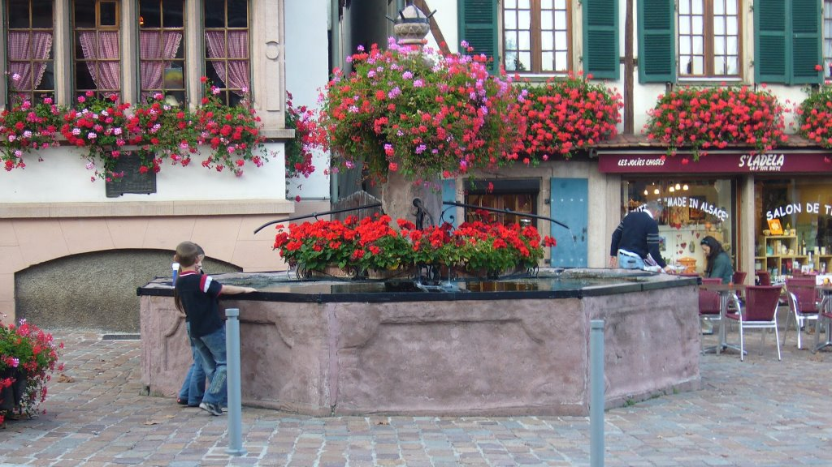
jotted by: Mathieu Werra

A family story
In this picture you can see one brother and one sister. These kids have a historical family tradition about this fountain in the center of Kintzheim.
They Old-parents met each other at this fountain so as their parents did.
The two kids like to go at this fountain because it is beautiful.
Next to this fountain the family have buy a restaurant to be the owner of this fountain.
47 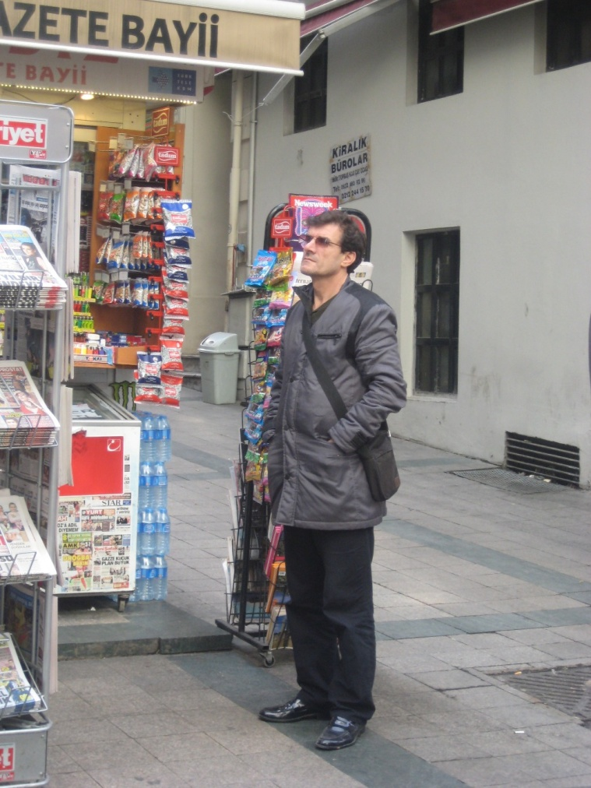
jotted by: Berkay

The Mysterious Man
Taksim is crowded and noisy. He is alone and quiet. He is a strange and mysterious man.Every time I see him, he stands in front of the store and waits for someone.He waits and waits, but no one turns up. He hasn't got any place to stay so he's a homeless man.I want to talk to him but I can't.Because I don't know what to say to a man who is really weird.But one day I'll ask him who is waiting for. Actually I know I can't help with his problems but I can share them.
48 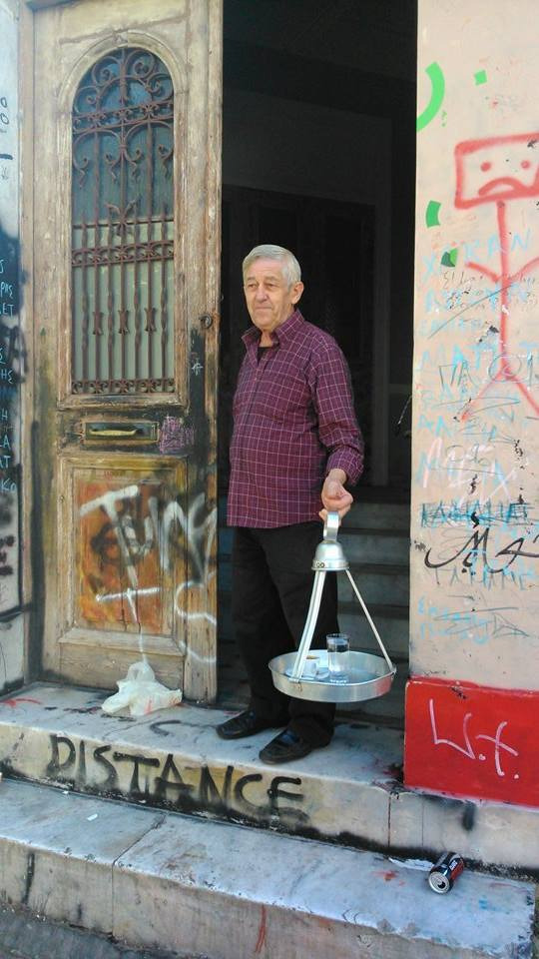

jotted by: john.psomas

Coffee flavours still in town
Times are changing. Technology has come for good in our lives. The past, however, will seem like a beautifull fairy tale. Thomas Ginis is the hero of a tale that many times my mother used to say!A walk in Thisio,Athens brought me face to face with this figure. The tradition among the narrow streets of Thisio.... uncle Thomas with the traditional tray of coffee, the fisherman hair, sweet smile and gentle presence. True to his profession and perhaps the only one left that serves traditional Greek coffee at the little "cafe" for many decades. A quiet man who refuses to follow the steps that lead to the future. Simple, true and absolutely picturesque, now familiar to residents and patrons of the area and many Athenians who still seek the nostalgia of old times.The company of uncle Thomas and his stories can be a pleasant note during your stay in the cafe. Everything seems surprisingly intimate and familiar even though times have changed.
49 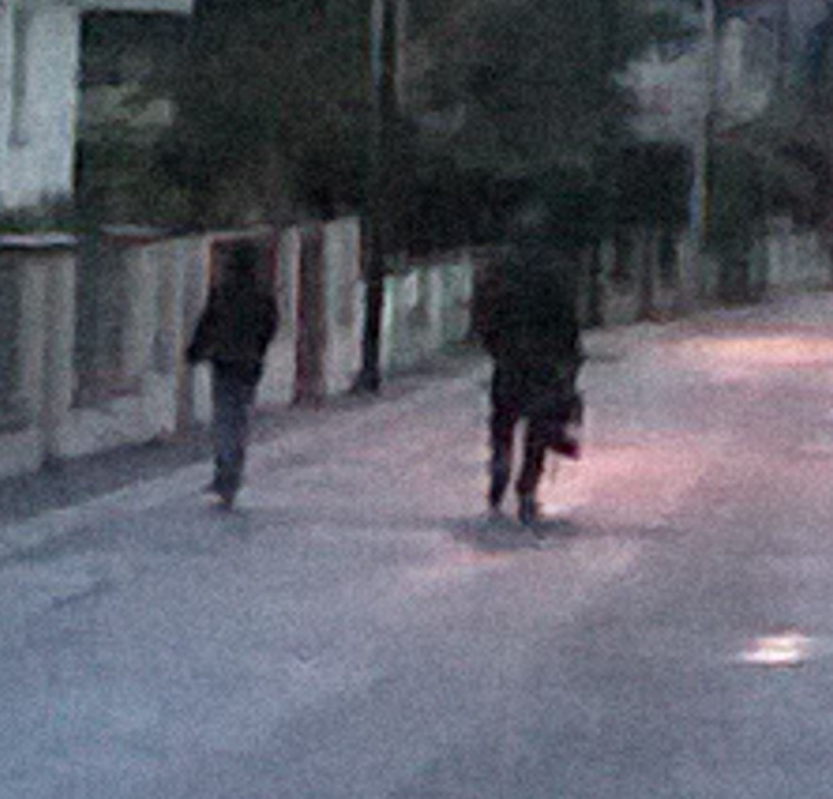
jotted by: manonvalentin29

The small gifted child
October the 21 st, Paul drives his son Antoine at the bus stop as every day of the week. The bus come at 7.35 am, Antoine goes to school like a studious student he likes math, French. At least that’s what his father believe because he is not a student as we could be believe he is. He takes the bus, but doesn’t go to school like her mother thinks!Antoine hides a secret which only his father know! Since that early childhood, his father to reveal he was much more to move forward intellectually.Wanting not to waste the talents of his son, Paul decided to put him in a school where only the gifted children as can him pass from exceptionally gifted pupil to exceptionally gifted pupil professor! Antoine teaches for more than 5 years the main subjects but more particularly the Alsatian because he likes more that everything ALSACE! 5 years that only Antoine and Paul know this secret.

