Friday, 7 November 2014

A collection of odd and fascinating photos...By Nitin Patil’s blog

http://andurle.blogspot.gr/2014/11/a-collection-of-odd-and-fascinating.html
A collection of odd and fascinating photos...
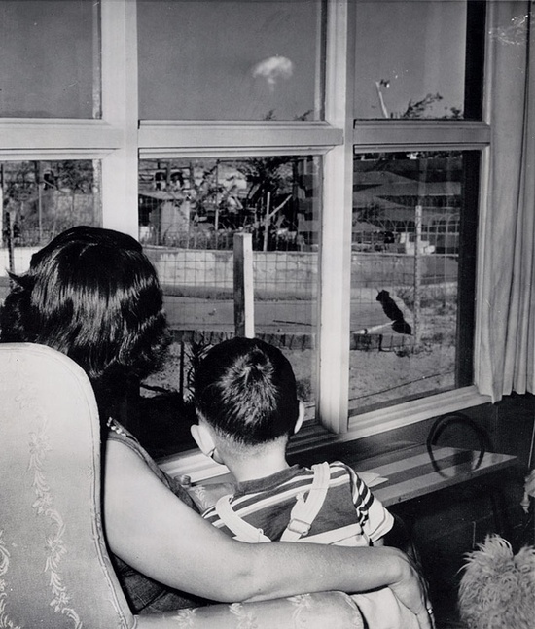
A mom and her son watch the mushroom cloud after
an atomic test 75 miles away, Las Vegas , 1953.
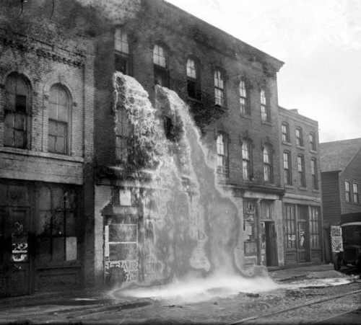

Illegal alcohol being poured out during Prohibition, Detroit 1929.

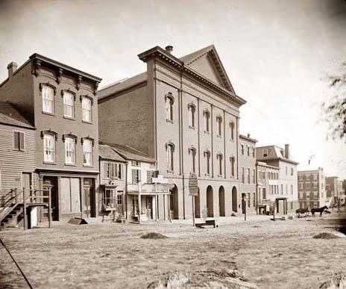
The Ford Theater, where Abraham Lincoln was assassinated.
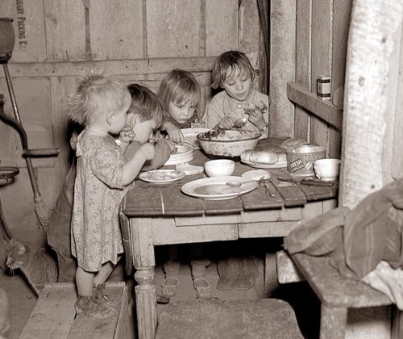
Children eating their Christmas dinner during the
Great Depression: turnips and cabbage.
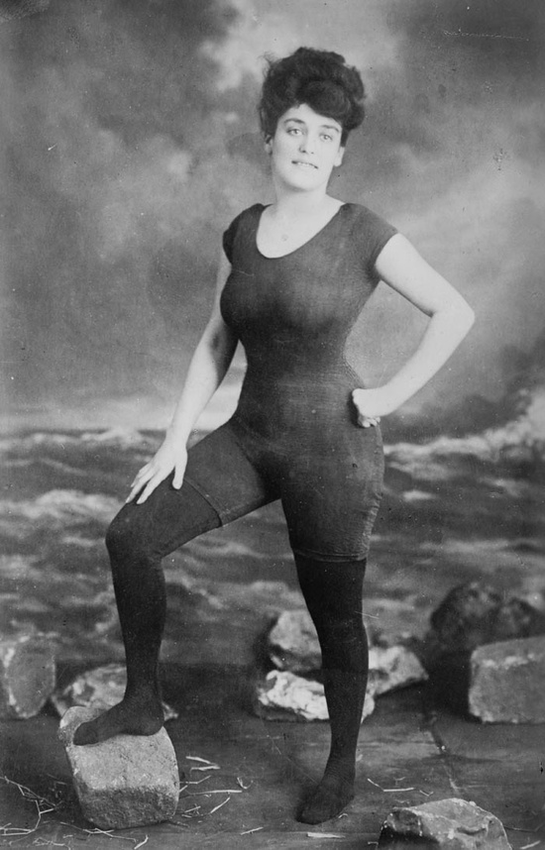
Annette Kellerman promoted women's right to wear a fitted one-piece
bathing suit, 1907. She was arrested for indecency.
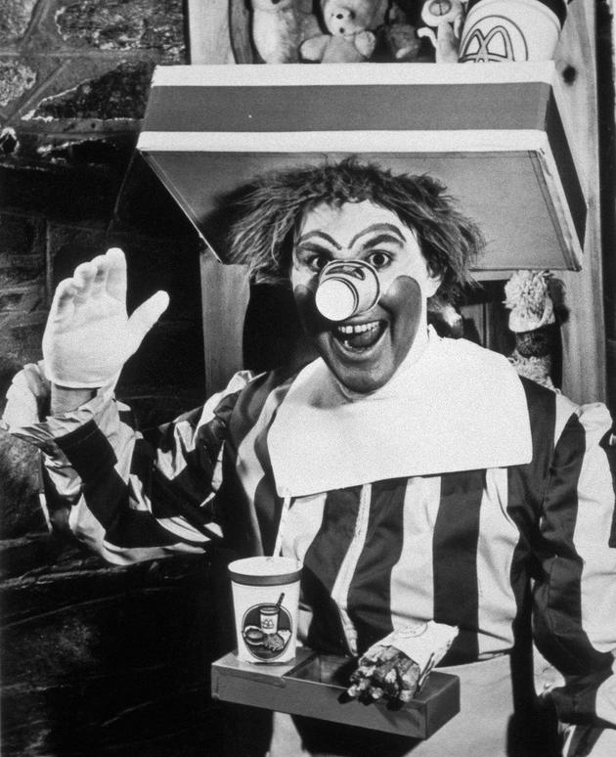
The original Ronald clown of McDonald's in 1963.
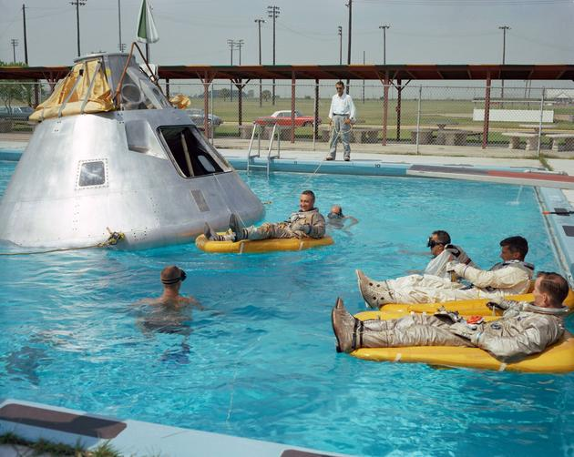
Apollo I crew members rehearsing their water landing in 1966.
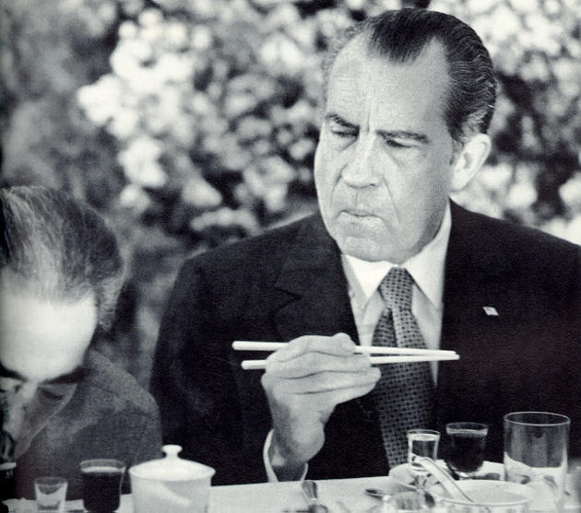
President Richard Nixon trying to use chopsticks while visiting China in 1972.
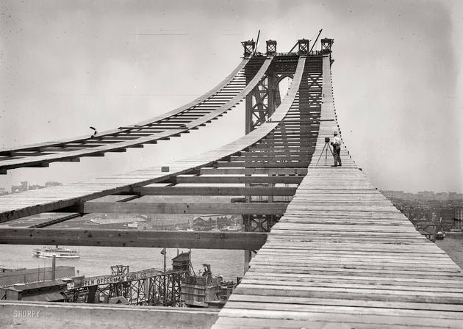
Construction of the Manhattan Bridge, 1908.
Construction of the Berlin wall, 1961.
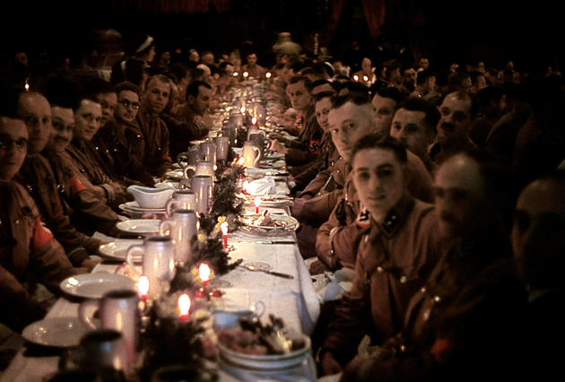
Hitler's officers and cadets celebrating Christmas, 1941.
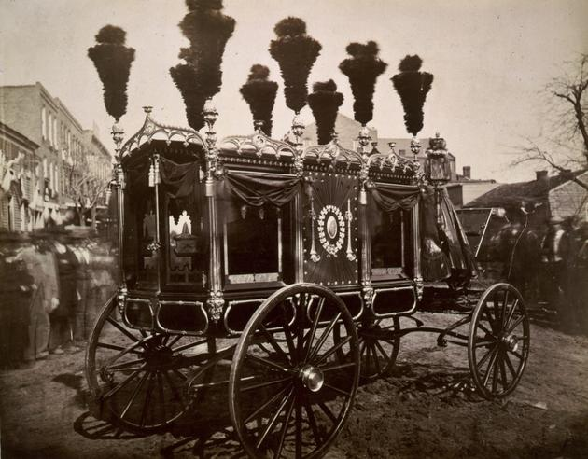
Abraham Lincoln's hearse, 1865.

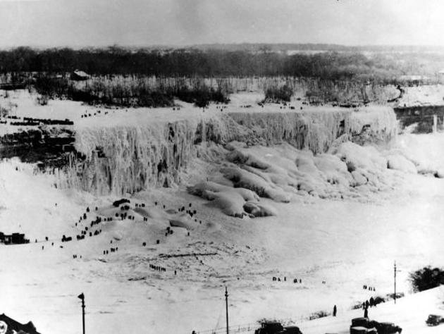
Frozen Niagara Falls , 1911.
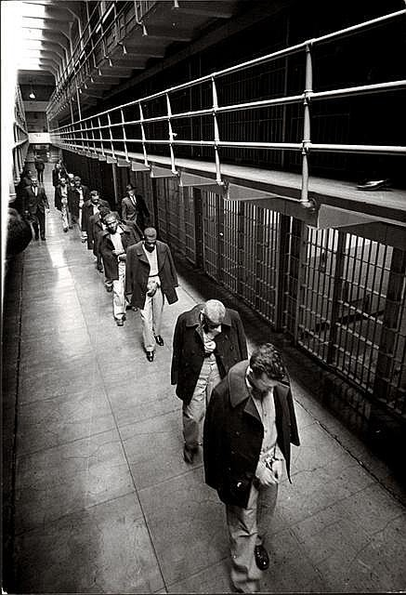
Last prisoners of Alcatraz leaving, 1963.
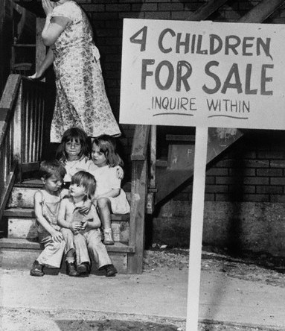
A penniless mother hides her face in shame after
putting her children up for sale, Chicago , 1948.

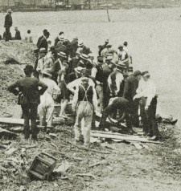
Recovering bodies after the Titanic disaster, April 1912.

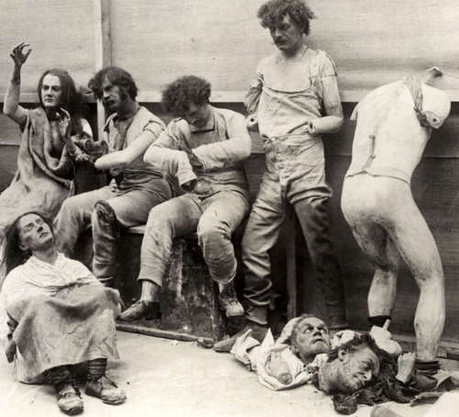
Melted and damaged mannequins after a fire at
Madam Tussaud's Wax Museum in London, 1930.

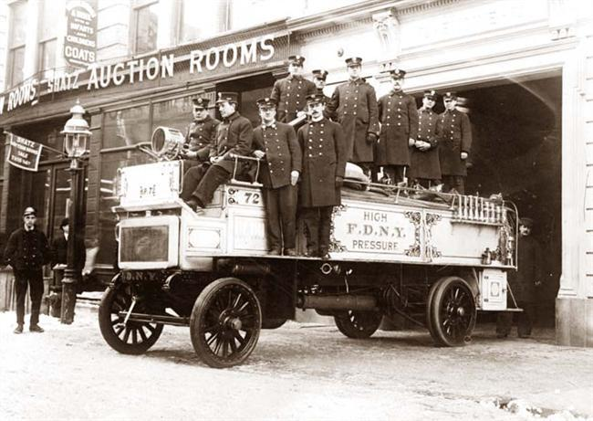
New York City fire station, ca. 1912.
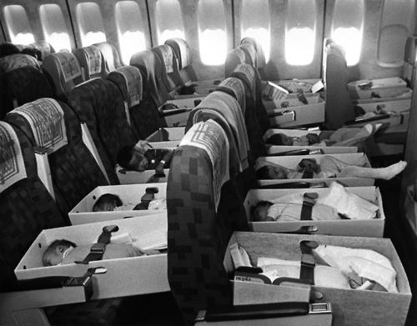
Operation Babylift: Vietnamese orphans transported by airplanes to America in 1975.

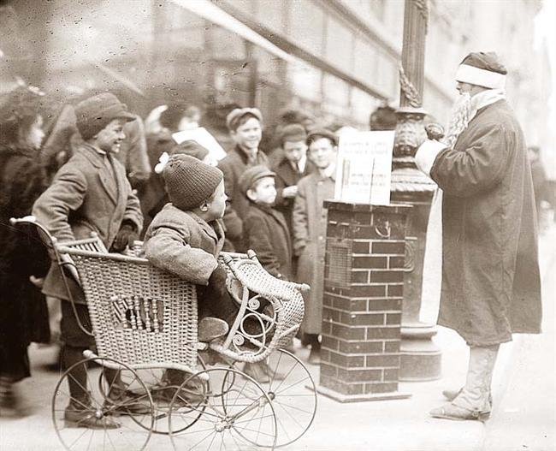
Santa Claus in New York, ca. 1900.
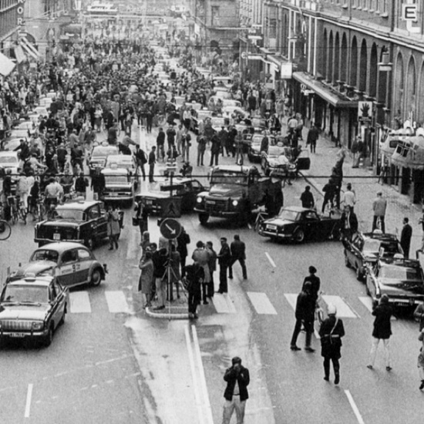
5:00 P.M., September 3rd, 1967 Sweden changed from driving on the
left side to driving on the right. - This was the result.
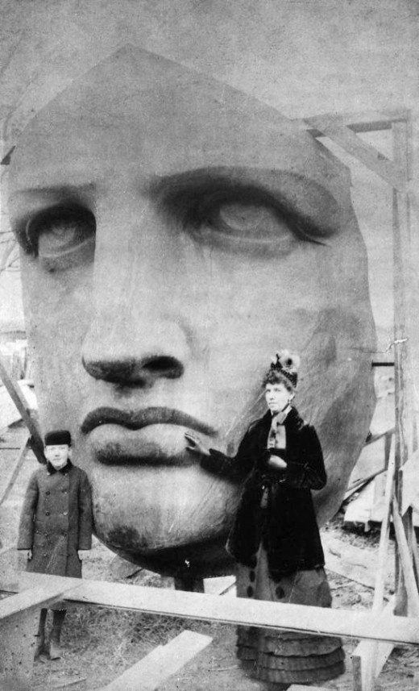
Unpacking the Head of the Statue of Liberty. Delivered June 17, 1885.

Posted by Nitin Patil at 23:02
Email ThisBlogThis!Share to TwitterShare to FacebookShare to Pinterest

